Start with an empty blender file.
Change the camera to view from the top (Numpad 7)
, and the view to orthographic (Numpad 5)
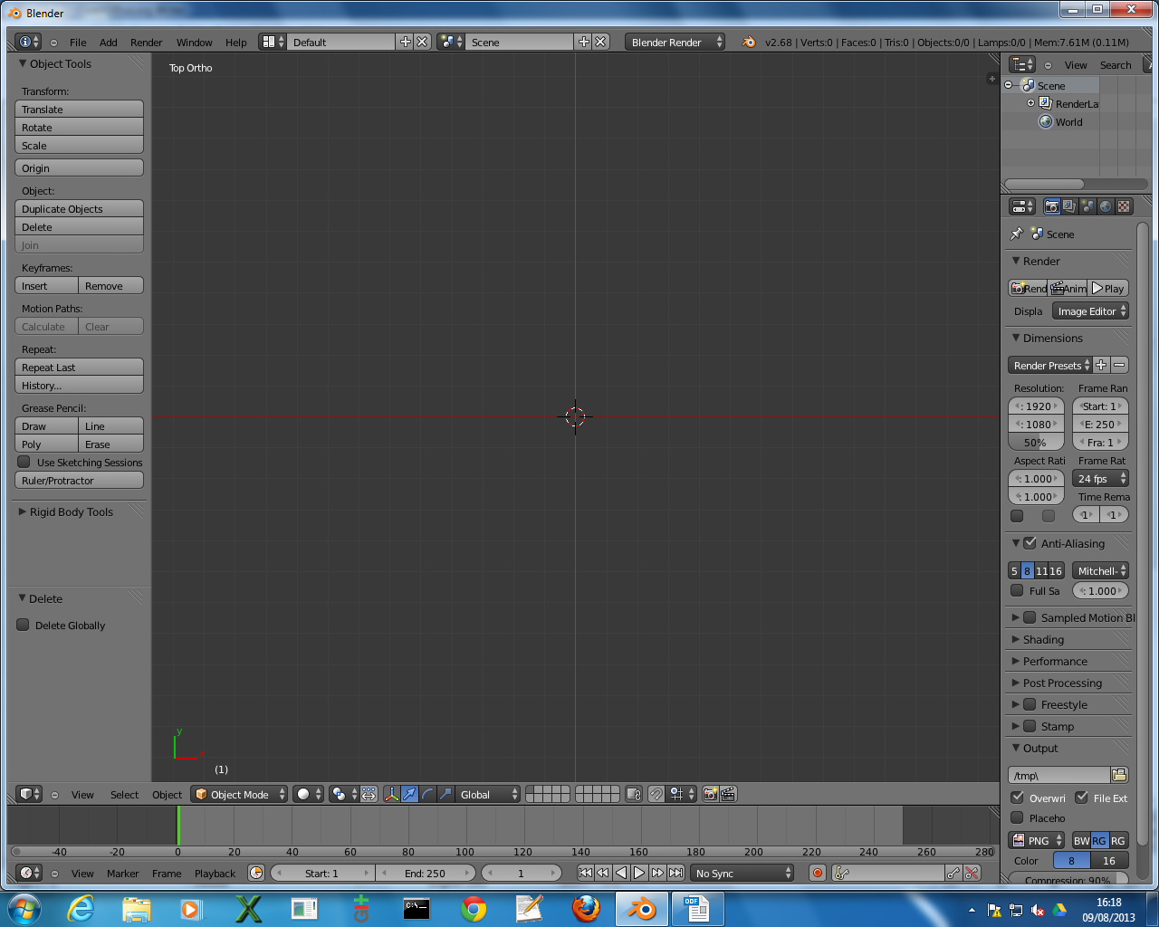

Adding a circle:

Menu “Add → Mesh → Circle”
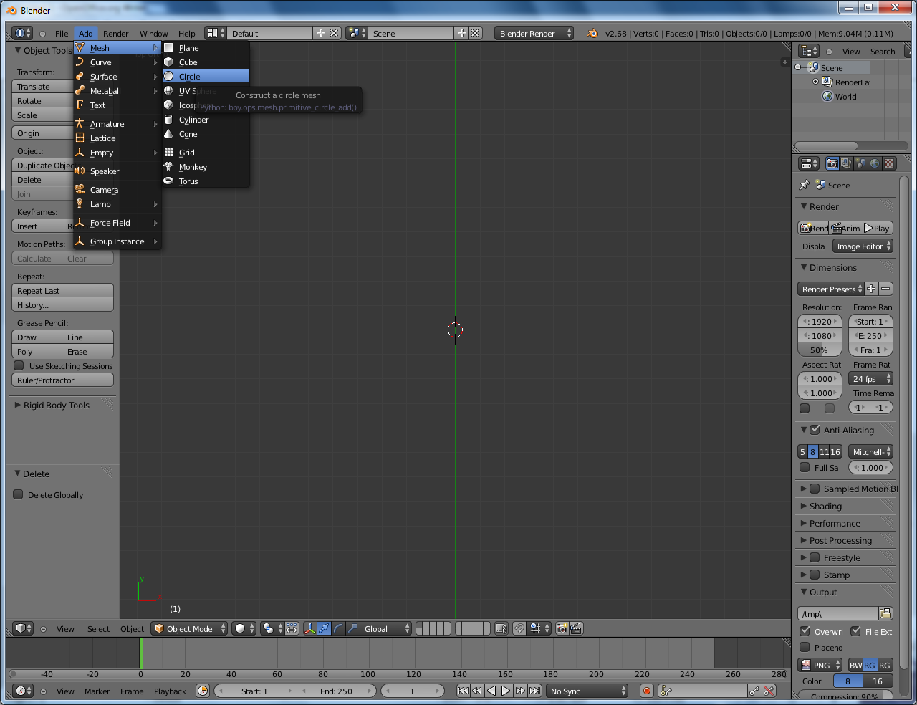
Circles must have “Circle” prefixed to their name (i.e. “CircleMyFirstCircle”)
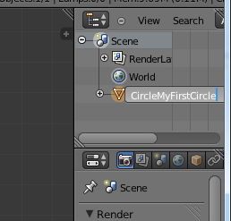
To edit the circle, use the grab and scale operation whilst in Object mode.
Rotations, or editing in edit mode will probably break the exporter

Adding a box:

Menu “Add → Mesh → Plane”
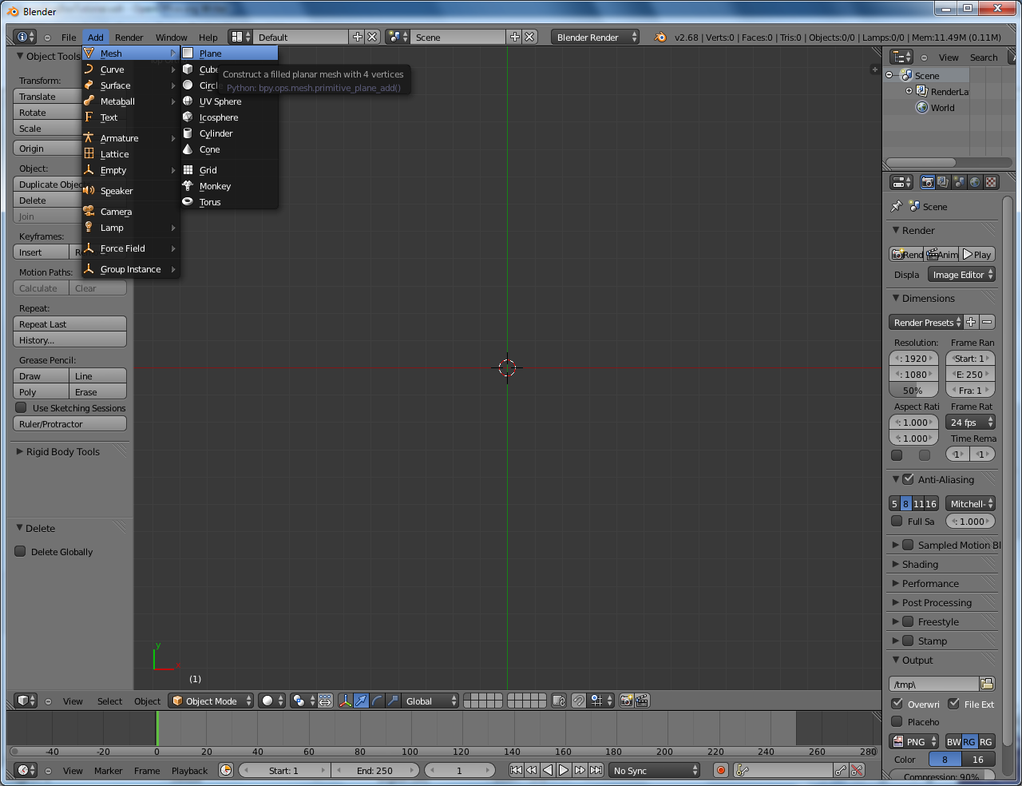
Boxes must have “Box” prefixed to their name (I.e “BoxMyFirstBox”)
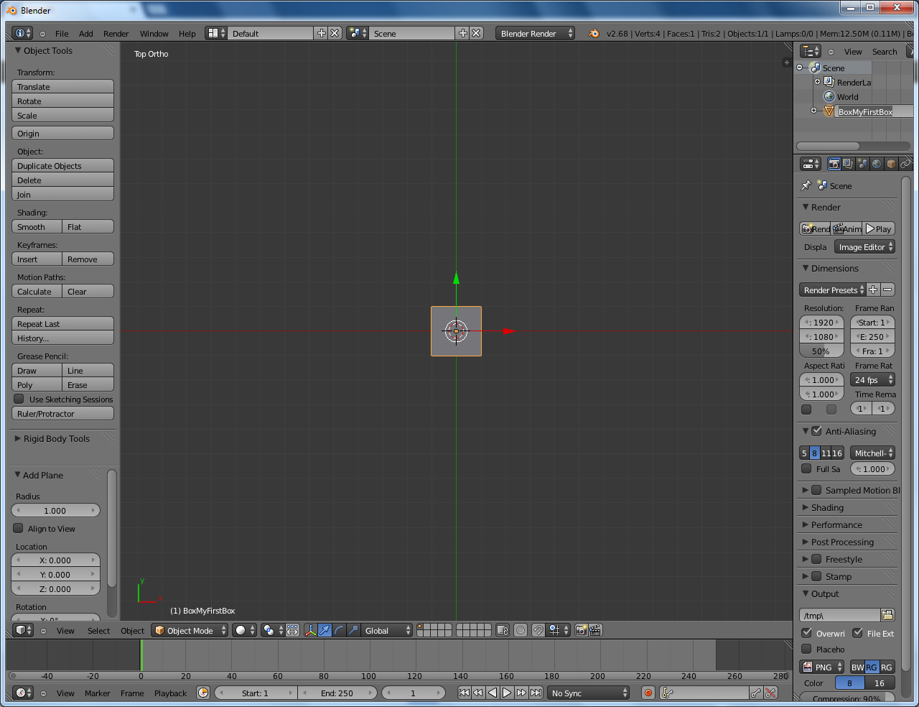
To edit the box, use the scale and grab operation whilst in object mode
Rotations, or editing in edit mode will probably break the exporter

Adding a Polygon

Menu “Add → Mesh → Plane”
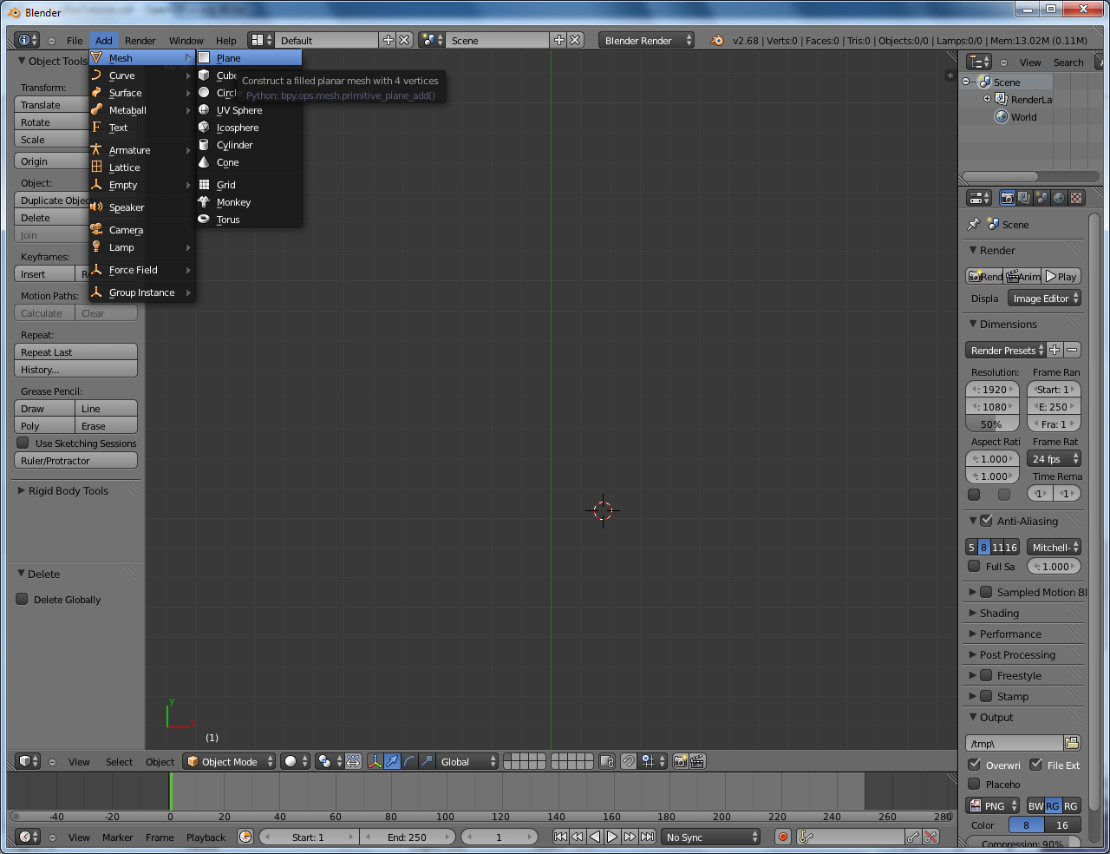
Polygons must have “Poly” prefixed to their name. (I.e “PolyMyFirstPoly”)
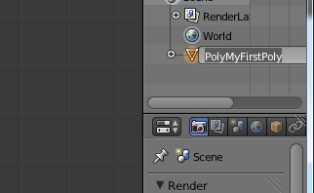
To edit the poly, either scale in object mode, or go into edit mode and move the vertices.
Rotation performed in object mode won't work.

Exporting a file:
Create a file with a box, circle, and poly.
Select these three components and group them (CTRL – G)
Name this group “CollisionGroup”
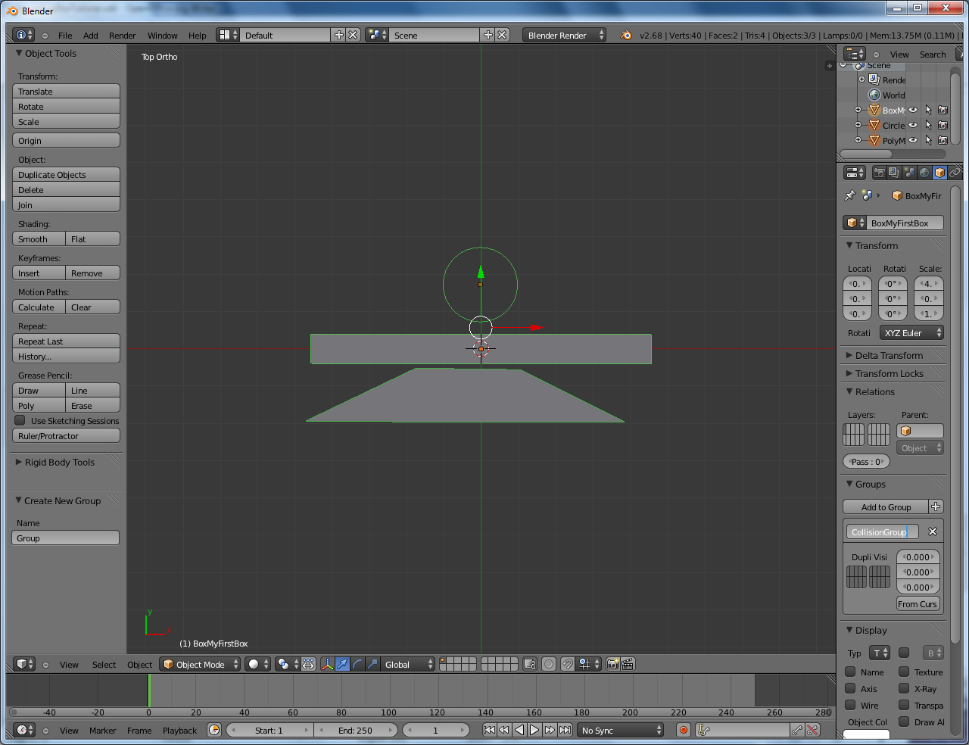

Select “File → Export → XpmBox2D”
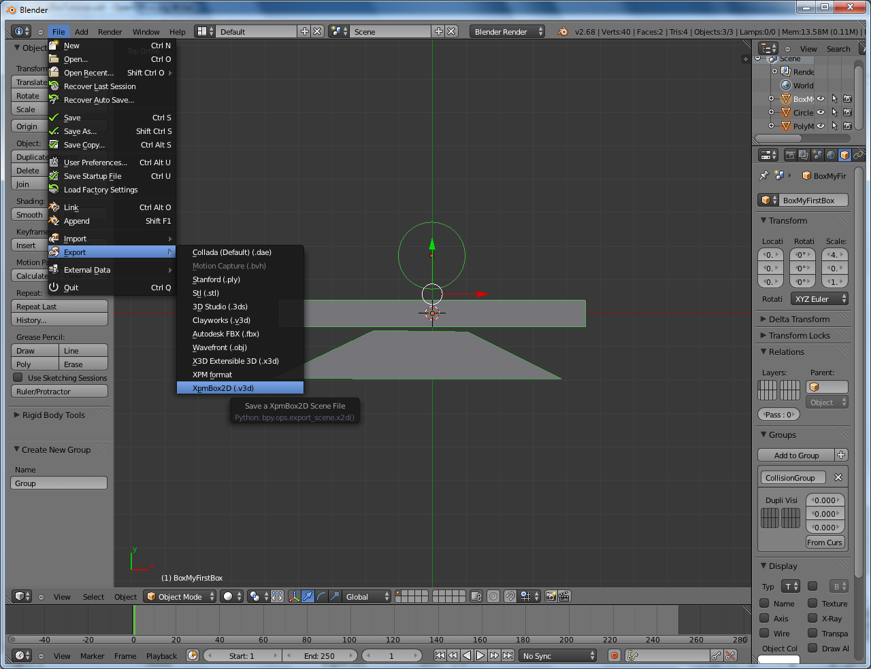
Then select the output destination.
This should create two files, a .x2d and a .x2db.

The .x2d file is a text file and should look something like this
CIRCLE
ID MyFirstCircle
Position -0.02031296119093895 1.7266016006469727
Radius 1.0
BOX
ID MyFirstBox
Position 0.0 0.0
Width 4.5580549240112305
Height 0.3959251642227173
POLY
ID MyFirstPoly
Position 0.0 0.0
Vert 1.060939 -0.564098
Vert -1.751580 -0.523472
Vert -4.696959 -1.934396
Vert 3.843815 -1.954709
Edge 0 1
Edge 1 2
Edge 2 3
Edge 3 0
END

The .x2db file is a binary file and is the one used in the game

Finally add this line an xml object
<component name="Box2DCompositeFixture">
<string name="BoundingFixtures">/FullDirTo/afterSort.x2db</string>
<float name="Density">0.1</float>
<float name="Restitution">1.0</float>
</component>

Also, to view bounding boxes in the game, uncomment the line //debugDraw
in cCmpBox2DCompositeFixture.cpp

