Attempting to create an offline mode with flask.
Step One, setup flask in a virtual environment.
As described here http://blog.miguelgrinberg.com/post/the-flask-mega-tutorial-part-i-hello-world
Step Two, setup directory structure.
Initially in online mode, the structure looks like:
**folders**
/cgi-bin/
/html/
/imgs/
/lmeds/
/tests/
I changed it to
/app/
**folders**
html/
imgs/
lmeds/
tests/
**files inside app/
views.py
**file in same directory as app/
/run.py
Step Three, making a view. A view is a reroute from a url to a handler function. I attempted to take the code from rpt_demo.cgi (contents of cgi-bin) and place it inside the handler function. The calls to experiment_runner had to be written from the new place in the directory structure. See the views.py file to read the code.

Step Four, fix the print error. Originally the buildPage() function of the rptMain module used a print command to put the html down. Instead, the view in views.py needs to return this string. Follow the callback track below and make sure buildPage returns htmlOutput.encode('utf-8') to run to runExperiment to views.
views.py → experiment_runner runExperiment() → rptMain run() → rptMain buildPage

Now I will show how this method worked out in hopes that someone else or me later can find the issue.
1. navigate in terminal to the directory containing run.py (the root of the project)
2. type python run.py
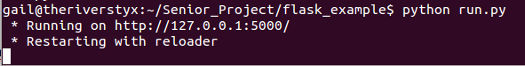
3. navigate in a browser to the address listed by the terminal response.
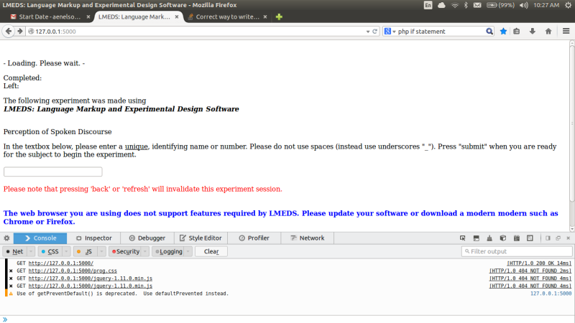
This is what comes up after solving the print error.

What I don't understand at the moment is where does the submit button reroute to? I followed it through the javascript and got lost at where the form posts to.

