Introduction to R and the tidyverse
  - Exercise 1 — ISS dataviz, Spring 2026
YOUR NAME HERE
Invalid Date
Table of contents

Task 1: Session check-in
Three interesting or exciting things:
- Something
- Something
- Something
Three muddy or unclear things:
- Something
- Something
- Something

Task 2: Penguins

Data description
For this exercise, you’ll be exploring data about 333 penguins living across three islands in Antarctica. See this website for complete details about the data and the variables included.
library(tidyverse)
penguins <- read_csv("data/penguins.csv") |>
drop_na(sex)

Recreate scatterplot
Run the code chunk below to see a plot.
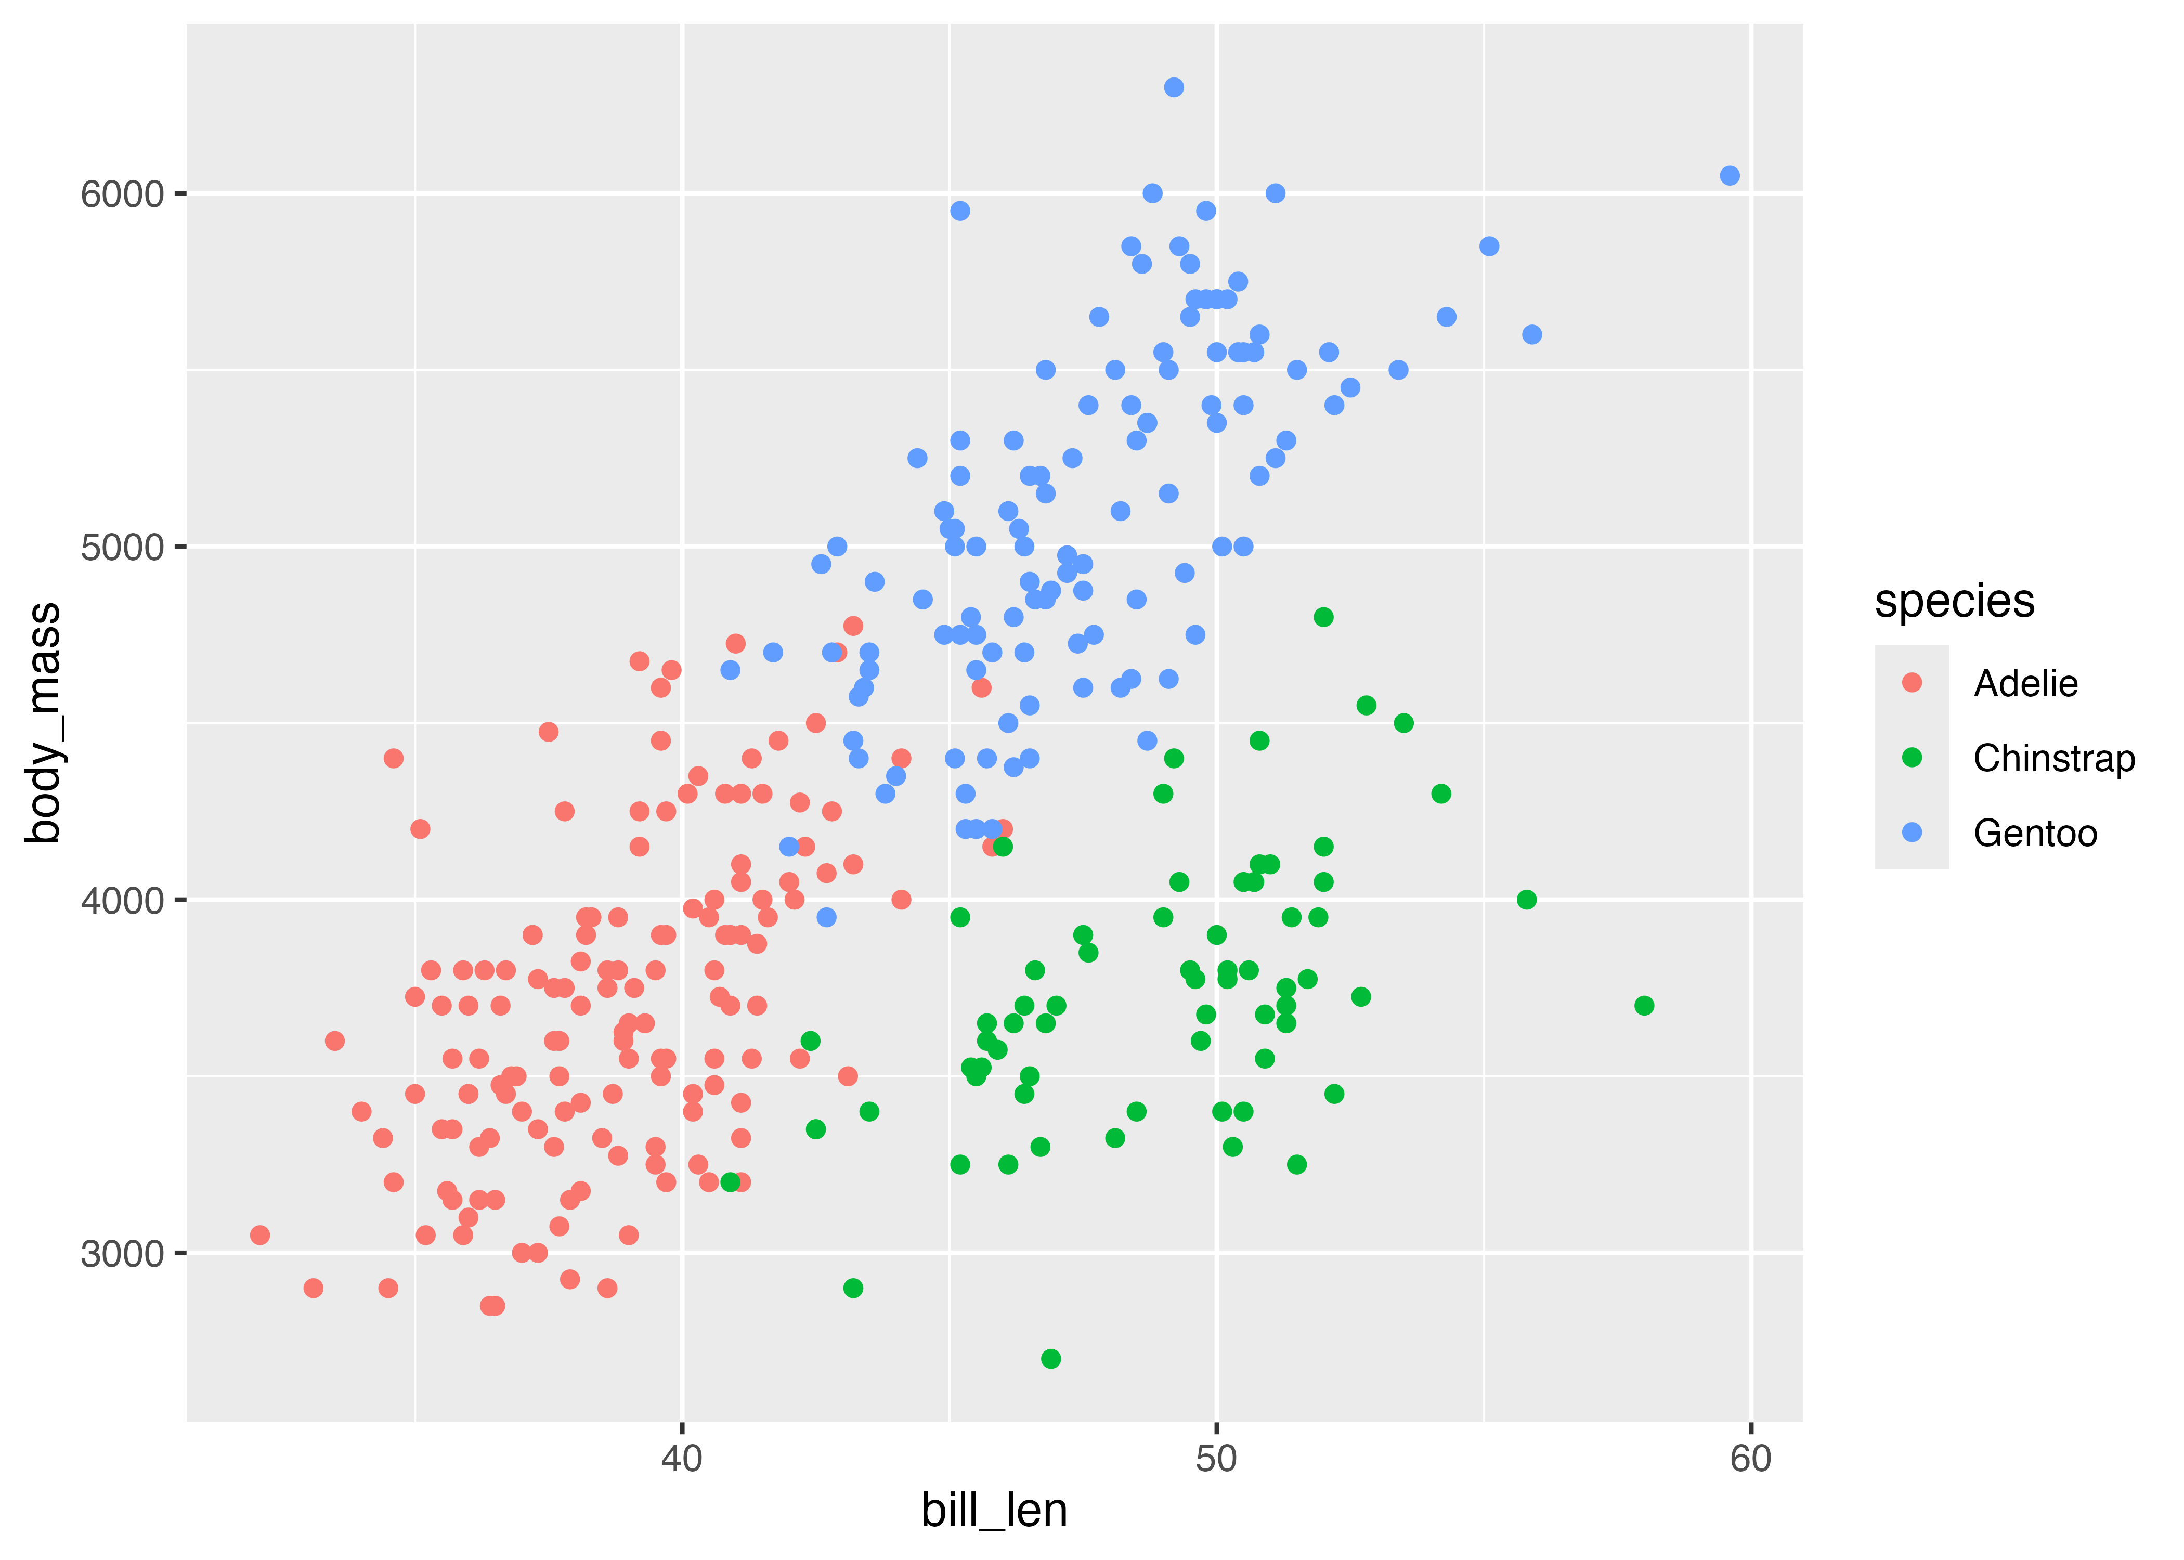
Use ggplot() in the chunk below to re-create the plot above.
# Do stuff here

Recreate histogram
Run the code chunk below to see a plot.
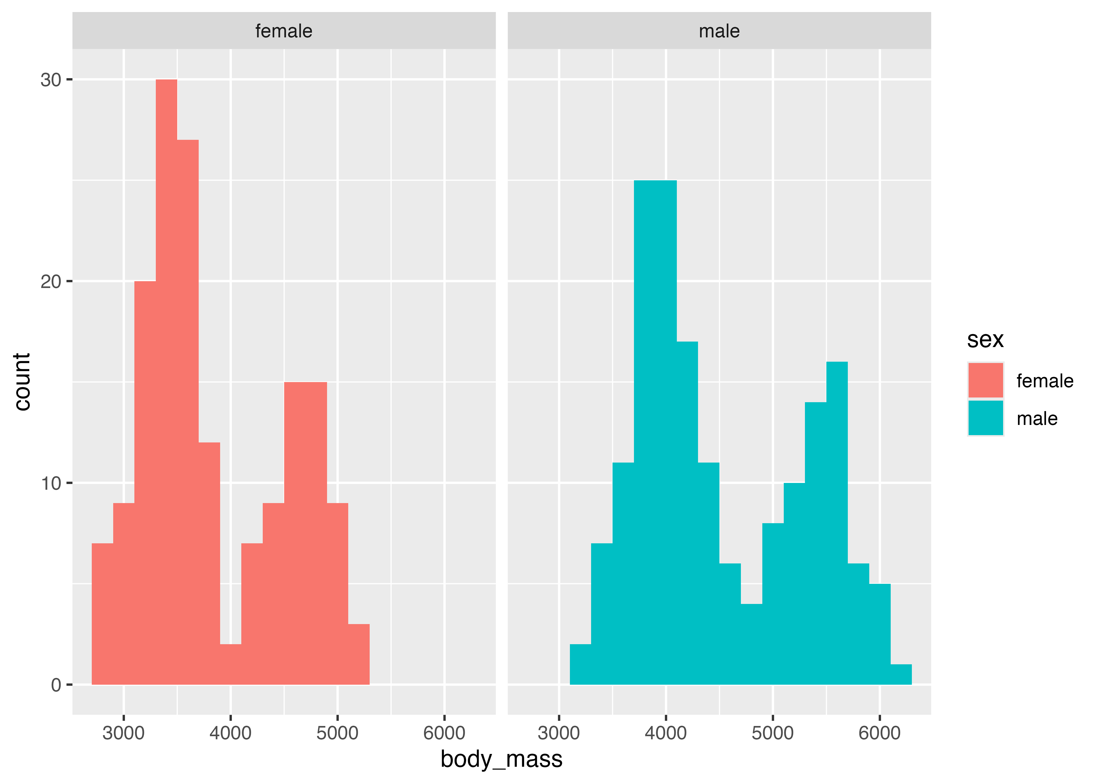
Use ggplot() in the chunk below to re-create the plot above (hint—it’s a histogram with a bin width of 200 grams).
# Do stuff here

Recreate scatterplot
Run the code chunk below to see a plot.
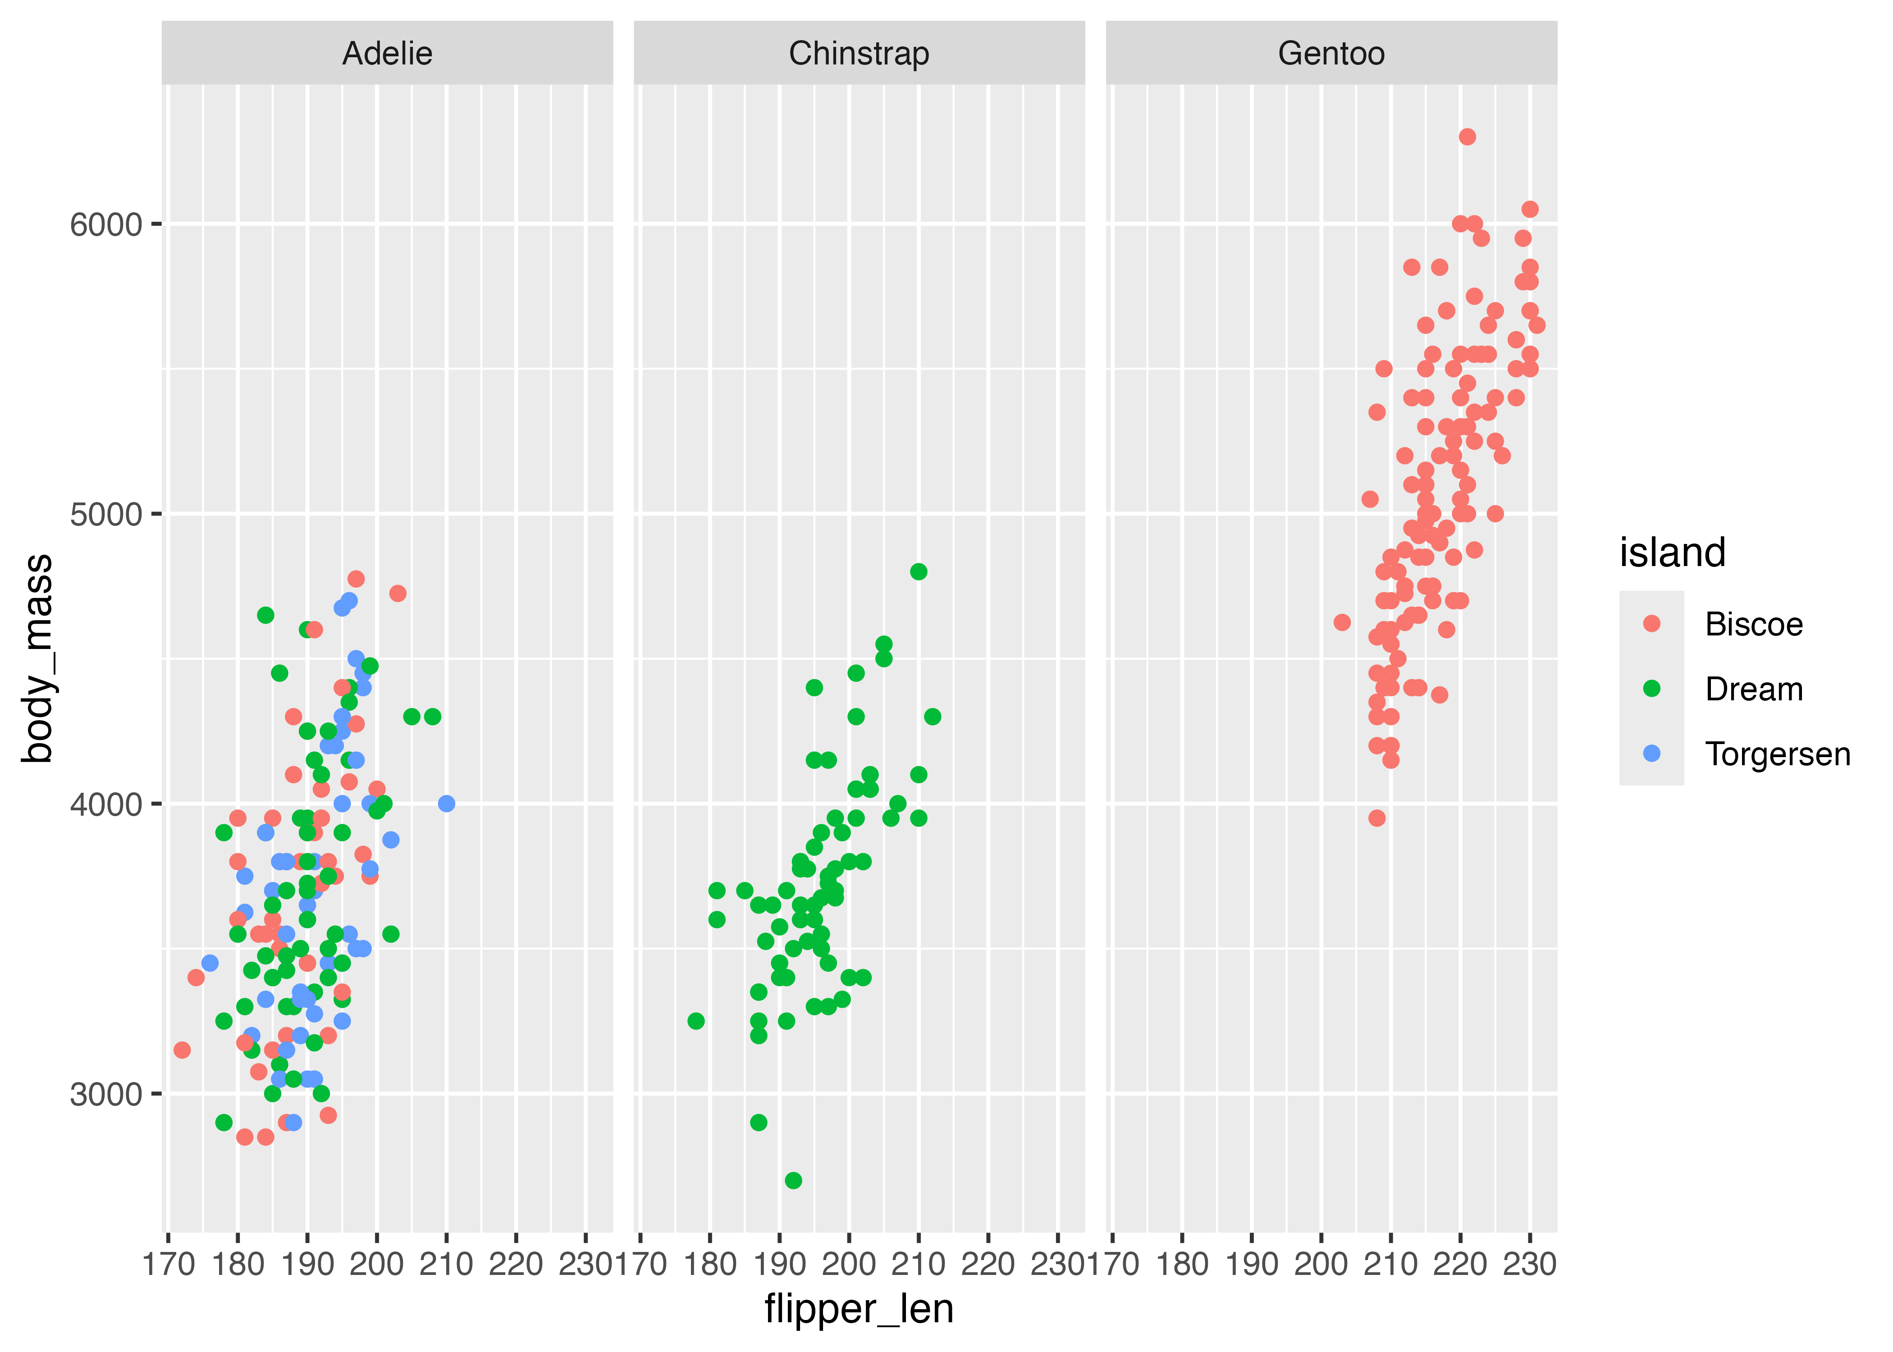
Insert a new chunk below and use ggplot() re-create the plot above.

Recreate filtered dataset
Here are all the Chinstrap penguins that weigh more than 4,000 grams:
# A tibble: 15 × 8
species island bill_len bill_dep flipper_len body_mass sex year
<chr> <chr> <dbl> <dbl> <dbl> <dbl> <chr> <dbl>
1 Chinstrap Dream 46 18.9 195 4150 female 2007
2 Chinstrap Dream 52 18.1 201 4050 male 2007
3 Chinstrap Dream 50.5 19.6 201 4050 male 2007
4 Chinstrap Dream 49.2 18.2 195 4400 male 2007
5 Chinstrap Dream 52 19 197 4150 male 2007
6 Chinstrap Dream 52.8 20 205 4550 male 2008
7 Chinstrap Dream 54.2 20.8 201 4300 male 2008
8 Chinstrap Dream 51 18.8 203 4100 male 2008
9 Chinstrap Dream 52 20.7 210 4800 male 2008
10 Chinstrap Dream 53.5 19.9 205 4500 male 2008
11 Chinstrap Dream 50.8 18.5 201 4450 male 2009
12 Chinstrap Dream 49 19.6 212 4300 male 2009
13 Chinstrap Dream 50.7 19.7 203 4050 male 2009
14 Chinstrap Dream 49.3 19.9 203 4050 male 2009
15 Chinstrap Dream 50.8 19 210 4100 male 2009
Use filter() in the chunk below to re-create that dataset:
# Do stuff here

Recreate summarized dataset
Here are the average weights of male penguins across the three islands:
# A tibble: 3 × 2
island avg_weight
<chr> <dbl>
1 Biscoe 5105.
2 Dream 3987.
3 Torgersen 4035.
Insert a chunk below and use filter(), group_by(), and summarize() to re-create that dataset:

Task 3: Extension
Copy the code for one of your plots or tables above and paste it into the chunk below. Do some extra things to it, like changing the labels, changing the colors, adding a new geom, plotting a different variable from the dataset, changing the theme, or whatever. This is your chance to play around and explore.
# Do stuff here

