Mapping data to graphics
  - Exercise 3 — ISS dataviz, Spring 2026
YOUR NAME HERE
Invalid Date
Table of contents

Task 1: Session check-in
Three interesting or exciting things:
- Something
- Something
- Something
Three muddy or unclear things:
- Something
- Something
- Something

Task 2: Lord of the Rings
# Load libraries here
library(tidyverse)

Data description and cleaning
This data contains counts of words spoken by characters of different species and genders in the Lord of the Rings movie trilogy. It originally comes from the manyeyes data blog, which no longer exists—Jenny Bryan has a copy here.
There are three CSV files in data/—one for each film. The code below loads, restructures, and cleans the data. You don’t need to modify anything in this chunk of code—you only need to run it.
The resulting lotr dataset contains the following columns:
- Film: The name of the film
- Species: The type of species (elf, hobbit, man)
- Gender: Female and male
- Words: The number of words spoken in each film, species, and gender
# Load the separate datasets
fellowship <- read_csv("data/The_Fellowship_Of_The_Ring.csv")
tt <- read_csv("data/The_Two_Towers.csv")
rotk <- read_csv("data/The_Return_Of_The_King.csv")
# bind_rows() stacks data frames on top of each other
lotr_wide <- bind_rows(fellowship, tt, rotk) |>
# Make the Film column a categorical variable (factor), and put it in the
# order the categories appear (so the films are in the correct order)
mutate(Film = fct_inorder(Film))
# Make this wide data long and tidy
lotr <- lotr_wide |>
pivot_longer(cols = c(Female, Male), names_to = "Gender", values_to = "Words")

Species
Does a certain species dominate (i.e. speak the most) the entire trilogy?

Recreate data summary
Use group_by() and summarize() to create a data frame named lotr_species that looks like this:
# A tibble: 3 × 2
Species total
<chr> <dbl>
1 Elf 3737
2 Hobbit 8796
3 Man 8712
# Do stuff here

Recreate plot
Run the code chunk below to see a plot.
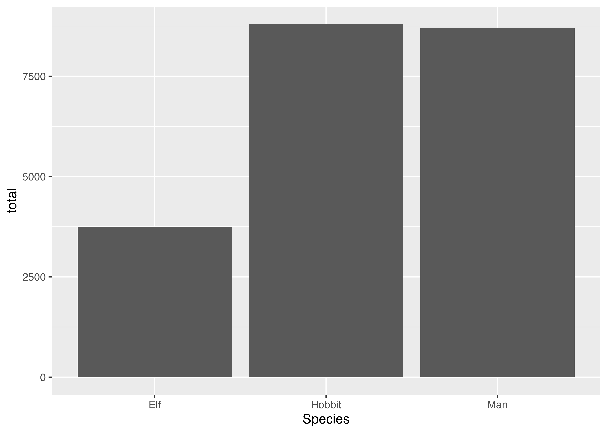
Use ggplot() and geom_col() in the chunk below to re-create the plot above using the lotr_species dataset.
# Do stuff here

Gender and film
Does a certain gender dominate a movie? (lolz of course it does, but still, graph it).

Recreate data summary
Use group_by() and summarize() to create a data frame named lotr_gender_film that looks like this:
# A tibble: 6 × 3
# Groups: Gender [2]
Gender Film total
<chr> <fct> <dbl>
1 Female The Fellowship Of The Ring 1243
2 Female The Two Towers 732
3 Female The Return Of The King 453
4 Male The Fellowship Of The Ring 6610
5 Male The Two Towers 6565
6 Male The Return Of The King 5642
# Do stuff here

Recreate plot
Run the code chunk below to see a plot.
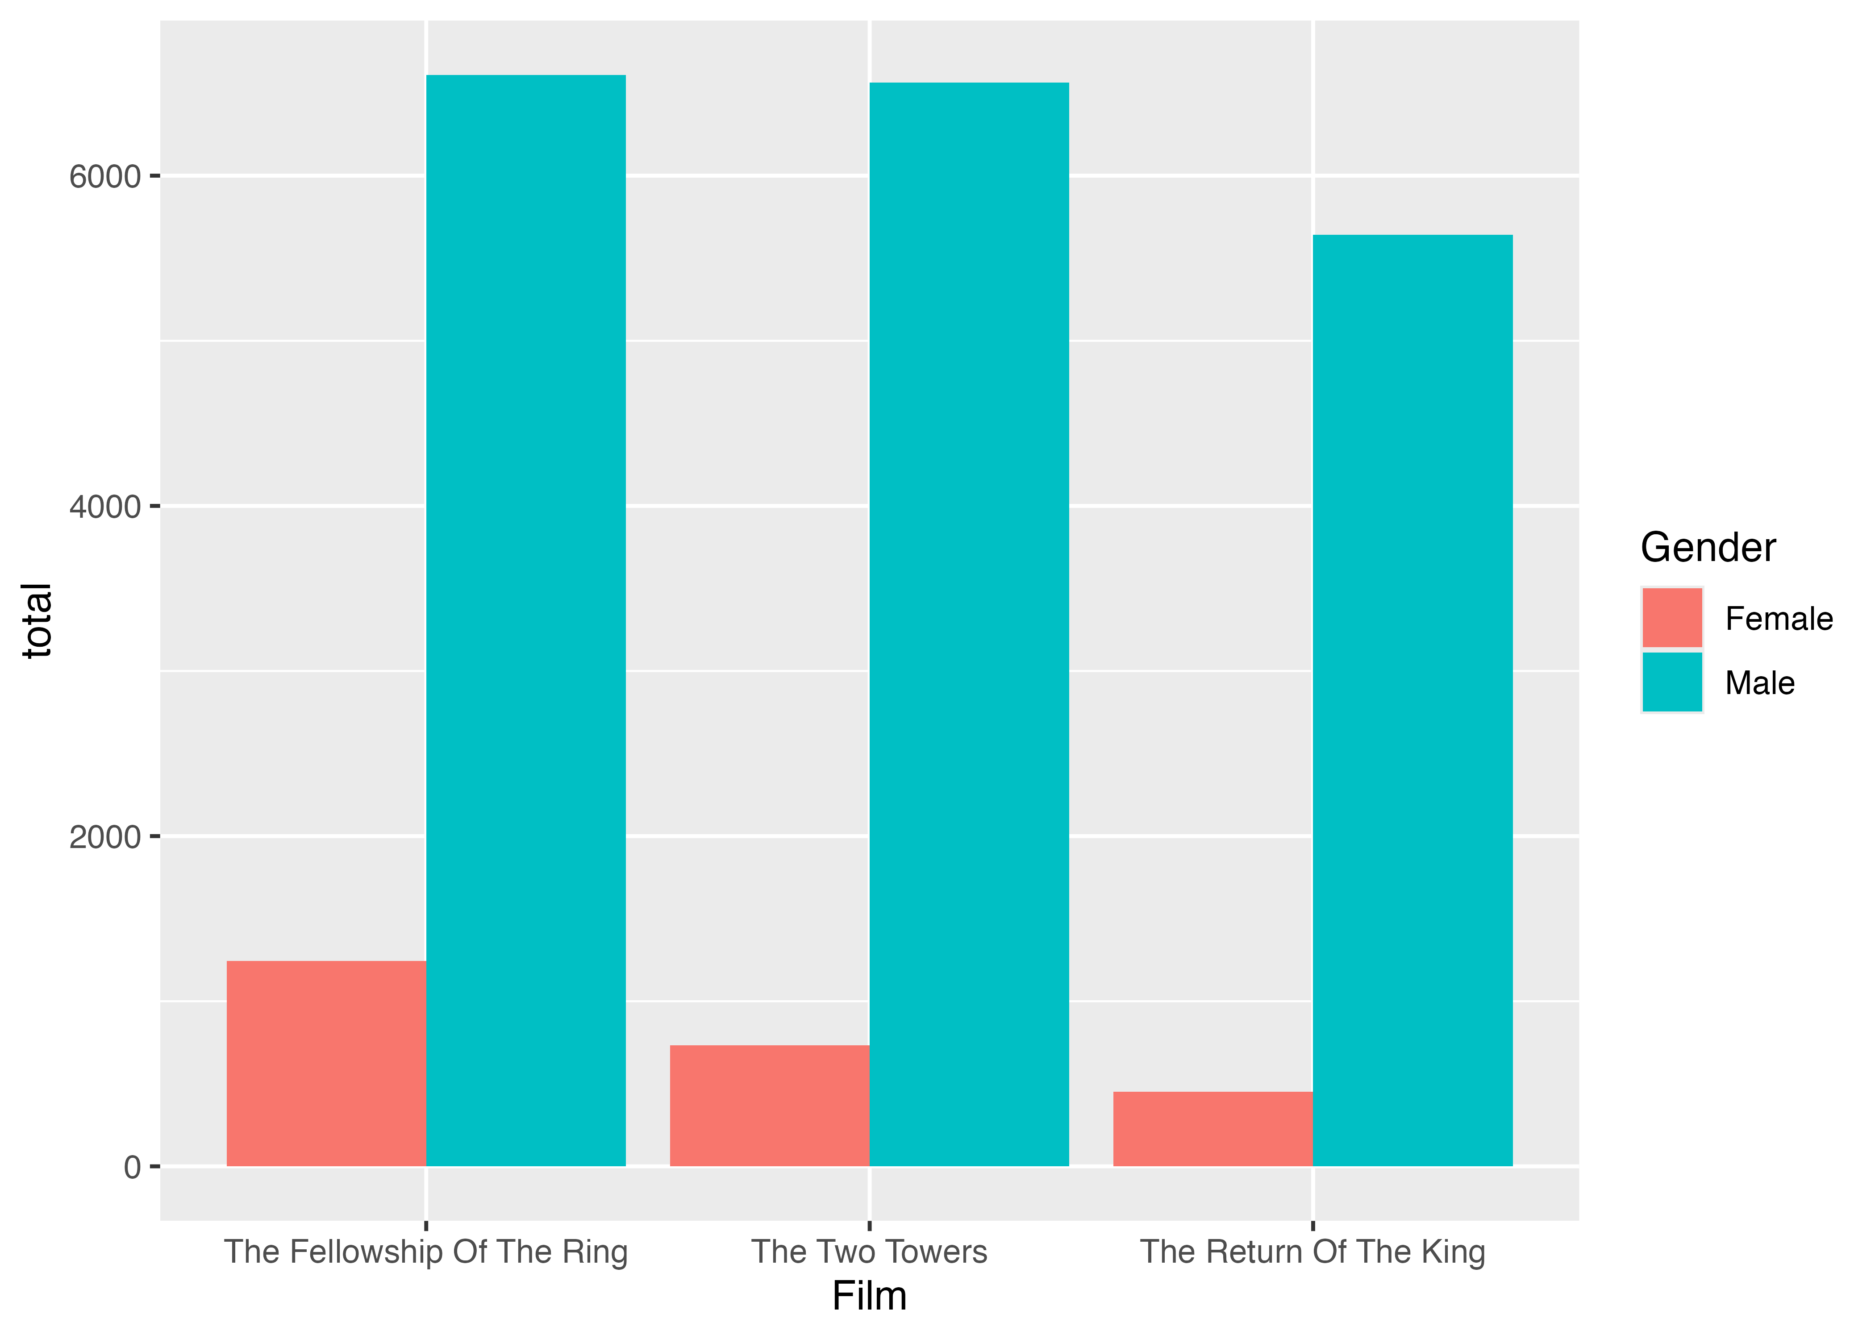
Use ggplot() and geom_col() in the chunk below to re-create the plot above using the lotr_gender_film dataset.
# Do stuff here

Species and film
Does the dominant species differ across the three movies?
There’s no recreation here—you have all the code you need above. Hint: you’ll need to group by Species and Film.
# Do stuff here

Species and gender and film
Create a plot that visualizes the number of words spoken by species, gender, and film simultaneously. Use the complete tidy lotr data frame. You don’t need to create a new summarized dataset (with group_by(Species, Gender, Film)) because the original data already has a row for each of those (you could make a summarized dataset, but it would be identical to the full version).
You need to show Species, Gender, and Film at the same time, but you only have two possible aesthetics (x and fill), so you’ll also need to facet by the third. Play around with different combinations (e.g. try x = Species, then x = Film) until you find one that tells the clearest story.
# Do stuff here

Task 3: Extension
Copy the code for one of your plots above and paste it into the chunk below. Do some extra things to it, like changing the labels, changing the colors, adding a new geom, plotting a different variable from the dataset, filling by something that you’re faceting with (or vice versa), changing the theme, or whatever. This is your chance to play around and explore.
# Do stuff here

