Themes
  - Exercise 5 — ISS dataviz, Spring 2026
YOUR NAME HERE
Invalid Date
Table of contents

Task 1: Session check-in
Three interesting or exciting things:
- Something
- Something
- Something
Three muddy or unclear things:
- Something
- Something
- Something

Task 2: Cheese!

Data description and cleaning
This data comes from cheese.com, and it was a #TidyTuesday dataset in June 2024
There are 19 columns, and they’re documented here—make sure you consult that page!
The code below loads and cleans the data, resulting in a data frame named cheeses_milk_country that contains the number of cheeses made by the top 8 cheese-producing countries, across three types of milk. You don’t need to modify anything in this chunk of code—you only need to run it.
library(tidyverse)
# Load the full data
cheeses_raw <- read_csv("data/cheeses.csv")
# The milk and country columns contain multiple values, like "cow, goat" and
# "Italy, France". separate_longer_delim() splits those into separate rows
# based on the ",", so that "cow, goat" would turn into one row for cow and one
# for goat, and so on
cheeses <- cheeses_raw |>
separate_longer_delim(milk, delim = ", ") |>
separate_longer_delim(country, delim = ", ") |>
# Technically England, Scotland, GB, and the UK are all different things, but
# for the sake of visualization, we can lump them all together
mutate(country = case_match(country,
"England" ~ "United Kingdom",
"Great Britain" ~ "United Kingdom",
"Scotland" ~ "United Kingdom",
.default = country
))
# Find the most common milk types
top_milk_types <- cheeses |>
group_by(milk) |>
summarize(total = n()) |>
filter(total > 100)
# Find the most common countries
top_countries <- cheeses |>
group_by(country) |>
summarize(total = n()) |>
filter(total > 30)
# Calculate the number of milk types across the most common countries
cheeses_milk_country <- cheeses |>
filter(milk %in% top_milk_types$milk, country %in% top_countries$country) |>
group_by(milk, country) |>
summarize(total = n()) |>
ungroup() |>
# Capitalize the milk types
mutate(milk = str_to_title(milk)) |>
# Sort by country and milk type and lock in the order for better plotting
arrange(desc(total), milk) |>
mutate(across(c(country, milk), \(x) fct_inorder(x)))
cheeses_milk_country
# A tibble: 24 × 3
milk country total
<fct> <fct> <int>
1 Cow United States 206
2 Cow United Kingdom 192
3 Cow France 105
4 Goat United States 89
5 Cow Italy 78
6 Sheep Italy 63
7 Goat France 60
8 Cow Canada 55
9 Cow Australia 36
10 Goat United Kingdom 34
# ℹ 14 more rows

Base plot
Here’s a basic bar chart showing the counts of countries and milk types. It’s stored as an object named base_plot:
base_plot <- ggplot(
cheeses_milk_country,
aes(x = total, y = fct_rev(country), fill = milk)
) +
geom_col() +
guides(fill = "none") +
# These colors come from ColorBrewer 2:
# https://colorbrewer2.org/#type=qualitative&scheme=Set1&n=3
scale_fill_brewer(palette = "Set1") +
facet_wrap(vars(milk))
base_plot
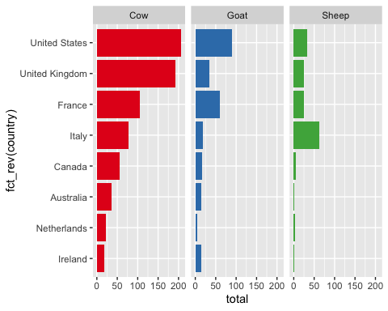

Recreate nice plot
Run the code chunk below to see a plot.
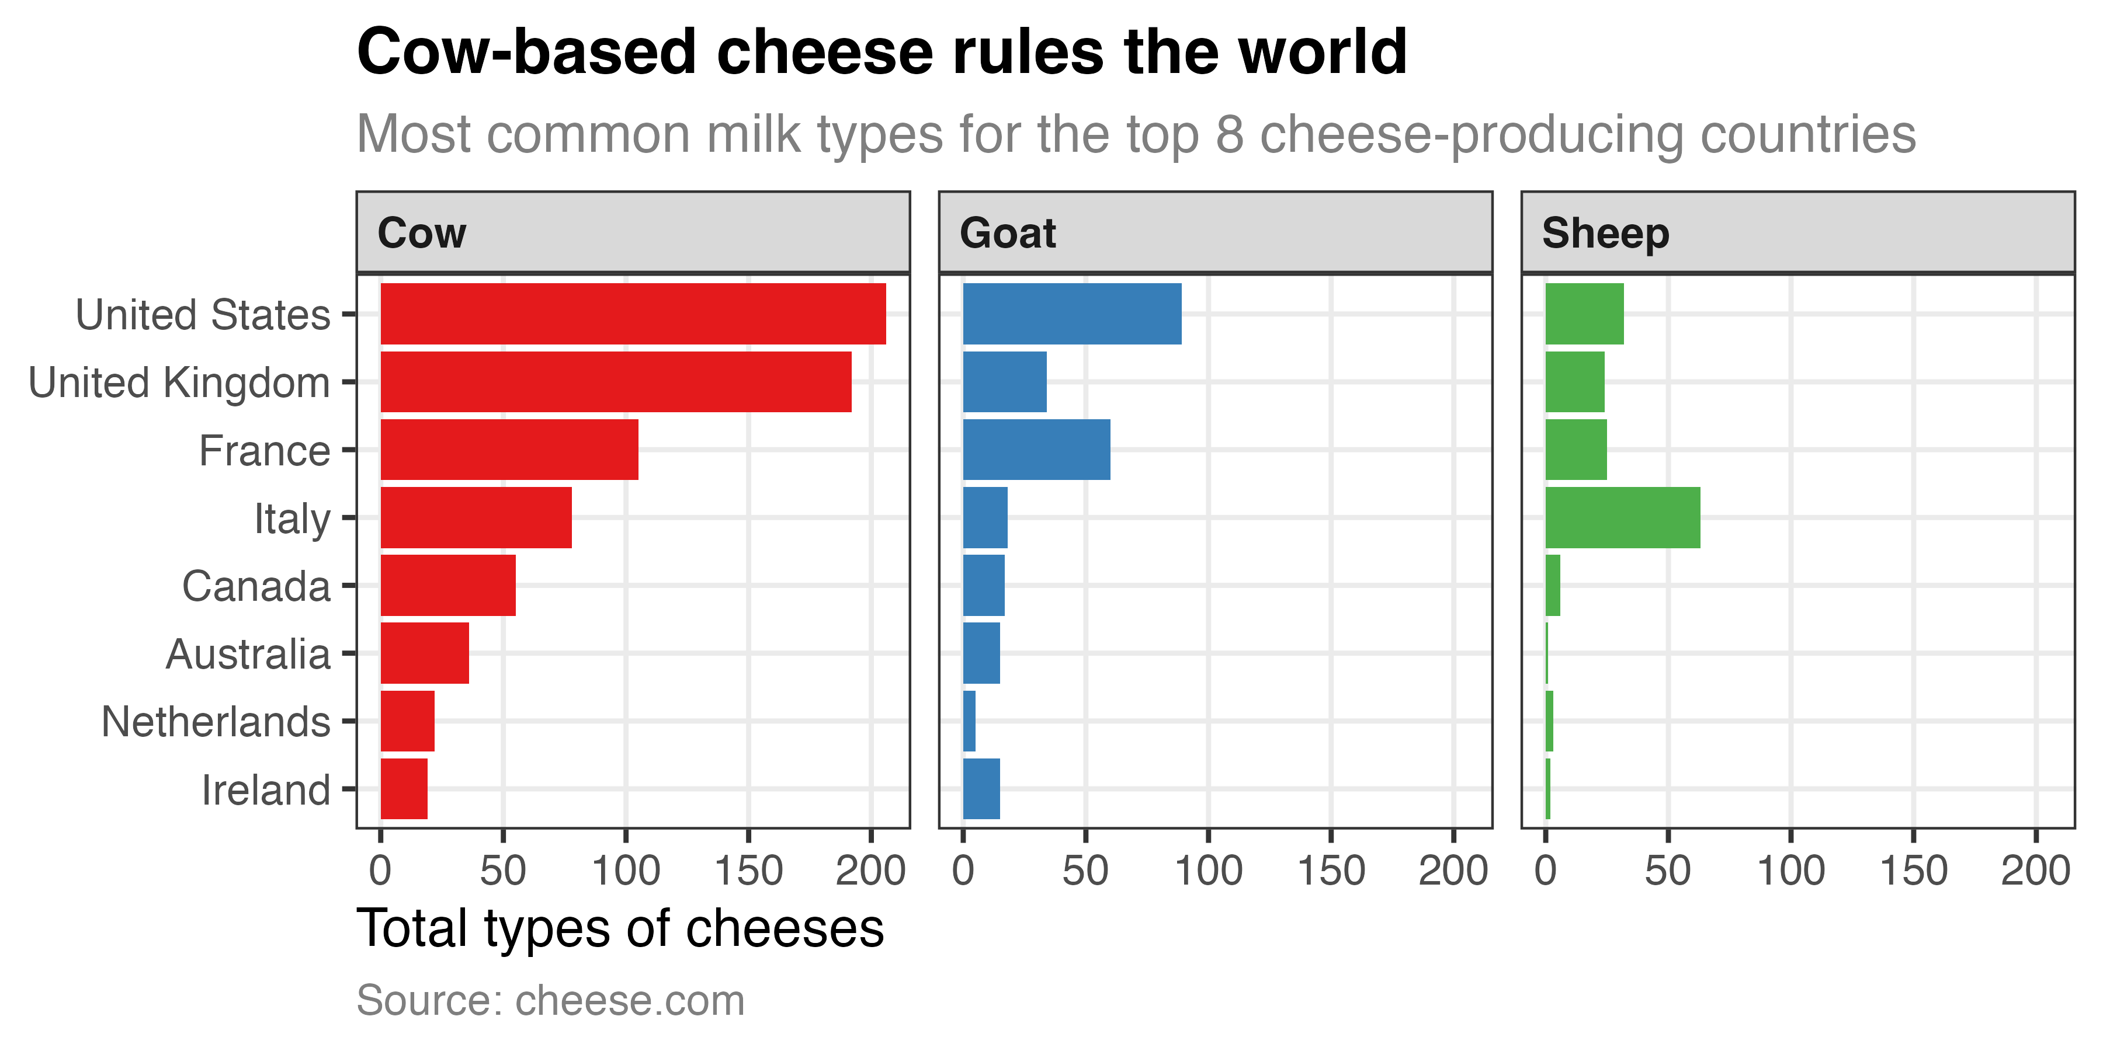
Your job is to use labs() and theme() to recreate this plot:
Some helpful big hints:
- The image is 6 inches wide and 3 inches tall. Use chunk options like fig-width and fig-height to control the dimensions (see https://datavizsp26.classes.andrewheiss.com/resource/quarto.html#chunk-options)
- Use labs() to modify the following things: x, y, title, subtitle, and caption
- Use theme_bw()
- Use theme() to adjust these things:
  - Strip text
  - Axis title
  - Panel grid major
  - Plot title
  - Plot subtitle
  - Plot caption
In the end, your code will look something like this:
base_plot +
labs(x = "BLAH", title = "BLAH") +
theme_bw() +
theme(
strip.text = element_text(BLAH),
axis.title = element_text(BLAH)
)
MAKE SURE you use the theme resources and cheatsheets from the content page. Also consider using {ggthemeassist} to help with the different settings.
# Do stuff here

Task 3: Extension Ugly plot
For your extension, forget all the wonderful CRAP design principles you just learned and try your hardest to make the ugliest plot in the world. Take base_plot and create the worst, ugliest, least CRAPful plot ever.
Change the colors, modify the theme, add labels, etc. and make this ugly. You can leave the geom_col() as is, or you can mess with it too (or even change it to a pie chart or heatmap or something if you feel up to it).
This is your chance to play around and explore.
# Do stuff here
base_plot +
theme()


