**Module 02 – Subscriptions**

Tim Mastarone

Rasmussen University

Microsoft C# Programming

Instructor: Jim Barringer

Module 02 - Lab 1

April 9, 2024

The Subscribers program starts by displaying a welcome message. It prompts the user to enter the customer’s first and last name. Then they can enter a subscription type, length in months, and a shipping method. The screenshot below shows a user entering 2 subscriptions:

On completion the program outputs the number of subscriptions, an itemized list of totals including the final cost with a tiered discount applied. I added the amount of discount value to the last line as well.

In the above image the discount was 0 because the sales were under $50.

If the sales total is above one of the discount thresholds, the discount is applied before the tax is calculated:

The screenshot below shows an invalid entry. If an option (1-2) is not entered in the menu, the user is alerted and re-prompted for a new choice:

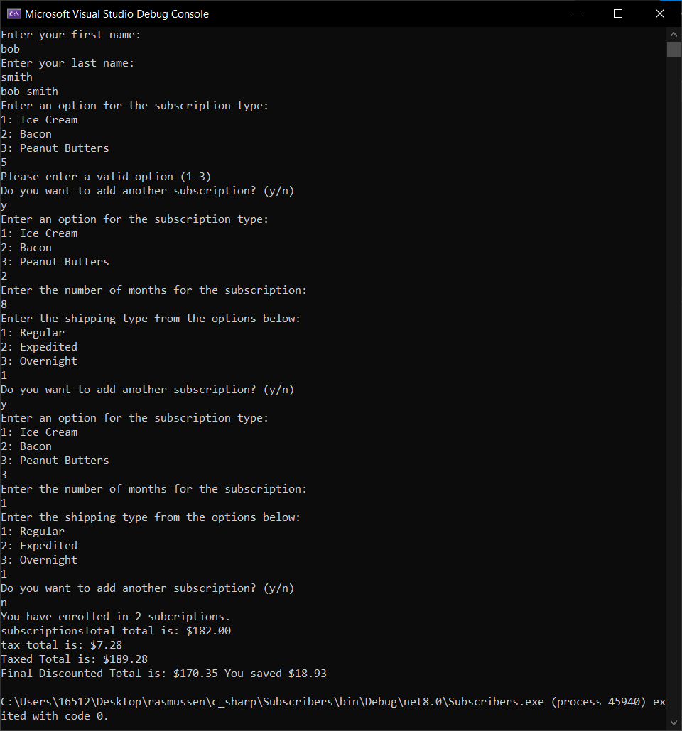

The user can enter a ‘q’ or ‘Q’ to quit from the subscription menu (doesn’t work on name menu).

My Program.cs C# code is below:

class Program

{

//4% fixed tax rate

const double taxRate = .04;

static int months;

static void Main(string[] args)

{

//array for subscription types, 12-15-17 per month

string[] subscriptionTypes = ["Ice Cream", "Bacon", "Peanut Butters"];

//array for shipping type, 5-10-30 dollars

string[] shippingPriority = ["Regular", "Expedited", "Overnight"];

bool quitMainLoop = false;

bool quitSubLoop = false;

bool quitShippingLoop;

bool firstEntryValid = false;

//display the welcome message

printGreeting();

Customer customer = new()

{

SubscriptionCount = 0,

SubscriptionTotal = 0

};

while (!quitMainLoop)//get customer information

{

string userInput;

//int months;

setCustomerName();

printCustomerName();

while (!quitSubLoop)//get order information

{

quitShippingLoop = false;//initialize here in case this is not the first time in the loop

Print("Enter an option for the subscription type:");

for (int i = 0; i < subscriptionTypes.Length; i++)

{

Print((i + 1).ToString() + ": " + subscriptionTypes[i]);

}

userInput = Console.ReadLine();

if (userInput == "1")

{

months = getSubscriptionLength();

customer.SubscriptionTotal += 12 * months;

firstEntryValid = true;

}

else if (userInput == "2")

{

months = getSubscriptionLength();

customer.SubscriptionTotal += 15 * months;

firstEntryValid = true;

}

else if (userInput == "3")

{

months = getSubscriptionLength();

customer.SubscriptionTotal += 17 * months;

firstEntryValid = true;

}

else if (userInput == "q" || userInput == "Q")

{

Print("Exiting.....");

quitSubLoop = true;

quitMainLoop = true;

}

else

{

Print("Please enter a valid option (1-3)");

}

if (firstEntryValid)//subscription entry successful, next we get the shipping type

{

while (!quitShippingLoop)

{

Print("Enter the shipping type from the options below:");

for (int i = 0; i < shippingPriority.Length; i++)

{

Print((i + 1).ToString() + ": " + shippingPriority[i]);

}

userInput = Console.ReadLine();

if (userInput == "1")

{

customer.SubscriptionTotal += 5 * months;

customer.SubscriptionCount += 1;

quitShippingLoop = true;

}

else if (userInput == "2")

{

customer.SubscriptionTotal += 10 * months;

customer.SubscriptionCount += 1;

quitShippingLoop = true;

}

else if (userInput == "3")

{

customer.SubscriptionTotal += 30 * months;

customer.SubscriptionCount += 1;

quitShippingLoop = true;

}

else

{

Print("Please enter a valid option (1-3)");

}

}//end of shipping loop

}

if (!quitMainLoop)//if user quits with 'q' this is skipped

{

Print("Do you want to add another subscription? (y/n)");

userInput = Console.ReadLine();

if (userInput != null && userInput != "y" && userInput != "Y")//anything but a 'y' exits the loop and prints customer information

{

quitSubLoop = true;

quitMainLoop = true;

}

else

{

firstEntryValid = false;//reinitialize to start the sub loops again

}

}

}//end of subLoop

}//end of mainLoop

//get tax rate, totals, and discount

double discountedTotal = getDiscountRate(customer.SubscriptionTotal);

double taxTotal = CalculateTax(discountedTotal);

double taxedTotal = discountedTotal + taxTotal;

Print("You have enrolled in " + customer.SubscriptionCount + " subcriptions.");

Print("Total for subscriptions is: $" + customer.SubscriptionTotal.ToString("F2"));

Print("The tax total is: $" + taxTotal.ToString("F2"));

Print("The total with tax is: $" + taxedTotal.ToString("F2"));

Print("Final Discounted Total is: $" + discountedTotal.ToString("F2") + " You saved $" + (customer.SubscriptionTotal - discountedTotal).ToString("F2"));

void Print(string message)

{

Console.WriteLine(message);

}

static double CalculateTax(double subtotal)

{

double tax;

tax = taxRate * subtotal;

return tax;

}

void setCustomerName()

{

//get the first and last name, trimming whitespace to avoid unexpected behavior with spaces

Print("Enter your first name: ");

customer.FirstName = Console.ReadLine()?.Trim();

Print("Enter your last name: ");

customer.LastName = Console.ReadLine()?.Trim();

}

void printCustomerName()

{

Print(customer.FirstName + " " + customer.LastName);

}

void printGreeting()

{

Print("Welcome to the Subscribers program.");

Print("You will be asked to enter the subscriber's first and last name.");

Print("You can then enter as many orders as you like for that subscriber.");

Print("Enter 'Q' to exit the program.");

}

double getDiscountRate(double totalWithTax)

{

//>50 = 5%, >100 = 7%, >150 = 10%

double discountRate = 0;

if (totalWithTax > 150)

{

discountRate = .1;

}

else if (totalWithTax > 100)

{

discountRate = .07;

}

else if (totalWithTax > 50)

{

discountRate = .05;

}

totalWithTax *= (1 - discountRate);

return totalWithTax;

}

int getSubscriptionLength()

{

Print("Enter the number of months for the subscription: ");

string userInput = Console.ReadLine();

if (int.TryParse(userInput, out int intValue))

{

return intValue;

}

else

{

Print("Invalid length, defaulting to 1 month.");

return 1;

}

}

}

}

public class Customer

{

public string? FirstName { get; set; }

public string? LastName { get; set; }

public int? SubscriptionCount { get; set; }

public double SubscriptionTotal { get; set; }

}