Week 3 Lab Assignment | I/O Ports

September 9th, 2023

Timothy McNamara

**Objectives**

This lab focuses on the preassigned memory locations allocated on the MC9S12 chip. Using the internal shift registers and read and write data to the I/O ports. The I/O ports in this lab consist of the LEDs and the Dip switches on the BDM multilink trainer board. We can assign the switches and LEDs as both inputs and outputs. Students are to practice their capabilities to read and write values to the data directional registers and to the I/O ports in assembly code.

**Procedure**

Completing the lab in short in simple fashion was easy. First, we completed the prelab, then we wrote our actual program. It was split into two parts. The first part of the lab we declared the dip switches as inputs and declared the LEDs an outputs using the data directional registers for port B and port C. We used mnemonics to read the dip switches by loading the status of the switches to the A register. Then we added the hex value 3 to the A register. Once we added 3 in hex, we took that value and stored it in Port C to light up the corresponding LEDs. The second part had the same steps; however, we declared a variable in the RAM section and changed its value in the debugging window to see how the ports read varying hex values.

**Analysis (Answers to Questions**)

Q1.1

a. What hex value is displayed on the LEDs when the switches are set to $3D?___40___

b. Discuss two ways you can verify your answer?

1. Answer: We can look at memory location $04 and see the output of the math operation that occurred.

2. Answer: 3D + 3 = 40. SIMPLE HEX MATH

Q1.2

a. What is the largest switch setting value (in hex) we can have without incurring a carry from the addition operation? ___FF___

b. Test your answer and get a screen shot of the code and the CCR register carry flag.

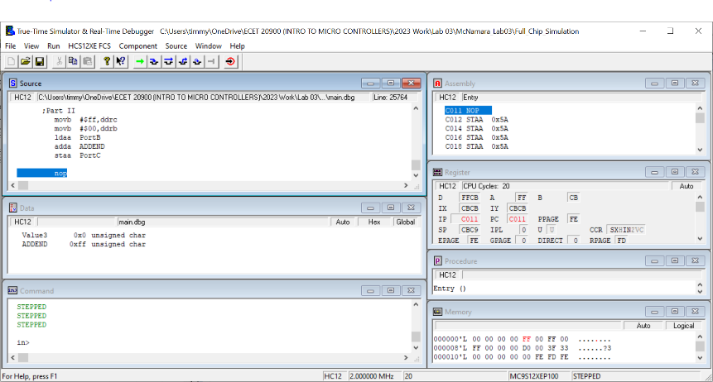

The screen shot shown above is loading FF into LEDs but the same is true for the switches. Sorry I did not change it because the dip switches were outputs. I was simulating. If I used the board in lab, I could’ve shown in a screenshot.

Q2.1:

In Lab 03 exercises, where in memory is PortC? _04_hex?

Q2.2:

If the value $C is stored in memory location ADDEND, and the switches are set to $D6, what value is displayed on the LEDs when you run your program? ___E2___hex.

**Observation/Conclusion**

This was a fun lab. I learned where on the MC9S12 chip in memory Port C and Port B and ddrc and ddrb are located. I learned how the Data Directional register works as well. It does its job determining whether the dip switches or LEDs are inputs or outputs by simply changing one of the eight bits to a zero or a one. The location of the ports with its corresponding data direction register are 2 bytes apart. Location $01 and $03 are in regard to the dip switches and the lower value links with Port B. Location $04 and $06 are in regard to the LEDs; the lower value happens to be Port C. Making the dipswitches an input and the LEDs an output is a breeze with the simple line: movb #$(HEXVALUE), ddr(B or C). I learned a lot in this lab. I can’t wait to learn more.