Week 7 | Lab Assignment | C Language Assignment and Logic

10/9/2023

Timothy McNamara

**Objectives**

The purpose for this assignment is to create three separate programs that utilize the PortC LEDs and the PortB dip switches. Within these programs, we use specific logic “writings” that help us clear or set specific bits without affecting other bits. This captivates all three programs, however, for the last program we have to use a switch case decision logic and call a function that passes a value from zero to seven. Once that value has been passed, the switch case makes a decision based upon the value.

**Procedure**

The lab was simple. We followed worded problems and directions that guided us on what we had to do. For the first program, we used the ~&= operator which caused the bit to clear and leave the other bits unaffected. The second program called for use of the |= operator which set a bit to always be on and not affected any other bits. The third program was trickier. We created a function that would pass a value. My value was 7. This value was passed onto my switch case. If the corresponding value matched the dip switch bit that was on also, this caused a 1 to be returned and all LEDs would light. If a zero is returned, this causes none of the LEDs to light; meaning the set dip switch does not match the passed value.

**Answers to questions (Analysis)**

**Lab Questions**

Program 1 Flow Chart:

w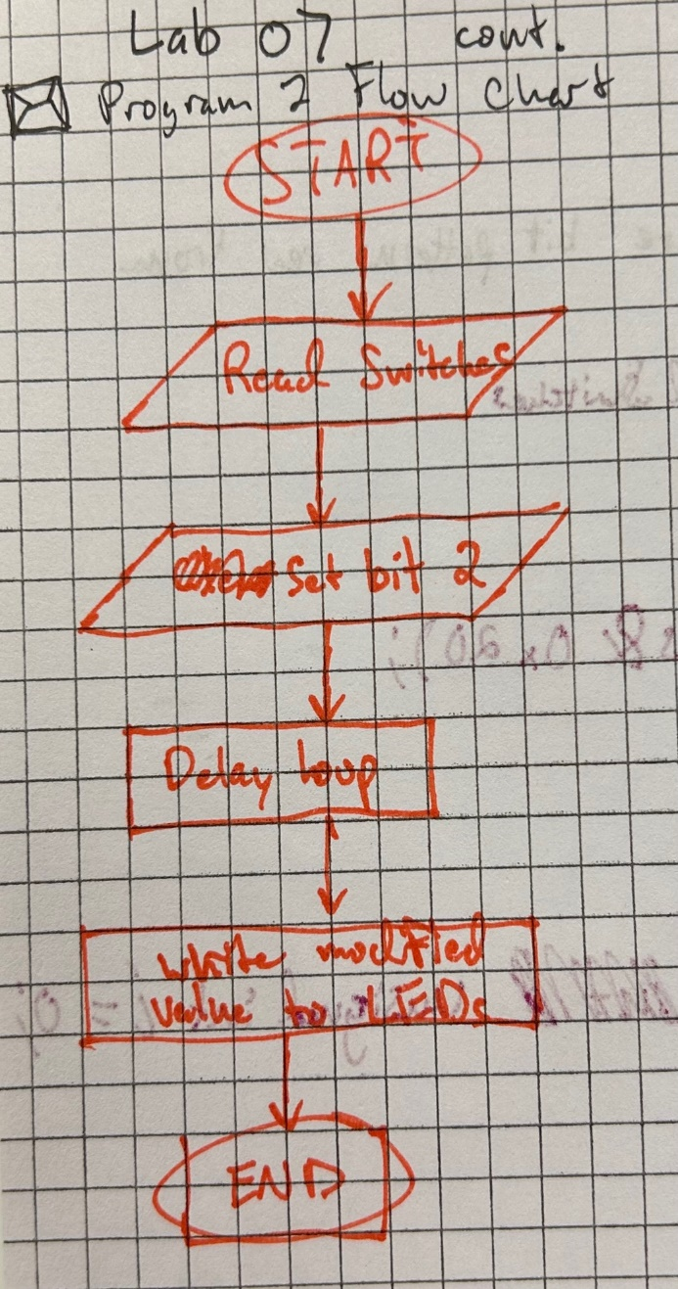

Program 2 Flow Chart:

Program 3 Flow Chart:

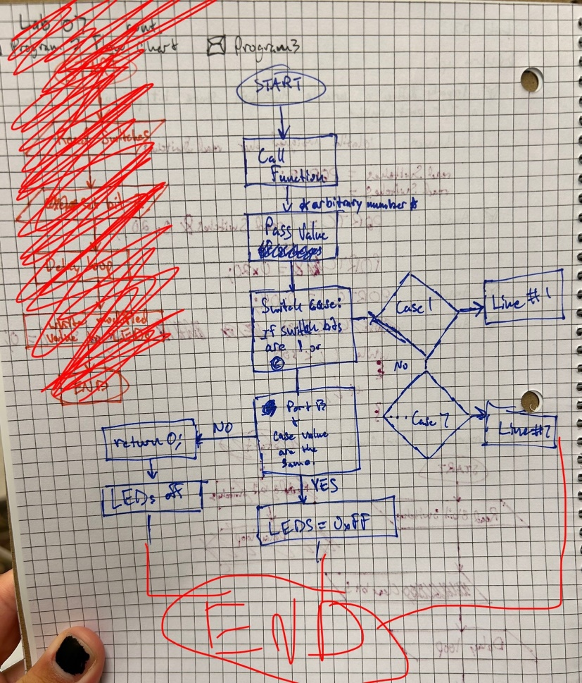

**Conclusion**

The lab was a big challenge for me. I hadn’t taken a C language course since 15700 and this was a challenge trying to remember how to define functions like we did in the class. Also had to remember to name a variable with reverse camel case, remember how Boolean works etc. But what I learned from this lab was so cool to know. Like the setting and clearing of certain bits was a great piece of knowledge, and reusing the old switch case statement was a crazy callback to 15700. Me and my fellow peers also had trouble determining what the program was to look like, but in the end, we figured it out. Knowing how the MC9S12XEP100 and many other chips work is fascinating and C is easier than assembly for sure. However, we have been writing in assembly for 1/3rd of the semester, so this shift has hit me hard. Luckily, my previous knowledge is slowly coming back to me, and I hope it stays with me this time.