Tim Miller

15.071

HW #7

**PROBLEM 1A**

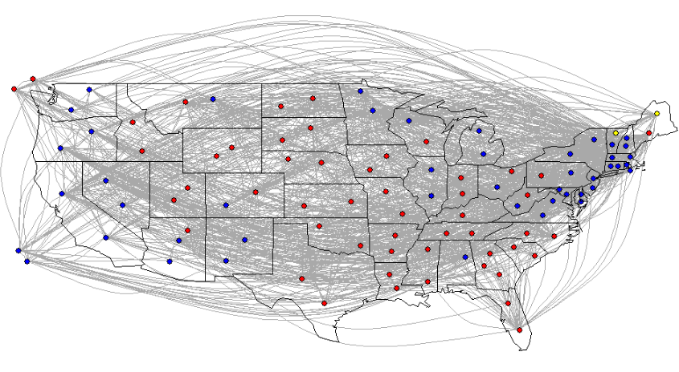

As expected, Democratic senators typically come from the west coast and northeast while Republican senators typically come from the south / southeast and Midwest of the country. This is because you typically find Democratic voters in the large coastal cities like L.A., SF, NYC, and Boston while Republican voters tend to be found in less densely populated areas across the south and Midwest.

**PROBLEM 1B**

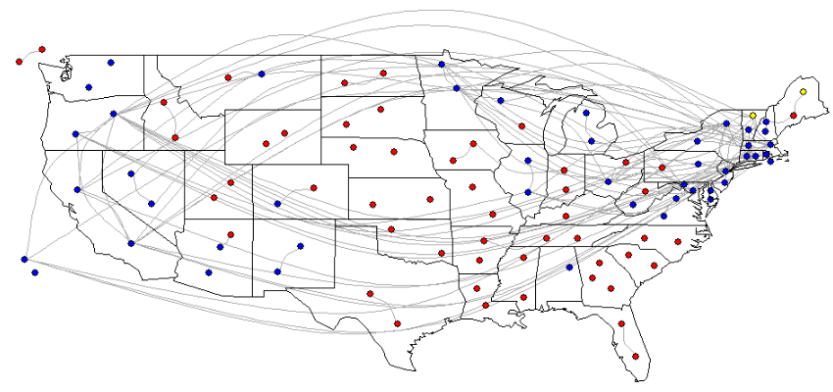

The above graph has a threshold of n = 30. One of the first interesting observations is that senators from blue states are more likely to co-sponsor bills with other senators than red states. You can see the number of connections between blue dots in this chart, but very few between red dots. The reason for this might be that the Republicans had a majority in the senate for this dataset. Therefore, the Democrats might have felt the need to co-sponsor bills as a way to show unity and push their ideas through the Republican majority.

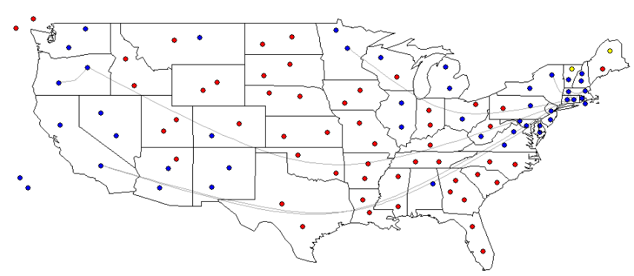

This chart was set at a threshold of n = 70. Another interesting observation is that there are a number of co-sponsorships across states e.g., west coast states with east coast states, but fewer co-sponsorships within a state. Interestingly, the senators from Oregon were on the same page frequently – one of the few (maybe only) states with this high of a co-sponsorship rate between senators from the same state.

**PROBLEM 1C**

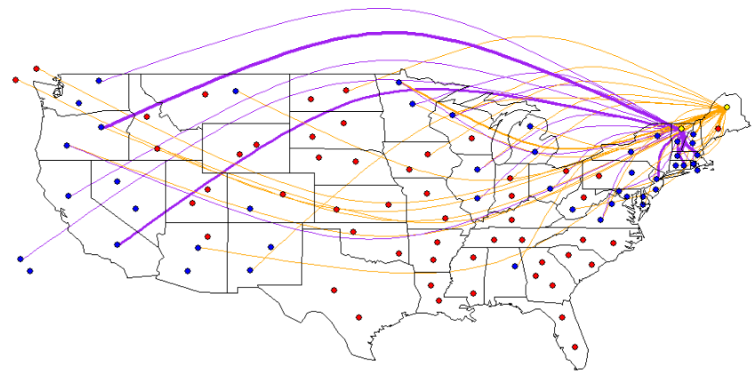

There are a few interesting observations from this chart.

First, we see that the independent senator from Maine mostly has connections with Republican senators from other states. This is no surprise given the other senator in Maine is a Republican. This tells us that although the senator is Independent, they likely have a Republican leaning in their politics and policies they back.

Similarly, we see that the independent senator from Vermont mostly has connections with Democratic senators from other states. This is no surprise given the other senator in Vermont is a Democrat. This tells us that although the senator is Independent, they likely have a Democratic leaning in their politics and policies they back.

**PROBLEM 1D**

Calculating centrality figures

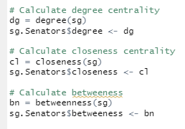

Senators with top 10 degree of centrality

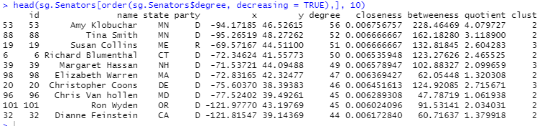

Senators with top 10 closeness centrality

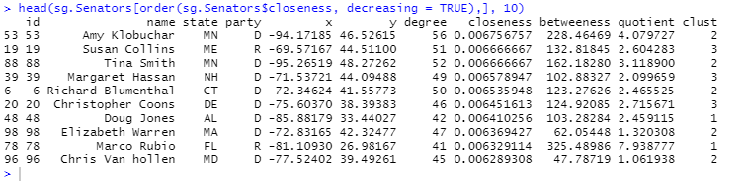

Senators with top 10 betweeness

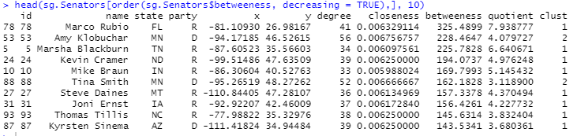

Map of degree of centrality (larger circle = higher degree of centrality)

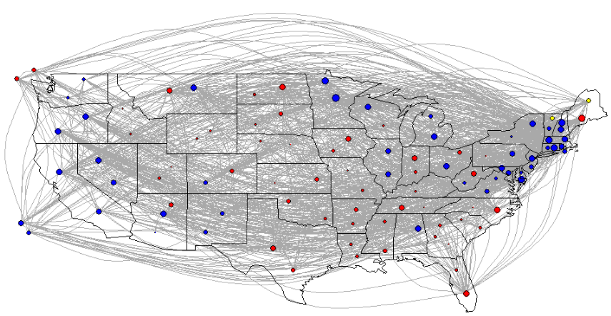

Map of closeness centrality (larger circle = larger closeness centrality)

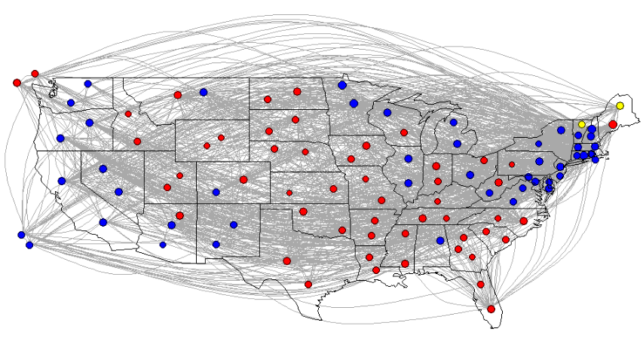

Map of betweeness (larger circle = higher betweeness)

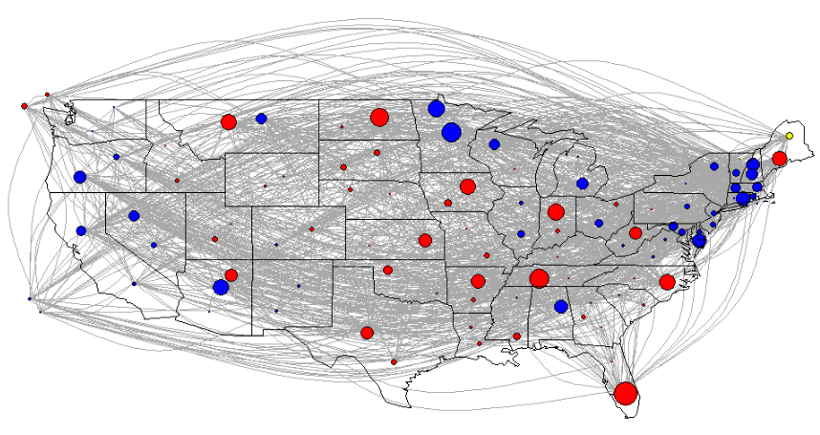

**Takeaways:**

* Amy Klobuchar is either #1 or #2 in all the centrality measures. She is often seen as a moderate Democrat. Given the Democrats had the minority, adding Sen. Klobuchar to many of these bills might have been a political strategy to get the Republicans to the bargaining table. My guess is they are more apt to listen to her vs. someone who is more liberal.
* For degree of centrality and closeness, most of the top senators in the list are Democratic. Not unexpected given what we said earlier about Democrats likely needing to band together for support given they had a minority senate position.
* However, for betweenness we see many more Republicans show up on the list. And surprisingly the senator with the highest betweenness score is Marco Rubio – a Republican. Much like Sen. Klobuchar, Sen. Rubio is seen more as a centrist and likely worked more closely with Democrats than his Republican colleagues were willing to do.
* Lastly, the betweenness chart shows how betweenness differs between senators in a specific state. States typically have a senior and junior senator. So likely the more senior senator - who has been in the senate longer – has a higher betweenness score.

**PROBLEM 1E**

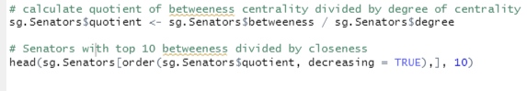

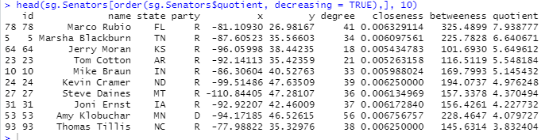

This metric normalizes the betweenness centrality by the number of people the senator is connected with (e.g., the degree of centrality). Someone might have a high betweenness simply because they are connected to a lot of people – perhaps because they have been in the senate a long time. However, we want to identify the right balance of betweenness and degree of centrality. In other words, we want to identify the people that still have a high betweenness i.e., a lot of shortest paths flow through them, but don’t rely on just knowing a lot of people. We might use this metric to identify the “arbitrators” in Congress i.e., the people that are being put to work to try to work across the aisle to get things accomplished. Or perhaps the “power brokers” because info flows through them and they are heavily connected to others.

**PROBLEM 1F**

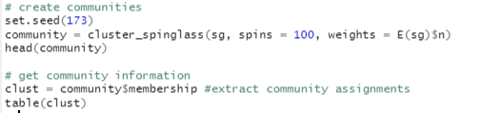

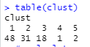

We find a total of 5 communities. In community 1 there are 48 members, in community 2 there are 31 members, in community 3 there are 18 members, in community 4 there is 1 members, and community 5 has 2 members.



Calculating the community modularity, we get a value of 0.03623698.

**PROBLEM 1G**

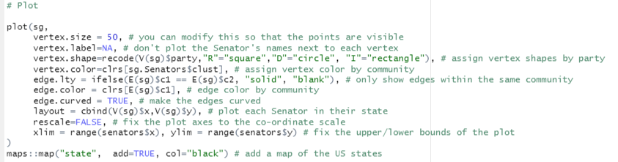

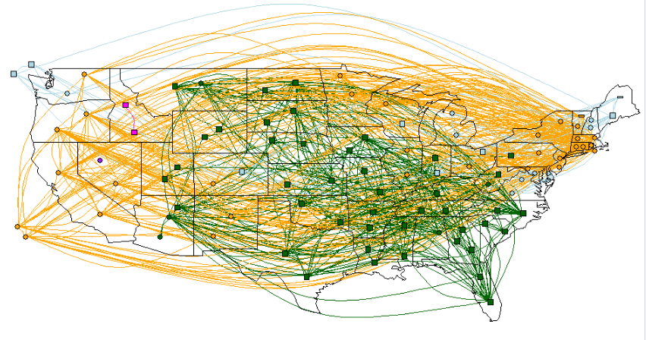

**PROBLEM 1H**

The below table shows the number from each party in each community:

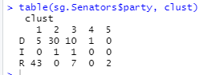

**PROBLEM 1I**

Looking at the below table, we find the following states have senators in different communities:

* Colorado
* Indiana
* Maryland
* Nevada
* Ohio
* Pennsylvania
* Washington
* Wisconsin

So in total, there are 8 out of 50 states with senators in different communities.

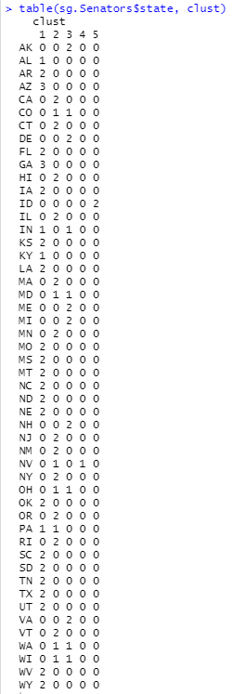

**PROBLEM 1J**

Cluster 1 is largely Republican. Based on the chart from problem 1G we find that most of the cluster 1 senators are located in the central and southern parts of the country. This is no surprise given this is where most of the Republican senators are coming from anyway. In cluster 1 we see that the 5 Democrats come from states that have a Republican senator including Arizona, West Virginia, Alabama, and Wyoming. This might suggest that although the senator might have a different party affiliation (Democrat), in practice they might be more likely to co-sponsor bills coming from the Republican party given pressure from either their fellow senator of from the will of the people of their state.

Cluster 2 falls along similar party lines. We see cluster 2 pops up in the northeast and west coast, areas that are Democrat strongholds. Unsurprisingly there are no Republicans in this cluster, suggesting this group might be a strongly Democratic agenda which is unlikely to attract co-sponsorship from Republicans.

Interestingly, of the 8 states that have senators in different clusters there is only 1 state – Pennsylvania – where one senator is in cluster 1 and the other in cluster 2. This again suggests strong policy differences between cluster 1 and 2 (driven by specific policy support by voters).

Cluster 3 is interesting because it has a more equal split between Democrats and Republicans. This is interesting because these clusters appear in some of the typical presidential election swing states e.g., Ohio, Michigan, and Virginia. What this might suggest is the ideology of cluster 3 is more moderate or centrist and includes senators that are more likely to work with and consider the other side.

Cluster 4 is one Democrat in Nevada. Perhaps this person is very new or they have very unique politics that they are unlikely to be similar to any other senator clusters.

Lastly Cluster 5 includes the 2 Republican senators from Idaho. Similar to cluster 4, these senators might have a lot in common with each other, but less with the broader Republican party. Some of this might be due to geography and them being disconnected from the core of the Republican base in midwestern and southern America.