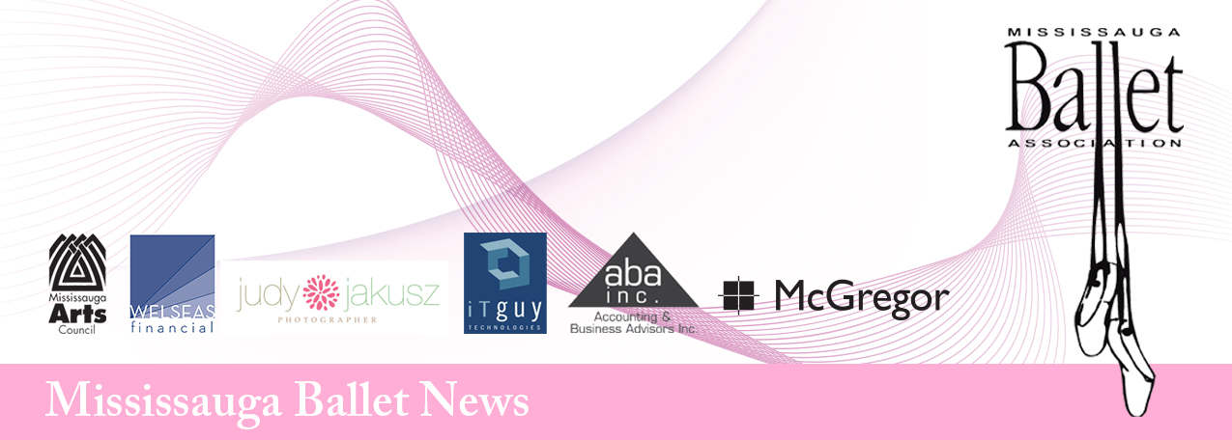
Open House Reminder November 18th, 2013

During the second week of December it will be our pleasure to share our progress with you at our annual Open House. Please be sure to arrive 20 minutes prior to the regular class start time to allow for accessory costuming in the Esso Kids’ Space (very end of the hall on the 2nd floor). Please note the date and location of your child’s demonstration.

Monday, December 9th - Staging Room (2nd floor)
Tuesday, December 10th - Dance studio (where regular classes are held)
Thursday, December 12th - Staging Room (2nd floor)
Friday, December 13th - Staging Room (2nd floor)
Saturday, December 14th - Staging Room (2nd floor)

In Addition, Please Note the Following:
- Each child will need one adult to help them with their costume and hair. Men are not allowed in the Esso Kids' Space, as we are using it as a change room.
- Everyone is welcome. Should young children become disruptive, please remove them from the demonstration area.
- Dancers should come dressed for class as usual with special attention to neat hair (hair must be worn in a ballet bun if long enough) and secure elastics on ballet slippers. A bit of lipstick and blush is appropriate if you like, but should be applied at home.
- No accessory costuming shall leave the building.
- Cameras and camcorders are allowed; however, please do not disrupt the view of any other guests.
- Dancer pickup is outside the Esso Kids’ Space doors.

Ballet Buns
The traditional hairstyle for a female ballet dancer is a bun. All of our dancers must wear a bun on a weekly basis, if their hair is long. Here are some easy instructions on how to make a bun. You will need one hair elastic, an invisible hair net and bobby pins or hair pins (hair pins are better for really long hair). An assistant teacher can give you some pointers at the studio if you need help.

Step 1: Place hair in a regular pony tail.
Step 2: Twist hair, then wrap around the base of the pony tail.
Step 3: Cover the bun with the hair net and pin in place.
Step 4: Secure with pins and hairspray if needed.

If hair is really long, braid the pony tail and wrap it into a bun or make two smaller buns.

Recital Information: PLEASE READ CAREFULLY
Date: May 3rd & 4th, 2014 (all classes except KI will be involved). Each class will learn a group dance for the recital. This is a team effort and all students are expected to participate. In January, I will be setting the show groups. There will be a mandatory dress rehearsal on May 3rd and two shows on May 4th. Most children will dance in only one show. If you have any conflicts that weekend such as First Communion or Confirmation, please let me know as soon as possible. If I am aware of these conflicts early enough, I might be able to schedule your daughter in a show that will not conflict with other important commitments. If you have not already marked your calendar for that weekend, be sure to do so now. If your have a request for a specific show, I must know before January 6th. I set the show groups before costume fitting and it is VERY inconvenient and not always possible to make changes after that time.

Volunteers
Starting at costume fitting week in January, we will be recruiting volunteers for this season’s recitals. If you are planning to help, please see our show coordinators, during your child’s class.
Important: You must sign up to volunteer before March Break in order to save your $100.00 task fee. If you do not volunteer for something during the dance season, you will be charged. Keep in mind that some jobs on recital weekend require the volunteer to be there on both days. If you are not sure about the time commitment for a specific job, ask us before you sign up.

Open house volunteers: We need one mom for each night of open house classes to help with costuming. Let me know if you are interested. The following time slots are available:
Monday, December 9th: 4:30-8:00
Tuesday, Decmber 10th: 4:45-9:00
Thursday, Decmber 12th: 5:00-8:00
Friday, December 13th: 4:45-8:00
Saturday, Decmber 14th: 10:00-2:00

K-Dance I Recital
The KI show is scheduled for Thursday, May 8th, 2014. It will be held in the evening at the Living Arts Centre. Be sure to reserve that evening on your calendar.

Classes Resume: Saturday January 4th, Monday January 6th, Thursday January 9th, Friday January 10th and Tuesday, January 14th.
Costume Fittings: January 13th, 14th, 16th, 17th, 18th. Attendance is very important.

Required Minimum Attendance: If a student misses 50% or more classes after March Break, participation in the spring recital shall be at the discretion of the Artistic Director.

Duty Rosters: Please check the Parent Observation schedule that was sent home in October for your Duty Day. If you are not on this schedule, you will be included in the New Year. This system was put in place for the safety of your children and full participation is required. If you cannot attend on your day, please arrange to switch with another parent in your child’s class. This is crucial for the safety of all of the students at MBA.

I would like to take this opportunity to thank those who attended our Annual General Meeting. Your encouragement and interest are most appreciated. I hope you all have a happy and safe holiday season.

Yours in Dance,

Miss Eilleen
director@mississaugaballet.com
416-410-9947

