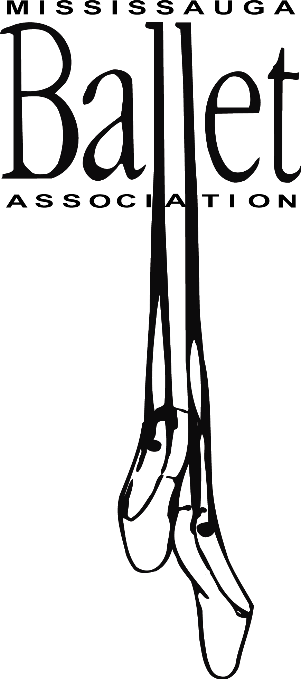

FEE SCHEDULE 2013-14

1/2 hour classes (KI) | $450.00
45 min. classes (KII, PBI, PBII) | $490.00
1 hour classes (CBI – VIII, Sr. B) | $520.00
1. 5 hour classes (Sr.) | $575.00
Modern (Jr. & Sr.) | $425.00
Pointe | $410.00

Payment Dates: | ½ hour  classes | 45 min.  classes | 1 hour classes | 1.5 hour classes | Modern | Pointe
September 1, 2013 | $180.00 | $190.00 | $190.00 | 255.00 | $165.00 | $160.00
November 1, 2013 | $135.00 | $150.00 | $165.00 | 160.00 | $130.00 | $125.00
December 1, 2013 | $135.00 | $150.00 | $165.00 | 160.00 | $130.00 | $125.00
April 1, 2014 – Task Fee  PAID PER FAMILY | $100.00 | $100.00 | $100.00 | $100.00
Please make cheques payable to the Mississauga Ballet Association. NOTE: A $30.00 charge will be applied to all NSF cheques.

TASK FEE
The Mississauga Ballet Association is a not-for-profit organization. Because we rely on parent volunteers, a task fee system has been put in place. Please include a separate cheque for $100.00, dated for April 1st, 2014 with your registration (one per family). If you or someone else in your family completes ONE task over the course of the season your task fee WILL NOT be cashed and the cheque will be destroyed. If you prefer not to volunteer, you will be charged $100.00. MBA would like to thank you in advance for your help in making next season an enjoyable and positive experience for your children.

Below are examples of tasks that we will need help with:
Task | Description
Board of Directors | Sit on board for meetings
Class Representative | Liaison between artistic director and other families in your child’s class
Word Processing / Graphic Design | Newsletters, Show programs, advertising, certificates
Open House | Help with set-up and preparations
Spring Recital | Hospitality, costume care, dressing room assistant, make-up application, backstage, front-of-house sales, transportation of costumes or scenery, sewing

When sending registration by mail, please return the following forms and make sure your name is clearly marked on each item. Also include your child’s name & class on each cheque.

a) A signed student registration form
b) A signed waiver form (on the back of information sheet)
c) 3 Post-dated cheques for class fees
d) Task fee cheque dated April 1, 2014

