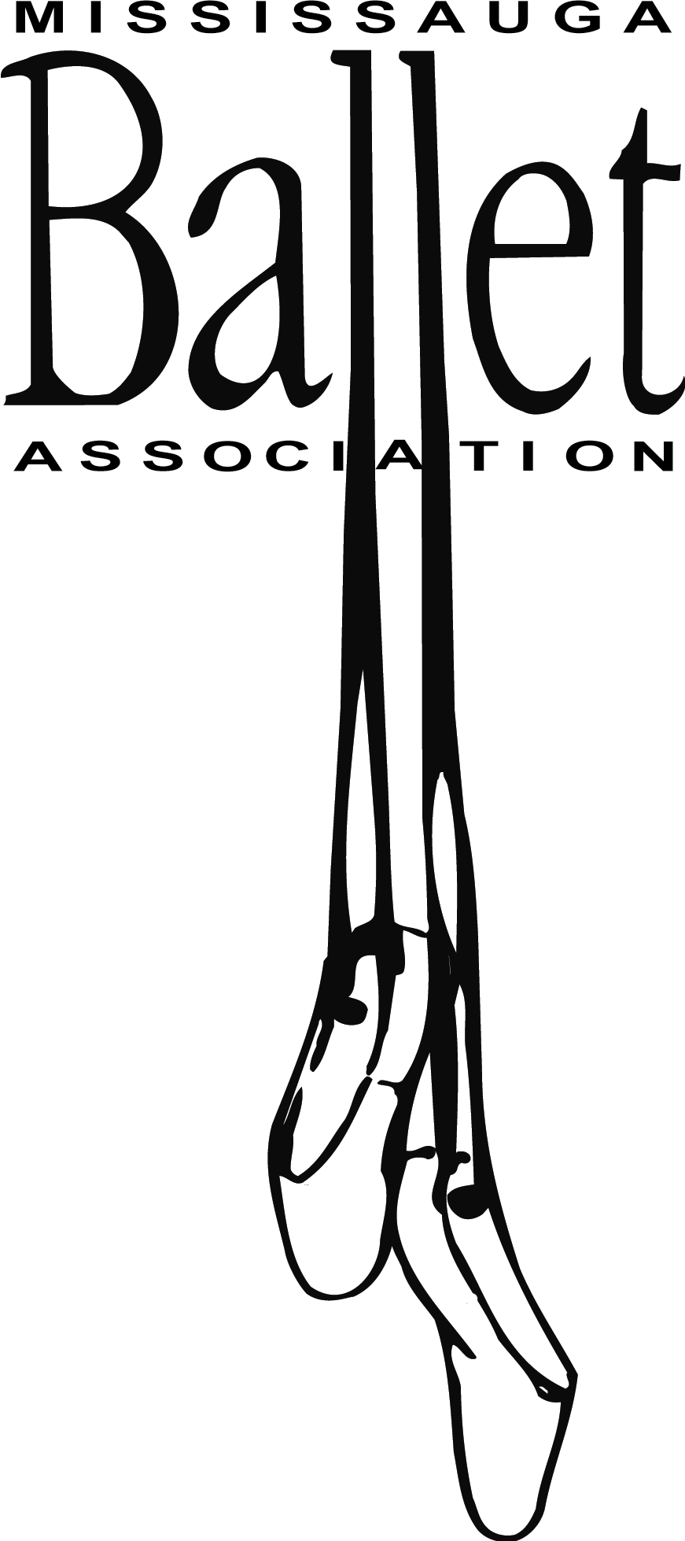**Hoodie Order Form** 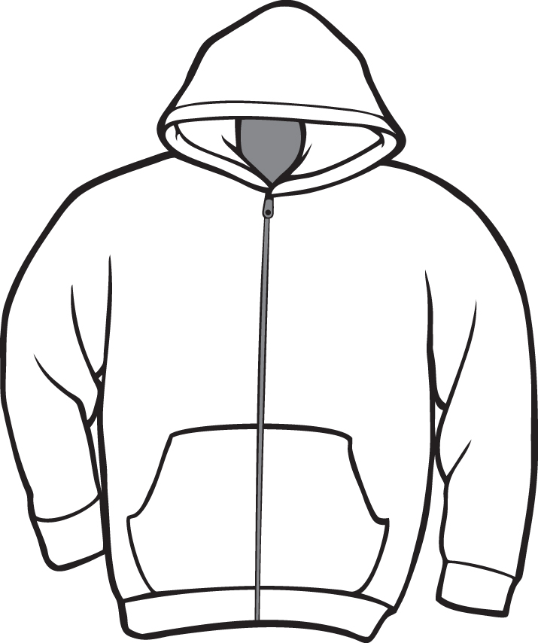

Child’s name ___________________________

Child’s class (day and time) ____________________

Parent’s name and # ___________________________

**______________________________**

**Child’s Black Hoodie $40.00**

x-small ___ small ___ med ___ large ___ x-large ___

**Adult’s Black Hoodie – $45.00**

small___ medium___ large ___ x-large ___

Front of sweat-shirt: logo on left lapel in hot pink

Back of sweat-shirt: “Mississauga Ballet Association” in hot pink

**Orders due by Nov. 12 (for delivery before the holidays).**

**________________________________________________**

Amounts include tax. Please provide exact cash (change will not be available) or a cheque made payable to Mississauga Ballet Association.

Total Amount paid _______