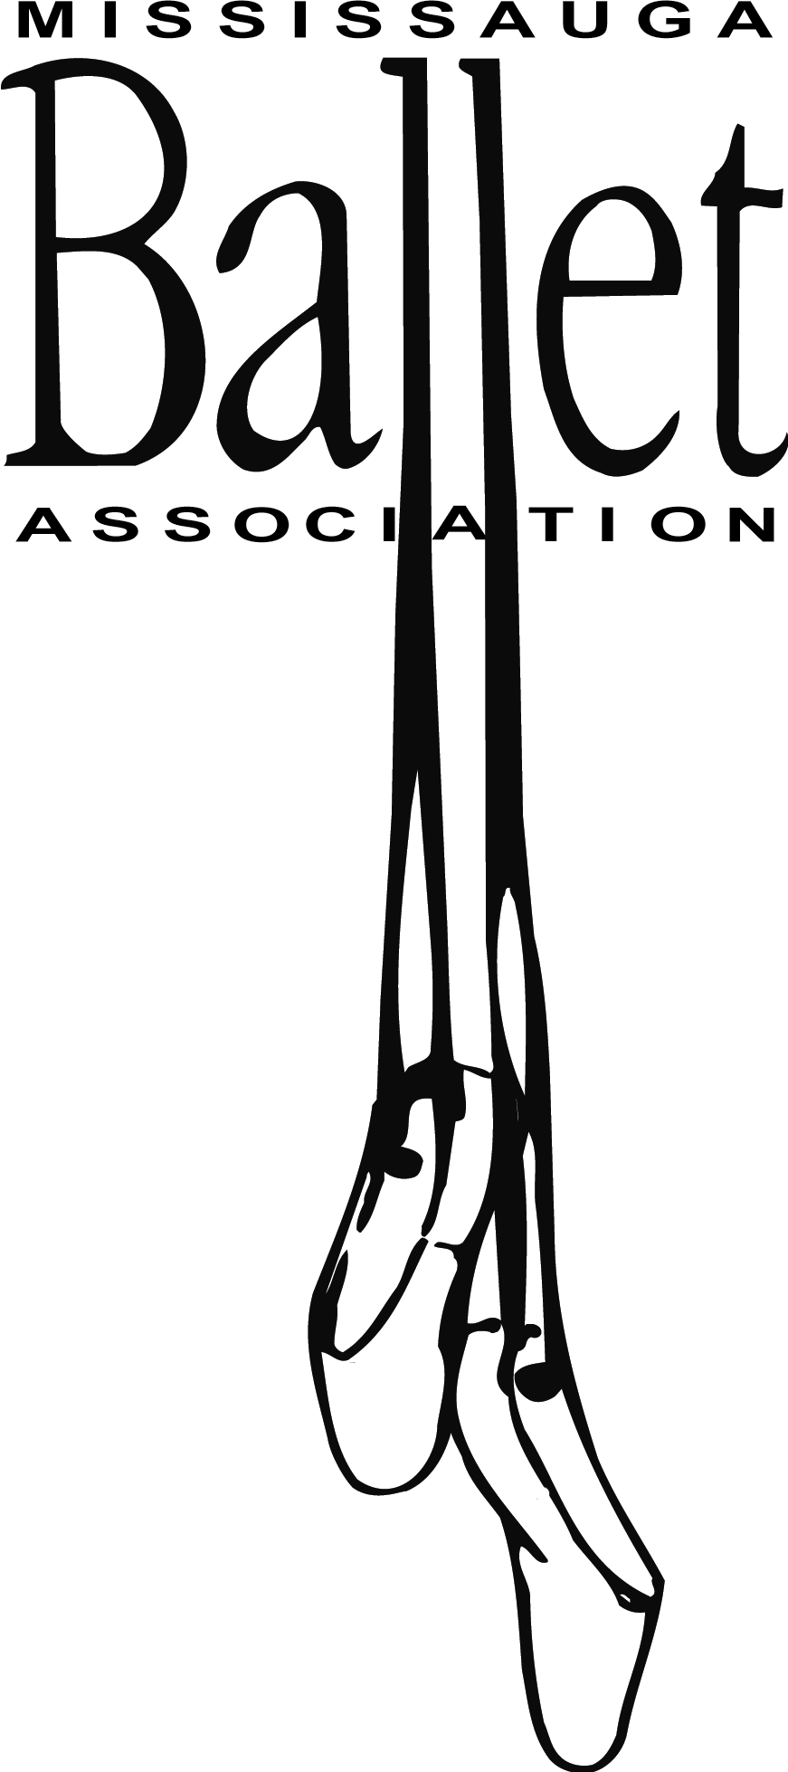

Due to COVID-19, a number of restrictions have been placed on participants in order to attend dance classes. Only 14 participants are permitted in the Dance Studio at the Living Arts Centre at a given time. Due to this restriction on the number of participants, some students may be placed in a different class or time.

Before anyone is allowed to participate in any Mississauga Ballet Association’s (MBA) activities, they need to meet the following requirements:

1. The mandatory MBA Waiver must be signed and returned before the first class.
2. The MBA’s Return to Dance Protocol is outlined below and must be signed and abided by.
3. All staff, students and volunteers, 12 years and older must be fully vaccinated to participate in any MBA live class or activity.
4. Before any classes, MBA’s COVID-19 Health Screening Questionnaire (found [below](https://www.portcreditfsc.ca/sites/files/Port%20Credit%20SC%20COVID%20Screening%20questionnaire%20v.July%2011.docx)) must be reviewed at home and at the Living Arts Centre in the presence of a staff member. If a child arrives at class without an adult, a paper version signed by their parent/guardian must be submitted upon arrival. Students born in 2009 or earlier, who arrive without an adult present each week can be granted permission by their parent/guardian to complete the questionnaire verbally on their own behalf.

**Mississauga Ballet Association Return to Dance Protocol**

**January 2022**

MBA’s Return to Dance Protocol is intended to enable a safe return to dance classes during the COVID-19 pandemic. This Protocol is based on current Peel Region statutes and regulations, current public health requirements and directives, and MBA's goal to make classes safe for all participants and their families.

* The Mississauga Ballet Association’s COVID-19 Waiver (including the Return to Dance Protocol) MUST be signed BEFORE a dancer will be permitted to participate in any classes, no exceptions. If a dancer arrives for their first class without completing the waiver they **will not be allowed to dance**and no refunds/credits will be issued for failure to comply. One waiver is needed PER dancer and need only be completed once.
* **Anyone 12 years and older, entering the Living Arts Centre will be required to show proof of vaccination and government issued ID upon arrival each day.**

**Preventing COVID-19 Exposure – Self Screening**

Person(s) must self-screen before arrival at the Living Arts Centre in accordance with current public heath guidelines.

* Individuals who do not pass the current screening requirements must not attend any MBA classes or activity.
* All dancers 12 years and older must be fully vaccinated to participate in any MBA live class or activity.
* Credits or refunds will not be issued due to failed self-screening.

Health Questionnaire and Tracking

Person(s) must complete an online health questionnaire provided by the City of Mississauga, prior to each entry to the facility and/or participation in any MBA live activity. Any Person(s) who fails the questionnaire will be denied entry to the facility. They should self-isolate immediately and follow directions given by public health officials. Failure to comply will lead to the person(s) being denied entry to the facility, being asked to leave the facility upon discovery of failure and being denied access to any MBA live class or activity until they have been cleared to return to dance according to current public health guidelines.

* Attendance at each MBA class or live activity will be taken which will capture all participants present. Daily class participation tracking sheets will be maintained by MBA to enable contact tracing should it be requested by Public Health.
* This list will not be shared beyond what is required by Ontario Law.

Symptoms/Ill-health During or Following an MBA Live Class/Activity

* Person(s) developing any COVID-19 symptoms identified by health experts during or following an MBA class or live event must inform the MBA staff immediately and may not attend/participate in any following class or live event until have completed their isolation based on current public health guidance. Failure to comply will lead to the person(s) being denied access to any MBA class or live event until they have completed their quarantine and/or been cleared to return to activities according to current public health guidelines.
* The individual shall immediately be separated from others in a supervised area—away from other persons inside the facility—until they can go home.
* Other children and staff in the dance studio, who were present while a child or staff member became ill, will be notified and should follow current public health guidelines.
* Following a positive COVID-19 test, an individual must follow all public health guidelines regarding return to activities.

Communication Plan During COVID-19

The MBA board of directors will continue to inform and share as much information as possible about the MBA Return to Dance Protocol with the members, staff and volunteers. Communication will be conducted primarily by email.

Procedure for Class

* Dancers must arrive 15 minutes early in uniform and their online health questionnaire completed prior to arriving at the facility.
* Access to the facility will be through the north entrance (close to the entrance of the underground parking). The underground parking is closed.
* Anyone 12 and older will be required to show proof of vaccination and ID to city staff working at the door every time they enter the building.
* Drop off and pickup will be outside of the studio doors on the 3rd floor.
* Dancers and family members will wait in the designated drop off area to complete verbal pre-class screenings.
* Dancers/staff/volunteers are required to wear a mask inside the Living Arts Centre.
* Dancers will assemble at the designated drop off area (maintaining two-metre physical distancing.
* Teachers/staff/volunteers must complete an online health questionnaire prior to entering the facility.
* Dancers should bring a bag large enough to store any personal items that enter the building while in class. The bag will be left in the hallway outside the studio. Valuables should not be brought to the Living Arts Centre. MBA will not be responsible for lost or stolen items.
* Dancers/teachers/staff/volunteers must wash or sanitize hands upon entry to the dance studio.
* Dancers will follow two metre physical distancing in the studio as much as possible.
* No parents or spectators will be allowed in the studio until capacity restrictions have been lifted.
* Recitals and demonstrations will not be staged during this session.
* Teachers will not make physical contact while teaching.
* Dancers/teachers/staff/volunteers will sanitize their hands before exiting the studio.
* Dancers will return to the designated pick-up area at the end of class. Dancers must be picked up on time. **Due to capacity restrictions implemented by the City of Mississauga,** **dancers will not be permitted to return to the studio if a parent is not present at the designated pick-up time.**
* High touch surfaces such as ballet barres and doors will be sanitized between each class.

Refund and Credit Policy

* No refunds or credits will be issued for missed sessions due to a positive COVID-19 test result or due to self-isolation.
* If classes are cancelled due to COVID-19 or necessary isolation periods for MBA staff, we will shift to online Zoom classes until we can safely return to the studio. Refunds or credits will not be issued.

**MBA COVID-19 Screening Questionnaire for Students**

Do you or anyone in your household have ONE or more of the following new or worsening symptoms?

* Fever (37.8℃ or higher) or chills
* Cough
* Shortness of breath
* Decrease of loss or sense of smell and taste

Do you or anyone in your household have TWO or more of the following new or worsening symptoms?

* Sore throat
* Headache
* Extreme tiredness
* Runny nose and nasal congestion
* Muscle aches or joint pain
* Nausea, vomiting or diarrhea

If an individual only has ONE of the above symptoms, they must remain home until the symptom is improving for at least 24 hours (48 hours for any nausea, vomiting or diarrhea).

If you received a COVID-19 vaccination and/or flu shot in the last 48 hours and have a mild headache, fatigue, muscle ache and/or joint pain that only began after immunization, and no other symptoms, answer **“No”** to those questions.

* Has a health care provider, public health unit, or the COVID-19 Alert app recently* told you that you should be self-isolating or staying home?
* Have you recently* been identified as a “close contact” of someone who has COVID-19? If the person is not a household member and you are fully vaccinated**, answer “No”.
* In the last 14 days, have you or anyone in your household travelled outside of Canada AND been advised to stay home per the federal quarantine requirements?
* Have you or anyone in the household recently* tested positive on a rapid antigen test or PCR test?

**Recently** means the last 5 days if you are fully vaccinated and otherwise healthy, or are under 12 years old; or, the last 10 days if you are not fully vaccinated or if you are immunocompromised.

**\*\* Fully vaccinated** means that you received all required doses of an approved COVID-19 vaccine at least 14 days ago.

If you are immunocompromised, you should isolate for 10 days, even if you are fully vaccinated. If you have questions, speak to your healthcare provider.

**IF you answered YES to any of the questions, stay home.**