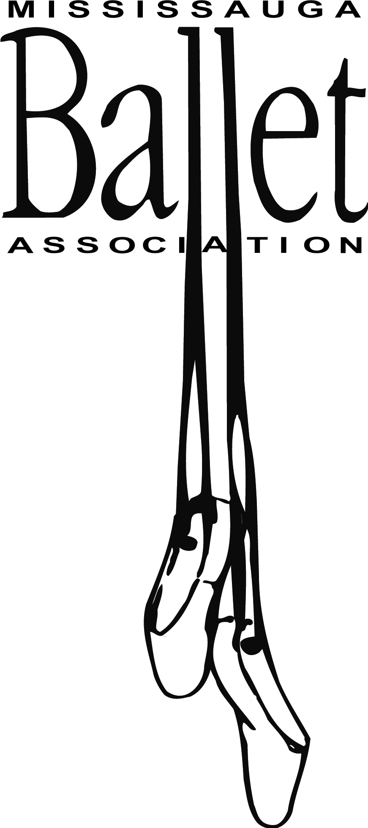

Due to COVID-19, a number of restrictions have been placed on participants in order to attend dance classes. Only 15 participants are permitted in the Dance Studio at the Living Arts Centre at a given time. Due to this restriction on the number of participants, some students may be placed in a different class or time.

Before anyone is allowed to participate in any Mississauga Ballet Association’s (MBA) activities, they need to meet the following requirements:

1. The mandatory MBA Waiver must be signed and returned before the first class.
2. The MBA’s Return to Dance Protocol is outlined below and must be signed and abided by.
3. All staff, must be fully vaccinated to participate in any MBA live class or activity.
4. Before any classes, MBA’s COVID-19 Health Screening Questionnaire (found [below](https://www.portcreditfsc.ca/sites/files/Port%20Credit%20SC%20COVID%20Screening%20questionnaire%20v.July%2011.docx)) must be reviewed at home. If you answer yes to any of the screening questions, do not proceed to the Living Arts Centre or take part in any MBA live class or activity.

**Mississauga Ballet Association Return to Dance Protocol**

**March 2022**

MBA’s Return to Dance Protocol is intended to enable a safe return to dance classes during the COVID-19 pandemic. This Protocol is based on current Peel Region statutes and regulations, current public health requirements and directives, and MBA's goal to make classes safe for all participants and their families.

* The Mississauga Ballet Association’s COVID-19 Waiver (including the Return to Dance Protocol) MUST be signed BEFORE a dancer will be permitted to participate in any classes, no exceptions. If a dancer arrives for their first class without completing the waiver they **will not be allowed to dance**and no refunds/credits will be issued for failure to comply. One waiver is needed PER dancer and need only be completed once.

**Preventing COVID-19 Exposure – Self Screening**

Person(s) must self-screen before arrival at the Living Arts Centre in accordance with current public heath guidelines.

* Individuals who do not pass the current screening requirements must not attend any MBA classes or activity.
* Credits or refunds will not be issued due to failed self-screening.

Contact Tracing

* Attendance at each MBA class or live activity will be taken which will capture all participants present. Daily class participation tracking sheets will be maintained by MBA to enable contact tracing should it be requested by Public Health.
* This list will not be shared beyond what is required by Ontario Law.

Symptoms/Ill-health During or Following an MBA Live Class/Activity

* Person(s) developing any COVID-19 symptoms identified by health experts during or following an MBA class or live event must inform the MBA staff immediately and may not attend/participate in any following class or live event until have completed their isolation based on current public health guidance. Failure to comply will lead to the person(s) being denied access to any MBA class or live event until they have completed their quarantine and/or been cleared to return to activities according to current public health guidelines.
* Other children and staff in the dance studio, who were present while a child or staff member became ill, will be notified and should follow current public health guidelines.
* Following a positive COVID-19 test, an individual must follow all public health guidelines regarding return to activities.

Communication Plan During COVID-19

* The MBA board of directors will continue to inform and share as much information as possible about the MBA Return to Dance Protocol with the members, staff and volunteers. Communication will be conducted primarily by email.

Procedure for Class

* Dancers must arrive 10 minutes early in uniform.
* Access to the facility will be through the south entrance.
* The underground parking is also open (entre on the west side).
* Drop off and pickup will be outside of the studio doors on the 3rd floor.
* Dancers and family members will wait in the designated drop off area to confirm they have completed self-screening before arrival.
* Dancers/staff/volunteers are required to wear a mask inside the Living Arts Centre.
* Dancers will assemble at the designated drop off area (maintaining two-metre physical distancing).
* Teachers/staff/volunteers must also self-screen before arrival at the Living Arts Centre.
* Dancers should bring a bag large enough to store any personal items that enter the building while in class. The bag will be left in the hallway outside the studio. Valuables should not be brought to the Living Arts Centre. MBA will not be responsible for lost or stolen items.
* Dancers/teachers/staff/volunteers must wash or sanitize hands upon entry to the dance studio.
* Dancers will follow two metre physical distancing in the studio as much as possible.
* Recitals will not be staged during this session.
* Dancers/teachers/staff/volunteers will sanitize their hands before exiting the studio.
* Dancers will return to the designated pick-up area at the end of class. **Dancers must be picked up on time.**
* High touch surfaces such as ballet barres and doors will be sanitized between each class.

Refund and Credit Policy

* No refunds or credits will be issued for missed sessions due to a positive COVID-19 test result or due to self-isolation.
* If classes are cancelled due to COVID-19 or necessary isolation periods for MBA staff, we will shift to online Zoom classes until we can safely return to the studio. Refunds or credits will not be issued.

**MBA COVID-19 Screening Questionnaire for Students**

Do you or anyone in your household have ONE or more of the following new or worsening symptoms?

* Fever (37.8℃ or higher) or chills
* Cough
* Shortness of breath
* Decrease of loss or sense of smell and taste

Do you or anyone in your household have TWO or more of the following new or worsening symptoms?

* Sore throat
* Headache
* Extreme tiredness
* Runny nose and nasal congestion
* Muscle aches or joint pain
* Nausea, vomiting or diarrhea

If an individual only has ONE of the above symptoms, they must remain home until the symptom is improving for at least 24 hours (48 hours for any nausea, vomiting or diarrhea).

If you received a COVID-19 vaccination and/or flu shot in the last 48 hours and have a mild headache, fatigue, muscle ache and/or joint pain that only began after immunization, and no other symptoms, answer **“No”** to those questions.

* Has a health care provider, public health unit, or the COVID-19 Alert app recently* told you that you should be self-isolating or staying home?
* Have you recently* been identified as a “close contact” of someone who has COVID-19? If the person is not a household member and you are fully vaccinated**, answer “No”.
* In the last 14 days, have you or anyone in your household travelled outside of Canada AND been advised to stay home per the federal quarantine requirements?
* Have you or anyone in the household recently* tested positive on a rapid antigen test or PCR test?

**Recently** means the last 5 days if you are fully vaccinated and otherwise healthy, or are under 12 years old; or, the last 10 days if you are not fully vaccinated or if you are immunocompromised.

**\*\* Fully vaccinated** means that you received all required doses of an approved COVID-19 vaccine at least 14 days ago.

If you are immunocompromised, you should isolate for 10 days, even if you are fully vaccinated. If you have questions, speak to your healthcare provider.

**IF you answered YES to any of the questions, stay home.**