FINAL PROJECT IN WAVELET THEORY AND APPLICATIONS

RELATIONSHIP OF FILTERS TO WAVELET AND SCALING FUNCTION SHAPES AND WAVELET-BASED IMAGE DECOMPOSITION, RECONSTRUCTION, AND DE-NOISING

PART I: FROM FILTERS TO WAVELETS AND SCALING FUNCTIONS
- Modify phi _ daub.m so that, given any wavelet name, the new program can be used to generate scaling function using quadrature mirror filters.
- Modify the code developed as described above to obtain Matlab m-file generating any required wavelet.
My new m-file is named ‘myPsi.m’, I try to analyze your code of convolving in ‘Phi_daub.m’ g(i,n) = g(i,n) + g(1,k+1)*g(i-1,tempindex); and here is one of my analyses
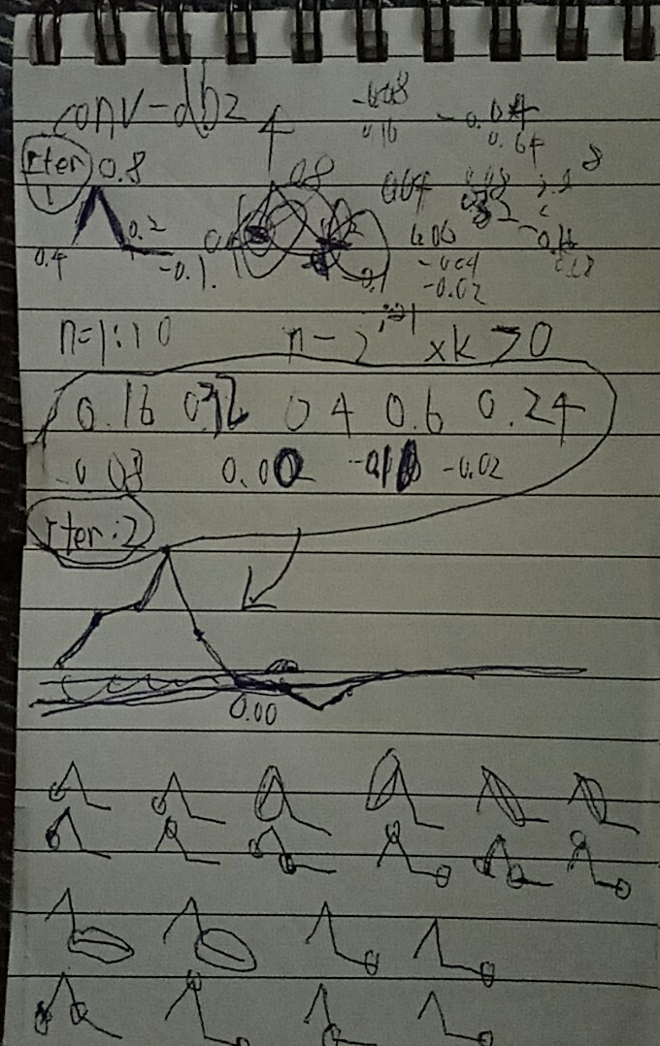
So after analyzing, I basically modify codes in the convolving part for i = 2:numits
- Combine two programs, developed above, i.e., obtain a program which would generate a wavelet and its scaling function and plot them side-by-side.
e.g. Figure 1 is a result of ‘sym10’, just run like this: task1(‘sym10’)
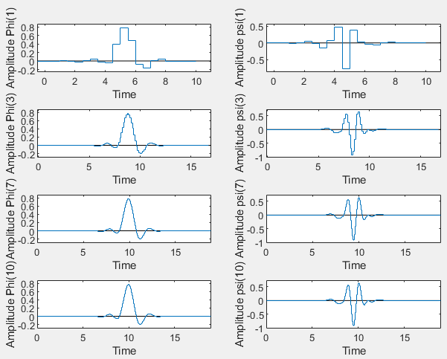
Figure 1 Task1 result

PART II: DE-NOISING
- Modify the function adding wavelet name as a parameter.
Evaluate the performance of the de-noising algorithm for different wavelets and for both soft and hard thresholding. Explain the difference between the soft and hard thresholding. Use wfilter function to obtain filters for other wavelets.
1.I choose “LoD” to be the “filter” in denoise.m, just according to the codes and algorithms in denoise.m, “filter” is refered to Decomposition-low-pass filter

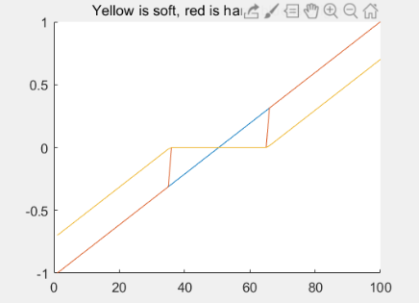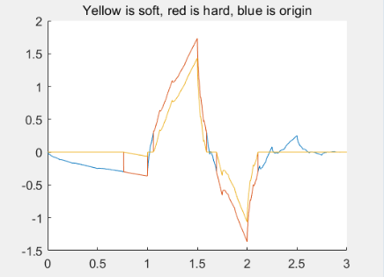
Figure 2. Soft or hard thresholding Figure 3. Soft or hard thresholding

- Try to increase number of decomposition levels.
The higher level, the more details we get(because we are iterating, with successive approximations being decomposed in turn), the more chance we can increase the percent of zeros, which implies the higher SNR or much clearer picture we could be able to get in reconstructed photo, basically I think around 4 level is enough for human eyes. But in the meanwhile, the higher level (e.g. 10) of decomposition also give chance of lower Retained-Energy, so not only choosing high level, but also choosing a good thresh value is important! Though you already design the algorithm about thresh value in denoise.m that we don’t need to modify ‘thr’ ourselves.
Furthermore, I try to observe more about decomposition levels, I run denoise with these parameters task2denoise (from 1 to 3 level,1,'S','haar'), I use ‘Haar’ because the length of ‘Haar’ wavelets are only 2, and it just takes simple features like Figure 4, which makes us more easy to observe the changes in reconstructed photo among different level of decomposition.
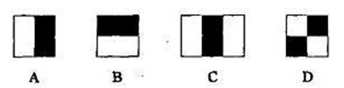
Figure 4. ‘Haar’ features

As in Figure 5, we see that for 1 level(one iteration) of decomposition, the square-boundary (in the ‘zoom-in part of image) is small, because after padding and then down-sampling, the Approximation-1 is 129*129, so when we reconstructed S=A1+D1, we see such 2*2 square-boundary. For 2 level, A-2 becomes 65*65 because padding and then down-sampling on A-1(successive approximations), so when we reconstructed S=A2+D2+D1, the square-boundary is two times bigger than last level due to the size of Approximation, the same reason for 3 level, A-3 becomes 33*33, and we see such 8*8 square-boundary in reconstructed-image, for more level k, the size of A-k will remain unchanged on 2*2 (can’t be smaller anymore for ‘haar’, because the filters length is 2), so the square-boundary in reconstructed image also won’t become bigger anymore, this somehow makes human eyes can’t observe the changes too much as I mentioned in beginning, but sure reconstructed image is still changing slightly with high level, because coefficients still change slightly since A-k and D-k is still changing
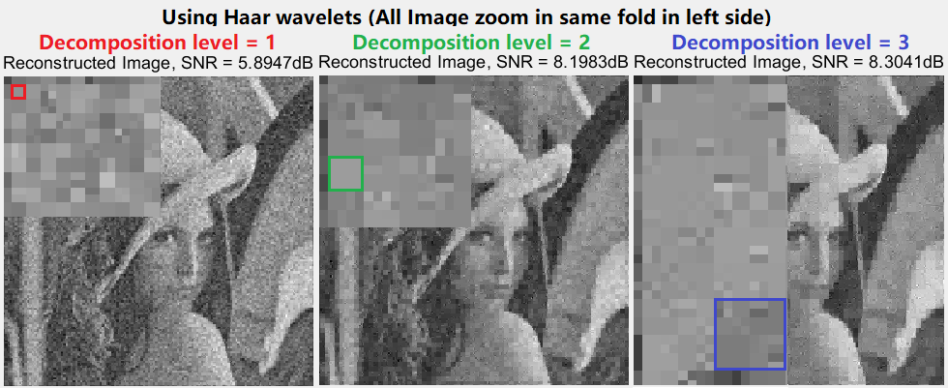
Figure 5 Differences in photos with different decomposition level
- Try de-noising using Wavelet Toolbox GUI and compare results with those obtained using denoise function. First, at Matlab command line, you have to create and save a Lena_plus_noise.mat file with noisy Lena and then import this file into GUI.
First, to create and save Lena_plus_noise.mat , I just add the code
noisyLena=Lena+eta
save ('Lena_plus_noise.mat','noisyLena')
in the end of task2denoise.m as you could see, then I run denoise with these parameters task2denoise (3,1,'S','db2')
So I generate a 1db SNR noisy Lena as an example,
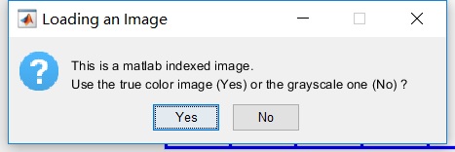
Figure 6. Wonder about consistency of input
Due to I am not too familiar with Matlab, so I don’t know does the ‘grayscale’ in Figure 6 keep the exact coefficients of the original Lena_plus_noise.mat, because the photo looks slightly different between denoise.m and Wavelet Toolbox GUI as in following 2 photos Figure 7 and 8:
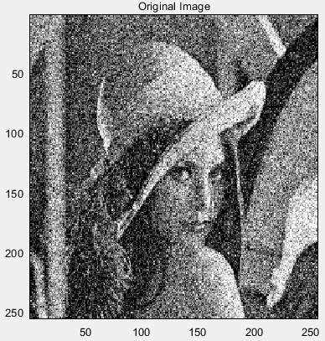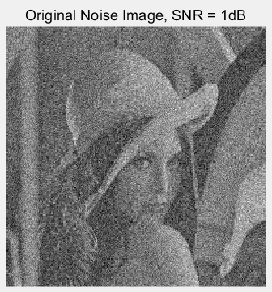
Figure 2. NoisyLena as input for Wavelet Toolbox GUI Figure 3. NoisyLena as input for denoise.m
And such little difference for inputs(Noisy Lena image) to programs could influent the comparison of the outputs.According to your algorithm about seting ‘thr’ value, I observe that for 1dB SNR noise, thr= 76.8895, so I set the same value in Wavelet Toolbox GUI (level=3, ‘S’,’db2’ thr=76.8895 for all Horizontal, Diagonal and Vertical details as we see in Figure 9)
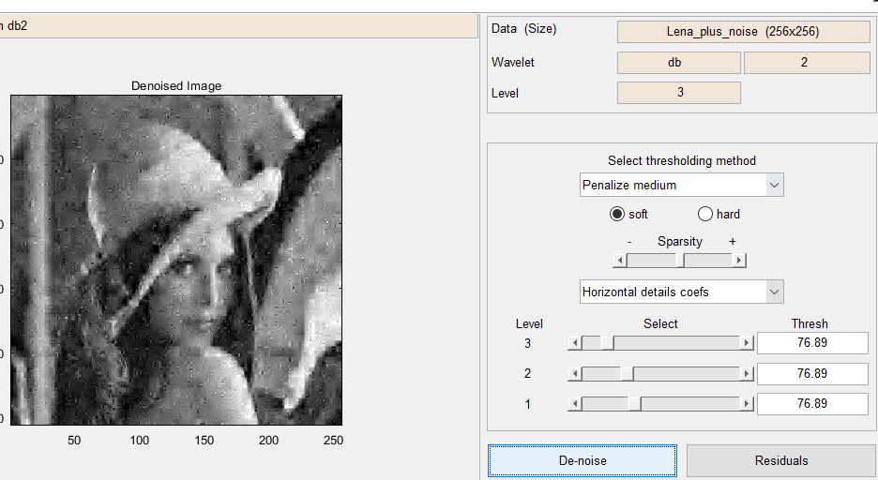
Figure 4. a denoise example in Wavelet Toolbox GUI
Figure 10. a denoise example in denoise.m
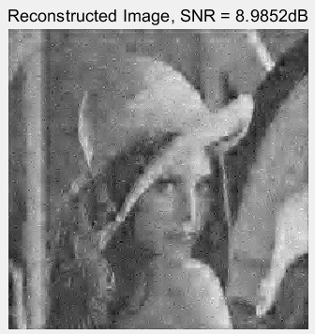
Lets compara it with result from denoise.m as Figure 10, they actually looks almost the same, the only slight different is the color, as I mentioned above (the sentence with green color), I guess such little difference on two outputs is because of the slight difference in inputs.
Furthermore, in Wavelet Toolbox, we can select the thresh values for each level and each type(Horizontal, Diagonal or Vertical) of details, so we could have many choices of output, but in denois.m, because the thresh value is fixed(calculated by your algorithm, but not selected by User), so for the same input(Noisy Lena image), the denoise.m program will give only one output. Anyway the result of denoise.m is mostly better than my all the random tries in Wavelet Toolbox GUI, maybe I am not familiar with Matlab right now, but the algorithm in denoise.m is very precise.

PART III: IMAGE DECOMPOSITION AND RECONSTRUCTION
- Properly modify denoise function to obtain a function that would first decompose Lena.bmp or any other image into a specified number of levels, each containing an approximation and horizontal, vertical, and diagonal details and then reconstruct. Try to decompose and then reconstruct your own image.
- I have two photos of my city as examples ‘CantonLeft.bmp’ and ‘CantonRight.bmp’, because my city has a building called ‘Canton Tower’ as in 'CantonLeft.bmp', so I want to check how it will be in vertical details. It catches the vertical feature that we can see in Level-3 Vertical Detail in Figure 11.
(parameters:task3denoise(4,10,'H','db2','CantonLeft.bmp'))
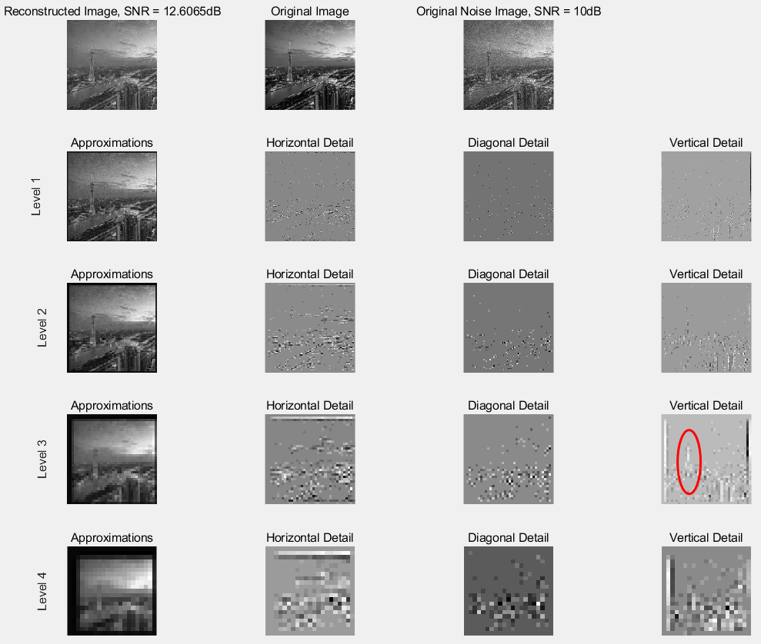
Figure 11. Approximations and Details of ‘CantonLeft.bmp’
- Your decomposition and reconstruction function should for every decomposition level plot the previous level approximation image along with the current level horizontal, vertical, and diagonal details.
In the case of screen size is limited, I limit the maximal number of level of images to be plotted, the maximal number is level 8, because more level makes the images become so small. So as you see in Figure 12, even if I run task3denoise(10,10,'H','db20','CantonLeft.bmp'), but it only shows 8 rows of images.
Let’s see why the images of same level become smaller (black edges are bigger) than Figure 11 when I choose 'db20'? in my opinion I guess it is because higher N of dbN(symN, coifN, fkN…..) has filters with bigger length, so we have to pad more zeros into the images on its edges before decomposition, this somehow results in such ‘black edges’ after decomposition.
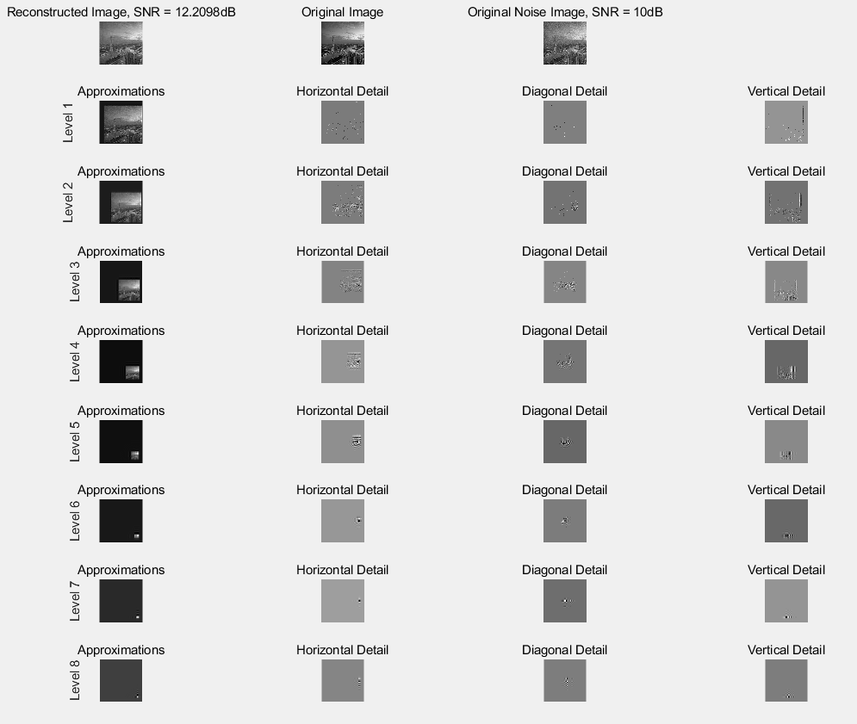
Figure 12. Approximations and Details of ‘CantonLeft.bmp’

- Using GUI decompose and reconstruct Lena.mat to be generated at Matlab command line.
If I didn’t misunderstand the meaning of this question, then my answer is in task32.m
Else if the question is asking to generate Lena.mat, and Lena.mat will be input to be loaded into GUI.
then my answer is in task33.m
