Histopathological cancer detection

Detecting cancer in a patch of a histological slide, using a convolutional neural network.

# Milestone 1: Baseline Model

## 1. The analysis of data and construction of features

Our dataset is a derivative of the PatchCamelyon (PCam) dataset, which is a derivative of the Cancer Metastases in Lymph Nodes Challenge 2016 (CAMELYON16) dataset.[1]

The CAMELYON16 dataset consists of 170 training and 129 testing, hematoxylin- and eosin–stained (H&E) whole image slides (WSI). Hematoxylin binds to DNA, colouring it purple. Eosin binds to amino acids found in cytoplasm, collagen and muscle fibers, colouring them pink. Therefore, both the nucleus of each cell, containing Hematoxylin bound DNA, and the surrounding cell structures arevisualized. All 400 slides were obtained from Radboud University Medical Center (RUMC) and the Medical Center Utrecht (UMCU), which scanned the images with a 20x (0.243 µ/pixel) and 40x (0.226 µ/pixel) objective lens respectively. These WSI were annotated by students, which were supervised and checked by pathologist. [2,3]

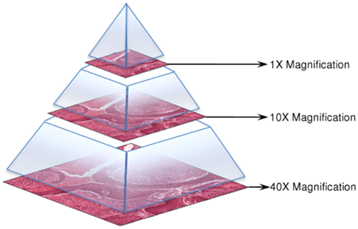

*Img. 1 Example of effect of magnification. [7]*

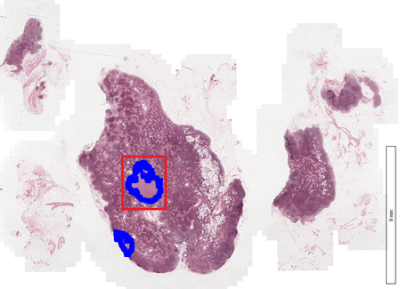

*Img. 2 Example of WSI. Tumour tissue has been annotated in blue. [7]*

The PCam dataset consists of 327.680 96x96xp patches selected from the WSI in CAMELYON16, at 10x magnification (0.972 µ/pixel). To filter out all the patches containing the background and no tissue, all patches were converted from RGB to HSV and blurred. Patches with a maximum pixel saturation of below 0.07 were dropped, since these patches were believed not to contain any tissue.

Afterwards, patches were sampled for the dataset by iterating through the WSI and choosing a negative patch with probability around 0.5. Because it’s a probability, some patches could be selected twice and the dataset will contain duplicates. Some patches are selected based on a CNN and a stochastic hard-negative mining scheme. Hard-negative mining is a technique in which training examples that a model has a hard time classifying correctly are extracted from the larger dataset, since they might contain features that the model can leverage to learn more effectively. [5,6] In this case specifically, a CNN was trained using an annotated dataset (the patches) and false positives with a prediction around 0.5, meaning they are hard to predict (e.g. lie close to the decision boundary), were kept. [3,4] This technique results in a dataset containing negative examples that are more difficult to distinguish from positive examples, compared to the average negative example.

A patch was labelled positive, if there was at least one pixel of tumour tissue in the 32x32 centre of the patch. In the PCam dataset, the entire 96x96 patch was included. However, the tissue outside of the 32x32 center of the patch was not taken into account when labelling the samples. Therefore, a 96x96 sample containing tumor tissue only outside the centre did not receive a positive label. This border was merely added to ensure the data could be used by models that don’t use zero-padding on their images.[3]

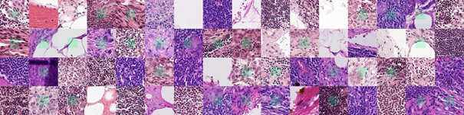

*Img. 3 Example images from the PCam dataset. Centres of patches have been coloured green.*

In the Histopathologic Cancer Detection Kaggle competition, only the 32x32 centres of the original 96x96 PCam patches were included as training and testing data. These centres are the image data that our model will be trained and tested on.

There is no overlap between training and testing data. All the duplicates are taken out, leaving 277.483 unique 32x32px image samples. The Kaggle competition has split this dataset into 220.025 (79%) training and 57.458 (21%) testing images. The testing data is not labelled, since it is used to judge performance in the Kaggle competition.[1] Both the training and testing data contained around 50% positive examples (patches containing tumorous tissue) and 50% negative examples.

We have split the labelled training dataset further, resulting in a training set (70%, 154018 samples) and validation set (30%, 66008 samples), which we used to evaluate the training of our model.

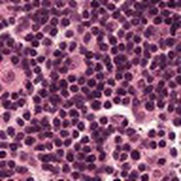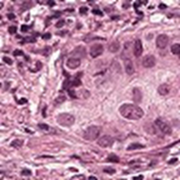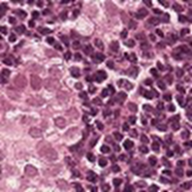

*Img. 4 Examples from our dataset. Left: negative training example. Middle: positive training example. Right: testing example.*

## 2. The inputs and structure of the model

Because the input data are images, a convolutional neural network was used as a model. Our baseline model

The input data is presented as tiff images of 32 x 32 pixels with 3 color channels. The collection of tiff images was converted to a four-dimensional Numpy array.

The dimensions of this Numpy array are as follows:

* Dimension 0: The different images
* Dimension 1: The columns of the images
* Dimension 2: The rows of the images
* Dimension 3: The three colour channels

The bare minimum for a CNN is 1 convolution followed by pooling, a flattening layer, a hidden layer and an output layer. If no pooling layers were added, there would be too much information and the model would not generalise well to other data. Features in a CNN are learned by passing patches of the image through filters with learned weights. The filters that operate on the second convolutional layer extract features that are combinations of lower level features. Features learned through one convolution might be too vague. We added a second convolution to have higher-level features, which might result in a higher accuracy for our initial model.

There are no set rules for determining the initial number of filters. Large amounts of filters pose no problem for NN’s, so we chose a number that was large, but could still be further expanded. We also didn’t know how many features we could distinguish in an image. Conventionally the amount of filters is a power of two.

The output layer needs a different activation than the hidden layer.

The resulting network architecture of the baseline model is as follows:

Convolution and maxpooling:

* Convolutional layer 1 (32 filters)
  + Applies convolutional filters resulting in 32 feature maps.
* Maxpooling layer 1
  + Applies maxpooling to feature maps with 2x2 patch
* Convolutional layer 2 (64 filters)
  + Applies convolutional filters resulting in 64 feature maps.
* Maxpooling layer 2
  + Applies maxpooling to feature maps with 2x2 patch

Dense layers:

* Flatten layer
  + Flattens the feature maps of the final convolutional layers into one vector which serves as input to the densely connected subsequent layer.
* Dense (hidden) layer 1 (64 nodes)
  + Densely connected hidden layer.
* Output layer
  + Two output nodes, corresponding to the two possible classes (cancer/no cancer).

model = models.Sequential()

model.add(layers.Conv2D(32, (3, 3), activation='relu', padding='same', input_shape=(32, 32, 3)))

model.add(layers.MaxPooling2D((2, 2)))

model.add(layers.Conv2D(64, (3, 3), activation='relu', padding='same'))

model.add(layers.MaxPooling2D((2, 2)))

model.add(layers.Flatten())

model.add(layers.Dense(64, activation='relu'))

model.add(layers.Dense(2, activation='softmax'))

train_and_evaluate(model, train_images, train_labels, val_images, val_labels)

## 3. The training methodology and results

model.compile(loss='categorical_crossentropy', optimizer='adam', metrics=['accuracy'])

For the baseline model, we used categorical cross entropy as loss function and Adam as optimizer for gradient descent, since Adam seems to be a very efficient optimizer in many situations. The learning rate for the Adam optimizer was set to the default value of 0.001. We trained the CNN for 20 epochs.

## 4. Comparison to previous models and analysis of results

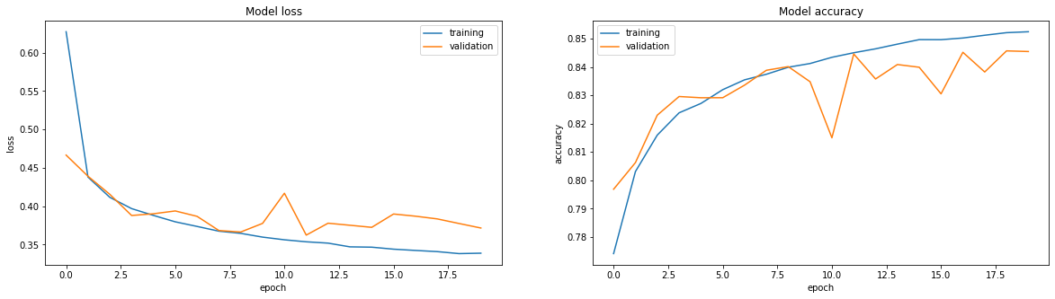

*Graph 1: Model loss and accuracy for the baseline model.*

Our baseline model performed surprisingly well. The final validation accuracy was 84.5%, which is far above the 50% chance level for a binary classification problem. While the training accuracy of the model seems to increase monotonically, the validation accuracy fluctuates quite a lot. There are many possible causes for a widely varying validation accuracy, such as overfitting or an unrepresentative validation dataset.

For future models, we have outlined several tweaks which could speed up the learning process and increase the generalizability of our model to the validation data.

Possible tweaks:

* Changing learning rate
  + The learning rate of the adam optimizer is currently set to the default value of 0.001. Increasing the learning rate could perhaps speed up the training process.
* Increasing number of epochs
  + As the graph above shows, the training accuracy had not quite reached a plateau after 20 epochs. Therefore, this model might benefit from using more epochs in the training process. Furthermore, this is the most ‘basic’ model that we have designed. In later, more complex, iterations of our model, the model might require even more epochs to fully train.
* Normalizing input
  + To borrow some abstract terms from a theory video by Andrew Ng, normalizing the input features might aid the learning process since it might make the ‘landscape’ of our cost function more symmetrical.
* Deepening the model
  + Deepening the model by adding more layers increases the freedom of the model in designing a function that corresponds to the underlying distribution of our image data. For instance, adding more convolutional layers to the model might increase the ability of the model to learn relevant features in the training images that are predictive of the presence of cancerous cells.
* Adding dropout layers
  + That being said, increasing the complexity of the model also increases the model’s capacity for overfitting the training data. Our relatively simple baseline model already seems to be overfitting slightly, since the training and validation accuracies seem to diverge after around 10 epochs. This might indicate that the model continues to change in a way that fits the training data more and more efficiently, but does not generalize well to the validation data. Therefore, the model might benefit from the regularizing effect of adding several dropout layers. The dropout layers might force the model not to rely too much on specific weights.
* Adding batch normalization layers
  + Our model uses ReLU activations after each of the convolutional layers and the dense layer. Therefore, normalizing the input (mean around 0 and standard deviation around 1) for each of these layers might speed up the learning process, as it might help the model leverage the non-linearity of the ReLU function near its origin. Batch normalization might also have a slight regularizing effect that our model could reduce overfitting in our model.
* Data augmentations
  + Cancer cells can come in many shapes, sizes and orientations. Therefore, using data augmentations which for instance zoom, rotate, flip, shift or shear the training images might result in a meaningful increase in the number of training examples our model can use to learn from. All of the abovementioned augmentations could result in new images of cancerous cells that are still biologically realistic.
* Feature extraction
  + Cancerous cells have defining visual features that can be determined by us humans. It might be possible to translate these visual features into filters that our neural network can use to learn more quickly and accurately.
* K-fold cross validation

References:

1. <https://www.kaggle.com/c/histopathologic-cancer-detection/overview>

2. Ehteshami Bejnordi et al. Diagnostic Assessment of Deep Learning Algorithms for Detection of Lymph Node Metastases in Women With Breast Cancer. JAMA: The Journal of the American Medical Association, 318(22), 2199–2210. [doi:jama.2017.14585](https://doi.org/10.1001/jama.2017.14585)

3. https://github.com/basveeling/pcam

4. B. S. Veeling, J. Linmans, J. Winkens, T. Cohen, M. Welling. "Rotation Equivariant CNNs for Digital Pathology". [arXiv:1806.03962](http://arxiv.org/abs/1806.03962)

5. <https://stats.stackexchange.com/questions/294349/hard-mining-hard-examples-does-hard-mean-anything-specific-in-stat>[SP2]

6.  [https://sci-hub.se/https://www.sciencedirect.com/science/article/abs/pii/S0925231219316984](https://sci-hub.se/https:/www.sciencedirect.com/science/article/abs/pii/S0925231219316984)

7. <https://camelyon16.grand-challenge.org/Data/>

Convolutional Neural Networks (CNN) generally provide the best results for image prediction, this is why this type of model is chosen. A disadvantage of this model is it’s lack of interpretability. The features the model learns are hard to define and can only be selected manually, by specifying the weights for a filter by hand.

# Milestone 2: Actual model

## 1. The analysis of data and construction of features

To aid us in the process of determining visual features that might be of importance in this image classification task, we were lucky enough to have had a short consultation session with a trained pathologist. At the scale of our image data, which mostly captures small groups of individual cells, a pathologist discerns between healthy and cancerous cells by looking at the following features:

* Cell nucleus size
* Shape of the nucleus
* Relative size of cell cytoplasm to nucleus (*cytonuclear ratio)*
* Edge of nuclear membrane
* The presence/absence of visible nucleoli (these structures become more visible in cancerous cells)

Cancer cells have a deregulated proliferation system and are constantly multiplying. Since the DNA of a cancerous cell is constantly active, it is more unraveled and spread out over the nucleus. Because the staining used in our image data binds to the DNA, the nuclei of cancerous cells appear to be much larger and lighter compared to healthy cells. Furthermore, the cytoplasm (the liquid space outside the cell nucleus) of cancer cells is often much larger than that of lymphocytes and the cancerous cells take on much more asymmetrical and atypical shapes. Finally, nucleoli are more often visible in cancer cells since these structures reside in a nucleus that is less densely packed compared to the nucleus of healthy cells.

All of the above characteristics are biologically inspired visual features that our model could potentially leverage to better learn to distinguish cancerous cells from healthy cells, at the individual cell level. At a larger image scale, a pathologist also looks at the relation between the different cells’ positions and the structures they form. This will not be possible for our model, because it is trained on images with insufficient scope. A 32x32 pixel patch often contains only several cells, thus visual information on larger structures is lost at this scale.

## 2. The inputs and structure of the model

### Network input

A very important change between the previous and the present milestone was made by reevaluating the size of the training images. In designing the previous model we mistakenly thought that the size of the input images was 32x32 pixels, corresponding to the centers of the images on which the classification was based. In reality the input images were actually the entire 96x96 pixels, including the borders which do not influence the image classification. Since we borrowed some code from the GTSRB notebook, we did not fully understand that we were actually resizing these 96x96 pixel images to a 32x32 format.

Since it is likely that some important visual information is lost when an image is resized to a much smaller resolution, we first tried to change the input back to the original 96x96 image size. Unfortunately however, we ran into hardware restrictions as this input size did not fit into the 35 gigabytes of memory in Google Colab Pro. Due to these limitations, we decided to try resizing the images to 48x48, in order to see whether this would result in a gain in model accuracy. We applied this change to several of our models.

Resizing to 48x48 instead of to 32x32 did not significantly increase the accuracy of our early models. Furthermore, training the models on 32x32 input images was much faster than on 48x48 input images. Therefore, we chose to keep the dimensions of our input images set to a 32x32 pixel format.

In future models, however, we want to attempt cropping the input images so that only the 32x32 centers are included, eliminating the need for any resizing. The motivation for this is twofold.

Firstly, since only the center of the images influences the classification, it is possible that the borders of the images contain cells which conflict with the center-based classification (e.g. cancerous cells in the borders of images classified as healthy cells). This might cause the model to associate features of the wrong type of cell with the wrong classification.

Secondly, the input images are quite small to begin with. Each of the input images contains only a handful of cells. Therefore, each cell is represented by only a few pixels. Since the model is likely distinguishing the cells based on their individual characteristics rather than their relation to each other, the scope of the images being too small to do the latter, it is important to retain as much information as possible on the individual cell level. By only including the center patches, we retain much more information on individual cell architecture compared to when the full-size image is resized to fit into a 32x32 format.

Since we only noticed the actual size of the input images recently, the models for this milestone are still based on 96x96 images resized to 32x32 pixel format. These resized images are used to train and evaluate the following models.

### Network architecture

We have built upon the architecture of our baseline model with incremental changes in order to document the effect of each change in network architecture individually. The order of additions to the network architecture was as follows:

1. Baseline model
2. Input normalization
3. Dropout layers
4. Deeper network (two extra convolutional and max-pooling layers)
5. Batch normalization

The additions of the above mentioned changes resulted in the following network architecture:

model = models.Sequential()

model.add(layers.Conv2D(32, (3, 3), activation='relu', padding='same', input_shape=(32, 32, 3)))

model.add(layers.MaxPooling2D((2, 2)))

model.add(layers.BatchNormalization())

model.add(layers.Dropout(0.2))

model.add(layers.Conv2D(64, (3, 3), activation='relu', padding='same'))

model.add(layers.MaxPooling2D((2, 2)))

model.add(layers.BatchNormalization())

model.add(layers.Dropout(0.2))

model.add(layers.Conv2D(128, (3, 3), activation='relu', padding='same'))

model.add(layers.MaxPooling2D((2, 2)))

model.add(layers.BatchNormalization())

model.add(layers.Dropout(0.2))

model.add(layers.Conv2D(256, (3, 3), activation='relu', padding='same'))

model.add(layers.MaxPooling2D((2, 2)))

model.add(layers.BatchNormalization())

model.add(layers.Flatten())

model.add(layers.Dropout(0.4))

model.add(layers.Dense(256, activation='relu'))

model.add(layers.Dropout(0.4))

model.add(layers.Dense(2, activation='softmax'))

train_and_evaluate(model, train_images, train_labels, val_images, val_labels, preprocess={'featurewise_center': True, 'featurewise_std_normalization': True}, epochs=50)

## 3. The training methodology and results

After designing an increasingly complex network architecture and deciding upon training the architecture outlined above, we attempted to tweak the training process in several different ways. The decisions we made in this process depended on the results of the models up to and including the addition of batch normalization layers. Therefore, in order to understand the section below, the reader has to first read the analysis of the model result up until that point.

### Different splits of training data

Our data was split into 70% training data and 30% validation data randomly. Since our training contains negative samples that were hard-mined it is possible that these samples which are hard to classify are distributed unevenly across the training and validation data. A hypothesis of ours was that in the specific split we performed in training our models, the validation data possibly contained relatively more difficult to classify examples (outliers). Since these outliers lie close to the decision boundary drawn by the model, small changes in model parameters might result in different predictions for these samples. As a result, the validation accuracy might differ quite heavily between parameter updates. Therefore, we tried several different random splits to determine whether an unequal distribution of outliers might be the root cause of our fluctuating validation accuracies.

### Hyperparameters

In this milestone, we tweaked each of the hyperparameters individually to determine which tweaks had the most beneficial effect on the learning of our model. For the next milestone we intend to try out different combinations of hyperparameter tweaks which might have a synergistic effect.

#### Learning rate

Another possible explanation for the fluctuations seen in the validation accuracies of our models could be that the default learning rate of 0.001 for the Adam optimizer was simply too large. Too large a learning rate could cause the model to update the parameters too much after each iteration of gradient descent. As a result, some updates might help the model converge while others cause the model to diverge. Alternating convergence and divergence might also explain the fluctuations in validation accuracy, since these accuracies are only based on the final parameter update of any epoch. If the learning rate is decreased, the model will update its parameters less drastically, hopefully reducing the swings in validation accuracy. To determine whether learning rate influenced the course of validation accuracies, we decreased the default value of 0.001 to 0.0001.

#### Batch size

By default, the Adam optimizer uses stochastic gradient descent to train the models. Since the parameter updates that the model makes during learning are only based on one sample at a time, and since the individual samples can differ quite a lot from each other, the model might perform quite varying updates at each gradient descent step. Some of these steps might be beneficial to the generalizability of the model, whereas others might harm it, which might cause fluctuations in the validation accuracy. To counter possible harmful steps taken by the stochastic gradient descent model, we experimented with several batch sizes. The batch sizes we tried out were 10 and 50.

#### Weight regularization

Another way of making the model less prone to overfitting is L2 regularisation, a form of weight regularization. When L2 regularisation is applied, large weights are penalised. This results in weight decay, the reduction of a weight to almost 0. Nodes with these very small weights can be interpreted as a (nearly) dead node, which means it will not affect the resulting classification. This reduces the size and complexity of the model, making it easier to generalise to other data points. The scale of the penalisation is determined by the hyperparameter lambda.

Regularisation might also affect the scale of fluctuation seen in the validation. If the model generalises to other data, then the loss and accuracy for different validation samples will not differ as much because the model fits these samples better.

There are several ways to apply L2 regularisation to a model. It can be applied to different layers and their lambda values could all be different. We have chosen to apply L2 regularisation to the dense layer in the model, with a standard lambda value. Presumably, adding L2 regularisation in the first convolutional layers could lead to too much information loss.

### Metrics

Introducing a metric to our model other than accuracy becomes important when selecting the final model from the several different models we have made. It is likely that we will have multiple models with similar accuracy scores, and in this case a second metric can be decisive. Therefore, we will begin evaluating precision, recall, sensitivity and specificity in the next milestone.

In order to determine which of these metrics is most important for our model, we have to evaluate the relative importance of false positives, false negatives, true positives and true negatives, since there is often a tradeoff between these metrics. In a real-world application, our model would be a screening tool for pathologists, where predictions of cancerous regions would be forwarded to the pathologist who in turn makes a final evaluation.

In cases of true positives of the network, the pathologist could confirm the prediction, saving the time the pathologist would need to find this region in a large image. In case of false positives, the region proposed by the network can be ruled out from the area the pathologist needs to examine, and the pathologist can continue examining the leftover area.

In the case of a true or false negative, no (or little) time is saved, as the pathologist would still need to examine the area more thoroughly to assure that no cancerous tissue is present. So true positives save the most time, as true negatives need a more thorough confirmation. False positives and false negatives save no time at all. That being said, false positives can be seen as a necessary evil in order not to miss any cancerous cells. To conclude, it would make the most sense to design a model which is very sensitive to the detection of cancer cells, since the emphasis in a clinical setting is on making sure whether cancer is present or not. Therefore, it is worth the extra time needed to reevaluate possible false positives. Thus, the sensitivity of the model is more important than its specificity for our purposes.

## 4. Comparison to previous models and analysis of results

### Input normalization

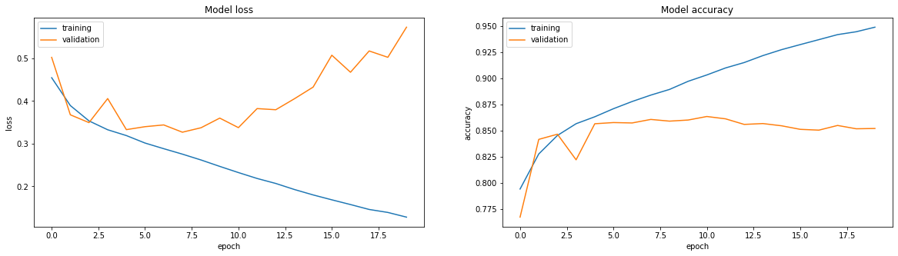

*Graph: Model loss and accuracy for the preprocessing model.*

Thanks to the normalization of the input data, the network was able to learn much quicker. This can be seen by the rapid increase in training accuracy as compared to the model of the previous milestone (baseline model).

However, the validation accuracy reaches a plateau at some point, while the training data increases steadily. This is a sign that the model is overfitting to the training data. The overfitting starts around epoch 3 (as seen by the naked eye).

### Dropout

In order to counteract the overfitting seen in the last model, we have added dropout to the network to increase its robustness.

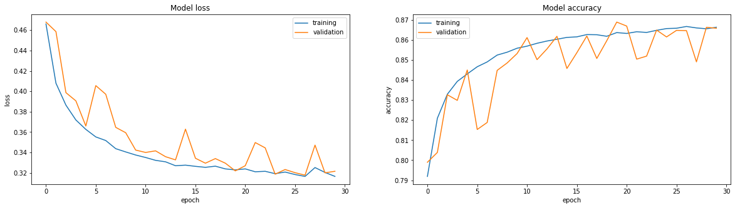

*Graph: Model loss and accuracy for the dropout model.*

In correspondence with our hypothesis, using dropout as a regularization technique brought the validation and training accuracy roughly on the same line and scale again.

### Deeper network

After having solved overfitting in the previous model, we made an attempt to make the network deeper.

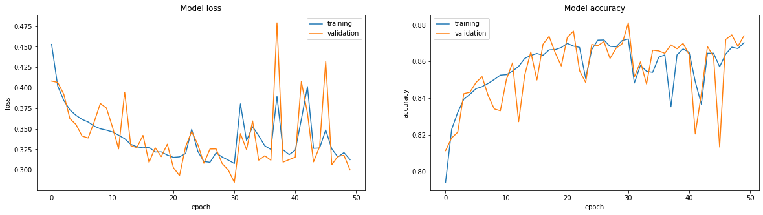

*Graph: Model loss and accuracy for the deeper model.*

As can be seen from the graph above, the validation accuracy starts to fluctuate early on in the training process. Beyond the 20th epoch, even the training accuracy starts fluctuating and decreasing. This problem can have a variety of causes, which is why we started experimenting to see whether one of our hypotheses could solve it.

### Batch normalization

Our first approach to solve the strong fluctuation of training and validation accuracy was to add batch normalization between different layers of the network.

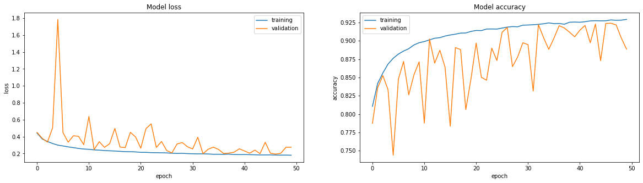

*Graph: Model loss and accuracy for the batch normalization model.*

As can be seen from the graph above, batch normalization appears to stabilize the training accuracy, but the validation accuracy is still fluctuating. In general terms, we believe that the fluctuating validation accuracy could mean that the features that the model learns based on the training data do not always seem to apply as well to the different validation samples. This is a form of overfitting which can be caused by many different issues and thus could potentially be solved in many different ways.

However, one also has to take into account the key difference in which the training accuracy and validation accuracy are computed. That is, while the training accuracy at each epoch is an average of the accuracies for all updates in that epoch (e.g. the average over close to 5000 updates in our case), the validation accuracy is determined solely on the final parameter update of the epoch. Therefore, the validation accuracy plotted in the graphs is much more cross-sectional than the training accuracy. This means that the curve of training accuracy might also contain more fluctuations than can be seen with the naked eye.

### Different splits

The different random splits of the data into training and validation sets did not change the learning of our model. Specifically, we hoped that using a different split might solve the fluctuating validation accuracies that we observed. Since the different splits did not seem to have any significant beneficial effect, we disqualified this as a possible improvement to our model.

### Learning rate 0.0001

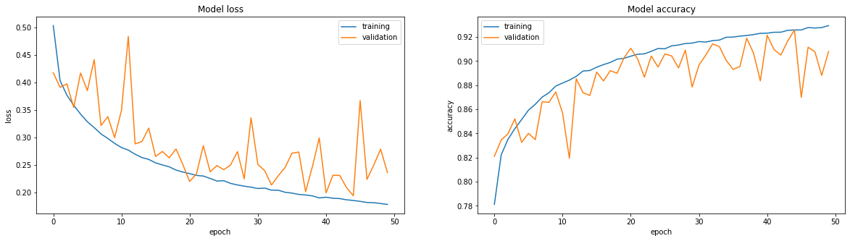

*Graph: Model loss and accuracy for the batch normalization model with learning rate = 0.0001.*

Looking at the graph, it appears that decreasing the learning rate from 0.001 to 0.0001 can help with reducing the fluctuation of the validation accuracy. It is noteworthy that the fluctuation decreases near epoch = 20, and then steadily increases again. A possible explanation may be the algorithm is overfitting from this point on, but other factors may be at play as well. For the next milestone we will try if an even lower learning rate or a combination with more regularization can help in smoothing out the validation accuracy curve.

### Batch size

We tried 2 different batch sizes to assess the effect of mini-batch size on the fluctuations and accuracy.

##### Batch size 10

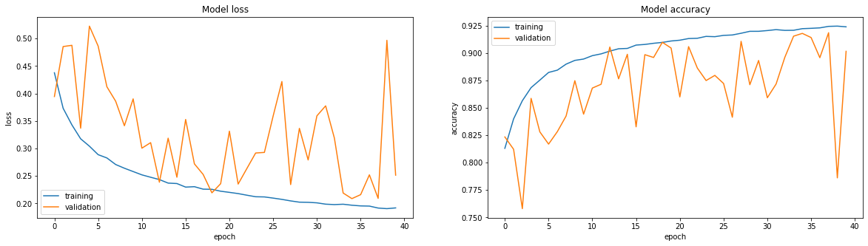

*Graph: Model loss and accuracy for the batch normalization model with batch size 10*

Comparing this to the batch normalised model the scale of the fluctuations in loss has become smaller, while the scale of the fluctuations in accuracy have stayed mostly the same.

##### Batch size 50

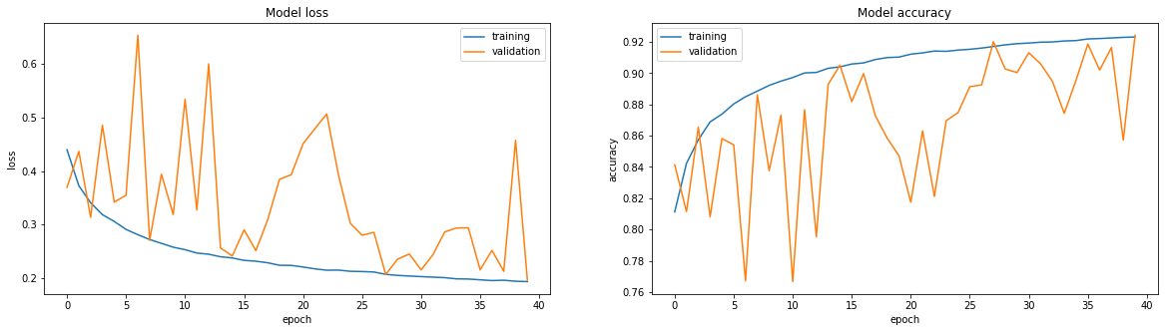

*Graph: Model loss and accuracy for the batch normalization model with batch size 50*

Compared to the 10-batch model, the scale of loss fluctuations has increased. The validation accuracy has increased, but the scale of fluctuation hasn’t changed much.

Sadly, both graphs present a very irregular pattern for validation loss and accuracy. It still hasn’t completely solved the problem of a fluctuating validation. Accuracy has not increased overall either.

### L2 Regularization

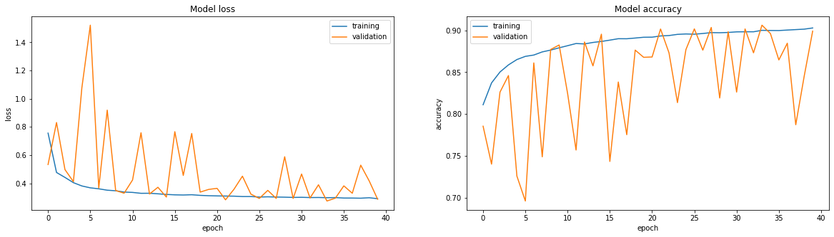

*Graph: Model loss and accuracy for the batch normalization model with L2 normalization*

L2 regularisation did not result in less fluctuations and better accuracy. Perhaps the model is still too complex even after this regularisation. Or the weights could not be the issue. In the future lambda could be tweaked to increase the rate of weight decay.

### Conclusion

As of now, it appears that the most useful hyperparameter to adjust is the learning rate. For the upcoming improvements of our model, we will experiment further with the learning rate and other possible combinations of hyperparameter configurations. Furthermore, we attempt to crop the input images so that only the classification-defining centers of the images will be taken into account. Finally, we will start to apply several different data augmentations to our training data.

# Milestone 3: Improved Model

As a preface to the following chapters, it might help to give a quick overview of the model on which the following experiments are performed. We expanded upon our baseline model by iteratively adding input preprocessing, dropout layers, extra convolutional layers, and batch normalization layers. Thus, the experiments below are performed on this network architecture.

## Chapter 1: ROI

### 1. The analysis of data and construction of features

#### Cropping v.s. Resizing

The images were cropped to 32x32px size, containing the center patch that determines the class of image. This means the amount of cells the model is trained on decreases but the features of these cells will be more distinct, because a single cell is composed of more pixels.

### Section 2: Data Pipeline

The code that loads the data has been altered.

def crop_ROI(image, size):

"""

Crops image to region of interest.

Only allows for 32x32 and 48x48 crop.

"""

assert size == 32 or size == 48

if size==48:

x1, y1 = 23, 23

x2, y2 = 71, 71

else:

x1, y1 = 31, 31

x2, y2 = 63, 63

return image[y1:y2, x1:x2]

This function was created to crop the images to a specified size. We wanted to try different cropping sizes.

def load_data(image_paths, ROI=False, size=32):

"""

Prepares data for training or validation.

Arguments:

File paths of relevant images as list.

ROI enabled or not

size of the final image (only 32x32 or 48x48 possible)

Returns: A tuple containing:

- Four dimensional Numpy array containing all the images (ready for training).

- Targets

"""

target_list = []

image_list = np.zeros((len(image_paths), size, size, 3))

for index, image_path in enumerate(image_paths):

# image id is equal to the filename

id = image_path[6:-4]

# get relevant label

target = id2label[id]

# add target to the list

target_list.append(target)

# crop ROI if requested

if ROI:

image = crop_ROI(cv2.imread(image_path), size)

else:

image = cv2.resize(cv2.imread(image_path), (size, size))

# add image to the list

image_list[index] = image

# convert to one-hot encoding

targets = tf.keras.utils.to_categorical(target_list)

return (image_list, targets)

train_images, train_labels = load_data(train_paths)

val_images, val_labels = load_data(val_paths)

print(f'Training images loaded: {train_images.shape}')

print(f'Training labels loaded: {train_labels.shape}')

print(f'Testing images loaded: {val_images.shape}')

print(f'Testing labels loaded: {val_labels.shape}')

To the original load_data() function, an if statement using a bool parameter was added. This way we can easily switch between cropping and resizing. The size can be set as well.

### Section 3: Model Training

All models were trained using default hyperparameters (LR: 0.001, SGD, no L2)

#### Base-model

Two sizes were tried for the base-model test:

32x32, 20 epochs.

train_and_evaluate(model, train_images, train_labels, val_images, val_labels, l_rate=0.001)

48x48, 20 epochs.

train_and_evaluate(model, train_images, train_labels, val_images, val_labels)

#### Batch-normalised model

Two crop sizes were tried on this model as well:

32x32, 40 epochs.

train_and_evaluate(model, train_images, train_labels, val_images, val_labels, preprocess={'featurewise_center': True, 'featurewise_std_normalization': True}, epochs=40)

48x48, 40 epochs.

train_and_evaluate(model, train_images, train_labels, val_images, val_labels, preprocess={'featurewise_center': True, 'featurewise_std_normalization': True}, epochs=40)

### Section 4: Model Evaluation

When trying out this cropped dataset on the base-model, both training and validation accuracy was lower than previous models. While training loss didn’t differ much, validation loss is higher for the model using cropped data. The scale of the changes in loss and accuracy is also different. The model using cropped data converges at a slower rate. We get the impression that the crop-base-model might just need more epochs to reach the same amount as accuracy.

Because the data contains less cells that have features defined by more pixels, it might be more difficult for the model to learn these features. An image is labeled positive, if at least one of these 32 pixels belongs to a cancer cell. Since many cells are lost due to the cropping, it could be more difficult for the model to learn why certain patches are labeled positive.

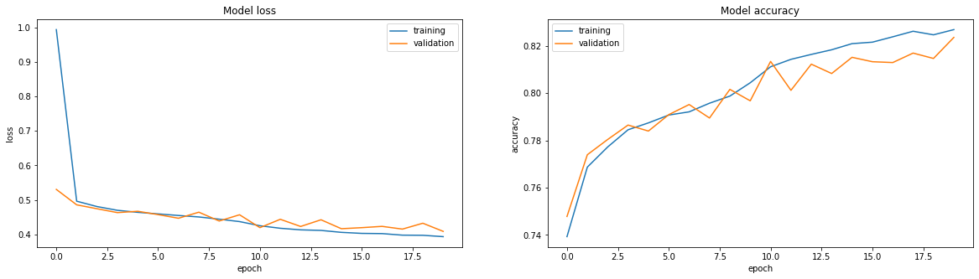

*Graph: Model loss and accuracy for the baseline model with crop size 32x32*px

Overall the training loss and accuracy of the 48x48 model is better than the 32x32 model. The validation accuracy plateaus quicker. This probably has to do with the larger amount of data/information per sample.

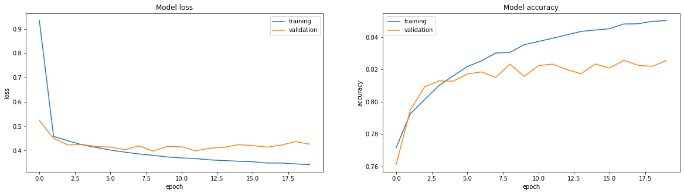

*Graph: Model loss and accuracy for the baseline model with crop size 48x48*px

## Chapter 2: Data augmentation

### Section 1: Data Analysis

The scope of our input data only captures the morphology of individual cells, rather than the configuration of multiple cells into larger recognizable biological structures. As a result, no important information would be lost if the cells were to be flipped, rotated or slightly zoomed. Borrowing terms from Veeling et al. (2018), the whole slide images, or WSI’s, from which our input images are extracted are said to exhibit translational, rotation and reflection symmetry. In theory these augmentations would therefore result in an increase of input data for our model, while retaining biological plausibility.

Therefore, we chose to analyse preliminarily what effects these three data augmentations would have on the learning process of our model. If any of the above data augmentations holds potential, we aim to apply it to our final optimized model in a last attempt to further increase performance.

### Section 2: Data Pipeline

Using the architecture of the model outlined in milestone 2, three individual models were made using the following data augmentations:

1. Horizontal and vertical flip
2. Zoom range (0.2)
3. Rotation range (20 degrees)

### Section 3: Model training

All models were trained using the default hyperparameters (eg. LR: 0.001, SGD, no L2) Models 1, 2, and 3 were trained for 70, 60 and 40 epochs respectively.

### Section 4: Model evaluation



*Graph: Model without data augmentations*

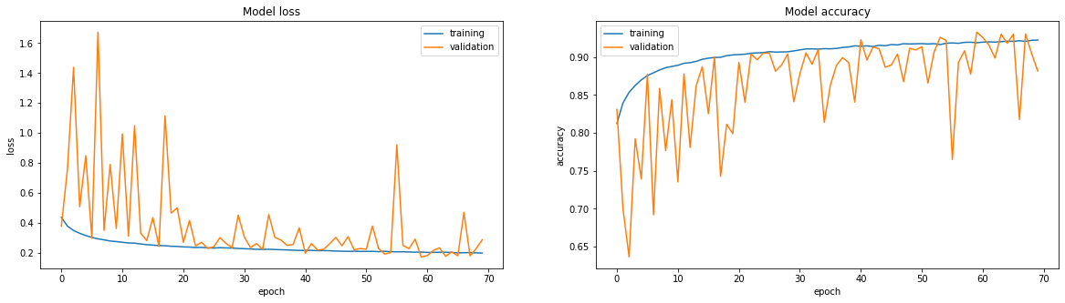*Graph: Horizontal + vertical flip*

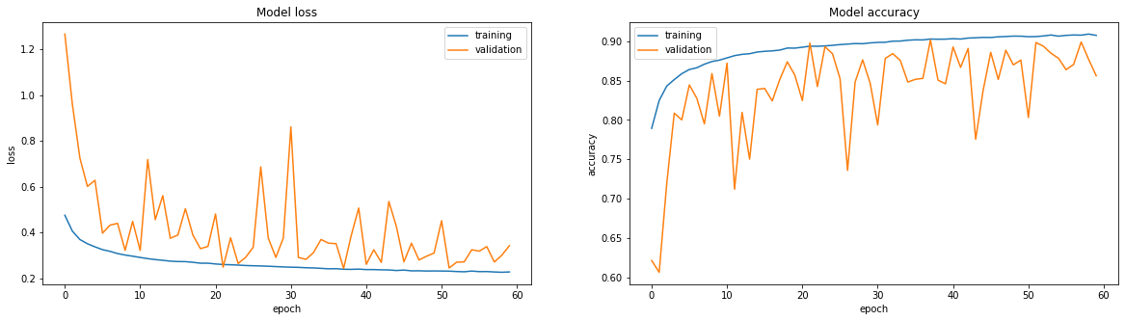*Graph: Zoom range*

As can be seen in the graphs above, the results for the horizontal and vertical flip condition and the zoom range condition do not differ much from the results of the model without any data augmentations. The model without any augmentations even seems to have a more stable loss trajectory than the above-mentioned models. As we still intend to run our best models with an increased number of epochs, the data augmentations could perhaps confer a benefit by allowing our model to continue training for longer, because of the increased training dataset.

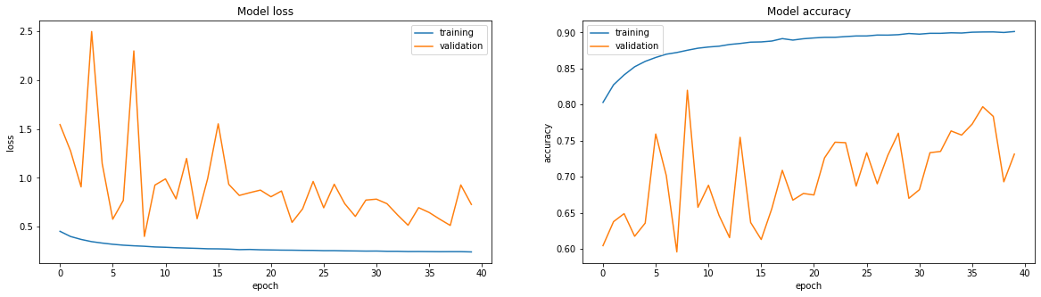

*Graph: Rotation range*

The model containing rotated input images performed significantly worse than the model without augmentations and the other two models with flipped and zoomed images. A likely explanation for this drop in performance is the fact that the images were rotated randomly in a 20 degree range, rather than rotated only a full 90, 180, or 270 degrees. When square input images are rotated for anything other than these three degrees, the resulting image is not square anymore. As a consequence, when the image is used as input for a model expecting a square input image, any parts of the image protruding from the 32x32 square format will be cropped off. Conversely, any of the missing corners are replaced by entirely black or white pixels. (illustration below) Since these pixels do not represent any of the original information of the image, a lot of information is lost. We were not aware of this fact upon running this model. If time allows, we would like to run a model which only performs rotations of 90, 180, or 270 degrees.

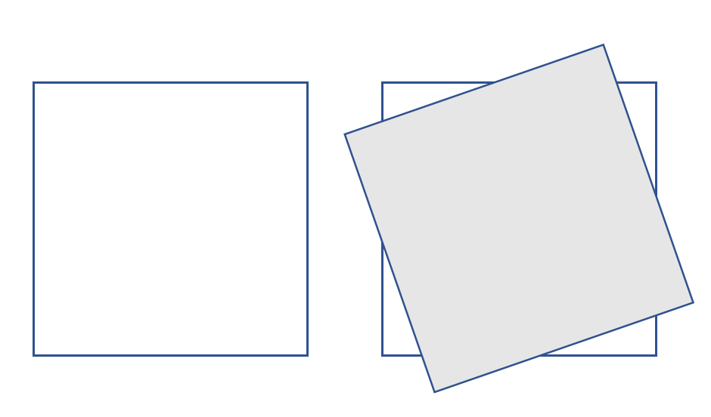  
*Figure: Rotated image overlaid on square input format*

Veeling, B. S., Linmans, J., Winkens, J., Cohen, T., & Welling, M. (2018, September). Rotation equivariant CNNs for digital pathology. In *International Conference on Medical image computing and computer-assisted intervention* (pp. 210-218). Springer, Cham.

## Chapter 3: Deeper Model

### Section 1: Data Analysis

For this chapter, there are no changes in data analysis.

### Section 2: Data Pipeline

The network architecture of this chapter is a deeper version of the batch normalization architecture of the previous chapter. The network has two hidden layers of 256 nodes instead of one. Both the hidden layers were given a dropout of 60 percent.

A deeper version of the previous network was examined because we hoped that the network would be able to break through the accuracy cap around 90 percent.

model = models.Sequential()

model.add(layers.Conv2D(32, (3, 3), activation='relu', padding='same', input_shape=(32, 32, 3)))

model.add(layers.MaxPooling2D((2, 2)))

model.add(layers.BatchNormalization())

model.add(layers.Dropout(0.2))

model.add(layers.Conv2D(64, (3, 3), activation='relu', padding='same'))

model.add(layers.MaxPooling2D((2, 2)))

model.add(layers.BatchNormalization())

model.add(layers.Dropout(0.2))

model.add(layers.Conv2D(128, (3, 3), activation='relu', padding='same'))

model.add(layers.MaxPooling2D((2, 2)))

model.add(layers.BatchNormalization())

model.add(layers.Dropout(0.2))

model.add(layers.Conv2D(256, (3, 3), activation='relu', padding='same'))

model.add(layers.MaxPooling2D((2, 2)))

model.add(layers.BatchNormalization())

model.add(layers.Flatten())

model.add(layers.Dropout(0.6))

model.add(layers.Dense(256, activation='relu'))

model.add(layers.Dropout(0.6))

model.add(layers.Dense(256, activation='relu'))

model.add(layers.Dropout(0.6))

model.add(layers.Dense(2, activation='softmax'))

train_and_evaluate(model, train_images, train_labels, val_images, val_labels,

preprocess={'featurewise_center': True, 'featurewise_std_normalization': True}, epochs=70, l_rate=0.0001)

### Section 3: Model training

The model was initially trained with 40 percent dropout, a learning rate of 0.0001 and 70 epochs (SGD, no L2). Because the validation loss and accuracy were fluctuating a lot, we increased the dropout rate to 60 percent to see whether this had an effect.

### Section 4: Model evaluation

#### Dropout rate of 40 percent

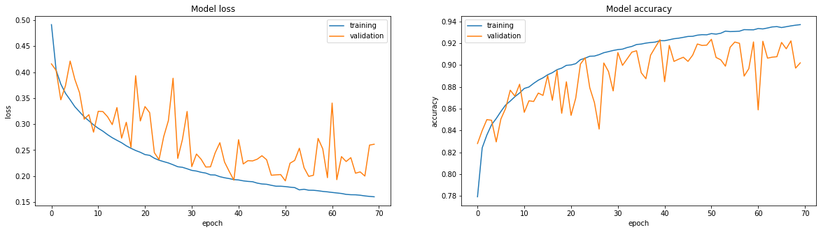

Graph: *Graph: Loss and accuracy for the even deeper model with dropout = 0.4*

Judging from the above graphs, a deeper network with a dropout rate of 40 percent does not perform better than the model of the previous milestone. However, we also ran the same model with a dropout rate of 60 percent to compensate for the increase in network nodes. This produced the graph below.

#### Dropout rate of 60 percent

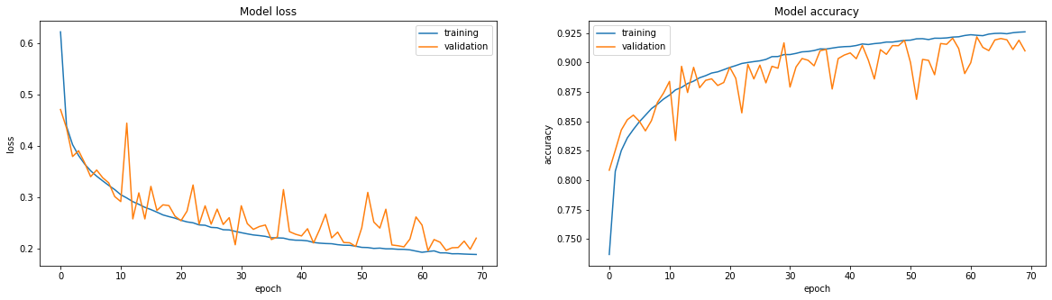

Graph: *Graph: Loss and accuracy for the even deeper model with dropout = 0.6*

Although the performance of the model has not increased, the validation loss and accuracy appear to be fluctuating less in this graph as compared to the model with a dropout of 40 percent. Moreover, it also appears to be more stable than the model of the previous milestone. Because of these results, this model became one of the two contestants for our final model.

## Chapter 4: Final Model Comparison

### Section 1: Data Analysis

For this chapter, there are no changes in data analysis.

### Section 2: Data Pipeline

The data pipelines of the following models were compared:

* Batch normalization with a lower learning rate (0.0001) and dropout rate of 40 percent.
* Batch normalization model with a lower learning rate (0.0001), an extra hidden layer and a dropout rate of 60 percent.

### Section 3: Model training

Of all the models we have developed during the course of this project, we have selected two models that had both the highest and most stable validation accuracy.

In order to select which of these two models is most suited for real life application, we needed metrics additional to accuracy to determine which one may be superior. Therefore, we trained the models again with more epochs (100), included recall into the evaluation graph and printed a confusion matrix for each model.

### Section 4: Model evaluation

#### Batch normalization model

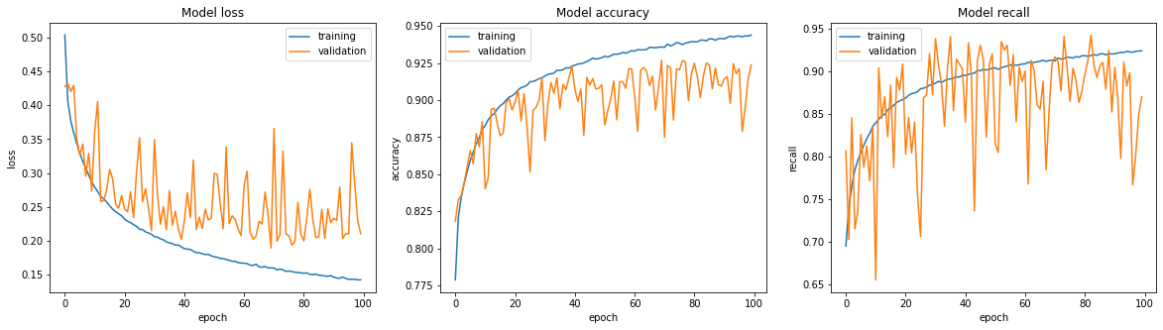

*Graph: Batch normalization network with more epochs*

A greater number of epochs did not significantly increase the validation accuracy of this model. A possible solution to the fluctuation of the validation loss and accuracy could be to use Adelta as an optimizer, because this lowers the learning rate every epoch.

#### Deeper batch normalization model

This model is still running. We will elaborate on this for the next deadline.