**Computer vision – HW10**

Question 1 2

A、 Source code 2

B、 Result map 3

Appendix(utils.py) 4

|  |  |
| --- | --- |
| Name: | WeiWen Wu |
| Student ID: | 10901007A |

# Question 1

## Source code

|  |
| --- |
| **from** utils **import** Classifier  ### Define x value and y value. ###  ## Example  X_EX**:list** **=** **[**0**,**1**,**2**,**3**,**4**,**5**,**6**,**7**,**8**,**9**]**  Y_EX**:list** **=** **[**1**,**1**,**1**,-**1**,-**1**,-**1**,**1**,**1**,**1**,-**1**]**  ## Homework  X_HW**:list** **=** **[**1**,** 3**,** 9**,**11**]**  Y_HW**:list** **=** **[**1**,-**1**,** 1**,-**1**]**  ### Homework ###  ## Design a strong Adaboost classifier for the following training set.  classifier_hw **=** Classifier**(**X_HW**,**Y_HW**)** # Create Classifier object.  **for** n**,**datas **in** **enumerate(**classifier_hw**,**1**):** # Start iterating.  AVG**,**E**,**A**,**W **=** datas # Get the data value.  **print(**f"Iterate {n}"**)** # Show number of iterations.  **print(**f"AVG={AVG}, E={E}, A={A}\nW={W}\n"**)** # Show iteration results  ### Adaboosting Example ###  # classifier_ex = Classifier(X_EX,Y_EX)  # for n,datas in enumerate(classifier_ex,1) :  # AVG,E,A,W = datas  # print(f"Iterate {n}")  # print(f"AVG={AVG}, E={E}, A={A}\nW={W}\n") |

## Result map

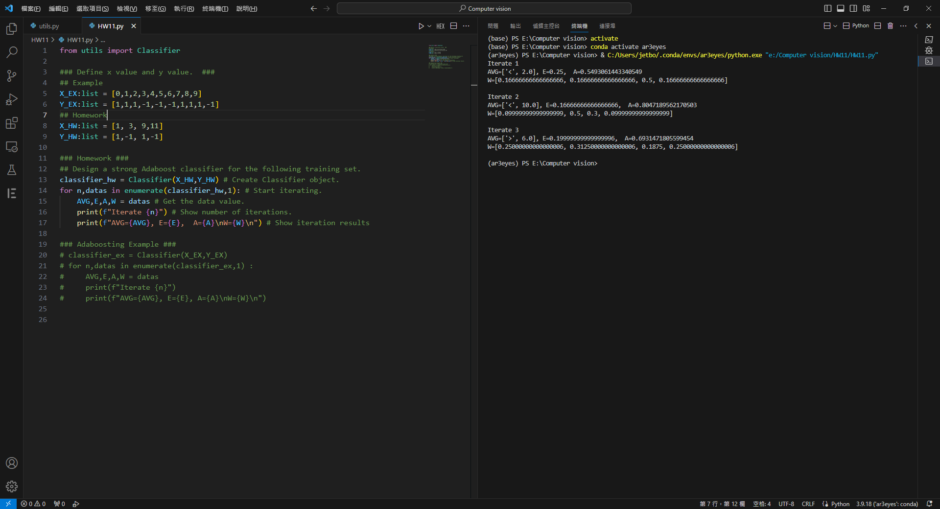

# Appendix(utils.py)

|  |
| --- |
| # utils.py WeiWen Wu  **from** typing **import** Union**,**Optional  **from** numpy **import** log**,**exp**,**sign**,**float64  **class** **Classifier:**  """  Adaboost (Adaptive Boosting algorithm)  # Example (for loop)  ```  classifier = Classifier(X,Y)  for n,datas in enumerate(classifier,1):  AVG,E,A,W = datas  print(f"Iterate {n}")  print(f"AVG={AVG}, E={E}, A={A}, W={W}")  ```  # Example (while loop)  ```  ### Parameter default value. ###  classifier = Classifier(X_EX,Y_EX)  verify = False  ### Start iterating. ###  while verify == False:  AVG,E = classifier.error()  A = classifier.alpha(E)  W = classifier.update_weight(alpha=A,avg=AVG)  verify = classifier.verify()  print(f"AVG={AVG}, E={E}, A={A}, W={W}")  ```  """  _verify**:bool** **=** **False**  ### Record ###  weight_record**:list** **=** **[]**  alpha_record**:list** **=** **[]**  avg_record**:list** **=** **[]**  error_record**:list** **=** **[]**  **def** __init__**(**self**,**x**:list,**y**:list)** **->** **None:**  _x_len **=** **len(**x**)**  **assert** _x_len **==** **len(**y**)**  self**.**X **=** x  self**.**Y **=** y  self**.**data_count **=** _x_len  self**.**update_weight**()**  **def** error**(**self**,**p**:**Optional**[list]** **=** **None)** **->** **tuple[list[**Union**[str,int]],float]:**  """Train a weak classifier h(x) weighted training data minimizing the error."""  x**,**y **=** self**.**X**,**self**.**Y  value**:list** **=** **[]**  ave**:list[float]** **=** **[]** # average  data_count**:int** **=** self**.**data_count  p **=** self**.**weight_record**[-**1**]** **if** p **==** **None** **else** p  **for** i **in** **range(**1**,**data_count**):**  ave**.**append**([**'<'**,(**x**[**i**]+**x**[**i**-**1**])/**2**])**  ave**.**append**([**'>'**,(**x**[**i**]+**x**[**i**-**1**])/**2**])**  _error**:int** **=** 0  **for** j **in** **range(**data_count**):**  **if** **(lambda** a **:** **-**1 **if** a **==** 0 **else** 1**)(**x**[**j**]** **<** ave**[-**1**][**1**])** **!=** y**[**j**]:**_error**+=**p**[**j**]**  _error_scale **=** _error  value**.**append**(**_error_scale**)**  value**.**append**(**1**-**_error_scale**)**  index **=** value**.**index**(min(**value**))**  # print(value)  # print(ave)  self**.**avg_record**.**append**(**ave**[**index**])**  self**.**error_record**.**append**(min(**value**))**    **return** ave**[**index**],** **min(**value**)**  **def** alpha**(**self**,**e**:**Optional**[float]=None)** **->** **float:**  """Compute voting weight of h(x)."""  e **=** self**.**error_record**[-**1**]** **if** e **==** **None** **else** e  **assert** e**!=**0**,** "<e> must not be 0"  _result **=** **float(**0.5**\***log**((**1**-**e**)/**e**))**  self**.**alpha_record**.**append**(**_result**)**  **return** _result # a=0.5*log((1-e)/e)  **def** update_weight**(**self**,**_w**:**Optional**[list]=None,**alpha**:**Optional**[float]=None,**avg**:**Optional**[float]=None)** **->** **list:**  """Recompute weights (Weighting update)."""  x**,**y **=** self**.**X**,**self**.**Y  data_count **=** self**.**data_count  weight_record **=** self**.**weight_record  **if** **len(**weight_record**)==**0**:** # Initialize weights.  _result **=** **[**1**/**data_count **for** _ **in** **range(**data_count**)]**  **else:**  _w **=** weight_record**[-**1**]** **if** _w **==** **None** **else** _w  alpha **=** self**.**alpha_record**[-**1**]** **if** alpha **==** **None** **else** alpha  avg **=** self**.**avg_record**[-**1**]** **if** avg **==** **None** **else** avg  I **=** self**.**I  _temp**:list** **=** **[]**  **for** n **in** **range(**data_count**):**  # print(f"{sign(X,avg)[n]}, {Y[n]}")  _exp**:**float64 **=** exp**(-**alpha**\***y**[**n**]\***I**(**x**,**avg**[**1**],**avg**[**0**])[**n**])**  _temp**.**append**(**_w**[**n**]\***_exp**)**  zt**:int** **=** **sum(**_temp**)**  _result **=** **[**_**/**zt **for** _ **in** _temp**]** # Normalization.  self**.**weight_record**.**append**(**_result**)**  **return** _result # 𝑤(𝑖)=𝑤𝑡(𝑖)*exp⁡{−𝛼𝑡*𝑦𝑖*ℎ𝑡(𝑥𝑖)}/𝑍𝑡  **def** I**(**self**,**_value**:list,**threshold**:float,**symbol**:str=**'<'**):**  _result**:list** **=** **[]**  **for** value **in** _value**:**  _ **=** 1 **if** value **<** threshold **else** **-**1  _result**.**append**(**_**)**  **if** symbol **==** '<'**:return** _result  **elif** symbol **==** '>'**:return** **[-**_ **for** _ **in** _result**]**  **else:** **raise** **ValueError(**"<symbol> must be '<' or '>'"**)**  **def** sign_of_h**(**self**,**alpha_lists**:**Optional**[list]=None,**avg_lists**:**Optional**[list]=None):**  """sign(H(x))"""  x **=** self**.**X  alpha_lists **=** self**.**alpha_record **if** alpha_lists **==** **None** **else** alpha_lists  avg_lists **=** self**.**avg_record **if** avg_lists **==** **None** **else** avg_lists  _result**:list** **=** **[]**  **assert** **len(**alpha_lists**)==len(**avg_lists**)**  **for** n **in** **range(**self**.**data_count**):**  _total **=** 0  **for** count **in** **range(len(**alpha_lists**)):**  a**=**self**.**I**(**x**,**avg_lists**[**count**][**1**],**avg_lists**[**count**][**0**])**  _total **+=** alpha_lists**[**count**]\***a**[**n**]**  _result**.**append**(**sign**(**_total**))**  **return** _result  **def** verify**(**self**,**alpha_lists**:**Optional**[list]=None,**avg_lists**:**Optional**[list]=None)** **->** **bool:**  """Verify the answer is correct."""  y **=** self**.**Y  **for** n**,**value **in** **enumerate(**self**.**sign_of_h**(**alpha_lists**,**avg_lists**)):**  **if** **float(**value**)** **!=** y**[**n**]:return** **False** # If verification error, exit the for loop.  **return** **True**  **def** __next__**(**self**)** **->** **tuple[list[str,int],** **float,** **float,** **list]:**  AVG**,**E **=** self**.**error**()** # Train a weak classifier weighted training data minimizing the error.  A **=** self**.**alpha**()** # Compute voting weight.  W **=** self**.**update_weight**()** # Recompute weights.  **if** self**.**_verify**==True:** # If the verification is correct, the iteration will end.  **raise** **StopIteration(**"The answer has been verified correct"**)** # Verified correct.  self**.**_verify **=** self**.**verify**()** # Verify the answer is correct.  **return** AVG**,**E**,**A**,**W    **def** __iter__**(**self**):** **return** self |