**Computer vision – HW7**

# Source code

|  |
| --- |
| # WeiWen Wu 2023-10-25 14:00:33  **import** cv2 **as** cv  **from** matplotlib **import** pyplot **as** plt  img **=** cv**.**imread**(**'lena_noise2.jpg'**)** # Read image.  img **=** cv**.**cvtColor**(**img**,** cv**.**COLOR_BGR2GRAY**)** # BGR to gray.  n**:int=**1  **def** plot**(**name**:str,**dst**,**cmap**:str=**'gray'**,**save**:bool=**1**):** # Make pictures.  **global** n # Global variables.  plt**.**subplot**(**2**,**2**,**n**),** plt**.**imshow**(**dst**,**cmap**),** plt**.**title**(**name**)**  plt**.**xticks**([]),** plt**.**yticks**([])** # Do not show scale.  **if** save**:** cv**.**imwrite**(**f"./HW7/{name}.png"**,**dst**,[int(**cv**.**IMWRITE_PNG_COMPRESSION**),**0**])**  n**+=**1  ### Otsu's thresholding ###  _**,**OTSU **=** cv**.**threshold**(**img**,**0**,**255**,**cv**.**THRESH_BINARY**+**cv**.**THRESH_OTSU**)**  plot**(**"Otsu's thresholding"**,**OTSU**)**  ### Otsu's thresholding (Gaussian) ### Otsu's thresholding after Gaussian filtering  blur **=** cv**.**GaussianBlur**(**img**,(**5**,**5**),**0**)**  _**,**OTSUG **=** cv**.**threshold**(**blur**,**0**,**255**,**cv**.**THRESH_BINARY**+**cv**.**THRESH_OTSU**)**  plot**(**"Otsu's thresholding (Gaussian)"**,**OTSUG**)**  ### ADAPTIVE_THRESH_MEAN_C ###  ATMC **=** cv**.**adaptiveThreshold**(**blur**,**255**,**cv**.**ADAPTIVE_THRESH_MEAN_C**,**cv**.**THRESH_BINARY**,**11**,**2**)**  plot**(**"ADAPTIVE_THRESH_MEAN_C"**,**ATMC**)**  ### ADAPTIVE_THRESH_GAUSSIAN_C ###  ATGC **=** cv**.**adaptiveThreshold**(**blur**,**255**,**cv**.**ADAPTIVE_THRESH_GAUSSIAN_C**,**cv**.**THRESH_BINARY**,**11**,**2**)**  plot**(**"ADAPTIVE_THRESH_GAUSSIAN_C"**,**ATGC**)**  ### Show matplotlib. ###  plt**.**show**()** |

# Result map

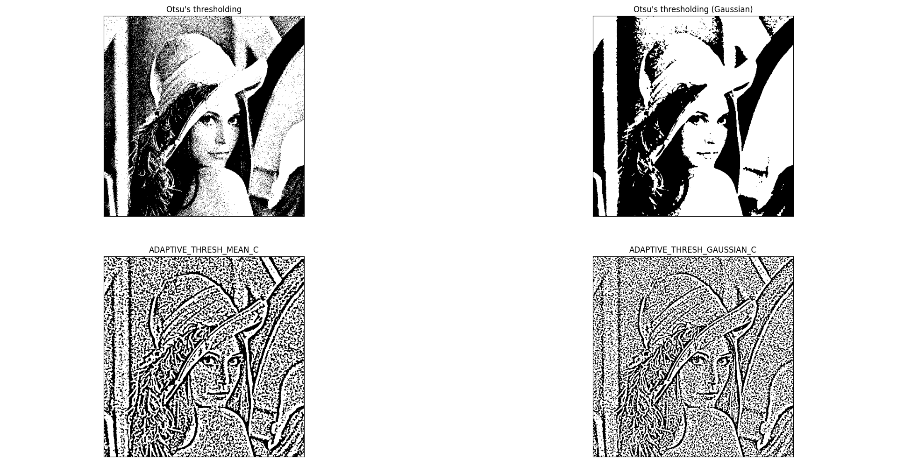

# Appendix (original picture)

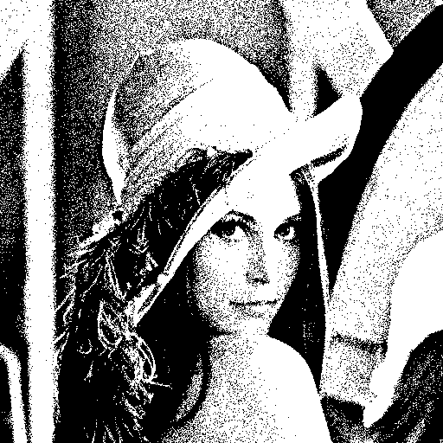

Figure 1 Otsu's thresholding

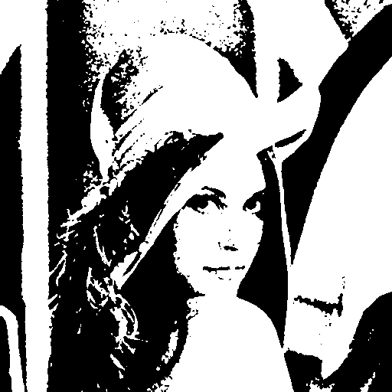

Figure 2 Otsu's thresholding (Gaussian)

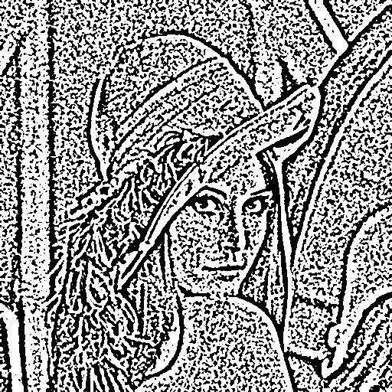

Figure 3 ADAPTIVE_THRESH_MEAN_C

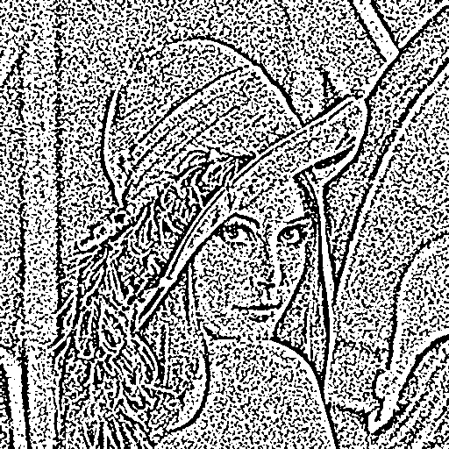

Figure 4 ADAPTIVE_THRESH_GAUSSIAN_C