**Computer vision – HW9**

# Source code

|  |
| --- |
| # WeiWen Wu 2023-11-15 15:07:04  **import** numpy **as** np  **import** cv2  object_cascade **=** cv2**.**CascadeClassifier**(**'./HW10/cascade.xml'**)** # cascade.xml was  cap **=** cv2**.**VideoCapture**(**0**)**  **while** **True:**  ret**,** img **=** cap**.**read**()**  gray **=** cv2**.**cvtColor**(**img**,** cv2**.**COLOR_BGR2GRAY**)**  gray **=** cv2**.**equalizeHist**(**gray**)**  **object** **=** object_cascade**.**detectMultiScale**(**gray**,** 1.07**,** 5**)**  # object = object_cascade.detectMultiScale(gray, 1.3, 5)  **for** **(**x**,** y**,** w**,** h**)** **in** **object:**  cv2**.**rectangle**(**img**,** **(**x**,** y**),** **(**x**+**w**,** y**+**h**),** **(**255**,** 0**,** 0**),** 2**)**  roi_gray **=** gray**[**y**:**y**+**h**,** x**:**x**+**w**]**  roi_color **=** img**[**y**:**y**+**h**,** x**:**x**+**w**]**  font **=** cv2**.**FONT_HERSHEY_SIMPLEX  object_name **=** 'WeiWen Wu'  cv2**.**putText**(**img**,** object_name **,** **(**x**,** y**),** font**,** .5**,** **(**0**,** 255**,** 255**),** 2**)**  cv2**.**imshow**(**'img'**,** img**)**  k **=** cv2**.**waitKey**(**30**)** **&** 0xff  **if** k **==** 27**:**  **break**  cap**.**release**()**  cv2**.**destroyAllWindows**()** |

# Result map

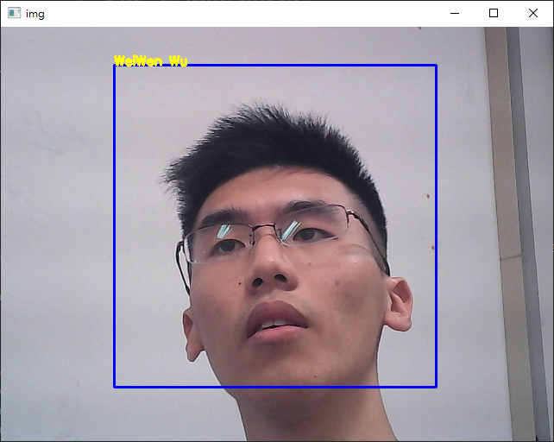

# Appendix (take_photo.py)

|  |
| --- |
| **import** cv2  **def** cap_num**(max:int=**5**)** **->** **list[int]:**  """  Get camera number.  # Example  ```  N = cap_num()  print(N)  cap = cv2.VideoCapture(N[0])  print(cap.isOpened())  ```  """  _ **=** **[]**  **for** n **in** **range(max):**  cap **=** cv2**.**VideoCapture**(**0**,**n**)**  ret**,** frame **=** cap**.**read**()**  **if** ret**:** _**.**append**(**n**)**  **return** _    N **=** cap_num**()**  cap **=** cv2**.**VideoCapture**(**N**[**0**])**  i **=** 0  **while** cap**.**isOpened**():** # https://www.codegrepper.com/code-examples/python/cv2+cap.isOpened  ret**,** frame **=** cap**.**read**()** # returned value of ret is either True (successful) or False (failed). frame: captured image frames  **if** ret**:**  cv2**.**imshow**(**'frame'**,** frame**)** # display captured video in gray level.  key **=** cv2**.**waitKey**(**1**)**  **if** key **==** **ord(**'q'**)** **or** key **==** 27**:**  **break**  **elif** key**==ord(**'s'**):** # Save photo.  gray **=** cv2**.**cvtColor**(**frame**,** cv2**.**COLOR_BGR2GRAY**)**  gray **=** cv2**.**equalizeHist**(**gray**)**  cv2**.**imwrite**(**f'./picture/{i}.jpg'**,**gray**)**  i**+=**1  **else:**  **break**  cap**.**release**()**  cv2**.**destroyAllWindows**()** |