Changeworker Project Owner Onboarding Deck
Simple walkthrough of platform operations and owner checkpoints
Prepared: June 29, 2026

1) Public Entry and Account Start
• Visitors land on homepage and choose Hire Talent or Find Work.
• Sign up/login flows route users into onboarding.
• Onboarding defines role behavior for dashboard and feature access.
• Public pages provide trust, policy, and support context before conversion.

Screenshot: Screenshot 2026-06-29 122121.png

2) Talent Operating Flow
• Talent discovers gigs, submits proposal, tracks status updates.
• Messages and workspace become active after acceptance.
• Talent submits milestones/final work and requests payout.
• Wallet records earnings and withdrawal history.

Screenshot: Screenshot 2026-06-29 121632.png

3) Client Operating Flow
• Client posts gig with budget, hires needed, and requirements.
• Client reviews proposals, shortlists/accepts best match.
• Workspace funding and approval actions control payout release.
• Client wallet supports top-up and project funding continuity.

Screenshot: Screenshot 2026-06-29 120844.png

4) Control/Admin Operations
• Control dashboard centralizes counts, queues, and wellness checks.
• Admin reviews users, gigs, workspaces, wallets, transactions, support.
• Dispute module enables evidence-based resolution actions.
• Admin alerts focus on critical money and trust events.
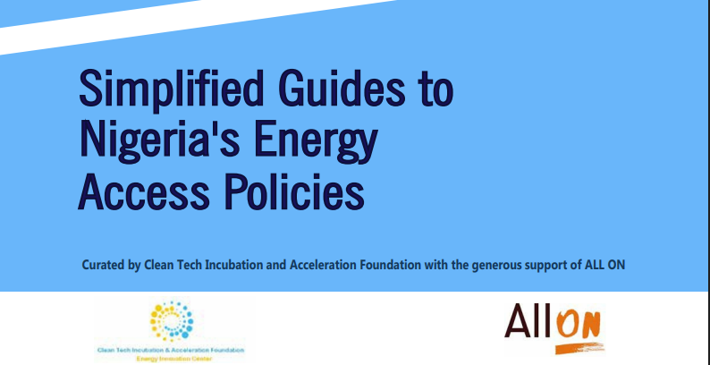
Screenshot: Screenshot 2026-06-29 120642.png

5) Dispute and Settlement Logic
• Dispute starts from workspace when delivery/payment conflict occurs.
• Admin reviews evidence, messages, payment records, and milestones.
• Resolution outcomes: release talent, refund client, split settlement, close case.
• Wallets, ledgers, statuses, and notifications update after decision.

Screenshot: Screenshot 2026-06-29 120326.png

6) Owner Go-Live Checklist
• Validate onboarding for both talent and client accounts.
• Run full gig-to-workspace-to-payout test using QA checklist.
• Confirm control access and dispute resolution end-to-end.
• Track first-week support and queue health daily.
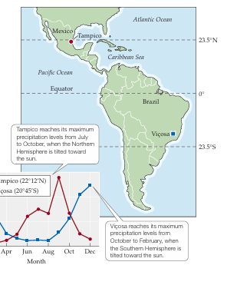
Screenshot: Screenshot 2026-06-24 223614.png

Delivery Pack Included
• Platform workflow report
• Role-based training SOP (Talent, Client, Control)
• Clickable QA checklist by route
• Onboarding deck document with screenshots

