Development of a Combined Ultrasound and Photoacoustic Endoscope for Gynecologic Cancer Imaging Applications

Abstract:

Developing a method that can and cost-effectively image early-stage gynecological cancer is needed to provide treatment to this deadly, mostly asymptomatic illness. Methods used today to measure this cancer are usually expensive or inaccurate causing physicians to miss signs of this cancer and patients don’t feel symptoms of this cancer until it has progressed to the point of necessary invasive care. This project looks at us ultrasound in conjunction with photoacoustic imaging modalities accurately in order to develop a device that can properly and cheaply image this type of cancer in its early stage, prior to necessary invasive treatment.

Introduction:

Gynecological cancers such as uterine cancer, ovarian cancer, and cervical malignancies impact around 18 percent of women during their lifetime around the world. Due to the symptoms of this type of cancer being similar to normal symptoms of aging, menopause, or previous pregnancies gynecological cancer can go unnoticed until late stages. This causes normal treatment to be extremely invasive with unfortunate side effects including pain, menopausal symptoms, sexual difficulties, infertility, and physical function. Creating an effect method of imaging gynecological cancer prior problematic symptoms will improve such side effects for patients and improve their quality of life. Also, with such a high mortality rate for these cancers it’s imperative that a sufficient, non-invasive test be procured as catching these cancers early enough lowers the mortality rate extremely.

Tools currently used by physicians in imaging gynecological cancer is ultrasound (US), magnetic resonance imaging (MRI), computed tomography (CT), and optical imaging. Each of these imaging modalities has its limitations that make them unusual or ineffective. These limitations include high cost (MRI), inefficiency in imaging (limited sensitivity and specificity – ultrasound imaging), harmful ionizing radiation (CT), and low depth penetration (Optical imaging). The negatives to each of these imaging modalities has caused physicians to regularly miss cancer in the area, leading to more complicated surgeries and side effects.

Due to the severity of the symptoms and mortality rate of these cancers and the lack of a mechanism to properly image such cancers, the goal of this research project is to develop an endoscope that uses the photoacoustic affect in conjunction with ultrasound imaging to create a low cost, safe, and high-resolution way to detect early-stage gynecological cancer in women. Using these imaging modalities in conjunction will provide a functional and molecular image. The ultrasound image shows the structural details of the tissue as a means to show where the image is taking place and the photoacoustic image shows functional information of the tissue with thermal expansion of active tissue that will show up in the image. Both of these imaging modalities used together will be cheap enough to be afforded by the average gynecologist and will provide an image with enough information to determine that the tissue is cancerous.

Materials and Methods:

Proposed, is a method to create a phased-array endoscope with additional light delivery by using ultrasound and photoacoustic imaging modalities in conjunction. An intra-cardiac echocardiography ultrasound catheter was used as the probe and operated at a frequency range of 5-8 MHz which allowed for high-resolution images in 90-degrees sector. The probe itself had a diameter of 2.54 mm with an active aperture size of 9 mm. Needing a light delivery system for accurate imaging the endoscope included six optical fibers with a silica core/cladding of 600 µm in diameter. The device was integrated with an ultrasound catheter as a means of collecting optical information from the tissue being imaged. In order to provide light to the space in front of the endoscope a side-firing approach was implemented. To accurately proceed with this side-firing approach the optical fibers needed to be polished at specific angles to meet a criterion of internal reflection. These angles were determined by the equation: *θcritical = arcsin (nmed/ncore)* where *nmed* and *ncore* refractive indices of media inside and outside the fiber respectively. Using the equations *θrefl1 = 2 × β- (90 - arcsin(ncl/ncore))* and *θrefl2* = 90 + *β* - *θcritical* (Figure 1b) with the critical angles, the reflection angles from out of the fiber from the side can be calculated for the light beam. This is all with *β* being the angle at which the optical fiber is polished to and *ncl*  being the refractive index of the fiber cladding. *θrefl1* and *θrefl2* are the high and the low angles in which the light beam is reflected between. So, based on the assumption that the fibers will be surrounded entirely by air, using the equations above implies that with the fibers be polished to an angle of 33 degrees providing a light beam range of 50.5-79.67 degrees to the horizontal axis. 33 degrees was chosen as the polishing angle based on simulation studies to optimize the largest illumination possible.

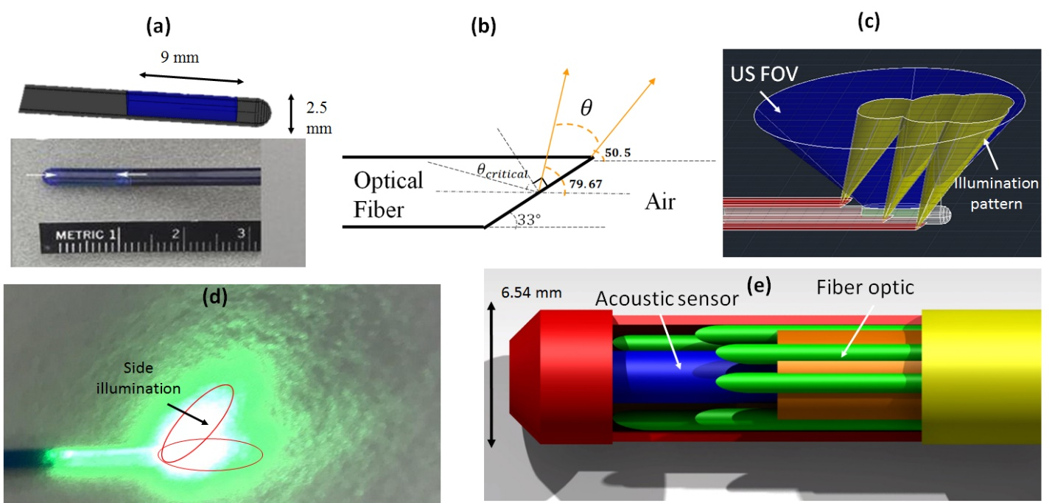

**Fig. 1:** (a) ICE US probe (core of the endoscope). (b) Schematic of a side-firing fiber indicating the illumination pattern. (c) Simulated US field of view (FOV) and overlapping illumination pattern. (d) Photograph of a side firing fiber polished at 33 degrees. (e) Schematic of the final proposed endoscope including biocompatible sheath.

The imaging device included the follow components in order for accurate complete imaging: a sizable, self-cooling, high power, rotatable, and pulsing light source, a fully digital programmable ultrasound scanner that will allow for data acquisition from the ultrasound and photoacoustic images, with processing power and image reconstruction ability (Vintage128, Versonics, WA), and a custom-created FPGA timing and synchronization controller (Figure 2).

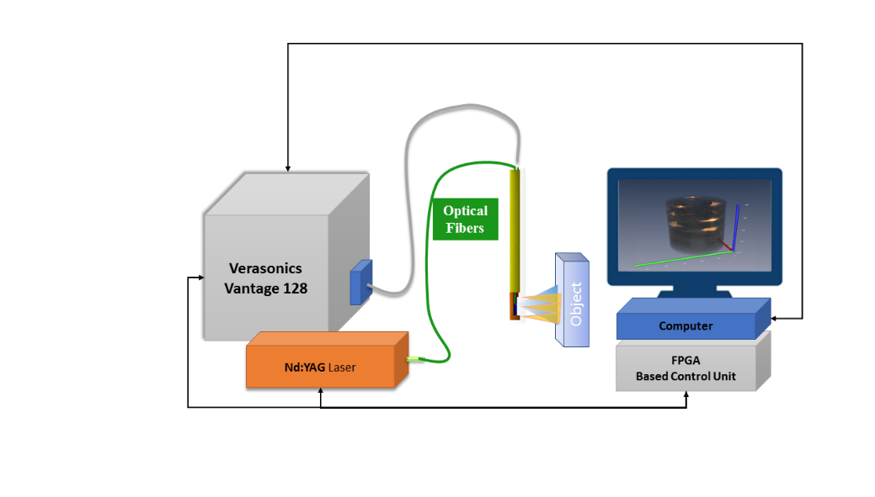

**Fig. 2:** Diagram of imaging system

Results and Discussion:

The first step in using the research that has been done and actually putting the endoscope together was polishing the optical fibers all to 33 degrees. Several techniques were used to do this including polishing by hand using sandpaper with different grit sizes ranging from .6 to 200 µm. Also, a small polishing machine was purchased (Siemon Company Automated Fiber Polisher Polishing Machine FPOL) for the same task. The automated machine was able to hold the fiber whilst moving a 3 inch diameter pad underneath the fiber. The FPOL machine came with .6 µm sandpaper pad of its own that were able to finely polish the optical fibers. FPOL moved at intervals of 15 seconds and needed to be manually switched after every interval.

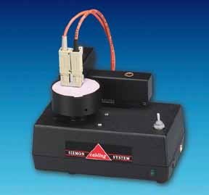

**Fig. 3:** Picture of Siemons FPOL Polishing Machine

Both of the two polishing systems had different pros and cons to their use. Polishing the fibers by hand allow to quickly get the fiber into its specific form but didn’t work very well at finishing the fiber. Trying this technique for the entire fiber caused low energy levels when the laser was shot through the optical, giving the belief that the optical fiber was polished incorrectly or broken. Polishing using the FPOL machine worked well for finishing the optical fiber and getting a nice, clean shine to it but it was difficult to break it down from a flat head at first to a angled head. This led us to believe that polishing by hand at first then finishing off the optical fiber with the FPOL machine was the right way to go.

Once the fibers were polished allowing for implementation of a side-firing light, the endoscope with a transducer was ready to be put together. A custom-build ultrasound holding sheath was built for the endoscope to hold the fibers as well as the ultrasound transducer (Figure 4). The six optical fibers were placed all around the ultrasound transducer with the flat polished faces of the optical fibers pointing in the same direction to provide the best light area for the ultrasound probe to measure. A cap was placed on top of the endoscope to keep the endoscope and the optical fibers from breaking. The entire endoscope had a 7.5 mm diameter from the outside of the top of the sheath to the outside of the bottom of the sheath, containing optical fibers that were 1 m long.

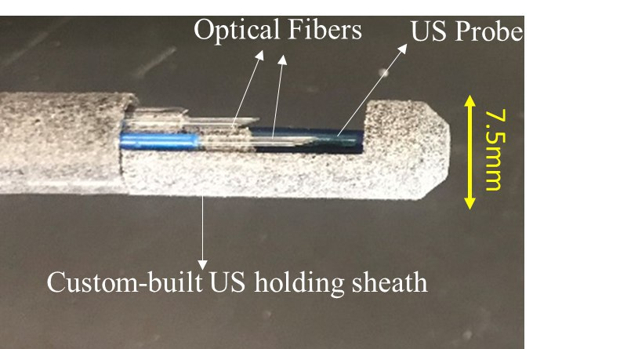

**Fig. 4:** Full endoscope with 6 optical fibers, ultrasound probe, and holding sheath

Testing on the fibers individually was done and testing on the endoscope as a whole was completed. The goal was to find an energy of about 2 mJ from each fiber and an energy of about 7 mJ from the entire endoscope itself. A energy laser meter was used to measure the energy from a laser that used different wavelengths from 680 to 900 kHz. The meter was connected to a laptop that used a program to determine the average energy every 15 seconds. This data was used to test the effectivity of the optical fibers. The experimental setup had the fiber being held by a clamp right in front of the meter, shining the laser onto the meter. The fiber was also connected to the laser (Figure 5).

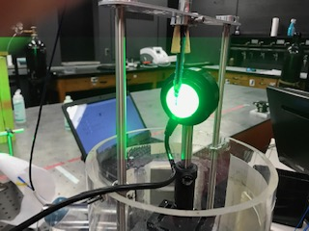

**Fig. 5:** Endoscope energy experiment setup

Once it was known that all the optical fibers individually and the entire endoscope itself provided enough energy to create an accurate image, experimentation on imaging a phantom was completed. The phantom was a 200 µm nylon filament in gelatin phantom and was imaged using ultrasound imaging (Figure 6.a), photoacoustic imaging (Figure 6.b), and both ultrasound and photoacoustic imaging (Figure 6.c). The photoacoustic imaging will only generate specific data when there is an absorbing substance where ultrasound imaging creates a background of the structure of interest. Together both of these create a superior image of interest outlining in figure in question including its activity and heat absorption. This imaging proves the use and effectiveness of using this endoscope as a means for imaging cancer in the cervical canal.

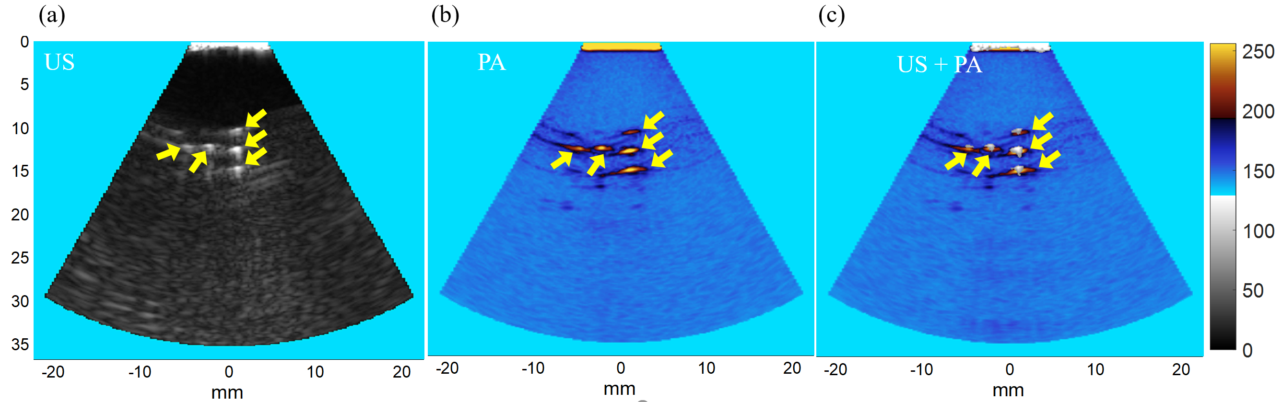

**Fig. 6:** Ultrasound and photoacoustic phantom experiment a) US b) PA c) US + PA

Future Work:

Ultimately, there was trouble when polishing the fibers. A unexpected amount of time was spent figuring out the best way to polish the optical fibers to get them to the correct fineness to get them to get the correct energy. This was a major setback in project causing experimentation to be delayed and some experiments that were supposed to be ran were not completed. Due to this, prior to March more work will be done on this project to be one-hundred percent sure that the endoscope is function and will work in any condition on a human.

Conclusion:

The endocervical endoscope developed in this study was a noninvasive, low cost, efficient, nonionizing imaging device with the purpose to create precise images of cervical cancer in the body. The 7.5 mm diameter probe uses a commercially available ultrasound probe in conjunction with six polished optical fibers for light delivery. The endoscope was shown to create images of abnormal tissue using ultrasound and photoacoustic imaging modalities. This allows for the belief that in the future with more testing this application can be used as a means of easily imaging different forms of cervical cancer by physicians.

References:

[1] K. Hodgkinson, P. Butow, A. Fuchs *et al.*, “Long-term survival from gynecologic cancer: psychosocial outcomes, supportive care needs and positive outcomes,” Gynecol Oncol*,* 104(2), 381-9 (2007).

[2] R. Siegel, D. Naishadham, and A. Jemal, “Cancer statistics, 2013,” CA Cancer J Clin*,* 63(1), 11-30 (2013).

[3] B. D. Gonzalez, S. L. Manne, J. Stapleton *et al.*, “Quality of life trajectories after diagnosis of gynecologic cancer: a theoretically based approach,” Support Care Cancer*,* 25(2), 589-598 (2017).

[4] I. Teo, Y. B. Cheung, T. Y. K. Lim *et al.*, “The relationship between symptom prevalence, body image, and quality of life in Asian gynecologic cancer patients,” Psycho-Oncology, n/a-n/a.

[5] J. H. Lee, G. Traverso, C. M. Schoellhammer *et al.*, “Towards Wireless Capsule Endoscopic Ultrasound (WCEU),” 2014 Ieee International Ultrasonics Symposium (Ius), 734-737 (2014).

[6] S. S. Tang, J. Chen, P. Samant *et al.*, “Transurethral Photoacoustic Endoscopy for Prostate Cancer: A Simulation Study,” Ieee Transactions on Medical Imaging*,* 35(7), 1780-1787 (2016).

[7] C. D. Lehman, C. Gatsonis, C. K. Kuhl *et al.*, “MRI evaluation of the contralateral breast in women with recently diagnosed breast cancer,” N Engl J Med*,* 356(13), 1295-303 (2007).

[8] S. Mallidi, G. P. Luke, and S. Emelianov, “Photoacoustic imaging in cancer detection, diagnosis, and treatment guidance,” Trends in Biotechnology*,* 29(5), 213-221 (2011).

[9] M. Mehrmohammadi, S. J. Yoon, D. Yeager *et al.*, “Photoacoustic Imaging for Cancer Detection and Staging,” Curr Mol Imaging*,* 2(1), 89-105 (2013).

[10] A. Aguirre, J. Gamelin, P. Y. Guo *et al.*, “Photoacoustic Characterization of Ovarian Tissue,” Photons Plus Ultrasound: Imaging and Sensing 2009*,* 7177, (2009).

[11] A. Aguirre, P. Y. Guo, J. Gamelin *et al.*, “Coregistered three-dimensional ultrasound and photoacoustic imaging system for ovarian tissue characterization,” Journal of Biomedical Optics*,* 14(5), (2009).

[12] D. R. Bauer, R. Olafsson, L. G. Montilla *et al.*, “3-D photoacoustic and pulse echo imaging of prostate tumor progression in the mouse window chamber,” Journal of Biomedical Optics*,* 16(2), (2011).