3380, 3480

AIR RATCHET WRENCH

Heavy Duty Ratchet Wrench

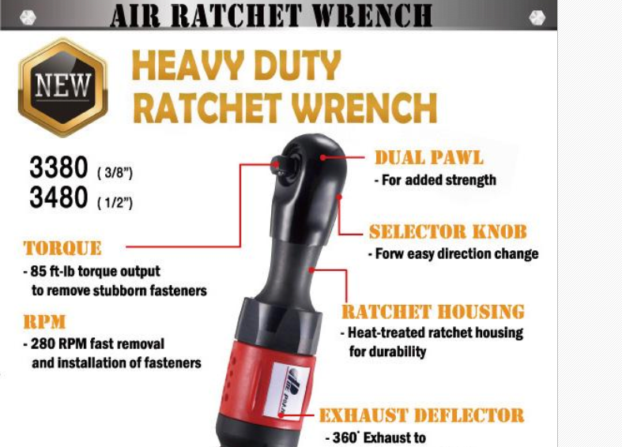

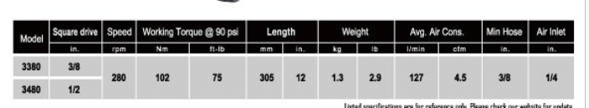

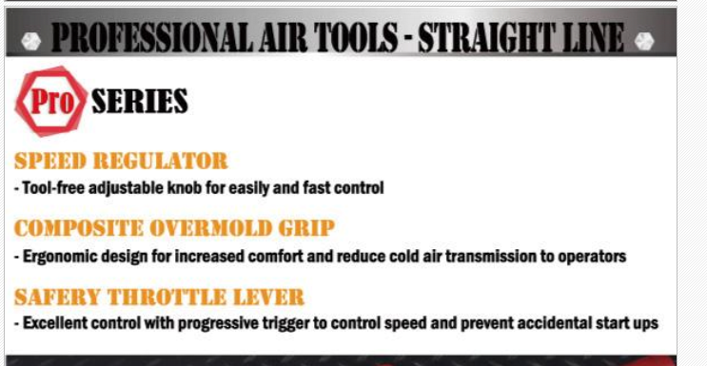

Professional Air Tools- Straight Line

Pro Series

Speed Regulator

-Tool-free adjustable knob for easily and fast control

Composite Overmold Grip

-Ergonomic design for increased comfort and reduce cold air transmission to operators

Safety Throttle Lever

-Excellent control with progressive trigger to control speed and prevent accidental start ups

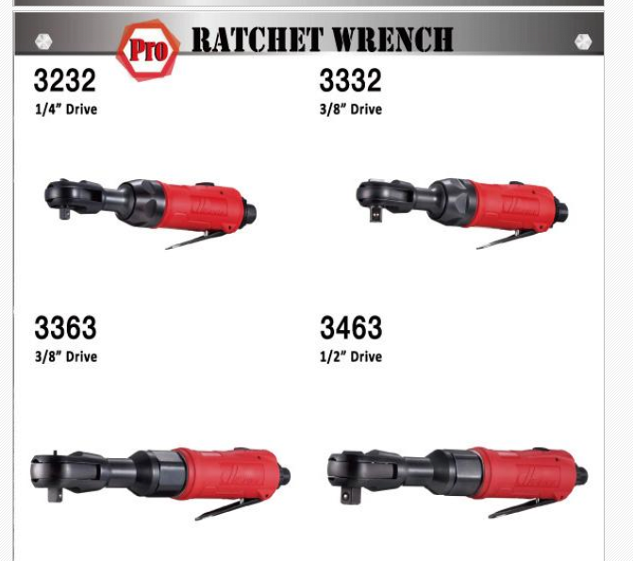

**Ratchet Wrench**

3232

1/4” Drive

3332

3/8” Drive

3363

3/8” Drive

3463

1/2” Drive

**Applications: To tighten or loosen nuts and bolts**

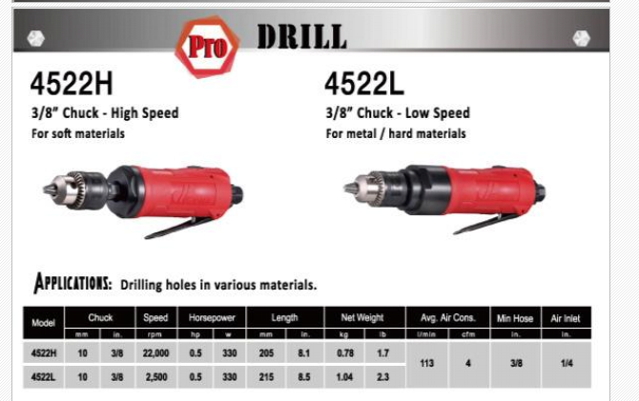

**Drill**

**4522H**

**3/8” Chuck-High Speed For soft materials**

**4522L**

3/8” Chuck- Low Speed for metal/hard materials

**Applications: Drilling holes in various materials**

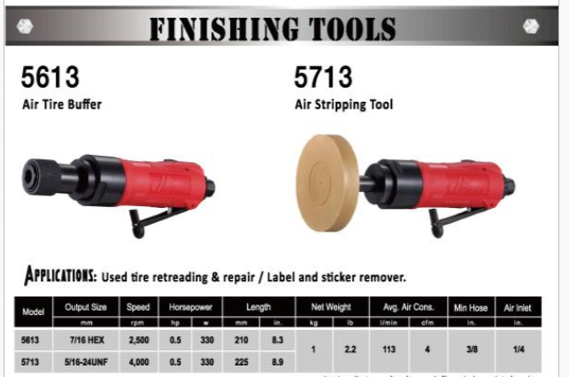

**Finishing Tools**

**5613**

**Air Tire Buffer**

**5713**

**Air Stripping Tool**

**Applications: Used tire retreading & repair/Label and sticker remover**

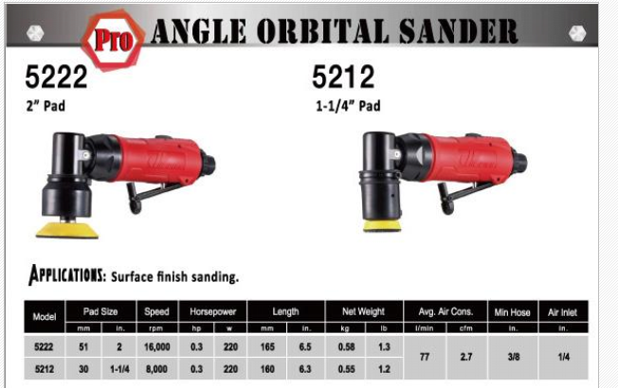

**Angle Orbital Sander**

**5222**

**2” Pad**

**5212**

**1-1/4” Pad**

**Applications: Surface finish sanding**

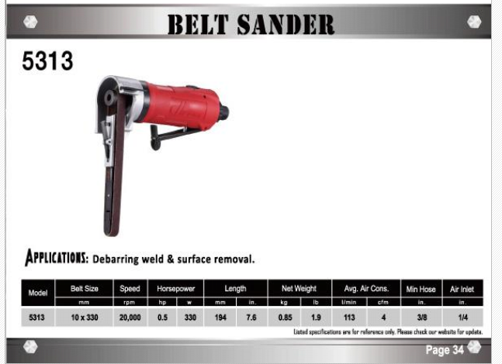

**Belt Sander**

**5313**

**Applications: Debarring weld & surface removal**

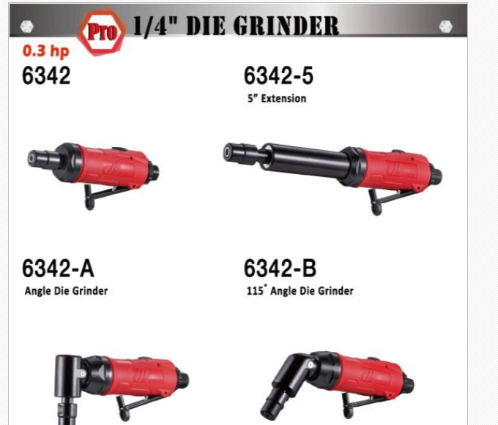

**1/4” Die Grinder**

**0.3hp**

**6342**

**6341-5 5” Extension**

**6342-A Angle Die Grinder**

**6342-B 115” Angle Die Grinder**

**Applications: Light mental grinding weld, surface removal, sanding deburring**

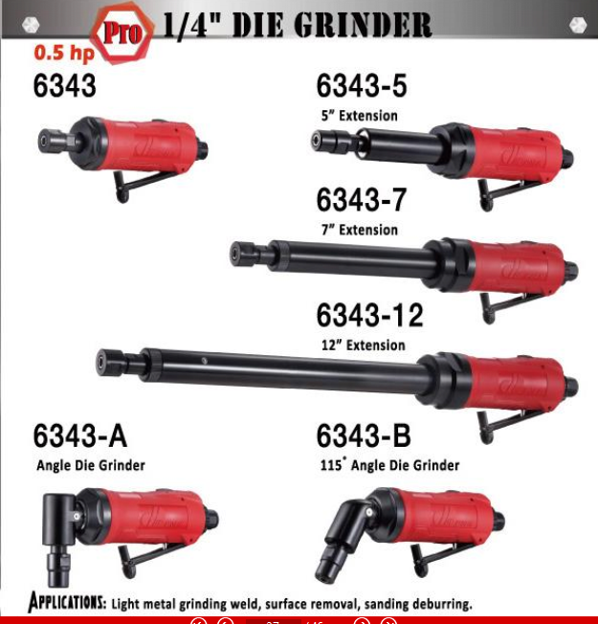

**1/4” Die Grinder**

**0.5hp**

**6343**

**6343-5 5” Extension**

**6343-7 7” Extension**

**6343-12 12” Extension**

**6343-A Angle Die Grinder**

**6343-B 115” Angle Die Grinder**

**Applications: Light mental grinding weld, surface removal, sanding deburring**

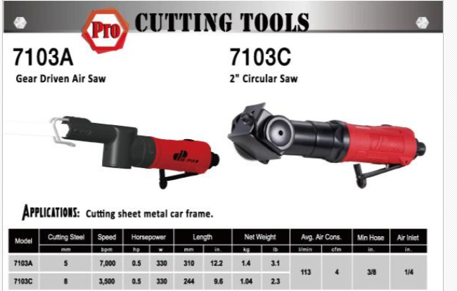

**Cutting Tools**

**7103A Gear Driven Air Saw**

**7103C 2” Circular Saw**

**Applications: Cutting sheet metal car frame**

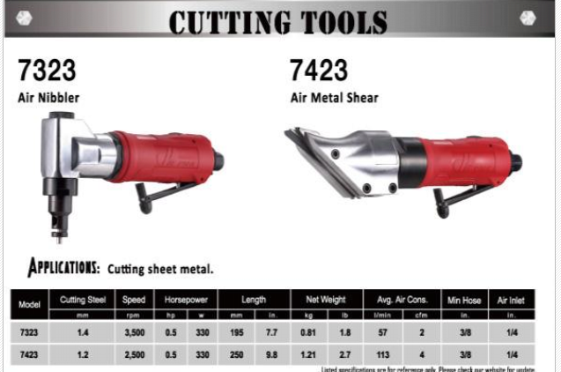

**Cutting Tools**

**7323 Air Nibbler**

**7423 Air Metal Shear**

**Applications: Cutting sheet mental**

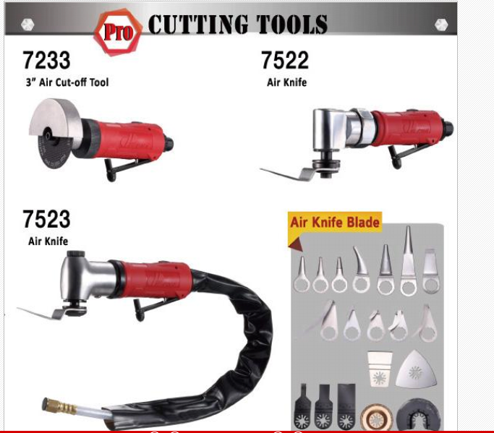

**Cutting Tools**

**7233 3” Air Cut-off Tool**

**7522 Air Knife**

**7523 Air Knife**

**Air Knife Blade**

**Applications: Cutting sheet mental car frame**