|  |  |
| --- | --- |
| **Are you looking to implement a Data Lake & want to know how to best govern it?**  **Our Data Lake offering**  Informatica and Convergent have worked together to design a  solution that helps you get started on your Data Lake journey, without the significant upfront investment.  **Pilot Implementation**  **Requirements**  A use case with 2 – 3 data sources that are easily  accessible to ingest into the Pilot Data Lake.  Inclusions  Platform architecture support Provisioning of the Pilot Data Lake in your AWS account Pilot use case design Data ingestion of up to 3 accessible data  sources 12 months of Informatica IICS and EDC license (S3 + Redshift native connectors)  **$135 000**Duration: 4 Weeks  ex GST | We can provision a new Data Lake for  your organisation, using AWS cloud, and  Informatica’s Intelligent Cloud Services (IICS), that integrates your disparate data sources - all while Informatica’s Enterprise Data Catalog (EDC) governs the environment and provides you with a business glossary, data profiling and data lineage. All of your information will remain within your AWS VPC and in your control.  **Pilot Implementation +**  **Managed Services**  **Requirements**  A use case with 2 – 3 data sources that are easily  accessible to ingest into the Pilot Data Lake.  Account access for Servian MS team.  Inclusions  All inclusions in the Pilot ImplementationServian Managed Service support for 12  months AWS, User and Information Job support and administration  **$230 000** **wsupport (9am - 5pm AEST)**  **Duration: 4 Weeks + 12 months platform** |

*Estimated AWS infrastructure costs for 12 months is $30,000 (not included in pricing). Estimate 5TB S3, 2TB Redshift, no-upfront reserved.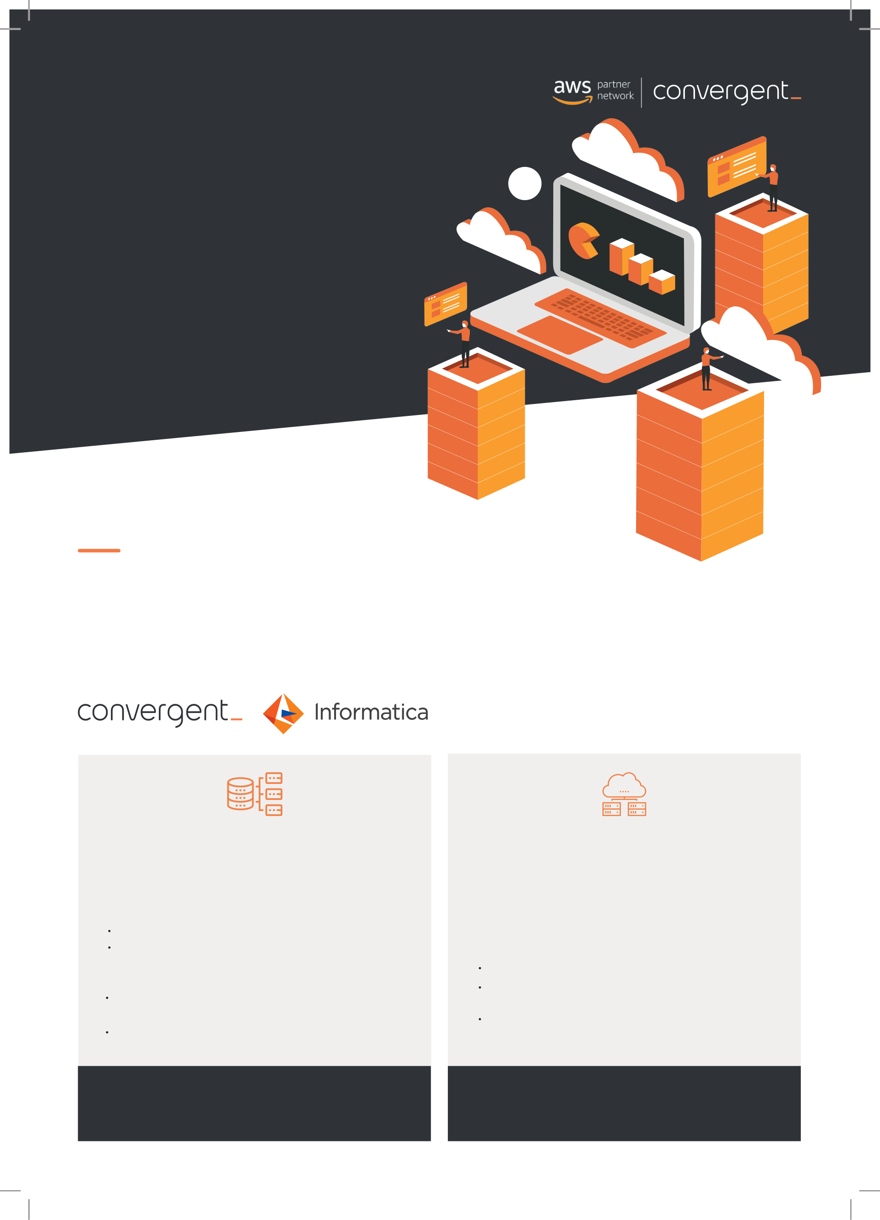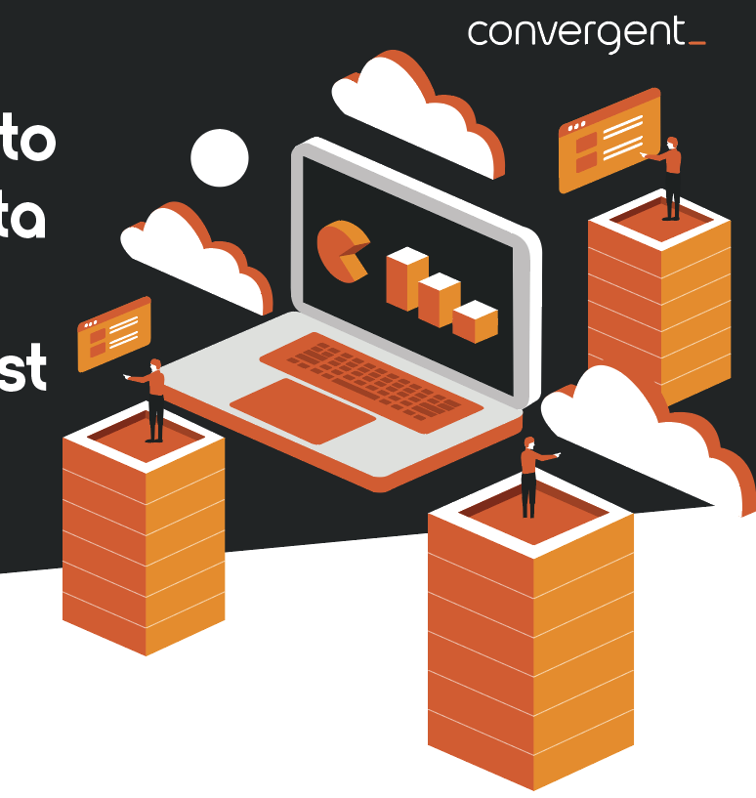

**What can you achieve?**

**Architecture**

Our team can help you design your data platform based on best Data Lake practices and automated deployment patterns.

Do you wish to take advantage of:

Seamless information sharing through your data lake?Reduced operating costs?  
Serverless products and services?  
Advanced analytics?

**Data Governance & Information Security**

The Convergent team will help ensure that you have complete visibility, traceability and control of your Data Lake.

Are you looking to:

Add data catalog and lineage capabilities to your new Data Lake platform?  
Build a system of information that the business can trust?Ingest sensitive data with access that you can control?

**Advanced Analytics**

AWS has a variety of tools available to enable self-service   
advanced analytics. Convergent will speed up your time to market by deploying a Pilot Data Lake that you use to explore your data and gain valuable insights.

Are you looking to:

Enable your Analysts / Data Scientists with governed sandpit environments?  
Prove out Artificial Intelligence or Machine Learning concepts?

|  |  |  |  |  |  |  |  |
| --- | --- | --- | --- | --- | --- | --- | --- |
| Learn More  servian.com/convergent  info@convergent.cloud | Convergent is the AWS dedicated division of Servian. Our strategy is to deliver meaningful business insights for complex data challenges utilising the economical and unlimited potential of cloud computing. | | | | | | |
| sydney | melbourne | adelaide | brisbane | canberra | hobart | auckland |

