MS.NET
Mini Project
Marketing Campaign Management
(MCM)

Document Revision History

Date | Revision No. | Author | Summary of Changes
08th Jun 2017 | 1 | Khaleelullah Hussaini Syed | Initial Draft

Table of Contents
Introduction 4
Setup Checklist 4
Instructions 4
Problem Statement 5
Objective 5
Abstract of the project 5
Functional components of the project 5
Technology used: 8
Implementation 10
Summary of the functionality to be built: 10
Guidelines on the functionality to be built: 10
Evaluation and assessment parameters 13

Introduction
This document outlines a mini project for the .NET Line of Technology (LOT). The project is to develop an Marketing Campaign Management (MCM). This document contains the work flow of the system and gives guidelines on how to build the functionality gradually in each of the course modules of the .NET LOT.

Setup Checklist
Minimum System Requirements
- Intel Pentium 4 and above Windows XP, 2000 and 2003
- Memory 1 GB
- Internet Explorer 6.0 or higher
- SQL Server 2012 client and access to SQL Server 2012 server
- Visual Studio 2013

Instructions
- The code modules in the mini project should follow all the coding standards.
- Create a directory by your name in drive <drive>. In this directory, create a subdirectory MiniProject. Store your Project here.
- You can refer to your course material.
- You may also look up the help provided in the MSDN
- Since this project work will span over couple of months, you will need to take care of maintaining the code

Problem Statement

Objective
Development of a Marketing Campaign Management (MCM)

Abstract of the project
This project is aimed at developing a Marketing Campaign Management (MCM) for marketing and sales team. This is a web based application that can be accessed via internet. MCM is an enterprise solution for managing different marketing campaigns for the organization. The primary goal of the application is to create and start marketing campaign and keep track of prospect lead gathered by marketing team.
XYZ Services Ltd launched in 2016, is an India – based laptop manufacturer that has rapidly grown in past 1 year. This has been possible because of high performance and low cost indigenous devices that fulfill the needs of Indian consumers. Observing the positive approach of consumers toward their product, company has decided to launch marketing campaign across the corporate office of various MNC’s to further increase its sales.
In the current setup, the campaign information and the prospect leads information is manually recorded in excel sheets.
The company intend to acquire a customized application where they can keep track of various campaign and leads generated out of the campaigns. Marketing team will connect the system using internet and record and summarize the information.
Administrator will play the vital role of generating new campaigns and marketing executives will be responsible for recording lead data related to campaign assign to them.

Role of Administrator
Administrator is the primary user of the application and will have the complete control over the marketing campaigns. Administrator details will be already available in the system. The following will be responsibilities of administrator in context of MCM:
- Add Product: Administrator is responsible to add new products into the system. Following information can be recorded for the product
- Product name
- Product description
- Price
- Add users: Administrator will be responsible to add new marketing executives into the system whenever a new executive join the team. Administrator will provide following information
  - Name
  - Date Of Joining
  - Address
  - Login id
  - Discontinued
- Create Campaign: Administrator is responsible to create new campaign and assigning it to marketing executive present in the system.
Administrator can provide the following information to create a new campaign
- Campaign name
- Venue
- Assigned to
- Start date
- Close Campaign: This option will enable the administrator to close a running campaign
- View Lead by campaign: Using this option administrator will be able to see all the leads that are gathered during a particular marketing campaign.
- View Campaign by executive: This functionality will allow the administrator to see all the campaigns assigned to each executive and total number of leads generated during the campaign.

Role of a Marketing executives
Marketing executive which are added by administrator will login to the system and performs the following operations.
- Add Lead: As a part of this operation executive will record the details of the interested consumer for the assigned marketing campaign.
Following information can be recorded by executive
- Name of person
- Contact No
- Email address
- Preferred mode of communication
- Campaign interested in
- Product interested In
- Date approached
He can only record the detail for marketing campaign assigned to him and campaign which is currently open.
- View leads by campaign: As a part of this operation executives will be able to view all the campaign assigned to them and the associated lead so that they can track whether their target has been achieved or not.
- Lead follow up: This option will help the executives to mark a lead as “Won” or “Lost” based on the further interaction with the consumer.
- Create Sales Order: This option will allow the executives to generate a sales order based on leads which are marked as “Won”
While creating a sales order the executive can record the following details
  - Payment mode
  - Billing address
  - Shipping address
  - Payment status
Other details like customer name, phone number and product will be filled automatically based on lead information.

Functional components of the project
Application Architecture:
Distributed web applications traditionally to be designed and built across three logical tiers:
- Database Access Layer (DAL)
- Business Logic Layer (BLL)
- Presentation Layer

The DAL refers to the database itself, the stored procedures, and the component that provides an interface to the database. The BLL refers to the component that encapsulates all the business logic of the application. And, the Presentation layer refers to the web application pages.

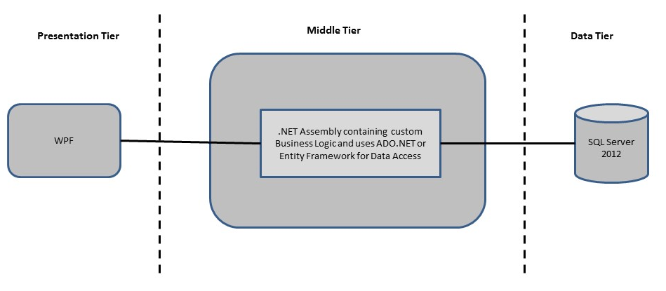ssss

Design guidelines
- All the exceptions/errors to be captured and user friendly message to be displayed on the Common Error page (to be done during PLP).
- Data access layer Data access layer Use ADO.NET. Make use of stored procedures. All the database interaction would be performed using Data Access Component. Most common methods in Data Access Component would be –
- Create Connection to the Database
- Create Command Object
- Set Command Type to Stored Procedure
- Create and Populate Parameters
- Execute the Command
- Close the Connection

Technology used:
    - Presentation Layer
        - WPF 4.5

    - Business Layer
      - Business Logic Components and Services :-
        - C# 5.0
    - Database Layer
      - Databases:-
        - SQL Server 2012

Sr. No | Course | Duration | Functionality to be built
Sr. No | Course | (in PDs) | Functionality to be built
1 | MS SQL Server 2012 | 4 | Creating relevant database tables and stored procedures
2 | NET Framework 4.5 + C# 5.0 | 7.5 | Developing Business components (C# classes)
3 | ADO.NET 4.5 | 3 | Integrating the DAL ,BLL and PL
4 | LINQ and Entity Framework | 2 | Creating data model and data context and using LINQ to Entities
5 | WPF 4.5 | 2 | Incorporating advanced UI functionality with WPF 4.5
6 | Mini Project Presentation | 1 | The Mini Project Presentation day

Note: Saturday half day will be devoted for mini project

Implementation

Summary of the functionality to be built:
The participants need to develop the Marketing Campaign Management by building the functionality incrementally in each of the course modules of .NET LOT.

Guidelines on the functionality to be built:

The functionality and components to be built in each of the course modules of .NET LOT is as follows:

1) Course: SQL Server 2012

This section describes some of the basic steps involved in designing and creation of the database for the application.

Create Data Model - identify the different tables and fields that we will need, which would later be used for building the rest of the application.

Database Schema - Create the following database tables (make your assumptions in case you require few more fields)

- Users:- This will contains details of the user of MCM application
- Products: - This will contains details of products.
- Campaigns:- This will store the details of campaigns
- Leads:- This will store the details of leads
- Sales Order:- This will be used to store details of sales orders

The Structure of the above mentioned tables

- Users: - Id int identity, FullName varchar(25), LoginId varchar(30), Password varchar(30), DateOfJoining Date, Address varchar(200), Discontinued bit, IsAdmin bit.
- Products: - ProductId int identity, Name varchar(20), Description varchar(300), Unitprice decimal
- Campaign: - Id int identity, Name varchar(30), Venue varchar(200), AssignedTo int foreign key (Users), StartedOn date, CompletedOn date, IsOpen bit.
- Leads: - Id int identity, CampaignId int foreign key(Campaign), ConsumerName varchar(30), EmailAddress varchar(30), PhoneNo varchar(10), PreferredModeOfCommunication varchar(5), DateAppoached date, ProductId int foreign key(Product), Status varchar(4)
Note: Status either “New” or “Won” or “Lost”
- Sales Order: - Order Id int identity, LeadId int foreign key(leads), ShippingAddress varchar(200), BillingAddress varchar(200), CreatedOn date, PaymentMode varchar(10)
Note: PaymentMode should be Prepaid or COD (Cash On Delivery)

2. Course: WPF 4.5

a. Develop the prototypes for following functionalities:
- Add users: - This page will allow administrator to add new users
- Add products: - This page allows administrator to add new products into the system and view all existing products
- Create Campaign: - This page allows administrator to create a new marketing campaign
- Close Campaign: - This page allows administrators to close an existing campaign.
- Reports: - This page will allow administrator to view leads by campaign and view campaign by executive
- Add lead: - This page allows executives to add new leads into the system
- Follow Leads: - This page allows executives to mark a lead as won or lost
- Create Sales Order: - This page allows executive to create new sales order from the won leads.
- Login: - This page will allow users to login to the system.

b. In this course you need to develop the user interface using Winforms and WPF. The screens should include the fields as per the functionality mentioned above. Include Validations where ever required.

3. Course: C# 5.0 and ADO.NET 4.5

a. Develop business components (C# classes) for the above functionality:

- Users :- This class will contain methods for managing users
- Products :- This class will contain methods to manage products
- Campaigns :- This class will contain methods to manage campaigns
- Leads :- This class will contain methods to work with leads
- Sales Orders :- This class will contain methods to manage sales orders.

You need to create Layered Architecture which comprises of PresentationLayer (WPF),Business Logic Layer (C# Classes) and DAL Layer(Using ADO.Net 4.5 or Linq and Entity Framework)

DAL Layer of ADO.NET 4.5 will include all the required code snippets for CRUD Operations.

All the CRUD operations should use SQL Server Stored Procedures (For Insert, Update, and Delete & Search).

The connectionString should be stored in the configuration file only.

OR

4. Course: LINQ and EF
a) using the Database first approach of Entity framework create an entity data model form the database created in earlier steps. The Entity data model should consist of the following entities

- Users: - This entity/class will hold users information.
- Products :- This entity/class will hold product information
- Campaigns :- This entity/class will hold campaign information
- Leads :- This entity/class will hold leads information
- Sales Orders :- This entity/class will hold sales order information

b) Using DataContext to perform CRUD operations and use LINQ to Implement the required business logic in the application (like retrieving data, sorting data, searching data etc).

5. Course: ADO.NET 4.5 and WPF 4.5
  - Integrate all screens (WPF ) with business components (C# classes) to complete the entire functionality.

Project Evaluation Guidelines
The project it is to be evaluated based on the following five parameters:

- Proper Database Structure and UI designing as per the specifications –(15 Marks)
  - Proper Database Design and Stored Procedure
  - Visual look and feel of the UI
- Project Completion – (20 Marks)
  - Timely Completion of the project
  - Integration of all component of the system
- Defect free execution – (30 Marks)
  - Error free execution of individual modules and the whole system
  - Validation
  - Functionality as per the specified requirements
- Compliance of standard and guidelines – (15 Marks)
  - Appropriate comments entries
  - Adherence to naming conventions for classes, functions, variables and files
  - Simplicity of user interface and screen layouts
  - Maintainability of codes (for example, no one function should be more than 100 lines)
- Group Presentation and Query handling – (20 Marks)
  - Participants (Group of 3 to 4) to present the project with UML Diagrams(use case diagram and one of the sequence or activity diagram) and PPT

