**Change all images to webP**

**Went from below performance:** 08/04/2024

mobile 54 Web 79 Together **133**

To

mobile 64 Web 94 Together **158**

**Change 25%**

When I **changed all images to webP**

**Installed aria code as per insights recommendation. Accessibility increased.**

**SEO section** 11/04/2024

**Error:** Robots/txt is not valid:

Tried on 11/04/2024. No success. Retried.

**Fix:** Eventually purged and rebuilt cache on cloudfare pages.

**Change to percentages:** **no real change.**

**Lazy loading** 10/04/2024

Was at **Mobile 65 Web 90** together **155**

Have only lazy loaded the **portfolio** and **testimonial** sections:

Increased to: **Mobile 69 Web 97** together **166**

**Change 11%**

**Reduction of images size by 50% using** [**https://www.xconvert.com/compress-webp**](https://www.xconvert.com/compress-webp)10/04/2024

**I only did 6 images in the BG folder. Originals still present.**

Was at **Mobile 69 Web 97** together **166**

Increased to: **Mobile 76 Web 97** together **173**

**Change 7%**

**Negligible change, this was based on three reloads of pagespeed insights.**

**SEO section**

**Error** “links do not have descriptive texts”

**Fix:** changed title tags on “read more” link to:

<a href="level1-building-survey.html" **title**="Read more about the Level 1 House Survey">Read More</a>

**Removal of magnificPopup (backup made)** 11/04/2024

Was at **Mobile 75 Web 94** together **170**

Increased to: **Mobile 77 Web 94** together **171**

**Negligible change**

**Addition of Font display=swap in css file (to change the google API fonts while loading)** 11/04/2024

Was at **Mobile 75 Web 96** together **171**

Increased to: **Mobile 80 Web 97** together **177**

**Change ` 6**

**Removal of API for google maps on index page**11/04/2024

Was at **Mobile 76 Web 94** together **170**

Increased to: **Mobile 77 Web 94** together **171**

**Negligible change**

**Preload fonts (helps as LCP is Montserrat font)** 11/04/2024

Inserted the below code in the head section of index.html before the CSS

<!--preloadFonts-->

<link rel="preload" href="https://fonts.googleapis.com/css2?family=Montserrat&family=Rubik&display=swap" as="style">

<link href="https://fonts.googleapis.com/css2?family=Montserrat&family=Rubik&display=swap" rel="stylesheet">

NOT WORKING. Temporarily boosted MOBP to 85

From: **Mobile 76 Web 97** together **173**

**LCP was 3ms**

**Maion thread work 2**

**R blocking 1.8ms**

**I THINK THERES AN API SOMEWHER FUCKING THINGS UP, CHECK LIGHTHOUSE**

11/04/2024

Removal of **<link rel="stylesheet" href="plugins/fontawesome/css/all.css">** from line 40

Removal of **contact.js from footer**

Removal of **<link rel="stylesheet" href="plugins/animate-css/animate.css">** from line 43

Removal of **<link rel="stylesheet" href="plugins/slick-carousel/slick/slick-theme.css">** from line 42

Was at **Mobile 77 Web 94** together **171**

Increased to: **Mobile 80 Web 97** together **177**

**Change ` 6**

11/04/2024

Heading elements are not in a sequentially-descending order.

*Ensure headings are in a logical order. Check that all headings are marked with h1 through h6 elements and that these are ordered hierarchically. For example, the heading level following an h1 element should be an h2 element, not an h3 element. Finally, don't use heading mark up on text that isn't actually a heading.*

FIX:

11/04/2024

Background and foreground colors do not have a sufficient contrast ratio.

Colour change #FF715B to #E62000 using dequeuniversity.com/rules/axe/4.4/color-contrast

*(I don’t think its required im 93% for accessibility)*

PurifyCSS: **REMOVE EXCESS CSS**. KB saving

From: **Mobile 83 Web 98** together **181**

**BEFORE**

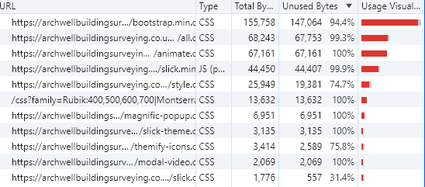

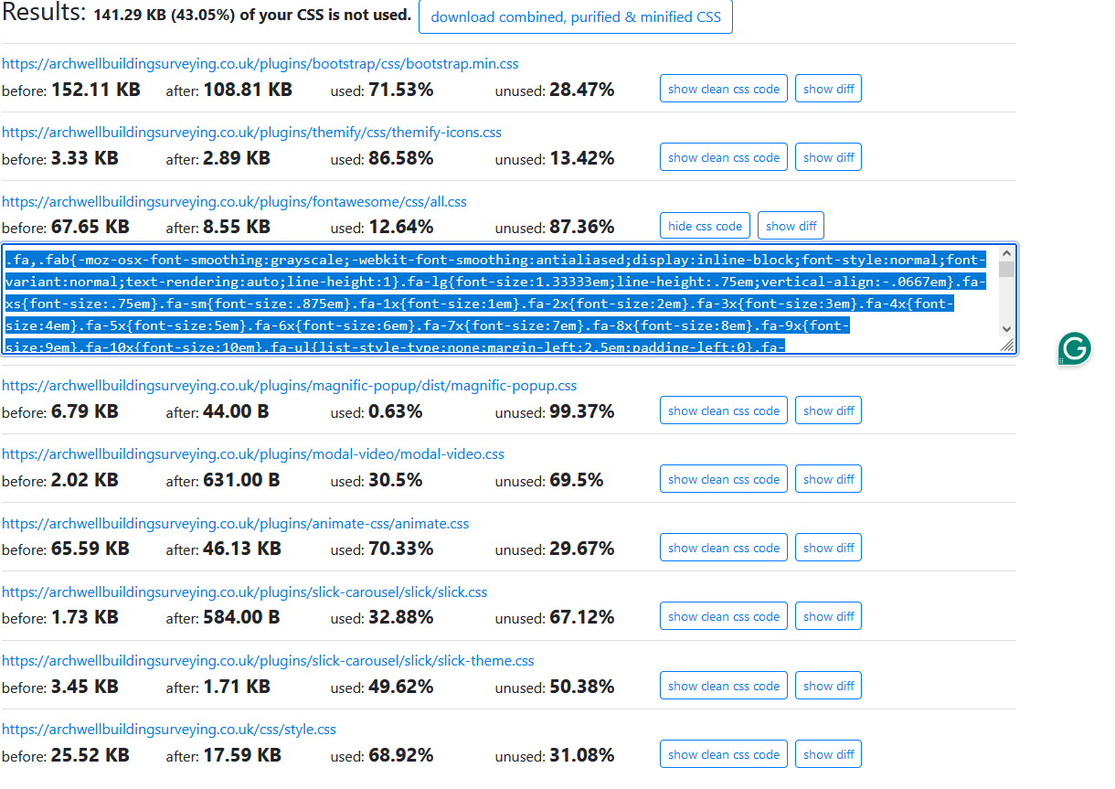

**AFTER**