Descriptive Overview of Transparent Practices in MoBa

Timo Roettger

2024-08-21

# General sample characteristics

799 articles were coded as in principle accessible (84.7%). Only those articles were further analysed. 58 articles could not be accessed by the coder (6.2%); 24 articles were coded as not being a full article, i.e. conference abstract or an erratum (2.5%); 2 articles were coded as not being written in English (0.2%); and 60 articles were coded as having other issues (6.4%) .

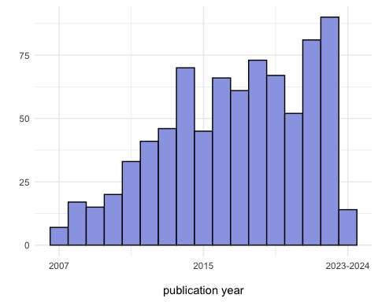

Of those articles that were in principle accessible, 701 articles were coded as secondary analysis of MoBa data (87.7%) and 32 were coded as being part of a meta analysis (including other epidemiological corpora, 4%). Only those two categories were further evaluated. 29 articles were coded as not presenting empirical data (i.e. editorials or reviews, 3.6%) and 37 could not be categorized (“unclear) but were considered not further accessible (4.6%). This left us with 733 articles that were further analysed.

# Individual transparent practices

## Preregistrations

In the entire corpus, there were 3 studies that reported to have preregistered aspects of their analysis. With the available information we were able to recover the original preregistration (albeit it required some digging). Upon further scrutiny, all three studies preregistered some aspects of the analysis including research question, variables and data analysis.

## Synthetetic data

None of the studies reported to use synthesized data, which in principle would allow to reproduce their analysis without violating data protection laws.

## Other data sharing

17 of assessed articles were coded as reporting to share resources that could be considered some form of non-primary data (2.3%), mostly additional metadata or summary statistics. This information was reported to be found in supplementary materials hosted by the journal (n = 8), available “upon request” from the authors (n = 4), or available from a third party (n = 3). Only one article pointed to an open online third-party repository like the OSF or Github and one article remained too vague to recover where to access the information. All in all, out of the 17 articles claiming to share some form of non-primary data, 11 could be accessed by us.

## Analysis sharing

31 of assessed articles were coded as reporting to share some form of analysis protocols either in form of step-by-step instructions or code (5%). Out of these, 16 articles pointed to an open online third-party repository like the OSF or Github, 7 articles pointed to supplementary materials hosted by the journal, 1 article pointed to personal or institutional websites, and 7 were described as available “upon request” from the authors. All in all, out of the 31 only 24 could be accessed.

## Robustness checks

472 of assessed articles reported neither a power analysis nor a sensitivity analysis (64%). 26 of assessed articles reported a power analysis (3.5%), 221 of assessed articles reported a sensitivity analysis (30%), and 18 of assessed articles reported both a power and sensitivity analysis (2.4%).

## Materials sharing

24 of assessed articles were coded as reporting to share some form of additional materials (3.4%). Out of these, 2 articles pointed to an open online third-party repository like the OSF or Github, 15 articles pointed to supplementary materials hosted by the journal, 4 articles pointed to third party, and 2 were described as available “upon request” from the authors. All in all, out of the 24 only 17 could actually be accessed.

## Replications

11 of assessed articles were coded as reporting to replicate a previous study (1.5%).

## Conflicts of Interests (COIs)

142 of assessed articles were coded as not reporting whether or not a conflict of interest applied to their study (19.3%); 488 of assessed articles were coded as reporting that there was no conflict of interest applied to their study (66.2%); and 107 of assessed articles were coded as reporting whether that there in fact was a conflict of interest applied to their study (14.5%)

## Open publishing

661 of assessed articles were coded as being openly published according to our definition (89.7%);

# Trends over time

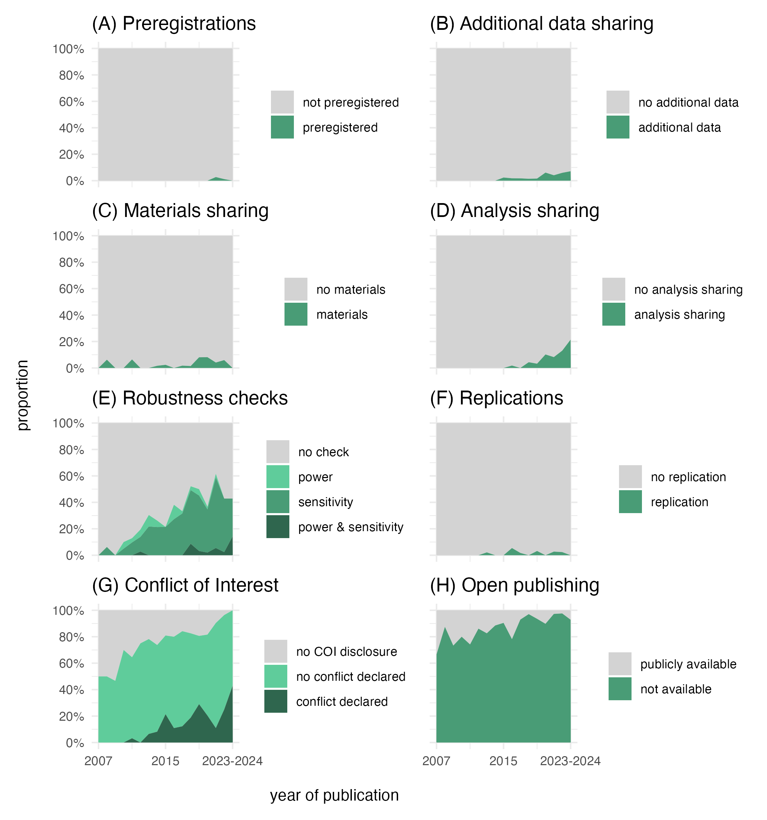

Figure 2: Proportion of transparent practices for articles as a function of publication year (2007-2024). Year 2023 and 2024 were collapsed due to a small number of n.