Listed below are the proposed websites that need further development. We have already visited and observed each of them before enumerating their design flaws, their misleading and lacking functions or features, and the possible improvements.

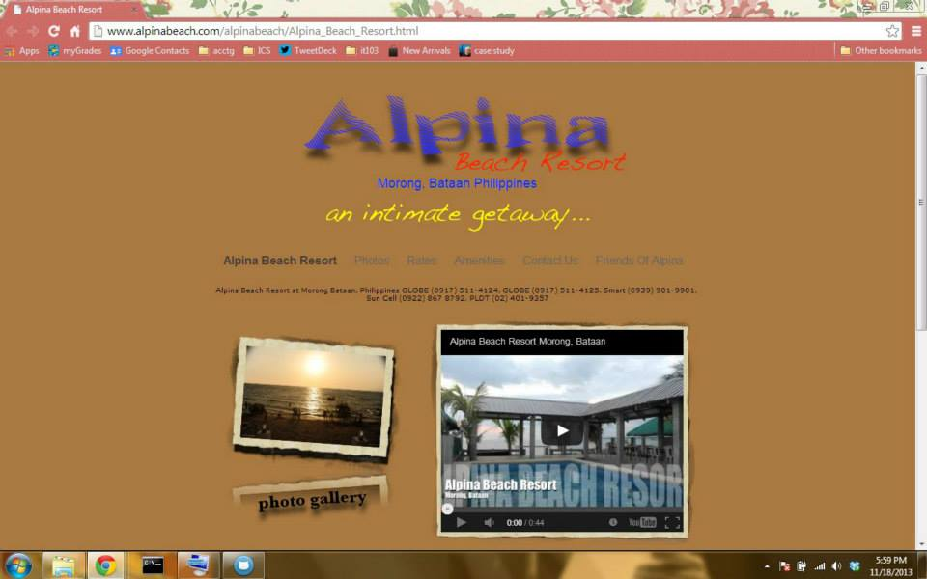**A. ALPINA BEACH RESORT**

www.alpinabeach.com

**DESIGN FLAWS**

* Menu text - dark colored and can’t be easily identified as part of menu
* Background – color is bordering on dark and light shade
* Text sizes – some are too small
* Text color - dark text on dark background
* Map in the “Contact Us” page is difficult to understand
* Overall color pallet is similar to older websites

**LACKING OF FUNCTIONALITIES**

* Online reservation
* Testimonials
* Live Chat

**POSSIBLE IMPROVEMENTS**

* Same menu but with different font style and color
* Menu for “Photos” should have a drop down sub-menu
* Color pallet should be updated to a more modern style
* Use of more professional font styles and sizes
* Use of a more accepted map service (ie Google Maps)
* “Alpina Beach Resort” in the menu should be replaced with “Home”

**B. PHOTOGRAPHER TORONTO**

www.photographertoronto.com

**DESIGN FLAWS**

* Text heavy
* Homepage does not clearly identify the site’s purpose
* Arrangement of text makes it difficult to read
* Buttons/Links are not well organized
* “Images” link links the user to a YouTube page
* Large moving text at bottom of page
* Color pallet is too bright – light text on light background

**LACKING FUNCTIONALITIES**

* Updates
* Sample portfolios/projects
* Contact numbers for local clients

**POSSIBLE IMPROVEMENTS**

* Use of a menu (top or side)
* Use of better fonts do differentiate content from menu
* Use of content slider (slideshow of photos)
* Removal of spinning trophy and moving text
* Addition of images on homepage

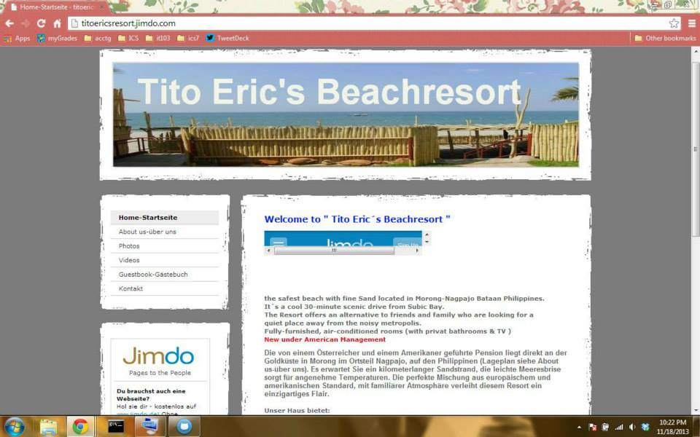**C. TITO ERIC’S BEACH RESORT**

www.titoericsresort.jimdo.com

**DESIGN FLAWS**

* Use of mixed languages
* Use of site counter for professional website
* Dull color pallet
* Jimdo item in the middle of home page cannot be seen without having to scroll a lot

**LACKING FUNCTIONALITIES**

* Online reservation
* Room rates

**POSSIBLE IMPROVEMENTS**

* Removal of unnecessary objects
* Option to change language
* Change of color pallet

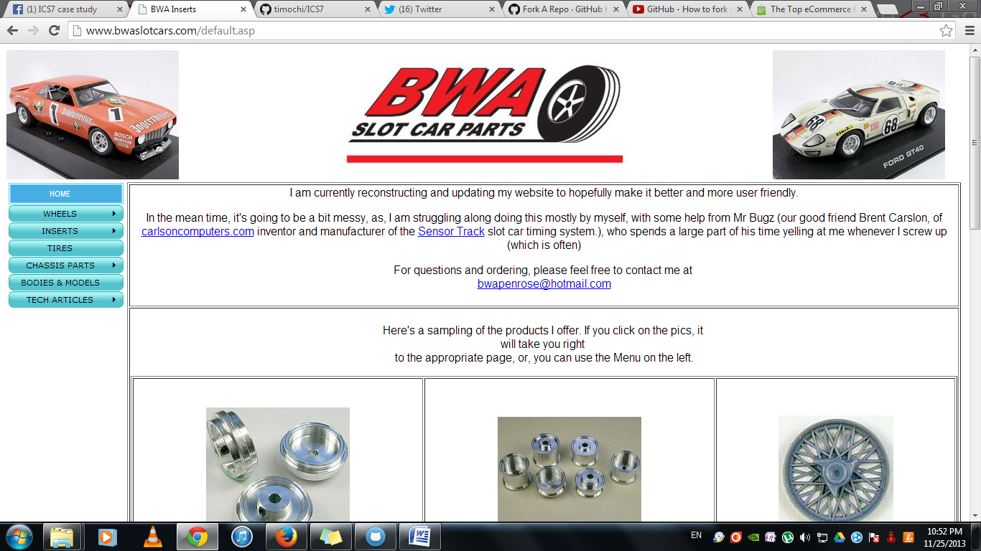

1. **BWA SLOT CAR PARTS**

www.bwaslotcars.com

**Design Flaws**

* Plain background
* Doesn’t make good use of space

**Lacking Functionalities**

* “Add to cart” feature
* Online payment
* Individual pages for each product
* “Buy now” button for each product page.

**Possible Improvements**

* Fixed size for each cell.
* Place navigations on top
* Fix text-alignment
* Change background

***Group members***

**Project Manager:** Nico Madarang

**Web Programmer/Designers:**

* Timothy Llanera
* Enrique Dizon
* Jean Lau
* Joncis Gella

**Business Analysts:**

* Janna Vinzon
* Enrique Dizon

**Testers:**

* Rex Edrosa
* Janica Jose