Economic impact patterns of COVID-19 on emerging markets, January-April/June 2020

June 09, 2020

With the global outbreak of COVID-19, many countries initially tried to contain a further spread of the virus and to change the dynamics of the pandemic with lockdowns and social distancing measures. This had two immediate effects; On the one hand, global demand collapsed and lead to a precipitous drop in the price for oil and other resources. On the other hand, governments had to mitigate the economic consequences on individuals which resulted directly from the virus or indirectly from the government imposed lockdowns, thereby expanding government deficits and bulking up sovereign debt. In the light of financial fragility of emerging markets during previous global crises, this paper examines the economic impact of the COVID-19 pandemic on government finances. Specifically, this paper traces the cross-country associations between COVID-19 mortality, economic fundamentals, policy interventions, and their impact on sovereign spreads. Our results suggest…

# Introduction

## Overview

This paper takes stock of the data gathered during the first four to six months of the year 2020. We say “four to six” because at the time of writing this document (early June), the data for June is not available yet. However, as soon as that data is available we will rerun the analysis and see if the results remain stable. In a nutshell: we explain the change in spread between 12/31/2019 - 04/30/2020 (and 12/31/2019 - 06/30/2020 as soon as the June data is out) through structural, macroeconomic, and epidemiologic variables.

## First step: defining the sample of countries

In a first step, we had to choose which emerging markets we want to investigate. Since we are interested in the effect of COVID-19 on governments’ ability to finance deficits in a sustainable way–that is, without increasing spreads beyond reasonable levels–we are primarily intersted in emerging markets which are “investible”. As a starting point, we defined a country’s “investibility” as being a constituent of the JPMorgan EMBI (Emerging Market Bond Index). This index gives investors exposure to U.S. dollar-denominated government bonds issued by emerging market countries. The index comprises more than 30 emerging market countries in a single fund. specifically, when we looked up the constituent countries of the fund, it appears as if 31 countries are in the index as of 25 April 2020 (cf. [https://www.ishares.com/us/products/239572/ishares-jp-morgan-usd-emerging-markets-bond-etf](www.ishares.com/us/products/239572/ishares-jp-morgan-usd-emerging-markets-bond-etf) ).

This data was obtained on Saturday 25 April 2020.

I saw that some potentially interesting and important markets were not in the EMBI, for example India and Thailand, which is why I am adding those to the sample. (See code below).

In addition, we originally talked about only including emerging markets with a Debt/GDP ratio above a threshold of 10% or 20%. To find out which ones those are, I first downloaded the Debt/GDP ratio of all available countries from the IMF’s global debt database. <https://www.imf.org/external/datamapper/CG_DEBT_GDP@GDD/FADGDWORLD> I chose the indicator “Central Government Debt” for e.o.y. 2018 as 2019 was not comprehensive. I saved the data to IMF.xls Next, I checked which countries the IMF classifies as Emerging Markets as per October 2019. <https://www.imf.org/~/media/Files/Publications/WEO/2019/October/English/text.ashx?la=en> p. 166 - 167 contains the list of countries classified as EM by the IMF. I hand-coded the EM classified countries as 1 in the IMF.xls sheet. All other countries are coded 0.

Second step: defining which countries are examined

Therefore it covers it roughly the first three months of the pandemic (March-)

This is an R Markdown document. Markdown is a simple formatting syntax for authoring HTML, PDF, and MS Word documents. For more details on using R Markdown see <http://rmarkdown.rstudio.com>.

When you click the **Knit** button a document will be generated that includes both content as well as the output of any embedded R code chunks within the document. You can embed an R code chunk like this:

summary(cars)

## speed dist   
## Min. : 4.0 Min. : 2.00   
## 1st Qu.:12.0 1st Qu.: 26.00   
## Median :15.0 Median : 36.00   
## Mean :15.4 Mean : 42.98   
## 3rd Qu.:19.0 3rd Qu.: 56.00   
## Max. :25.0 Max. :120.00

# Including Plots

You can also embed plots, for example:

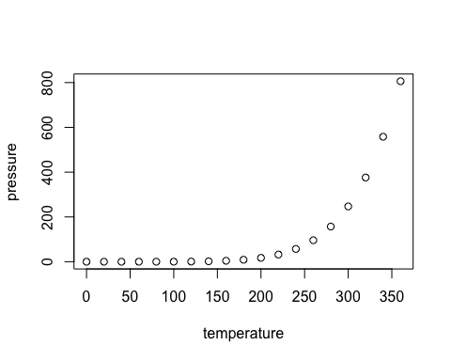

Note that the echo = FALSE parameter was added to the code chunk to prevent printing of the R code that generated the plot.