Name: Timofey Abramski
Student no.: 15321776

Abstract

In this computation lab, we familiarised ourselves with some basic programming in python and utilised these skills to solve the problem of finding roots of a function numerically (using 2 methods). We then used this on a more direct physical problem, showing that knowledge in programming can be applied to solving real life problems. We found these methods to be successful although it is important to note that these methods have their limitations.

Introduction

The first method, the Bisection Method shifts our approximation of the root by simply judging by whether the value of the function of that approximation is greater than or less than 0. This explains its inefficiency in that it doesn’t shift in the correct proportion. On the other hand, Newton’s Method (in our case the first order of taylor expansion series) reaches the root much quicker because it retains information about the derivative which is used to estimate more closely where the root is.

Results
Lab exercise 1
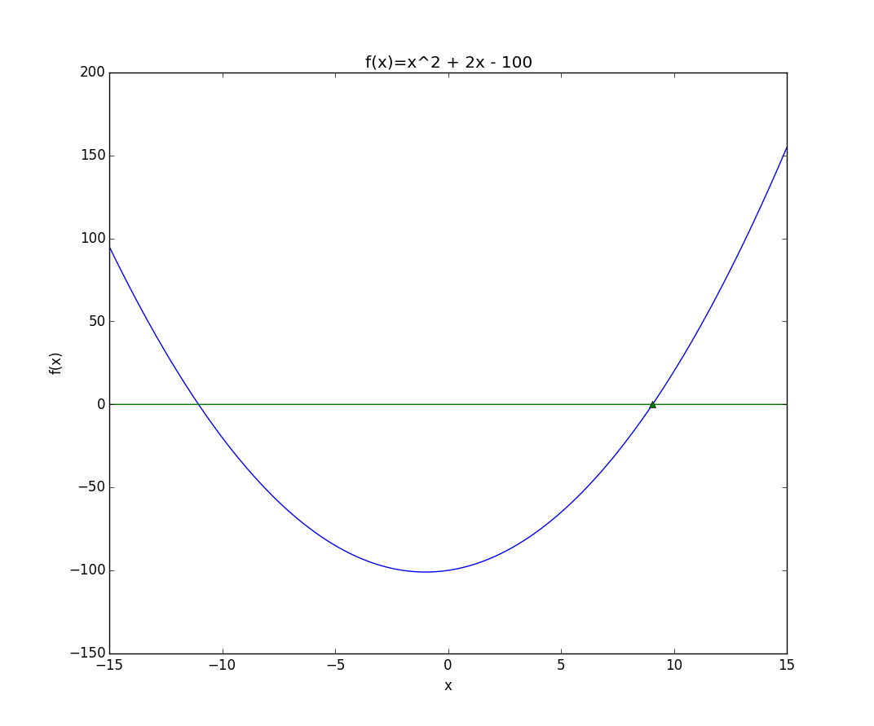

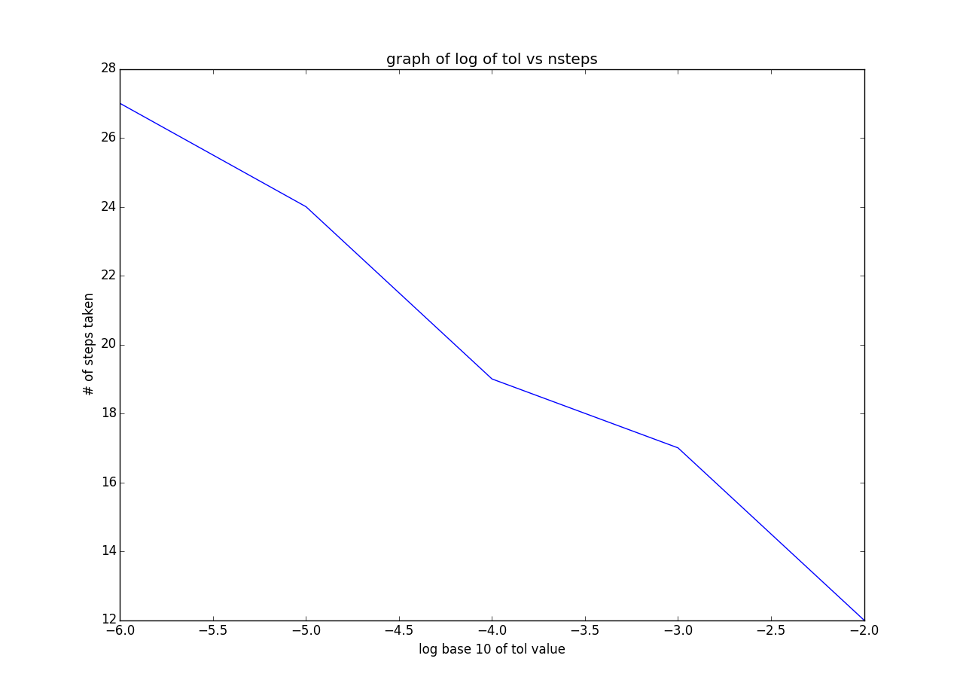

There is a linear dependence of the log₁₀ of the tol value and how many steps it takes to get a good approximation of the root with the Bisection method. The number of steps increases as we set the tol number to a smaller value as we require the estimation to be closer to the true value

Lab exercise 2
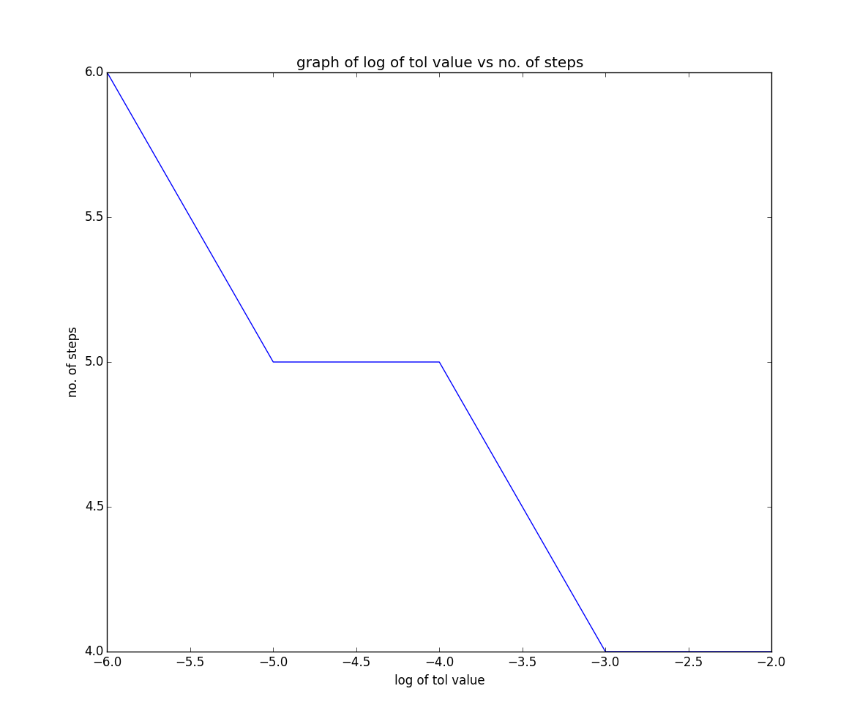

Since Newton’s method finds a value very close to the root so quickly, the number of steps does not get to decrease much even if the tol value is made bigger. This explains the “step” where the number of steps remains 5 despite a change in tol value

Using the same function, the Bisection Method took 24 iterations to find the result while Newton’s Method took only 4. This is a big enough difference to say that Newton’s method is much more efficient.

Lab exercise 3
Because we are looking for the minimum of the function V(x), we need to find the roots of dV/dx, meaning that the second derivative needed to be found to use Newton’s method.
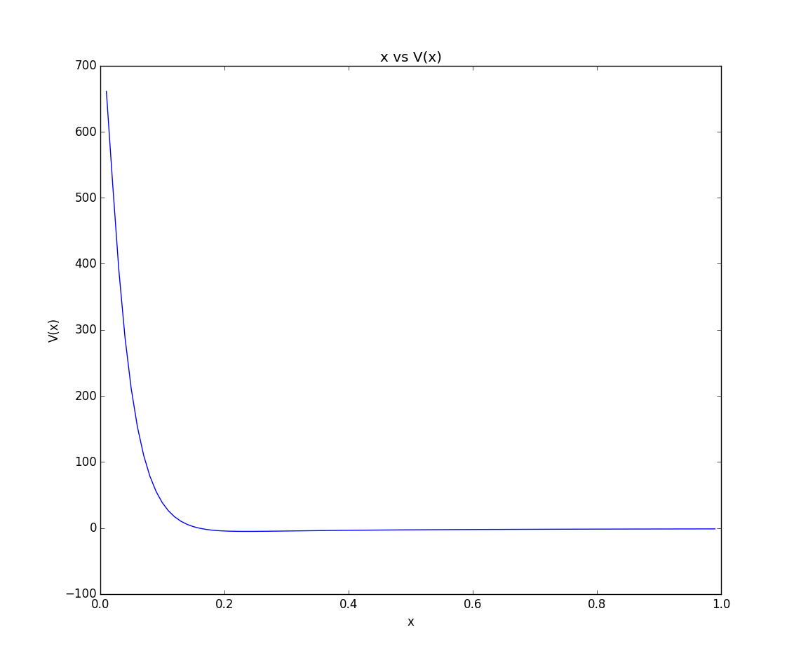

The min value of the potential energy function was found to be 0.23605

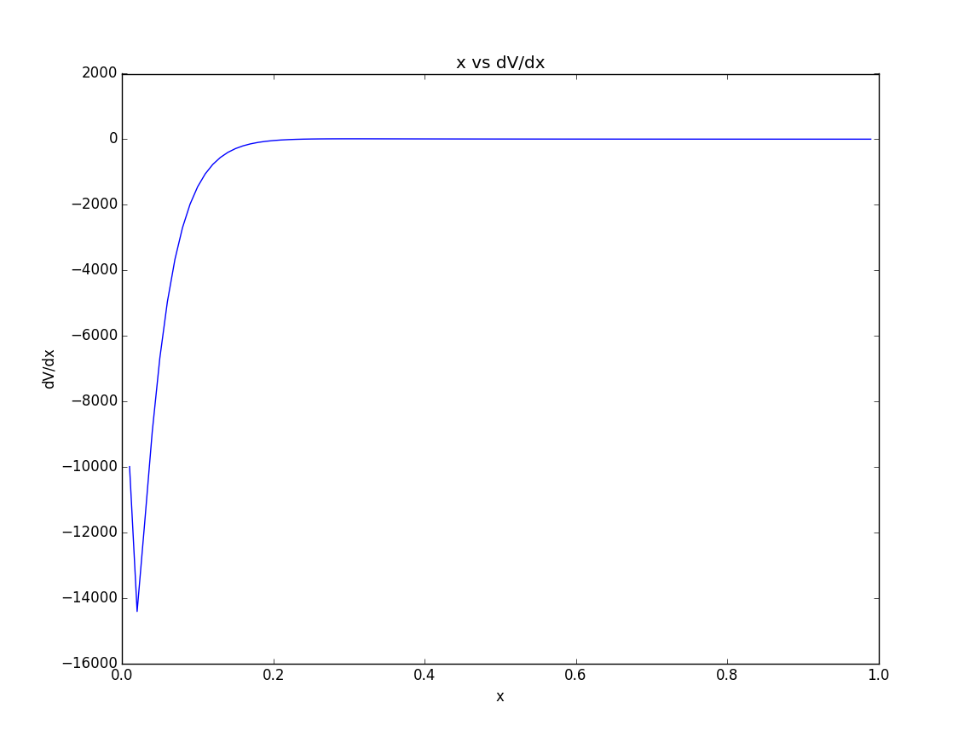

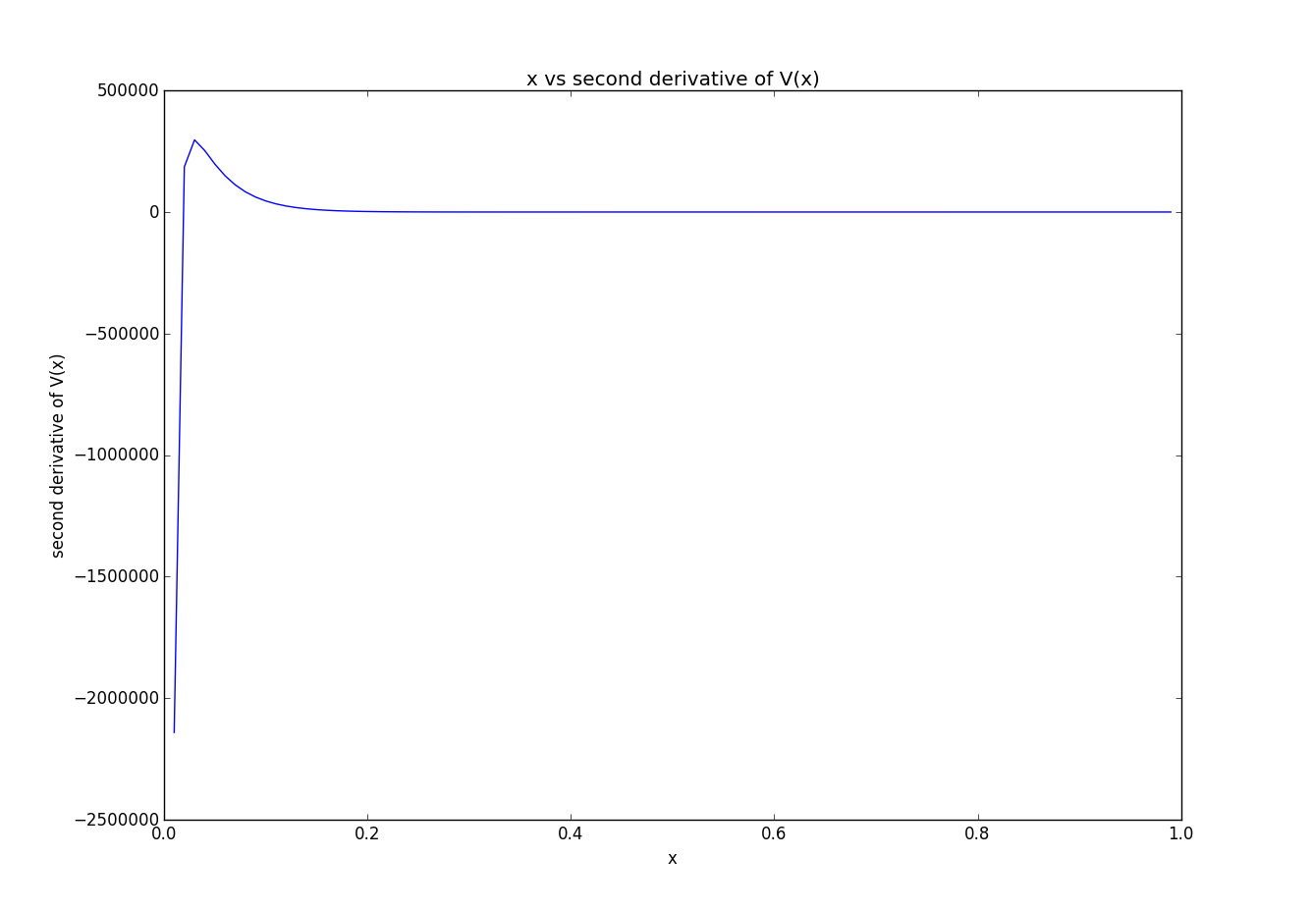

Method

The first method, called the bisection method starts off by choosing one value of x₁ for which f(x₁) is less than zero, and one for x₃ for which f(x₃) is greater than 0. A warning message was programmed to be given out if the user failed to choose f(x₁) and f(x₃) in this way:

if p(x3)>0 and p(x1)>0:
print 'BAD CHOICE OF VARIABLES'
if p(x3)<0 and p(x1)<0:
print 'BAD CHOICE OF VARIABLES' #give warning sign if bad variables
x2=(x1+x3)/2

The average of the two x values is taken as a guess for the root. If f(x) of this value is greater than zero, then the average of x₁ and the first estimate is taken. Otherwise the average is taken with x₃.. This is repeated over and over again until our estimate for the root becomes very good. This was all done with a simple while statement:

while abs(p(x2)) > tol:
if p(x2)>0:
x3=x2
else:
x1=x2
x2=(x1+x3)/2
counter = counter+1
print counter,x1, x2, x3, p(x2)

For Newton’s method, an initial value x₁ was chosen and a while condition was added to renew the value of x1 to the new estimate of the root until the absolute value of the function was less than the tolerance value defined previously:

while abs(f(x1))>tol:
x1=x1 – (f(x1)/df(x1))

The final exercise was computed using Newton’s method in the same way as exercise 2, except that to find the minimum value of the function we need to find where the derivative of the function crosses the x-axis. Here is the while statement that was used:
while abs(dV(x1))>tol:
x1=x1 - (dV(x1)/ddV(x1))

Discussion

The second method for finding the roots is called the Newton-Raphson Method (or Newton’s Method). It is based on the Taylor series expansion but it can be explained more interestingly and intuitively graphically. Taking a guess for the root x₁, we draw the tangent (equivalent to derivative) of the curve at (x₁, f(x₁)). The point at which this line crosses the x-axis becomes our new (generally) closer approximation of the root of the function.

The formula that we use can be derived from this explanation.
Define the line f’(x) that goes through the point (x₁, f(x₁)):
y –y₁ = m(x-x₁)
y -f(x₁) = f’(x₁)(x-x₁)
@y=0 (crossing the x-axis, this is our first approximation so x=x2)
-f(x₁) = f’(x₁)(x₂-x₂)
-f(x₁) = f’(x₁)x₂ – f(x₁)x₁
x₂ = x₁ – f(x₁)/f’(x₁)
This final formula is the one that we use in python iteratively to continue finding better and better approximations for the root. In python it is written as
x₁ = x₁ – f(x₁)/f’(x₁)
because we are renewing the same value of x1 each iteration.

It is important to note that this method has limitations. It will always work for polynomials of power 1 and 2 and some other functions, generally those where the maximum order derivative is not a large order but it may fail (diverge) for other functions if an unlucky starting point is chosen. This is due to overshooting of the tangent line. However, for the purposes of the physical problem at hand, it is sufficient.

Since this problem in itself is not too computationally taxing, it may be may be favoured in some more complicated cases to make an ideal algorithm which would use both methods simultaneously while also choosing a range of different starting points with certain increments. This would be preferred in the case of a cubic equation we could “miss” one root by sheer luck. The bisection method is often used as the first method to approximate a range within which lies the root, and other methods take over after.

Conclusion

In conclusion, we simulated 2 numerical methods of approximating the root of a function by using the very simple logical statements while and if. These exercises demonstrated the simplicity that python can have and how problems can be coded quite intuitively without having to learn much programming at all and without having to worry about complicated syntax.

Most importantly, we successfully employed the Newton’s Method to find the minimum value of V(x) which was found to be -5.247 where x=0.23605

