Introduction

Abstract

Method

Discussion
In the first exercise, we set up the conditions for a simple pendelum. This was done by setting k and A to 0, and sin(theta) was replaced by theta in:

def f(theta, omega, t):
force= -(g/L)*theta-k*omega + A*math.cos(fi*t)
return force
This means that there is no driving force for the pendelum and there is no friction. The trapezoid rule was used to iterate omega and theta. This is equivalent to first order taylor series.

Theta (t+deltat) = theta(t) + deltat dtheta/dt
omega(t+deltat) = omega(t) +deltat dw(t)/dt

We plotted theta and omega vs time for different initial conditions (Fig 1.1-1.4). As expected, they all took the same shape. Fig 1.3 is sqeezed in comparison to the other 3 graphs because the initial condition, theta=3.1 is too big for theta to approximate sintheta well, but the same general shape still follows from this initial condition.

In the second exercise we plotted the same graphs with the same initial conditions except for a nonlinear pendelum. This was done by changing the definition of f, changing theta to sin(theta)

Results
Exercise1
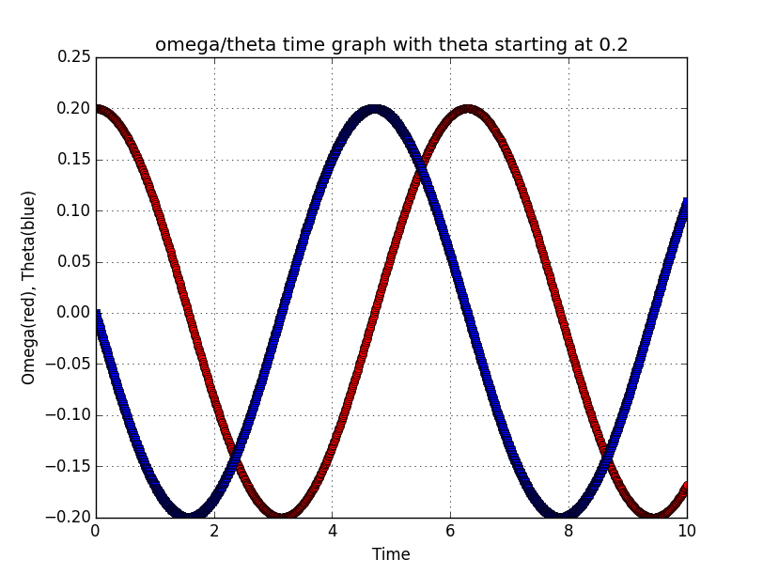

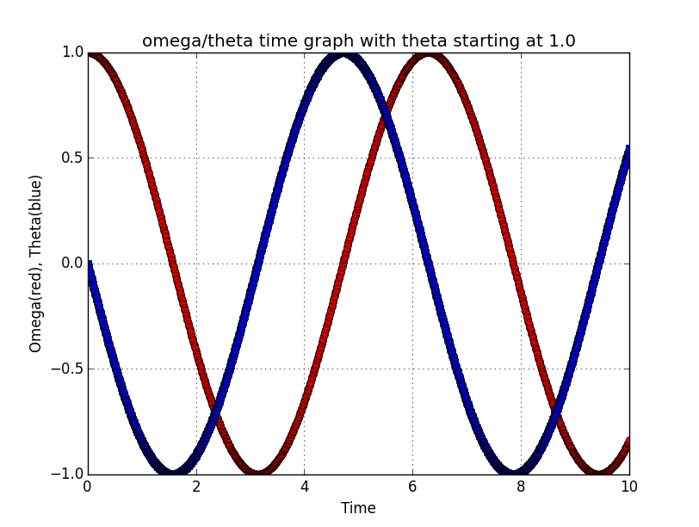

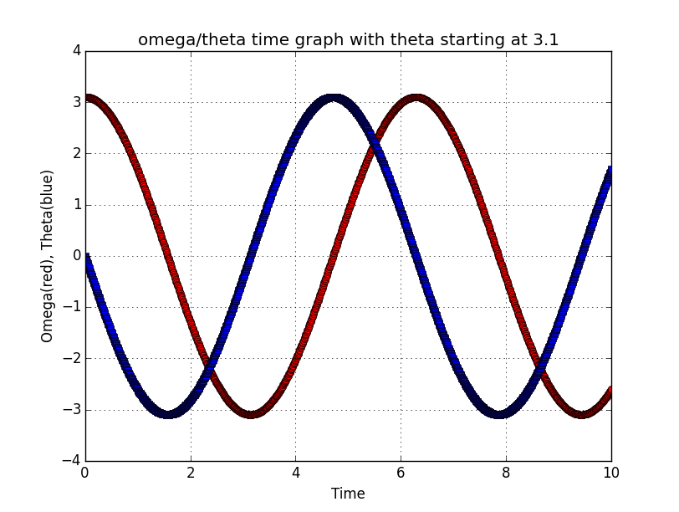

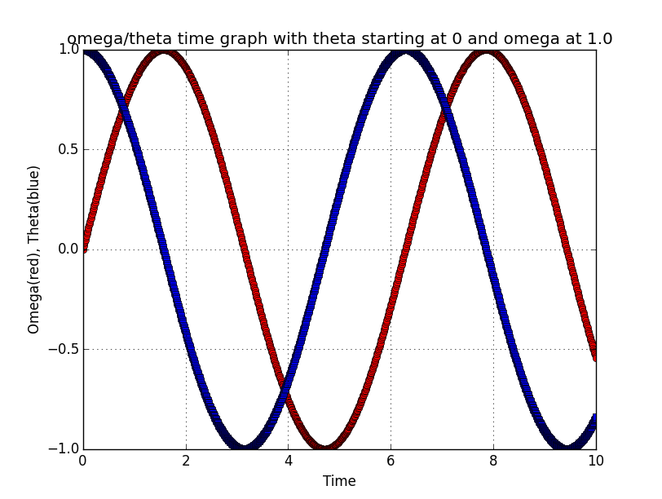

Discussion

Conclusion

