Asset Reference No: 1

Artist: Penny Bidd

Title: <strong>"Jarnungnarri"</strong>

Size: 136 x 184 cm pigments on Canvas

Amount Paid: $3,230

Insured: Yes - Annette Larkin Fine Art (2009) - $15,000The Curators’ Department Valuation (2016) - $5,500

Provenance: Wanjina Art ProjectAcquired from The Power of the Wandjina – An exhibition of paintings and pearlshells by the Mowanjum Artists, Grosvenor Place Foyer, Sydney, NSW, 1998

Office Location: St Leonards Office – Scott’s Office

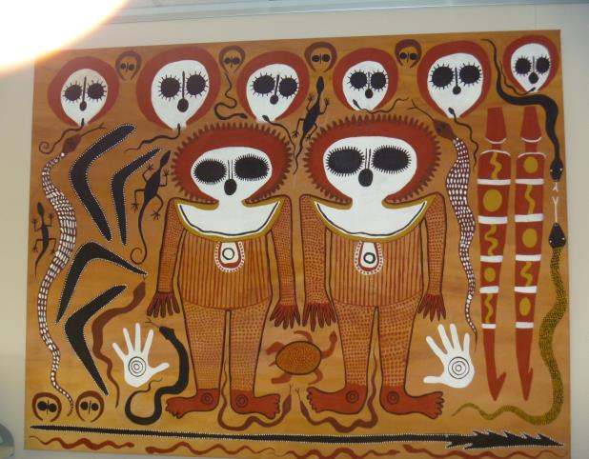

Asset Reference No: 42

Artist: Djarrdi Ashley

Title: "Ngambi" (stone spearheads), 2004

Size: Natural earth igments on paper 150 x 100 cm

Amount Paid: $10,000

Insured: Yes - Annette Larkin Fine Art (2009) - $9,500The Curators’ Department Valuation (2016) - $10,500

Provenance: Bula’bula Arts, Ramingining, NT (cat. WOP939)Private collection, Canberra, ACTCaruana and Reid Fine Art, Sydney, NSWAcquired from the above on 8 December, 2006 (inv. 0115)

Office Location: St Leonards Office – Behind Reception

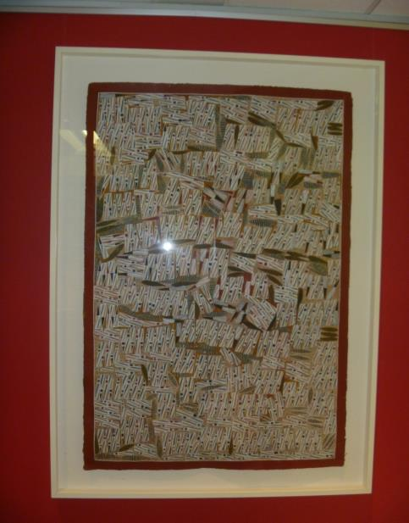

Asset Reference No: 28

Artist: Roma Nyutjangka Butler

Title: "Minyma Kutjarra Tjukurrpa", 2006

Size: Synthetic polymer paint on linen 147 x 91 cm

Amount Paid: $4,500

Insured: Yes - Annette Larkin Fine Art Valuation (2009) - $10,000The Curators’ Department Valuation (2016) - $6,000

Provenance: Irrunytju Arts Centre, WA (cat. 05646)Private collection, WAAcquired from Lawson Menzies, 14 November 2007 – Lot 268 (inv. 120931.1)Certificate of Authenticity issued by Lawson-Menzies and Irrunytju Arts Centre, signed by Adrian Newstead (Head of Aboriginal Art)

Office Location: St Leonards Office – hall near Stationery area

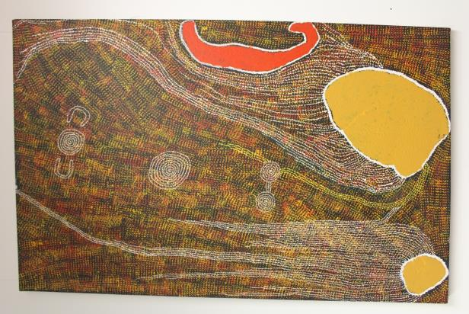

Asset Reference No: 93

Artist: Walter Ebatarinja

Title: "Central Australian Landscape"

Size: Watercolour on board 35 x 52 cm

Amount Paid:

Insured: Yes - Annette Larkin Fine Art Valuation (2009) - $1,500The Curators’ Department Valuation (2016) - $1,500

Provenance: Collected by the District Welfare OfficePrivate collection, NTAcquired from Lawson Menzies, 14 November 2007Certificate of Authenticity issued by Lawson Menzies

Office Location: St Leonards Office – Behind Kitchen

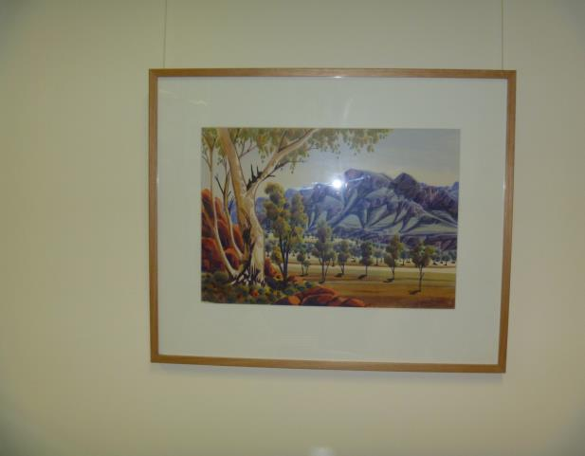

Asset Reference No: 75

Artist: Shirley Bray

Title: Bungle Bungles / "Purnululu", 1999

Size: Ochres on canvas 91 x 120 cm

Amount Paid: $500

Insured: Yes - Annette Larkin Fine Art Valuation (2009) - $2,000The Curators’ Department Valuation (2016) - $6,000

Provenance: Warmun Arts Centre, WA (cat. WAC228/99)Private collection, Melbourne, VictoriaAcquired at Aboriginal Benefit Auction, Museum of Contemporary Art, Sydney, 2008

Office Location: Adelaide Training Room

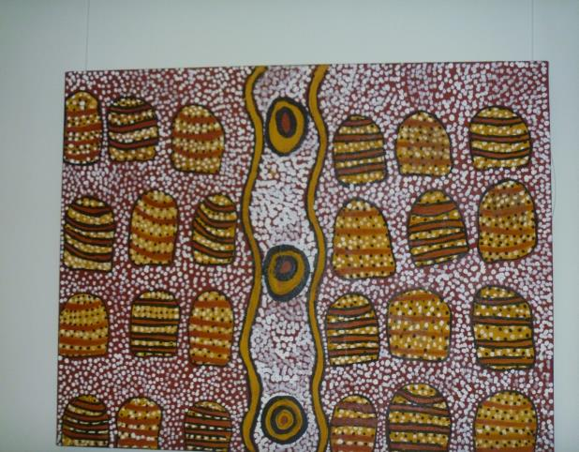

Asset Reference No: 51

Artist: Joy Gamuriluy

Title: "Fish", circa 2004

Size: Natural fibres and paint 27 x 67 cm

Amount Paid: $400

Insured: Yes - Annette Larkin Fine Art Valuation (2009) - $500The Curators’ Department Valuation (2016) - $500

Provenance: Barry Stern Galleries, Paddington, NSWAcquired from above in 2005 (inv. 1074)

Office Location: St Leonards Office – Boardoom

