Instructions

Install
1.0 install matlab I used R2022a
1.1
Go to http://psychtoolbox.org/download.html, download, and follow the instructions.

1.2
Go to https://www.palamedestoolbox.org/download.html, download and put in this directory if it is not already there

1.3 press ”Get More Apps” and download the “signal processing toolbox”
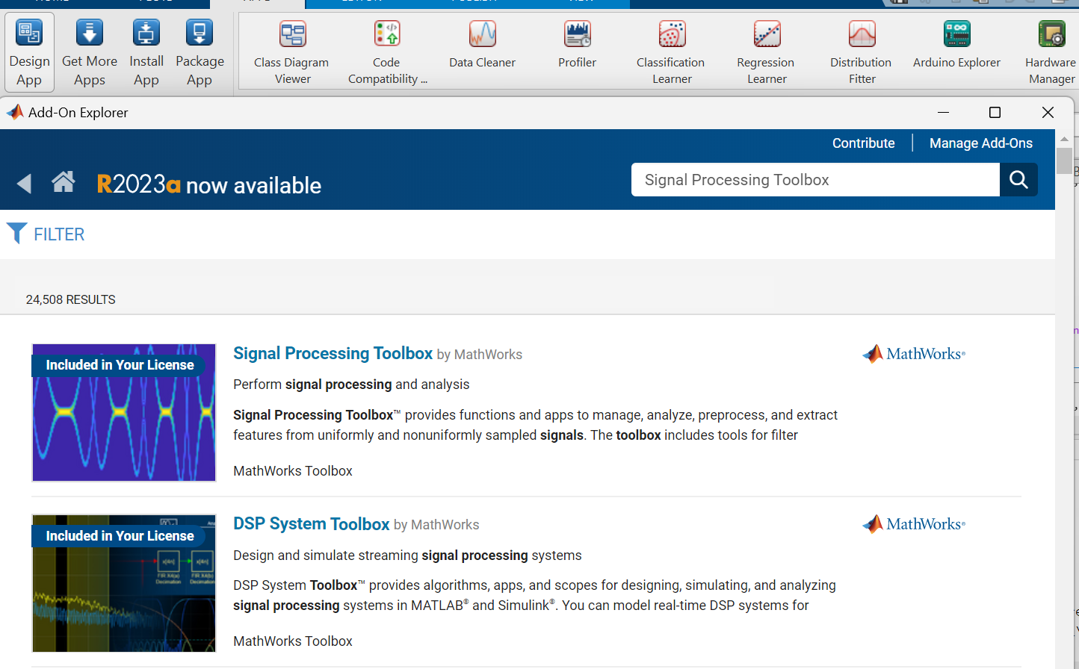
And the “Communications Toolbox”

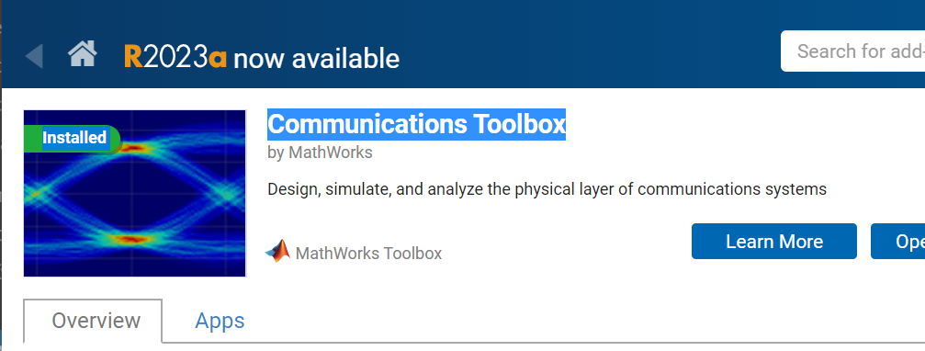

2. Screen set up
It is better to use the monitor with a fresh rate set to 100 f/s so that the duration of the visual stimuli can be presented more precisely.
Participants should be seated at a distance of 60 cm from the monitor, with their heads stabilized using a chin and forehead rest.

3. Auditory devices
Put the loudspeakers on each side of the monitor, and set the volume to half of the maximum. Set the sound output of the computer to 50% of the maximum.

4. Execution
- Each experiment is conducted separately by running the “run_all.m” file with different “Exp No.”. (note that the order of each task is counterbalanced so that the task can be different even if the “Exp No.” is the same for different participants)
- Each experiment has a training phase and a formal test phase (should re-run the “run_all.m” file to specify whether it is a practice or a formal experiment), before the training phase starts, the experimenter should give a short introduction to the participant.
- NOTE: it is very important to tell participants not to use strategy (counting, beating, etc.) in duration discrimination experiments (exp. 1/2/3).
- After each formal phase, the result will be stored in “results/Sub_xxx/”.
- Example:
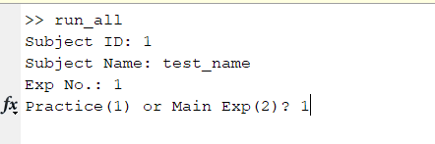
- Keynotes for introducing each experiment to participants:
  - 1_duration_visual: fixate on the center of the screen; ignore the size change of the ball, focus on the duration; do not use strategy.
  - 2_duration_auditory: fixate on the center of the screen; compare the duration of the continuous tone and the duration between two clicks; do not use strategy.
  - 3_duration_crossmodal: fixate on the center of the screen; do not use strategy.
  - 4_lumincance_visual_kanisza: fixate on the center of the screen; ignore the background of the rectangle.
  - 5_sifi_crossmodal: fixate on the center of the screen; ignore the sound.

- Do not press “esc” / “escape” during the experiment as that may stop it. Perhaps tell the participant the same.

Errors
If you get red text.
Restart Matlab
If it continues
Restart the computer and restart Matlab
If it continues
Redownload: https://github.com/timokvamme/japan_cost
If it continues

Panic.
Then Write
Timokvamme@gmail.com Or chenhao0709@gmail.com

