Formatting Instructions for C.S. Honors Projects

Timothy W. O’Neil

Department of Computer Science

Honors Research Project

Submitted to

The Honors College

Approved: Accepted:

______________________ Date ________ __________________ Date _________
Honors Project Sponsor (signed) Department Head (signed)

______________________________ _______________________
Honors Project Sponsor (printed) Department Head (printed)

______________________ Date _______ __________________ Date ________
Reader (signed) Honors Faculty Advisor (signed)

_________________________ _____________________________
Reader (printed) Honors Faculty Advisor (printed)

______________________ Date _______ __________________ Date _________
Reader (signed) Dean, Honors College

_________________________________

Reader (printed)

ABSTRACT

Write your abstract for your Senior Honors Project here. The abstract should provide a brief overview of your project. The abstract should be in paragraph form, double-spaced with 12 point font. Abstracts have a maximum of 200 words! Once you have finished your abstract, save it as a Microsoft document and send your abstract to dgannon@uakorn.edu.
Your abstract should be prepared according to the following guidelines:
- In your first few sentences, define your project indicating its purpose, scope, and limits.
- Then describe, as concisely and clearly as you can, what you did, what you found, and what made it worth doing. In this part you summarize your research methods and design, your major findings and conclusions, the significance of your investigation and so forth.
- The final version of the title for your project should include, as appropriate to your field of study, the subject words with which it would be located through a scholarly index.
The abstract must be perfect in spelling, punctuation, grammar, and syntax.
CHAPTER 1
INTRODUCTION
This document is intended as a template for Senior Honors Project Reports in the Computer Science Department. Consult your sponsor, readers, and Honors College personnel for information about final paper submission.
CHAPTER 2
PAGE LAYOUT
An easy way to comply with the department’s formatting requirements is to use this document as a template and simply type your text into it.
  - Page Layout
Your paper should use a letter-size paper (8½” – by – 11”). The margins must be set as follows:
- Top and bottom = 1”
- Left and right = 1¼”
- Chapter header = 1"
Double-space, fully justify and use ½” paragraph indentation.
1.2 Specific Requirements
Your final manuscript should include, in order:
- Signature page, including title and author information.
- Abstract.
- Introduction chapter, clearly explaining the nature of the problem, previous work, purpose and contribution of the paper.
- Body of paper, with multiple chapters detailing the work performed.
- Conclusion chapter, clearly indicating the advantages, limitations and possible applications of the described work.
- References chapter.

CHAPTER 3
PAGE STYLE
All paragraphs must be indented. All paragraphs must be justified, i.e. both left-justified and right-justified.
3.1 Text Font of Entire Document
The entire document should be in 12-point Times New Roman font. Other font types (e.g. Symbol) may be used if needed for special purposes.
3.2 Title and Author Details
All title and author details must be in single-column format and must be centered.
Every word in a title must be capitalized except for short minor words such as “a”, “an”, “and”, “as”, “at”, “by”, “for”, “from”, “if”, “in”, “into”, “on”, “or”, “of”, “the”, “to”, “with”.
To avoid confusion, the family name must be written as the last part of each author name (e.g. John A.K. Smith).
3.3 Section Headings
No more than 3 levels of headings should be used. Every word in a heading must be capitalized except for short minor words as listed above.

3.3.1 Chapter Heading
A chapter heading is to be in all capital letters, centered and numbered using Arabic numerals. (For example, see heading “Chapter 3. Page Style” of this document.) The two chapter headings which must not be numbered are “Abstract” and “References”.
3.3.2 Section Heading
A section heading must be left-justified and numbered using an Arabic numeral representing the chapter number, a period, and another Arabic numeral. For example, see heading “3.3. Section Headings” above.
3.3.3 Subsection Heading
A subsection heading must be left-justified and numbered with the section number, a period, and an Arabic numeral. For example, this paragraph begins with a level-3 heading.
4. Figures and Tables
Figures and tables must be centered in the page. Large figures and tables should be positioned either at the top or at the bottom of the page and not broken across multiple pages.
Graphics may be full colour. Please use only SOLID FILL colours which contrast well both on screen and on a black-and-white hardcopy, as shown in Figure 1 below.

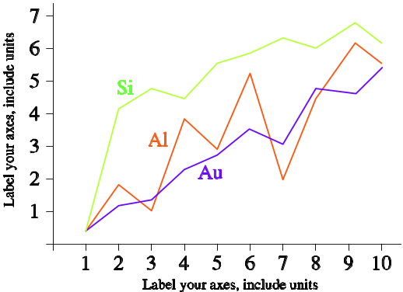
Fig. 1 A sample line graph using colours which contrast well both on screen and on a black-and-white hardcopy
Figure 2 shows an example of a low-resolution image which would not be acceptable, whereas Figure 3 shows an example of an image with adequate resolution. Check that the resolution is adequate to reveal the important detail in the figure.

Fig. 2 Example of an unacceptable low-resolution image
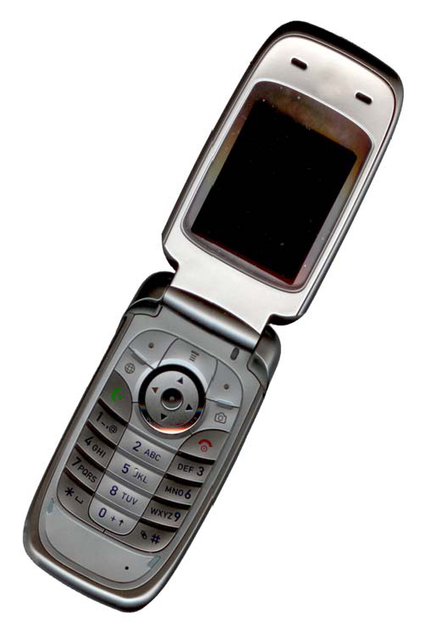
Fig. 3 Example of an image with acceptable resolution
Please check all figures in your paper both on screen and on a black-and-white hardcopy. When you check your paper on a black-and-white hardcopy, please ensure that:
- the colours used in each figure contrast well,
- the image used in each figure is clear,
- all text labels in each figure are legible.
5. Figure and Table Captions
Figures and tables must be numbered using Arabic numerals. Figure and table captions must be in 12 pt Times New Roman font and centered. Captions with figure or table numbers must be placed after their associated figures and tables, as shown in Figure 1.
6. Page Numbers, Headers and Footers
Page numbers, headers and footers must not be used.
7. Links and Bookmarks
All hypertext links and section bookmarks will be removed from papers during processing. If you need to refer to an Internet email address or URL in your paper, you must type out the address or URL fully in Times New Roman font.

CHAPTER 4
BIBLIOGRAPHICAL REFERENCES
Number citations consecutively within brackets [1]. The sentence punctuation follows the bracket [2]. Refer simply to the reference number, as in [3]—do not use “Ref. [3]” or “reference [3]” except at the beginning of a sentence: “Reference [3] was the first . . .”
Number footnotes separately in superscripts. Place the actual footnote at the bottom of the page in which it was cited. Do not put footnotes in the reference list. Use letters for table footnotes.
Unless there are six authors or more give all authors' names; do not use “et al.” Papers that have not been published, even if they have been submitted for publication, should be cited as “unpublished” [4]. Papers that have been accepted for publication should be cited as “in press” [5]. Capitalize only the first word in a paper title, except for proper nouns and element symbols.
For papers published in translation journals, please give the English citation first, followed by the original foreign-language citation [6].

ACKNOWLEDGEMENT
The contents of this document are derived from the formatting instructions for authors from the (jpcc) and Parallel and Distributed Computing and Networks (Acta Press).

REFERENCES
- S. M. Metev and V. P. Veiko, Laser Assisted Microtechnology, 2nd ed., R. M. Osgood, Jr., Ed. Berlin, Germany: Springer-Verlag, 2005.
- S. Zhang, C. Zhu, J. K. O. Sin, and P. K. T. Mok, “A novel ultrathin elevated channel low-temperature poly-Si TFT,” IEEE Electron Device Lett., vol. 20, pp. 569–571, Nov. 1999.
- M. Wegmuller, J. P. von der Weid, P. Oberson, and N. Gisin, “High resolution fiber distributed measurements with coherent OFDR,” in Proc. ECOC’00, 2000, paper 11.3.4, p. 109.
- R. E. Sorace, V. S. Reinhardt, and S. A. Vaughn, “High-speed digital-to-RF converter,” U.S. Patent 5 668 842, Sept. 16, 2007.
- (2002) The IEEE website. [Online]. Available: http://www.ieee.org/
- M. Shell. (2002) IEEEtran homepage on CTAN.
- archive/macros/latex/contrib/supported/IEEEtran/
- FLEXChip Signal Processor (MC68175/D), Motorola, 2010.
- “PDCA12-70 data sheet,” Opto Speed SA, Mezzovico, Switzerland.
- A. Karnik, “Performance of TCP congestion control with rate feedback: TCP/ABR and rate adaptive TCP/IP,” M. Eng. thesis, Indian Institute of Science, Bangalore, India, Jan. 2009.
- J. Padhye, V. Firoiu, and D. Towsley, “A stochastic model of TCP Reno congestion avoidance and control,” Univ. of Massachusetts, Amherst, MA, CMPSCI Tech. Rep. 99-02, 2008.
- J. Breckling, Ed., The Analysis of Directional Time Series: Applications to Wind Speed and Direction, ser. Lecture Notes in Statistics. Berlin, Germany: Springer, 2008, vol. 61.

