**Image Analysis Program for VRmagic USB Cameras**

This manual presents an image viewer with integrated analysis tools for VRmagic USB cameras. The images are displayed live. Furthermore the program can detect a Gaussian beam in a region of interest (ROI). Additional data of the ROI and the Gaussian beam is also displayed.

For questions: michael.hoese@physik.uni-muenchen.de

# Preparations

Before the image viewer program can be started, two programs have to be installed on the computer:

1. From <https://www.vrmagic.com/de/imaging/downloads/> download the suitable “VRmUsbCam DevKit” and install it on your computer.
2. If not installed yet, install “pyqtgraph” on your computer. A manual can be found on <http://www.pyqtgraph.org/>.
3. In the AFS of the group go to: \lithium\engineering\software\PythonStuff_Michael\VRmagicUSBCam

The “Python” folder contains the “Git” – repository of the Image Analysis program.

# Overview

The folder contains the Python files “GaussBeamSimulation.py”, “MathematicalTools.py”, “VRmUsbCamAPI.py” and “ImageViewerTemplate.py”. These four files have to be kept in the same folder as the main program “ImageViewer.py”. Furthermore the file “vrmusbcam2.dll” is contained in the folder and has to be kept there for the main program to work. Additionally a manual and a list of suggested improvements can be found there.

To start the program call “python ImageViewer.py” in the terminal. Make sure the Variable “RealData” in “ImageViewer.py” is set to “True” when you want to use a camera. If it is set to “False” a simulation for testing purposes is started.

# Settings

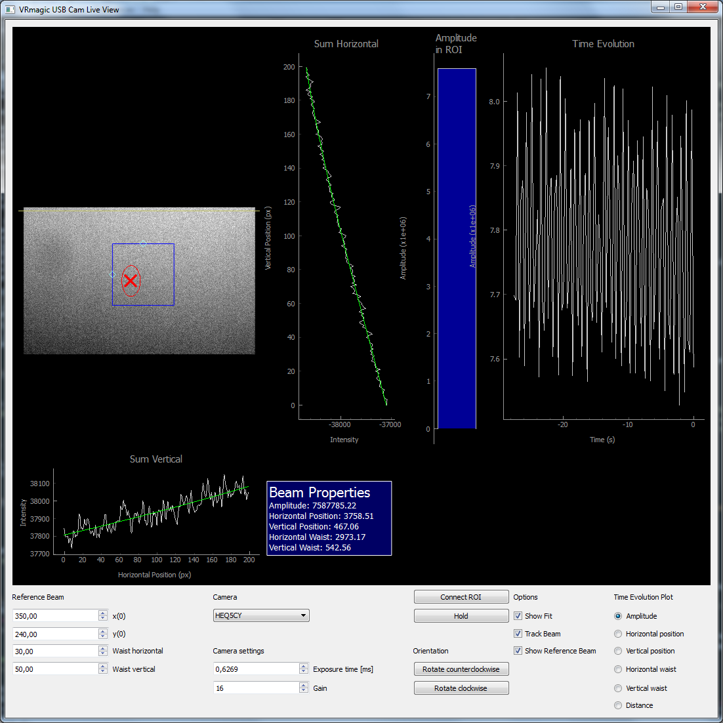

Several options can be modified. On the far left side the properties of the reference beam can be adjusted. In the box “camera”, the camera can be choosen out of the available cameras. They are identified by their serial ID. Furthermore the exposure time and the gain can be adjusted. The “Connect ROI” button connects the ROI to the beam position. This means that the ROI is moved together with the beam position, that is detected. The “Hold” button pauses the live view. The image can also be rotated clockwise and counterclockwise. Additionally, one can choose wether the reference beam, the detected beam or the fit should be shown. The time evolution plot on the right side shows the evolution of several properties. The one shown can be chosen below.

By right – clicking on the plots, the automatic scaling can be switched off and the scaling can be adjusted manually.