Introduction
- Few studies explored invasive neural signals in OCD and their relationship with clinical scores.
- Acute neural representations of obsessions, compulsions and current distress were analyzed within subcortical OCD DBS targets (Fridgeirsson et al 2023, Arbab et al 2025 Nature Mental Health). Additionally, long-term neural signatures within the VC/VS stimulation target were identified in response to DBS therapy (Provenza et al 2024).
- Here we examined short resting-state in-clinic recordings to identify neural signatures that track OCD, depression and mania symptom fluctuations across the duration of DBS treatment.
- Neural correlates could thus serve as a symptom-trajectory read-out and potentially improve clinical DBS programming.
- We computed a set of previously clinical relevant and interpretable features based on time-series local field potentials. We quantified, in addition to commonly used oscillatory band-power, separation of periodic and aperiodic components, which showed previously high clinical and behavioural relevance (Hacker et al 2025, https://doi.org/10.1016/j.bpsc.2024.10.019, Donoghue et al https://www.nature.com/articles/s41593-020-00744-x). Furthermore, quantification of temporal waveform shape (Cole et al 2017 DOI: 10.1016/j.tics.2016.12.008, Jackson et al 2019 DOI: 10.1523/ENEURO.0151-19.2019) and bursting features (Lofredi et al 2023 https://www.nature.com/articles/s41531-022-00443-3, Tinkhauser et al 2017 https://doi.org/10.1093/brain/awx252) were computed, due to their implication as previous presented biomarkers in different disorders treated with DBS.

Methods
- We computed electrophysiological characteristics from the ventral capsule striatum ventral (VCVS) using DBS-LFP signals and from orbitofrontal cortex (OFC) electrocorticography (ECoG). We sought to identify the region and local field potential features that correlate strongest with clinical scores.
- Therefore, we recorded resting-state invasive electrophysiological recordings from 8 patients. In addition to DBS-LFP signals, we acquired ECoG recordings of five patients.
- For each clinical visit we measured clinical scores that reflect the diverse symptomatology of OCD: OCD total scores (YBOCS II Total), obsessions (YBOCS II Obsessions), compulsions (YBOCS II Compulsions), self-rated depression (BDI Total), clinician-rated depression (HDRS Total) and mania (YMRS Toal).
- For each resting-state recording we computed an aggregate measure of different local field potential characteristics.
- First, we separated data into batches of 10 s. Since we recorded data with therapeutic effective stimulation ON, stimulation-related artifacts contaminated signal quality. Therefore, we manually annotated device artifacts (potentially cite CNS presentation Diab et al 2024 10.1227/neu.0000000000003360_252)?, and remove 10 s batches if artifacts were present.
- Next, we notch-filtered data around the 60 Hz line noise, bandpass filtered between 0.5 Hz and 100 Hz, and low-pass filtered at 100 Hz twice to remove the stimulation artifact (mne-python version 1.9.0, Gramfort et al 2013).
- Subsequently, we extracted local field potential features from each channel. We first estimated oscillatory power using Welch’s method (scipy v1.16.0; Virtanen et al., 2020). We then used the log-transformed power spectra to characterize the aperiodic components with FOOOF (v1.1.1; Donoghue et al., 2019), applying a fitting range of 10–50 Hz, a peak width limit of 0.5–12 Hz, and a fixed aperiodic fitting mode.
- We computed band-power in different frequency bands: delta (0 – 4 Hz), theta (4 – 8 Hz), alpha (8 – 15 Hz), beta (15 – 30 Hz) and low gamma (30 – 55 Hz), and normalized each band-power estimate by the sum of the of the complete power spectrum.
- In each of the defined frequency band, we computed the mean burst duration and burst amplitude given the 75th percentile threshold of the 50 Hz resampled band-pass and Hilber-transformed power estimate.
- We computed Hjorth activity, mobility and complexity features (Hjorth et al 1970) and temporal waveform-shape as previously described (Merk et al 2023, https://doi.org/10.21203/rs.3.rs-3212709/v1). In brief, we bandpass-filtered signals in 1 – 5 Hz and 1 – 12 Hz ranges, estimated the peaks and troughs (find_peaks function, scipy version 1.16.0, Virtanen et al 2020), and computed the interval, prominence and sharpness of detected temporal waveform events as previously described (Merk et al 2025, DOI: 10.21105/joss.08258).
- We then computed the median feature measure within each resting recording, and estimated the Pearson correlation between all neural features and clinical scores for each patient and recording site.

Results
For cortical OFC and subcortical VC/VS regions we computed a set of different local field potential characteristics, such as band-power, spectral aperiodic components, bursting, temporal waveform-shape and Hjorth features using the py_neuromodulation toolbox (Merk et al 2025, DOI: 10.21105/joss.08258).
By computing a verity of different LFP measures, we aimed to capture different optimal signals that correlate strongest with clinical scores.
Due to the implanted ECoG OFC electrodes, we could additionally investigate the optimal sensing site for symptom read-out.
We found that for different clinical scores (YBOCS II Total, Compulsions, Obesessions, BDI, HDRS and YMRS) the average best OFC feature correlations were higher than VC/VS scores (Figure Y a).
For YBOCS-II scores the comparison was significant for all tested scores (OFC mean r = pm std, VC/VS mean r = pm std, relative permutation test p = ).
Overall, we found significant correlations for each individual patient for YBOCS II Total scores. Individual best features tracked symptom scores with high correlations (Figure X b+c).
We identified a different set of best features for both OFC and VC/VS. For the OFC, highest correlating features were Hjorth activity, delta burst duration and aperiodic exponent, while for the VC/VS region gamma, beta power and aperiodic exponents resulted in highest correlations.
Additionally, we quantified grouped correlations by feature type (Figure Xe). This analysis showed strong patient-to-patient variation. While for individual patients feature correlations were high, the overall cohort-average was reduced by outliers with correlations often showing opposite sign.
We identified overall highest absolute correlation feature modalities for OFC to be delta burst amplitude (mean Pearson r pm std, p=) and for VC/VS aperiodic offset (mean r pm std, p=).
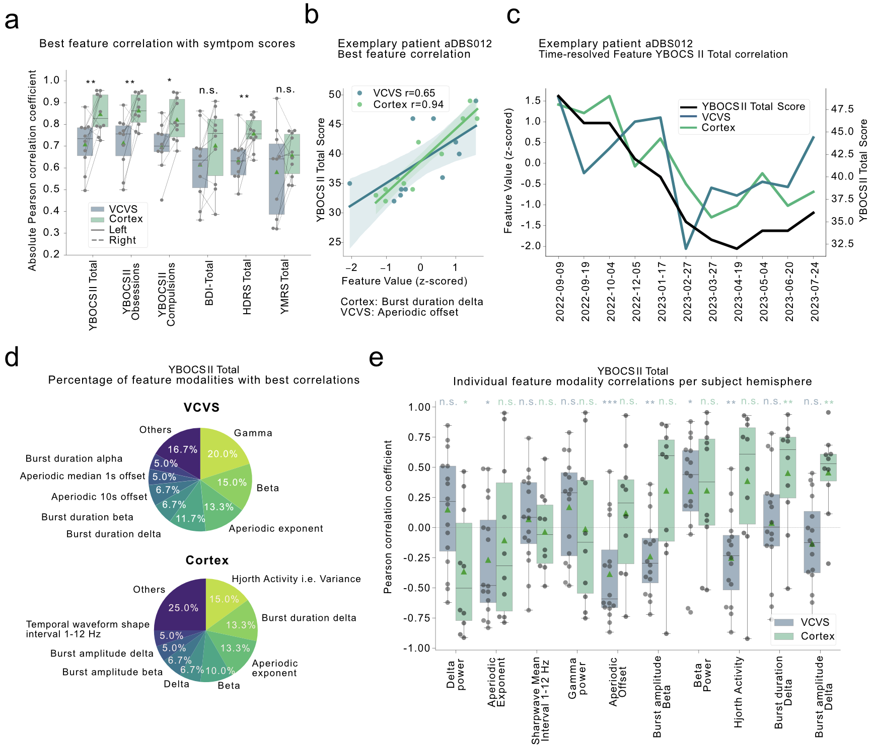

Discussion
Our results highlight the potential of utilizing cortical recordings in addition to subcortical DBS-LFP recordings.
Cortical recordings were shown to be an optimal feedback signal for aDBS in PD (Oehrn et al 2024, Nature Medicine) and significantly outperformed subcortical recordings for decoding in PD (Merk et al 2021 eLife).
While recent DBS implants improved sensing quality (Stanslaki et al 2018, DOI: 10.1109/TBCAS.2018.2880148), ECoG recordings offer improved signal quality with diminished stimulation artifacts (Herron et al 2025 Nature BME https://doi.org/10.1038/s41551-024-01314-3). Additionally, previous studies showed that cortical recordings have overall higher signal amplitude by multiple magnitudes (Bush et al 2024, Cereb. Cortex).
Here we present significantly higher symptom correlations in the OFC compared to VC/VS. In addition to YBOCS II correlations, we found the same effect for depression and mania scores. For the development of future aDBS designs, complementing symptom read-outs could be identified to guide patient-individual programming. The high neural feature correlation with YMRS mania symptoms could also guide programming by including a OCD-specific measure for stimulation-related side-effects (maybe Koning et al 2016 Translational Psychiatry?).
Our results present an optimal set of features specific for each patient. We did not find a converging biomarker signal that generalized across patients (Figure Xe). This result highlights the need of larger cohort sizes to quantify patient-to-patient variability and heterogeneity within psychiatric disorders.
Furthermore, this finding calls for methods that can prospectively quantify symptom variations and therapy response states. Our results show that during short resting-state recordings, there exist patient-individual signal chrematistics that track symptom fluctuations with high correlations over time.
Future neuromodulation strategies could therefore incorporate cortical and subcortical neural recordings to guide DBS programming in psychiatric disorders.

