# Kleuren:

Primair: rgba(255, 255, 255, 0.15)  
Highlight: #00FF00

Color: #00FF00

# Lettertype:

1 em = 16px

<H1>4.688em<h3> 2.188em

<h3> 1.17em

<p>1em

Background

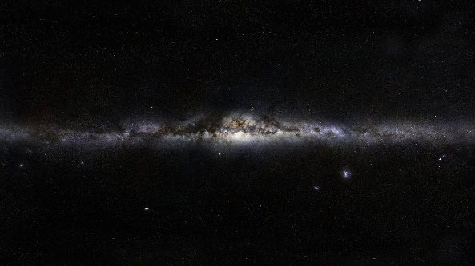

Logo

