*SOAP manipulation*, Web Services TP

A project by Timothé CHAUVET and Camille MATHIEU

# Introduction

After learning how to make a rudimentary database and connect it to a web service we had to learn SOAP, we decided to follow the same principle and creates interconnected classes:

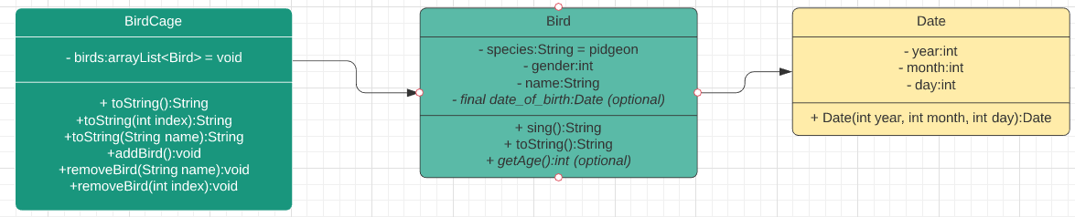

# Generating the SOAP response

When first loaded, the SOAP API generates a WSDL file in XML that sends all information necessary to connect from the Web service to the client.

<types>

        <!-- Imports the XSD schema for this XML file -->

        <xsd:schema>

            <xsd:import namespace="http://tp4jax.efrei.com/" schemaLocation="http://localhost:8080/WS/MonServiceWeb?xsd=1"/>

        </xsd:schema>

    </types>

    <!-- Creates the entity in the interface WS implementation -->

    <message name="createEntity">

        <part name="parameters" element="tns:createEntity"/>

    </message>

    <message name="createEntityResponse">

        <part name="parameters" element="tns:createEntityResponse"/>

    </message>

    <!-- The entity is created and a port is associated -->

    <portType name="InterfaceWebService">

        <operation name="createEntity">

            <!-- The entity request -->

            <input wsam:Action="http://tp4jax.efrei.com/InterfaceWebService/createEntityRequest" message="tns:createEntity"/>

            <!-- The entity answer -->

            <output wsam:Action="http://tp4jax.efrei.com/InterfaceWebService/createEntityResponse" message="tns:createEntityResponse"/>

        </operation>

    </portType>

    <!-- The SOAP API binding -->

    <binding name="InterfaceWebServiceImplPortBinding" type="tns:InterfaceWebService">

        <soap:binding transport="http://schemas.xmlsoap.org/soap/http" style="document"/>

        <operation name="createEntity">

            <soap:operation soapAction=""/>

            <input>

                <soap:body use="literal"/>

            </input>

            <output>

                <soap:body use="literal"/>

            </output>

        </operation>

    </binding>

    <!-- Launching of the server for the WS -->

    <service name="InterfaceWebServiceImplService">

        <port name="InterfaceWebServiceImplPort" binding="tns:InterfaceWebServiceImplPortBinding">

            <soap:address location="http://localhost:8080/WS/MonServiceWeb"/>

        </port>

    </service>

# Creating the Interface

fuck