Exp-12:
Develop test cases for the above containerized application using selenium.
1.Create a Folder my-regi-from
2.Folder should be like the following screen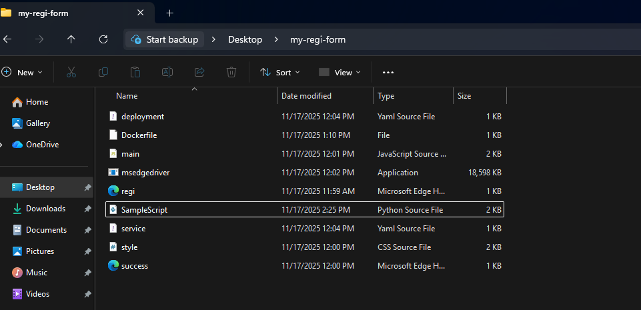
3.regi.html:
<!DOCTYPE html>
<html>
<head>
<title>Registration Form</title>
<link rel="stylesheet" href="style.css">
<script defer src="main.js"></script>
</head>
<body>
<div class="container">
<h2>Registration Form</h2>

<form id="regForm">
<label>Username</label>
<input type="text" id="username">
<span class="error" id="usernameError"></span>
<label>Email</label>
<input type="text" id="email">
<span class="error" id="emailError"></span>
<label>Password</label>
<input type="password" id="password">
<span class="error" id="passwordError"></span>
<label>Confirm Password</label>
<input type="password" id="confirmPassword">
<span class="error" id="confirmPasswordError"></span>
<button type="submit" id="registerBtn">Register</button>
</form>
</div>
</body>
</html>
Style.css:
body {
font-family: Arial, sans-serif;
background: #eef2f3;
margin: 0;
padding: 0;
}

.container {
width: 350px;
margin: 70px auto;
background: white;
padding: 25px;
border-radius: 10px;
box-shadow: 0 0 10px #aaa;
}

h2 {
text-align: center;
color: #333;
}

label {
font-weight: bold;
display: block;
margin-top: 15px;
}

input {
width: 100%;
padding: 8px;
margin-top: 4px;
border: 1px solid #aaa;
border-radius: 5px;
}

button {
width: 100%;
padding: 10px;
margin-top: 20px;
background: #005bbb;
color: white;
border: none;
border-radius: 5px;
font-size: 16px;
cursor: pointer;
}

button:hover {
background: #004199;
}

.error {
color: red;
font-size: 12px;
}

.success-box {
width: 300px;
margin: 100px auto;
background: white;
padding: 25px;
border-radius: 10px;
text-align: center;
}

.back-btn {
display: inline-block;
margin-top: 20px;
background: #009900;
padding: 10px 20px;
color: white;
border-radius: 6px;
text-decoration: none;
}

.back-btn:hover {
background: #007700;
}
Success.html:
<!DOCTYPE html>
<html>
<head>
<title>Registration Successful</title>
<link rel="stylesheet" href="style.css">
</head>
<body>
<div class="success-box">
<h2>Registration Successful!</h2>
<p>You have registered successfully.</p>
<a href="reg.html" class="back-btn">Go Back</a>
</div>
</body>
</html>
Main.js:
document.getElementById("regForm").addEventListener("submit", function(event) {
event.preventDefault();

// Clear errors
document.getElementById("usernameError").innerText = "";
document.getElementById("emailError").innerText = "";
document.getElementById("passwordError").innerText = "";
document.getElementById("confirmPasswordError").innerText = "";
let valid = true;
// Input values
let username = document.getElementById("username").value.trim();
let email = document.getElementById("email").value.trim();
let password = document.getElementById("password").value;
let confirmPassword = document.getElementById("confirmPassword").value;
// Validation
if (username === "") {
document.getElementById("usernameError").innerText = "Username is required";
valid = false;
}
if (email === "") {
document.getElementById("emailError").innerText = "Email is required";
valid = false;
} else if (!email.includes("@") || !email.includes(".")) {
document.getElementById("emailError").innerText = "Enter valid email";
valid = false;
}

if (password === "") {
document.getElementById("passwordError").innerText = "Password is required";
valid = false;
}

if (confirmPassword === "") {
document.getElementById("confirmPasswordError").innerText = "Please confirm password";
valid = false;
} else if (password !== confirmPassword) {
document.getElementById("confirmPasswordError").innerText = "Passwords do not match";
valid = false;
}
// Final success redirect
if (valid) {
window.location.href = "success.html";
}
});
Deployment.yaml:
apiVersion: apps/v1
kind: Deployment
metadata:
name: my-regi-form
labels:
app: my-regi-form
spec:
replicas: 2
selector:
matchLabels:
app: my-regi-form
template:
metadata:
labels:
app: my-regi-form
spec:
containers:
- name: my-regi-form
image: my-regi-form:latest # or your-dockerhub-name/my-regi-form:v1
ports:
- containerPort: 8084

Service.yaml:
apiVersion: v1
kind: Service
metadata:
name: my-regi-form-service
spec:
selector:
app: my-regi-form
type: NodePort
ports:
- protocol: TCP
port: 8084 # service port
targetPort: 8084 # container port
nodePort: 30084 # external port on Node

Dockerfile:
FROM nginx:alpine
COPY regi.html /usr/share/nginx/html/regi.html
COPY style.css /usr/share/nginx/html/style.css
COPY main.js /usr/share/nginx/html/main.js
COPY success.html /usr/share/nginx/html/success.html
EXPOSE 8084
SampleScript.py:
import time
from selenium import webdriver
from selenium.webdriver.common.by import By
from selenium.webdriver.support.ui import WebDriverWait
from selenium.webdriver.support import expected_conditions as EC
from selenium.webdriver.edge.service import Service
from selenium.webdriver.edge.options import Options

print("Test Execution Started")

# Set Edge driver path
driver_path = r"C:\Users\BDALAB-33\Desktop\my-regi-form\msedgedriver.exe"

options = Options()
options.add_argument('--ignore-ssl-errors=yes')
options.add_argument('--ignore-certificate-errors')
options.add_argument("--disable-logging")
options.add_experimental_option("excludeSwitches", ["enable-logging"])

service = Service(driver_path)
driver = webdriver.Edge(service=service, options=options)

try:
# Load your registration form (update if needed)
driver.get("http://localhost:8084/regi.html")
print("Navigated to registration form...")

# Wait and fill username
username = WebDriverWait(driver, 10).until(
EC.presence_of_element_located((By.ID, "username"))
)
username.send_keys("testuser")

# Fill email
email = driver.find_element(By.ID, "email")
email.send_keys("test@mail.com")

# Fill password
password = driver.find_element(By.ID, "password")
password.send_keys("Test@123")

# Fill confirm password
confirm = driver.find_element(By.ID, "confirmPassword")
confirm.send_keys("Test@123")

# Click Register button
register = driver.find_element(By.ID, "registerBtn")
register.click()

print("Form submitted successfully!")

time.sleep(4)

except Exception as e:
print("Error occurred:", e)

finally:
driver.quit()
print("Test Execution Finished")

Steps to Run the Folder:
- Go to Docker Terminal:
pip install selenium
docker pull selenium/standalone-chrome
- docker build -t my-regi-form .
- docker run -d -p 8084:80 my-regi-form
- http://localhost:8084/reg.html
- In terminal python SampleScipt.py

Screenshots:


