APARTMENT COMMUNITY MANAGEMENT APP

A Project Submitted

By

SHETKAR SAGAR (24261A05Q9)
SRINIVAS KONALA (24261A05R0)
SYED SALEM (24261A05R1)
T SPARSH SINGH (24261A05R2)

Under the esteemed guidance of
Dr. Vootla Subbaramiah



Department of Computer Science and Engineering
MAHATMA GANDHI INSTITUTE OF TECHNOLOGY
(Autonomous)
Chaitanya Bharathi P.O., Gandipet, Hyderabad–500 075

2026-2027


CERTIFICATE

This is to certify that the Laboratory project titled “Apartment Community Management App” is submitted by SHETKAR SAGAR (24261A05Q9), SRINIVAS KONALA (24261A05R0), SYED SALEM (24261A05R1) AND T. SPARSH SINGH (24261A05R2) to the Computer Science and Engineering, Mahatma Gandhi Institute of Technology for UI Design - Flutter lab course in B. Tech V Semester during the academic year 2026-2027.

Project Guide

Dr. Vootla Subbaramiah
Department of Computer Science and Engineering

1. ABSTRACT
Apartment Community Management App is a Flutter mobile application prototype that brings routine apartment operations into one responsive interface. Residents can submit visitor requests, report maintenance issues, view announcements, and reserve shared facilities. The project demonstrates how a clean UI can coordinate several everyday workflows while keeping each task concise and easy to track.
The application is designed as a UI Lab project, so its primary emphasis is Flutter widgets, layouts, visual consistency, navigation, validation, state changes, animation, REST-style data handling, and UI testing. A lightweight local repository is used in the prototype so screens can be demonstrated without depending on a live backend.

2. INTRODUCTION
Apartment communities often communicate through calls, paper registers, and informal message groups. Those channels make it difficult to find announcements, know whether a complaint was received, or confirm an amenity booking. A single mobile interface can reduce this friction by placing common resident actions behind clear navigation and short forms.
The proposed application uses a resident dashboard as the central point of interaction. From the dashboard, a user can see current announcements, open quick actions, review service requests, and navigate to visitor, maintenance, facility, and profile modules. The screen hierarchy remains intentionally simple so the project is suitable for a Flutter UI laboratory demonstration.

3. OBJECTIVES OF THE PROJECT
• Design a responsive Flutter interface for typical apartment-community workflows.
• Use Material widgets, custom cards, themes, and reusable UI components to maintain a consistent experience.
• Implement named-route navigation between dashboard, visitor, maintenance, announcement, booking, and profile screens.
• Create validated forms for visitor requests and maintenance complaints with clear error feedback.
• Demonstrate local state handling, simple animations, REST-style asynchronous data loading, and widget tests.

4. SOFTWARE AND TECHNOLOGIES REQUIRED
Item | Purpose in the project
Flutter SDK and Dart | Build the cross-platform interface and application logic.
Android Studio or VS Code | Edit, run, debug, and inspect the Flutter application.
Android emulator or device | Preview responsive layouts and interactions.
Provider package | Manage shared UI state such as selected tab and request status.
http package or mock service | Demonstrate asynchronous REST-style announcement data.
Flutter test framework | Verify form validation, widgets, and navigation behaviour.

5. FUNCTIONAL REQUIREMENTS
Module | Resident action | Expected result
Dashboard | Open the application and choose a quick action. | See summary cards, latest announcements, and navigation.
Visitor requests | Enter visitor name, phone, vehicle, and visit time. | Validated request is saved and shown as pending.
Maintenance | Select a category and describe a complaint. | Ticket receives a status such as Open or In Progress.
Announcements | View notices fetched from a service layer. | Notices are shown in a readable, scrollable feed.
Facility booking | Choose an amenity, date, and time slot. | Booking confirmation appears after availability checks.

6. SYSTEM DESIGN

6.1 Application architecture
The prototype follows a presentation-focused architecture. Screens are responsible for layout and user interaction, reusable widgets reduce repeated code, providers hold changeable UI state, and repositories expose asynchronous data methods. This separation keeps UI code readable and makes a later API integration straightforward.
Layer | Responsibility | Examples
Presentation | Renders screens and reacts to taps, form submission, and navigation. | DashboardScreen, VisitorFormScreen
Reusable widgets | Provides consistent visual components across screens. | QuickActionCard, StatusChip, AppScaffold
State | Stores selected navigation index, requests, and loading states. | CommunityProvider
Data | Loads announcement and booking data asynchronously. | AnnouncementRepository, MockApiService

6.2 Navigation flow
Start | Primary route | Supporting routes
App launch | Dashboard | Announcements, profile
Quick action | Visitor request | Visitor history, request detail
Quick action | Maintenance | Ticket history, ticket detail
Quick action | Facility booking | Available slots, confirmation

6.3 Widget hierarchy
MaterialApp
└─ AppScaffold
├─ BottomNavigationBar
├─ DashboardScreen
│ ├─ WelcomeHeader
│ ├─ QuickActionGrid
│ └─ AnnouncementList
├─ VisitorFormScreen
├─ MaintenanceFormScreen
├─ FacilityBookingScreen
└─ ProfileScreen

7. USER INTERFACE DESIGN

7.1 Theme and reusable components
The visual language uses a deep blue primary color, pale blue surface tint, rounded cards, clear icons, and dark text. The theme centralizes fonts, colors, input decoration, and button shapes. Reusable widgets prevent visual drift between modules and satisfy the requirement for custom UI elements.
Component | Purpose | Key Flutter widgets
AppScaffold | Provides page title, body spacing, and bottom navigation. | Scaffold, AppBar, NavigationBar
QuickActionCard | Presents a prominent dashboard shortcut. | InkWell, Card, Icon, Column
StatusChip | Communicates request or booking status. | Container, Text, DecoratedBox
EmptyState | Explains a screen with no current records. | Icon, Text, FilledButton

7.2 Responsive layout strategy
A LayoutBuilder selects a two-column action grid on wide screens and a two-column compact grid on phones. Cards use flexible width rather than fixed pixels. Forms are placed inside a constrained scroll view so keyboard input and smaller screens remain usable. MediaQuery padding is used to respect device safe areas.
LayoutBuilder(
builder: (context, constraints) {
final crossAxisCount = constraints.maxWidth >= 700 ? 4 : 2;
return GridView.count(
crossAxisCount: crossAxisCount,
childAspectRatio: constraints.maxWidth >= 700 ? 1.35 : 1.05,
children: actions.map((item) => QuickActionCard(item)).toList(),
);
},
)

8. IMPLEMENTATION

8.1 Named route configuration
MaterialApp(
initialRoute: '/',
routes: {
'/': (_) => const DashboardScreen(),
'/visitor': (_) => const VisitorFormScreen(),
'/maintenance': (_) => const MaintenanceFormScreen(),
'/booking': (_) => const FacilityBookingScreen(),
},
)
Named routes make the flow easy to inspect during demonstration. Buttons call Navigator.pushNamed with only the required route name, while detail pages can receive typed arguments when the project is extended.

8.2 Stateful visitor form and validation
final _formKey = GlobalKey<FormState>();
void _submitRequest() {
if (_formKey.currentState!.validate()) {
context.read<CommunityProvider>().addVisitorRequest(
VisitorRequest(name: _name.text, phone: _phone.text),
);
ScaffoldMessenger.of(context).showSnackBar(
const SnackBar(content: Text('Visitor request submitted')),
);
}
}
The form uses TextFormField validators for empty name, invalid phone length, and unselected visit time. Errors appear directly below the relevant field rather than only after a failed submission. This improves both usability and the lab requirement for error handling.

8.3 State management
Provider is used for lightweight application state. CommunityProvider stores visitor requests, maintenance tickets, selected bottom-navigation index, and loading flags. Consumer widgets rebuild only the parts of the page whose state changes, keeping the dashboard responsive after a new request is submitted.

8.4 Animation
Dashboard cards use a staggered FadeTransition and SlideTransition when the screen opens. A booking confirmation uses AnimatedSwitcher to transition from the form to the success state. The animations are short and purposeful: they guide attention without delaying interaction.
AnimatedSwitcher(
duration: const Duration(milliseconds: 280),
child: booked
? const BookingSuccess(key: ValueKey('success'))
: BookingForm(key: const ValueKey('form')),
)

8.5 REST style data loading
AnnouncementRepository exposes Future<List<Announcement>> fetchAnnouncements(). In a classroom demonstration, MockApiService returns JSON after a short delay. The UI displays a progress indicator while loading, an error state when a fetch fails, and an empty state when no announcements are returned. Replacing the mock service with http.get later does not require redesigning the screen.

9. COURSE OUTCOME MAPPING
Syllabus focus | Implementation in this project
Flutter widgets and layouts | Rows, columns, stacks, grids, cards, forms, lists, and navigation bar are used throughout the app.
Responsive UI | LayoutBuilder, MediaQuery, flexible cards, scrollable forms, and phone/tablet breakpoints are included.
Navigation | Named routes connect dashboard, forms, booking, detail, and profile screens.
Stateful and stateless widgets | Reusable cards are stateless; forms, loading views, and animation states are stateful or provider-driven.
Custom widgets and themes | AppScaffold, QuickActionCard, StatusChip, and centralized Material theme are implemented.
Forms and validation | Visitor and maintenance forms validate required fields and show inline messages.
Animation | Fade, slide, and animated-switcher transitions support feedback and page entry.
REST API and testing | Repository-based asynchronous announcements and widget tests demonstrate data and quality workflows.

10. TEST PLAN
Test ID | Scenario | Expected outcome
T1 | Launch dashboard on a phone-width screen. | Quick actions remain visible without horizontal overflow.
T2 | Submit visitor form with a blank name. | Inline validation message is displayed; request is not saved.
T3 | Submit visitor form with valid details. | Success snack bar appears and request is added to state.
T4 | Tap Maintenance from dashboard. | Named-route navigation opens the maintenance form.
T5 | Load announcements from mock repository. | Progress indicator changes to announcement cards.
T6 | Choose a facility slot and confirm. | Animated confirmation view replaces booking form.

11. SAMPLE WIDGET TEST
testWidgets('visitor form shows error for blank name', (tester) async {
await tester.pumpWidget(const CommunityApp());
await tester.tap(find.text('Visitor Request'));
await tester.pumpAndSettle();
await tester.tap(find.text('Submit Request'));
await tester.pump();
expect(find.text('Enter visitor name'), findsOneWidget);
});
The test checks an observable user outcome instead of private implementation details. Additional tests can verify named-route navigation, rendered announcement cards, and the booking-confirmation state.

12. EXPECTED OUTPUT SCREENS
Screen | Visible content | Interaction demonstrated
Dashboard | Welcome message, action grid, notice preview, request summary. | Tap each module and responsive grid behaviour.
Visitor request | Input fields, date/time selector, validation messages. | Form validation and submission feedback.
Maintenance | Category selector, priority chip, description field. | State update and status display.
Facility booking | Amenity options, date, available time slots. | Animated confirmation after booking.
Announcements | Loading state, notice cards, retry error state. | Asynchronous repository data handling.

- Dashboard

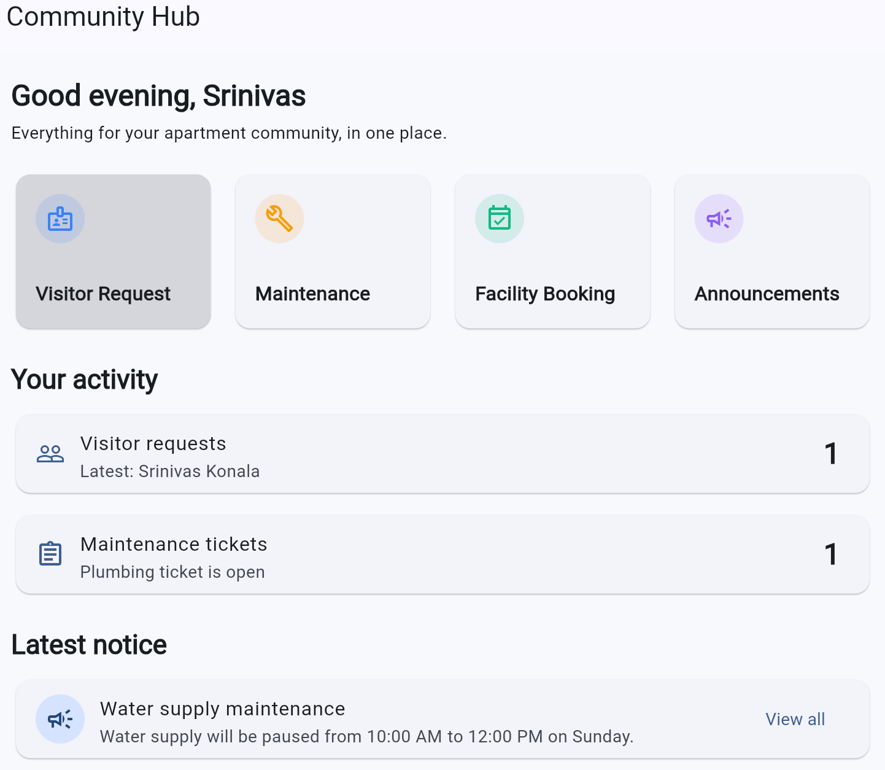

- Visitor Request
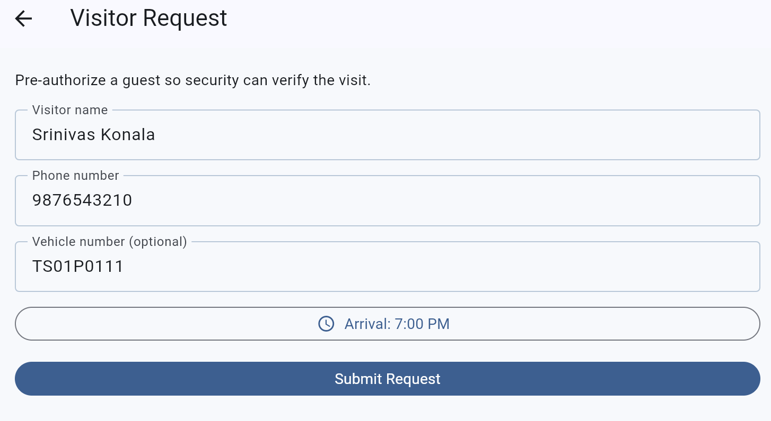

- Maintenance
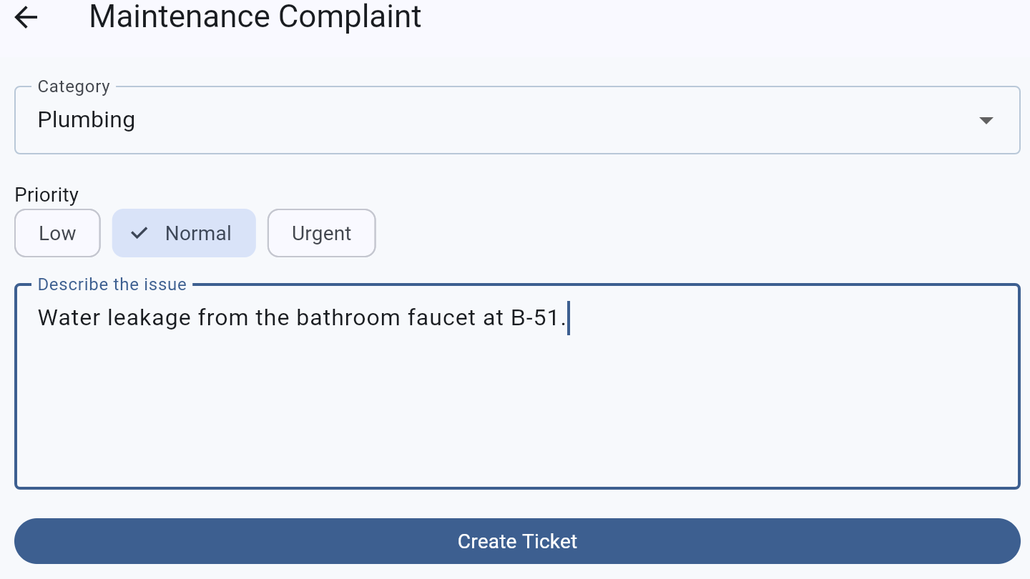
- Facility Booking
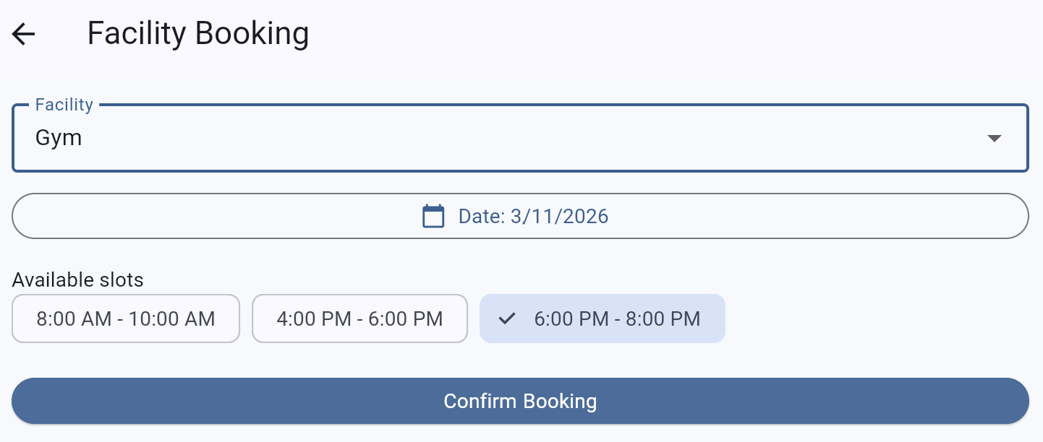

- Announcements

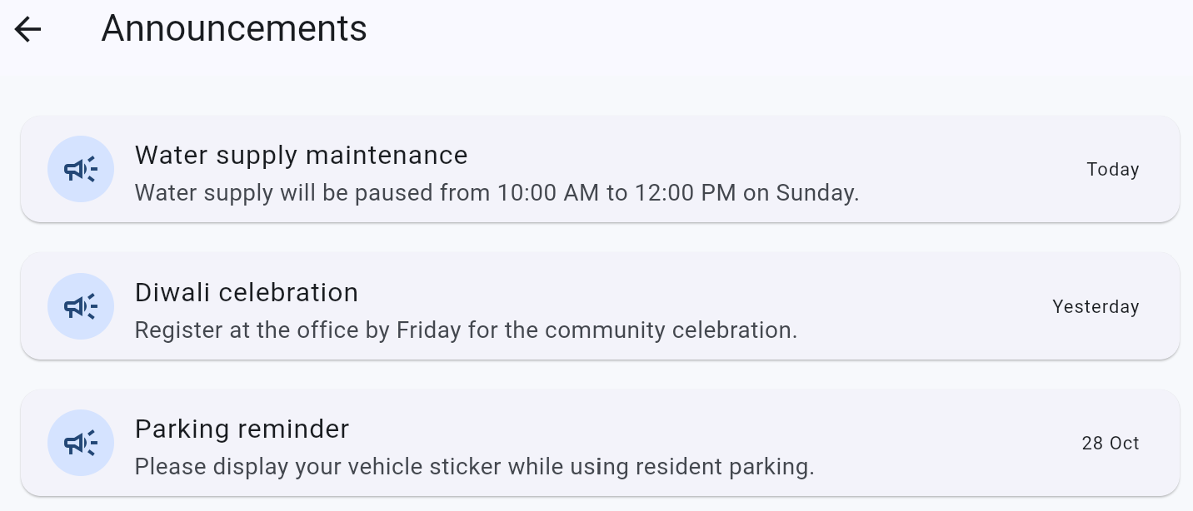

13. RESULT AND CONCLUSION
The Apartment Community Management App successfully demonstrates a practical Flutter UI for four common community workflows: visitor requests, maintenance complaints, announcements, and facility bookings. Its screen structure uses reusable components, named navigation, form validation, responsive layouts, purposeful animation, local state management, and asynchronous data presentation.
The project meets the intent of the UI Design Flutter Lab by showing that a polished mobile interface is not only a collection of widgets. A useful design connects layout choices, feedback states, validation, navigation, and data loading into one consistent user journey. The same prototype can be expanded later with authentication, Firebase or REST backend integration, notifications, role-based screens, and persistent booking records.

14. REFERENCES
• Flutter Documentation. Flutter widgets, navigation, layout, forms, animation, and testing guides.
• Dart Documentation. Language and package reference.
• Napoli, Marco L. Beginning Flutter A Hands On Guide to App Development.

Signature of Students | Signature of Faculty
SHETKAR SAGAR ____________________ | _______________________
SRINIVAS KONALA ____________________
SYED SALEM ____________________
T SPARSH SINGH ____________________

