Result Analysis System

Node JS / React JS / Django (CS454PC)

Submitted
In partial fulfilment of the requirements for completion of
Bachelor of Technology
In
Computer Science and Engineering

By

Srinivas Konala
24261A05R0

And

Timothy Saxena
24261A05R4

Under the guidance of

Ms. Anitha Talari
Assistant Professor
Department of Computer Science and Engineering


Department of Computer Science and Engineering,
MAHATMA GANDHI INSTITUTE OF TECHNOLOGY(A)
GANDIPET, HYDERABAD-500 075, INDIA.
2025-2026
MAHATMA GANDHI INSTITUTE OF TECHNOLOGY(A)
(Affiliated to Jawaharlal Nehru Technological University Hyderabad)
Gandipet, Hyderabad-500 075, Telangana (India)


CERTIFICATE

This is to certify that the NODE JS/ REACT JS/ DJANGO (CS454PC) entitled Result Analysis System”, is being submitted by Mr. Srinivas Konala bearing Roll No: 24261A05R0 and Mr. Timothy Saxena bearing Roll No: 24261A05R4 in partial fulfilment for completion of Bachelor of Technology IV Semester in Computer Science and Engineering to Mahatma Gandhi Institute of Technology is a record of Bonafide work carried out by them under our guidance and supervision. The results embodied in this project have not been submitted to any other University or Institute for the award of any degree or diploma.

Project Guide Head of the Department
Ms. Anitha Talari Dr. C.R.K Reddy
Asst. Professor, Dept. of CSE Professor, Dept. of CSE

DECLARATION

This is to certify that the work reported in NODE JS/ REACT JS/ DJANGO (CS454PC) titled “Result Analysis System” is a record of work done by us in the Department of Computer Science and Engineering, Mahatma Gandhi Institute of Technology, Hyderabad. No part of the work is copied from books/journals/internet and wherever the portion is taken, the same has been duly referred to in the text. The report is based on the work done entirely by us and not copied from any other source.

SRINIVAS KONALA
(24261A05R0)

TIMOTHY SAXENA
(24261A05R4)

ACKNOWLEDGEMENT
The satisfaction that accompanies the successful completion of any task would be incomplete without the mention of people who made it possible because success is the abstract of hard work and perseverance, but steadfast of all is encouraging guidance. So, we acknowledge all those whose guidance and encouragement served as a beacon light and crowned my efforts with success.

We would like to express our sincere thanks to, Prof G. Chandra Mohan Reddy, Principal MGIT, for providing the working facilities in college.

We wish to express our sincere thanks and gratitude to Dr. C R K Reddy, Professor and HoD, Department of CSE, MGIT, for all the timely support and valuable suggestions during the period of project.

We are extremely thankful to Ms. Anitha Talari, Assistant Professor, Department of CSE, MGIT, NODE JS/ REACT JS/ DJANGO (CS454PC) faculty for her encouragement and support throughout the project.

We are also extremely thankful and indebted to our mentor, Dr. B. Madhava Rao, Assistant Professor, Department of CSE, MGIT for his constant guidance, encouragement, and moral support throughout the project.

Finally, we would also like to thank all the faculty and staff of the CSE Department who helped us directly or indirectly in completing this project.

SRINIVAS KONALA
(24261A05R0)

TIMOTHY SAXENA
(24261A05R4)

TABLE OF CONTENTS
CERTIFICATE 1
DECLARATION 2
ACKNOWLEDGEMENT 3
TABLE OF CONTENTS 4
LIST OF FIGURES 6
LIST OF TABLES 7
ABSTRACT 8

1. INTRODUCTION 10
2. PROBLEM STATEMENT 11
2.1 Challenges Faced by Students 11
2.2 Challenges Faced by Administration 11
2.3 The Gap This System Fills 11
3. TECHNOLOGIES USED 12
4. SOLUTION 15
4.1 System Architecture 15
4.2 Database Design 15
4.3 Excel-to-MySQL Data Pipeline 16
4.4 Excel-to-MySQL Data Pipeline 17
4.5 Role-Based Access Control 18
4.6 GPA Calculation 19
4.7 Linear Regression SGPA Projection 20
4.8 Student Dashboard — Five-Tab Design 20
4.9 Admin Dashboard Design 21
4.10 Git Workflow and Deployment 21

5. CODE 22
5.1 Import Script — Core Loop 22
5.2 JWT Authentication — Student Login 22
5.3 GPA Calculation Utility 23
5.4 Linear Regression Projection 23
5.5 Auth Middleware 24
5.6 Batch Rank Endpoint 24
6. SCREENSHOTS 25
6.1 Login Page 25
6.2 Student Dashboard Tab 25
6.3 Student Results Tab 26
6.4 Student GPA Overview Tab — Actual Trend 26
6.5 Student GPA Overview Tab — Projection 27
6.6 Student Failed Subjects Tab 28
6.7 Student Marksheet Tab and PDF Output 28
6.8 Admin Dashboard Overview 29
6.9 Admin Toppers / Ranklist 30
6.10 Admin Subject Analysis 31
6.11 Admin CGPA Distribution 31
7. FUTURE ENHANCEMENTS 32
7.1 Student Name Integration 32
7.2 Password Change Feature 32
7.3 Projection Model Improvement 32
7.4 Email Notifications 32
7.5 Mobile Application 32
7.6 Attendance Integration 32
8. CONCLUSION 33

LIST OF FIGURES
FIGURE PAGE NO

Figure 4.1: Three-Tier Architecture Diagram 22
Figure 4.2: Entity-Relationship Diagram 23
Figure 4.3: Import Pipeline Flow 25
Figure 4.4: JWT Authentication Flow 26
Figure 4.5: Linear Regression SGPA Projection Chart 27
Figure 6.1: Login Page — Role tab switcher with Student and Admin tabs 32
Figure 6.2: Student Dashboard Tab — Stat cards, batch rank card, 33
Figure 6.3: Student Results Tab — Semester-grouped table 34
Figure 6.4: GPA Overview Tab — Cumulative CGPA trend 35
Figure 6.5: GPA Overview Tab — Linear regression projection 36
Figure 6.6: Failed Subjects Tab — Backlog list with per-semester filter 37
Figure 6.7: Marksheet Tab — Per-semester download cards 37
Figure 6.7.1: Generated PDF Marksheet 37
Figure 6.8: Admin Dashboard — Department stat cards, section breakdown 37
Figure 6.9: Admin Toppers — CGPA-ranked student list with section 37
Figure 6.10: Admin Subject Analysis — Per-subject statistics table 37
Figure 6.11: Admin CGPA Distribution — Histogram with 0.5-step buckets 37

LIST OF TABLES
TABLE PAGE NO

Table 3.1: Technologies and their roles in the project 17
Table 4.1: Database schema overview 23
Table 4.2: Backend API route reference 23

ABSTRACT
The Result Analysis System is a full-stack web application developed for the Department of Computer Science and Engineering at Mahatma Gandhi Institute of Technology. The system addresses the absence of a centralised platform through which students can view and analyse their academic results, and administrators can monitor performance across the department.
The application supports two user roles. Students are provided with a five-tab personal dashboard covering a summary overview, subject-wise results with search and filter, a GPA overview with a cumulative CGPA trend chart and a linear regression-based SGPA projection for Year 3 and Year 4 students, a dedicated failed subjects tab, and a marksheet download facility. The Admin role provides a department-wide analytics platform covering section-wise performance, semester-wise trends, topper rankings with CGPA and SGPA-based filtering, subject-level analysis, and a CGPA distribution histogram.
The system was built using Node.js and Express.js for the backend, MySQL as the relational database, and React with Vite for the frontend. Authentication is implemented with JSON Web Tokens and bcrypt password hashing. Role-based access control is enforced at the middleware layer. The dataset comprises results for approximately 1,090 students across 35,582 result rows spanning multiple semesters, imported from departmental Excel files using a custom Node.js pipeline.
The application is fully deployed in the cloud: the React frontend on Vercel, the Express backend on Render, and the MySQL database on Railway. It is accessible through a live public URL at https://result-analysis-three.vercel.app and requires no local installation.

Keywords: Result Analysis, Academic Performance, Node.js, Express.js, MySQL, React, JWT, Role-Based Access Control, Linear Regression, GPA Projection, Cloud Deployment

1. INTRODUCTION
The Result Analysis System is a multi-role academic performance management platform designed for the CSE Department at MGIT. It replaces the traditional approach of distributing printed marksheets and maintaining results in disconnected Excel spreadsheets with a centralised web application that provides instant, authenticated access to results, automated GPA calculations, performance projections, and department-wide analytics.
The application was developed as a team project by two IV Semester students as part of the CS454PC course on Node JS / React JS / Django. The project covers a realistic academic dataset of over 35,000 result entries across five sections (CSE-1 through CSE-5) and multiple semesters, representative of actual department-scale data management requirements.
The system is structured around two user roles. The Student role provides a rich personal academic dashboard with five dedicated tabs: a summary overview with batch rank, a results browser, a GPA overview with trend analysis and future projections, a failed subjects tracker, and a marksheet generator. The Admin role provides a comprehensive department-wide analytics platform enabling data-driven oversight of academic performance.
Beyond functional features, the project demonstrates core engineering concepts from the CS454PC curriculum: RESTful API design with Express.js, relational database modelling with MySQL, client-side rendering with React, stateless JWT authentication, statistical projection using linear regression, and full-stack deployment across cloud platforms.

2. PROBLEM STATEMENT
Academic result management in most engineering departments continues to rely on printed marksheets, individually maintained Excel files, and periodic notice board displays. This approach has significant shortcomings that affect both students and the department administration.

2.1 Challenges Faced by Students
Students have no on-demand access to their complete academic record. Marksheets are distributed physically and are easily misplaced. There is no automated calculation of SGPA or CGPA, and students who need to estimate their performance in future semesters have no data-driven tool to do so. Failed subjects are not tracked centrally, and there is no single view of academic performance trends across semesters.

2.2 Challenges Faced by Administration
The department has no consolidated view of academic performance. Comparing pass percentages across sections, identifying subjects with consistently high failure rates, generating a department-wide topper list, or producing a CGPA distribution of the batch requires manually aggregating data from multiple sources. This makes academic monitoring slow and reactive rather than proactive.

2.3 The Gap This System Fills
The Result Analysis System addresses all of the above by providing a single authenticated web application that centralises result data, automates GPA computation, enables future semester performance projection using linear regression, and makes real-time analytics accessible to the admin without any spreadsheet work. The system converts a fragmented manual process into a coherent, data-driven workflow accessible from any device through a web browser.

3. TECHNOLOGIES USED

3.1 Node.js
Node.js is a JavaScript runtime environment built on Google Chrome's V8 engine. It executes JavaScript on the server side using a non-blocking, event-driven I/O model suited for handling concurrent API requests efficiently. In this project, Node.js serves as the runtime for the entire backend application.

3.2 Express.js
Express.js is a minimal web application framework for Node.js. It provides an API for defining HTTP routes, applying middleware, and handling requests and responses. The backend is structured as an Express application with route files for authentication, student operations, and admin analytics. Middleware handles CORS, JSON body parsing, and JWT-based route protection.

3.3 MySQL
MySQL is an open-source relational database management system. The project uses four tables: students, results, faculty, and admins. The results table contains over 35,000 rows. MySQL's support for JOIN queries, aggregate functions, and GROUP BY operations is central to GPA calculations and analytics. The database is hosted on Railway and connected via a connection pool using the mysql2 library.

3.4 React and Vite
React is a JavaScript library for building user interfaces through reusable components and a virtual DOM. Vite is the build tool and development server used to bundle the React application. The frontend uses a custom client-side router implemented directly in App.jsx using window.location.pathname, keeping the dependency footprint minimal. All five student dashboard tabs and both admin dashboard pages are React components.

3.5 JSON Web Tokens (JWT)
JSON Web Tokens are used for stateless authentication. On successful login, the server signs a token containing the user's ID and role. This token is stored in the browser's localStorage and attached to every API request as a Bearer token in the Authorization header. The server verifies the signature on each request without a database lookup, making authentication scalable and sessionless.
Technology | Role | Where Used
Node.js | Server-side runtime | Backend
Express.js | HTTP framework & routing | Backend
MySQL | Relational database | Railway (cloud)
React + Vite | Frontend UI library & build tool | Frontend (Vercel)
JWT (jsonwebtoken) | Stateless authentication tokens | Backend + Frontend
bcryptjs | Password hashing | Backend
pdfkit | PDF marksheet generation | Backend
json2csv | CSV data export | Backend
xlsx | Excel file parsing | Import script
Vercel | Frontend static hosting + CDN | Cloud
Render | Backend Node.js hosting | Cloud
Railway | Managed MySQL hosting | Cloud
Table 3.1: Technologies and their roles in the project

3.6 bcryptjs
bcryptjs is used for one-way password hashing. Passwords are never stored in plain text. During import, each student's default password is hashed with bcrypt at a salt round of 10. At login, bcrypt's compare function tests the submitted password against the stored hash, returning true or false without ever reversing the hash.

3.7 pdfkit
pdfkit is a Node.js library for generating PDF documents programmatically without requiring a browser or headless Chrome. It is used to generate semester marksheets on demand. The backend constructs a complete A4 PDF in memory — including the college header, subject table, SGPA summary boxes, and a pass/fail status banner — then streams it to the browser as a downloadable file.

3.8 json2csv
json2csv converts JavaScript arrays of objects into CSV-formatted strings. It is used by the admin export routes to allow bulk download of filtered result data in spreadsheet-compatible format.

3.9 xlsx
The xlsx library reads Excel files in Node.js. It is used exclusively in the import script to parse departmental result files, converting each worksheet row into a JavaScript object for database insertion.

3.10 Deployment Platforms
Three cloud platforms handle deployment. Vercel hosts the React frontend, building and deploying it automatically on every push to the dev branch. Render hosts the Node.js backend as a persistent web service with environment variables for database credentials and the JWT secret. Railway hosts the MySQL database and provides a publicly accessible connection endpoint. All three services are connected to the same GitHub repository and deploy automatically when the dev branch is updated.

4. SOLUTION

4.1 System Architecture
The system follows a three-tier architecture. The presentation tier is a React application hosted on Vercel that communicates with the backend through HTTP API calls only. The application tier is a Node.js Express server hosted on Render that handles all business logic including authentication, GPA calculation, linear regression, and PDF generation. The data tier is a MySQL database hosted on Railway. No tier has direct knowledge of another tier's internal implementation, allowing each to be modified independently.
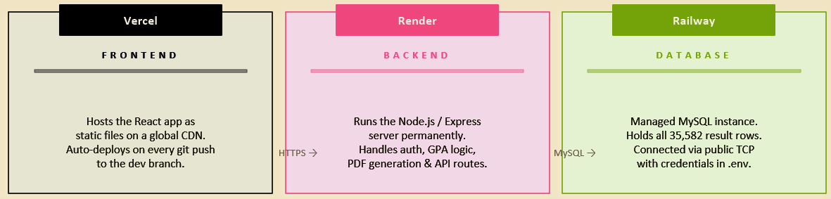Figure 4.1: Three-Tier Architecture Diagram: Browser → Vercel (React) → Render (Express) → Railway (MySQL)

4.2 Database Design
The database consists of three tables. The students table stores one row per student with their hall ticket number as the primary key, a bcrypt password hash, and their assigned branch, year, and section. The results table is the core data store — each row represents a single student's performance in one subject in one semester. A unique constraint on (ht_no, semester, course_code) prevents duplicate entries and enables idempotent re-import. The faculty table stores accounts each scoped to a single course code. The admins table stores admin credentials with unrestricted access.
Table | Primary Key | Key Columns | Purpose
students | ht_no | password_hash, section, year, branch | 1 row per student
results | id (auto) | ht_no (FK), semester, course_code, total_marks, grade_letter, credits | 1 row per student-subject-semester
admins | id (auto) | username, password_hash | Admin accounts with full access
Table 4.1: Database schema overview
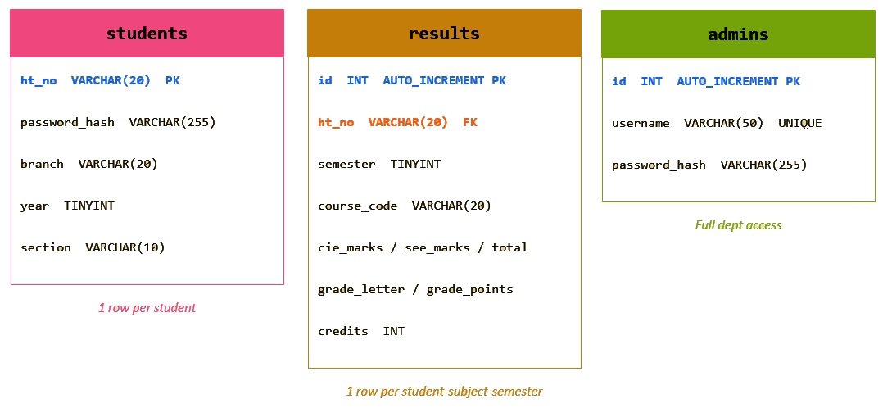
Figure 4.2: Entity-Relationship Diagram: students ←→ results, faculty, and admins tables with key columns and constraints

4.3 Excel-to-MySQL Data Pipeline
The department supplied result data as Excel files — one file per semester with approximately 3,000 rows each in the format: HT_NO, COURSE_CODE, COURSE_NAME, CIE_MARKS, SEE_MARKS, TOTAL_MARKS, GRADE_LETTER, GRADE_POINTS, CREDITS. A custom Node.js script (backend/scripts/import.js) was written to process these files and populate the database.
The script accepts two command-line arguments: the Excel file path and the semester number. The semester number is passed manually because it is not present in the Excel file itself. For each row, the script checks whether the student already exists; if not, it creates a new student record with a default password hashed with bcrypt. The result row is inserted using ON DUPLICATE KEY UPDATE, making the script safely idempotent. The result row is inserted using ON DUPLICATE KEY UPDATE, making the script safely idempotent. The semester number is passed manually because it is not present in the Excel file itself. For each row, the script checks whether the student already exists; if not, it creates a new student record with a default password hashed with bcrypt. Section assignment is inferred from the last two characters of the HT number using the department's roll range boundaries.
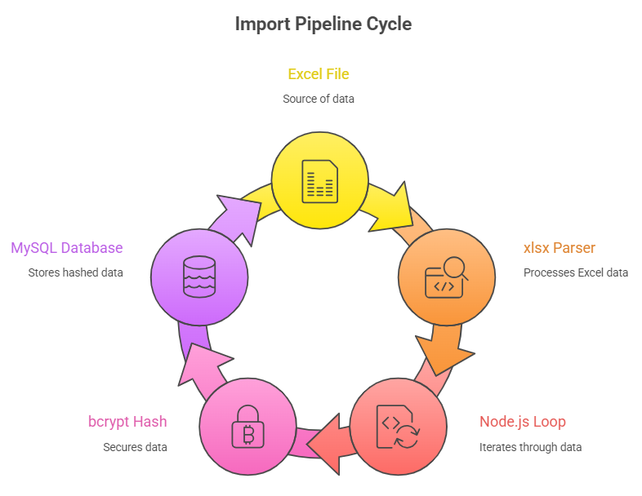
Figure 4.3: Import Pipeline Flow: Excel File → xlsx parser → Node.js loop → bcrypt hash → MySQL INSERT

4.4 API Route Design
The backend exposes RESTful endpoints grouped by role. Every protected route passes through a JWT verification middleware followed by a role guard.

Method | Endpoint | Role | Purpose
POST | /api/auth/student-login | Public | Student login, returns JWT
POST | /api/auth/admin-login | Public | Admin login, returns JWT
GET | /api/student/results | Student | Fetch all results, optional ?semester filter
GET | /api/student/sgpa | Student | SGPA per semester for trend chart
GET | /api/student/cgpa | Student | Overall CGPA and failed count
GET | /api/student/failed | Student | All failed subjects
GET | /api/student/rank | Student | Batch rank and percentile
GET | /api/student/marksheet/:semester | Student | Download PDF marksheet
GET | /api/admin/dashboard | Admin | Dept overview, section & semester tables
GET | /api/admin/toppers | Admin | Ranked list by CGPA or SGPA
GET | /api/admin/subject-analysis | Admin | Per-subject stats
GET | /api/admin/cgpa-distribution | Admin | CGPA histogram data
GET | /api/admin/section/:section | Admin | Drill-down for a specific section
GET | /api/admin/export | Admin | Full CSV export with optional filters
Table 4.2: Backend API route reference

4.5 Role-Based Access Control
Each role has a precisely defined data scope enforced at the server level. A student's JWT contains their HT number; every student route queries using req.user.id, making it impossible for one student to access another's records even if they manipulate the request. The admin role has no scope restriction and can query across all students, sections, and semesters.
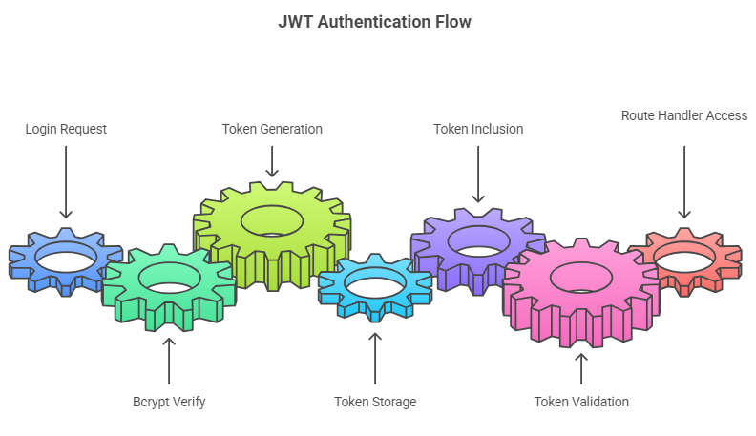
Figure 4.4: JWT Authentication Flow: Login Request → bcrypt verify → jwt.sign → Token stored → Bearer header → jwt.verify → Route handler

4.6 GPA Calculation
GPA calculation is implemented as a shared utility in backend/utils/gpa.js. The SGPA for a given set of results is the sum of (grade_points × credits) divided by total credits, excluding subjects with zero credits. CGPA applies the same formula across all semesters combined. Both student-facing routes and admin analytics use this single shared function, ensuring GPA values are consistent regardless of which part of the application computes them.

4.7 Linear Regression SGPA Projection
The GPA Overview tab includes a forward-looking SGPA projection for Year 3 and Year 4 students who have sufficient historical data. The projection is computed using simple linear regression applied to the student's existing SGPA values across semesters.
In linear regression, given a set of data points (xᵢ, yᵢ) where x is the semester number and y is the SGPA, the best-fit line is determined by calculating the slope (m) and intercept (b) as follows:
m = ( n×Σ(x×y) − Σx×Σy ) / ( n×Σx² − (Σx)² )
b = ( Σy − m×Σx ) / n
Where n is the number of semesters completed. The projected SGPA for future semesters is then computed as: projected_SGPA = m × semester_number + b. The projected values are capped between 0 and 10. The chart displays actual SGPA values as a solid line and projected values as a dashed line in a different colour, making the boundary between historical data and prediction. 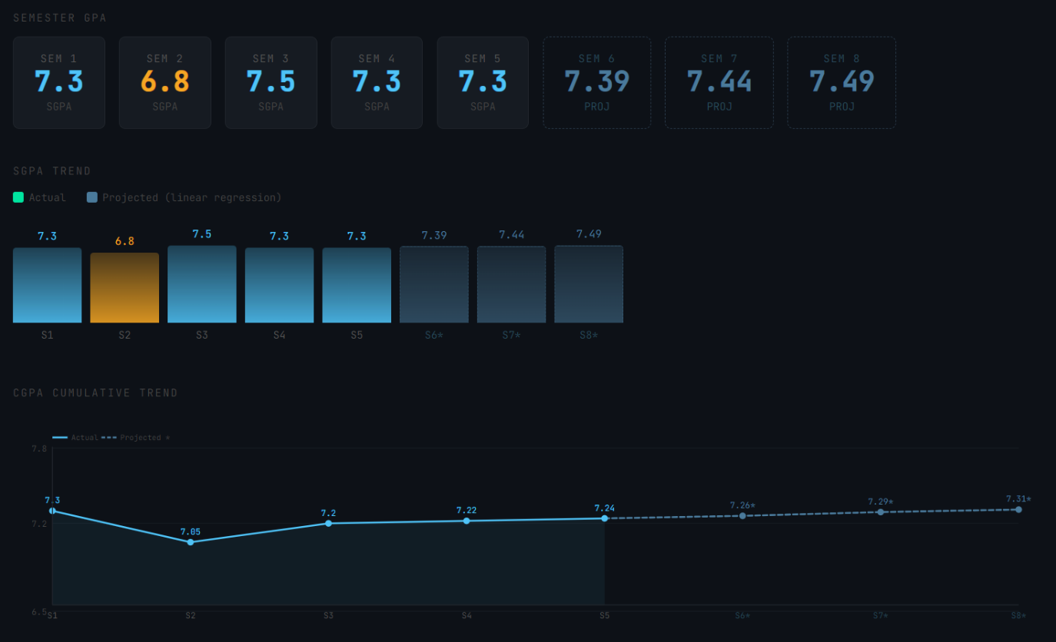Figure 4.5: Linear Regression SGPA Projection Chart: Actual SGPA (solid line) vs Projected SGPA (dashed line)

4.8 Student Dashboard — Five-Tab Design
The student interface is organised into five tabs to avoid information overload while keeping all features accessible from a single page.
Tab 1: Dashboard
The Dashboard tab serves as the landing screen after login. It displays the MGIT logo, a welcome message with the student's HT number, and four summary stat cards: overall CGPA, latest SGPA, number of semesters completed, and backlog count. A batch rank card shows the student's rank within their batch computed by the /api/student/rank endpoint. The most recent semester's results are displayed in a summary table below the cards.
Tab 2: Results
The Results tab displays all subject results grouped by semester. A semester dropdown filter and a text search box allow the student to quickly find specific subjects or narrow down to a particular term. Each semester group shows the SGPA for that term. Failed subjects are visually highlighted with a red indicator and a faint red row background.
Tab 3: GPA Overview
The GPA Overview tab contains two charts. The first is a cumulative CGPA trend line showing how the student's overall CGPA has evolved as each semester was completed. The second chart shows the SGPA trend with the linear regression projection for Year 3 and Year 4 students. Both charts are rendered as pure SVG with no external charting dependencies. A table below the charts lists SGPA per semester alongside grade statistics.
Tab 4: Failed Subjects
The Failed Subjects tab provides a dedicated view of all subjects in which the student has received an F grade. A semester filter allows the student to check whether failed subjects belong to a specific term. Each entry shows the subject code, subject name, semester, marks obtained, and the grade. This tab is intentionally separated from the main results view to make backlogs immediately visible without scrolling through a full results table.
Tab 5: Marksheet
The Marksheet tab displays one download card per completed semester. Each card shows the semester number and the SGPA for that term. Clicking the download button triggers a request to the backend, which generates an A4 PDF marksheet using pdfkit and streams it to the browser. The PDF includes the college header, student details, a subject table, summary boxes, and a colour-coded pass/fail banner.

4.9 Admin Dashboard Design
The admin interface is a single-page application with a persistent left sidebar for navigation. Four tabs are available: Department Overview, Toppers / Ranklist, Subject Analysis, and CGPA Distribution. Sidebar filters for semester, section, and year apply to whichever tab is currently active. A CSV export button triggers a full data download with the active filters applied.

4.10 Git Workflow and Deployment
Development followed a structured Git branching strategy. The main branch holds stable, tested code. The dev branch is the integration branch and is the branch from which both Vercel and Render deploy automatically on push. Feature work is done on short-lived feature branches created off dev, which are merged back via pull requests after review by the second team member.
The deployment pipeline requires no manual steps after a push. Vercel detects the push to dev, runs npm run build to produce the static React bundle, and serves it from a global CDN with a custom SPA rewrite rule in vercel.json. Render detects the push, runs npm install, and restarts the Express server. Railway requires no redeployment as the database persists independently of application deployments.

5. CODE
This chapter presents key code excerpts from the project. The full source code is available at https://github.com/timothy-saxena/result-analysis on the dev branch.

5.1 Import Script — Core Loop (backend/scripts/import.js)
The import script processes one Excel file per run. For each row it creates a student account if one does not exist and upserts the result record using ON DUPLICATE KEY UPDATE, making repeated runs safe.

for (const row of rows) {
const ht_no = String(row["HT_NO"]).trim();

// Create student if not already present
const [existing] = await db.query(
"SELECT ht_no FROM students WHERE ht_no = ?", [ht_no]
);
if (existing.length === 0) {
const hash = await bcrypt.hash(`${ht_no}@123`, 10);
const meta = inferStudentMeta(ht_no);
await db.query(
"INSERT INTO students VALUES (?, ?, ?, ?, ?)",
[ht_no, hash, meta.branch, meta.year, meta.section]
);
}

// Upsert result — safe to re-run on the same file
await db.query(
`INSERT INTO results
(ht_no, semester, course_code, course_name,
cie_marks, see_marks, total_marks,
grade_letter, grade_points, credits)
VALUES (?,?,?,?,?,?,?,?,?,?)
ON DUPLICATE KEY UPDATE
total_marks = VALUES(total_marks),
grade_letter = VALUES(grade_letter),
grade_points = VALUES(grade_points)`,
[ht_no, semester, courseCode, /* ... */]
);
}

5.2 JWT Authentication — Student Login (backend/routes/auth.js)
The login route queries the student record, compares the submitted password against the stored bcrypt hash, and returns a signed JWT on success.

router.post("/student-login", async (req, res) => {
const { ht_no, password } = req.body;
const [rows] = await db.query(
"SELECT * FROM students WHERE ht_no = ?", [ht_no]
);
if (rows.length === 0)
return res.status(401).json({ error: "Invalid credentials." });

const valid = await bcrypt.compare(password, rows[0].password_hash);
if (!valid)
return res.status(401).json({ error: "Invalid credentials." });

const token = jwt.sign(
{ id: ht_no, role: "student" },
process.env.JWT_SECRET,
{ expiresIn: "7d" }
);
res.json({ token, role: "student", ht_no });
});

5.3 GPA Calculation Utility (backend/utils/gpa.js)
The SGPA function is the shared source of truth used by both student routes and admin analytics.

const calculateSGPA = (results) => {
let totalWeighted = 0;
let totalCredits = 0;
for (const row of results) {
if (row.credits > 0) {
totalWeighted += row.grade_points * row.credits;
totalCredits += row.credits;
}
}
if (totalCredits === 0) return 0;
return parseFloat((totalWeighted / totalCredits).toFixed(2));
};

// CGPA = same formula applied across all semesters combined
const calculateCGPA = (allResults) => calculateSGPA(allResults);

5.4 Linear Regression Projection (frontend — GPA Overview tab)
The following function computes the slope and intercept of the best-fit line through the student's historical SGPA values, then projects SGPA for future semesters.

function linearRegression(points) {
const n = points.length;
const sumX = points.reduce((a, p) => a + p.x, 0);
const sumY = points.reduce((a, p) => a + p.y, 0);
const sumXY = points.reduce((a, p) => a + p.x * p.y, 0);
const sumX2 = points.reduce((a, p) => a + p.x * p.x, 0);
const m = (n * sumXY - sumX * sumY) / (n * sumX2 - sumX * sumX);
const b = (sumY - m * sumX) / n;
return { m, b };
}

function projectSGPA(sgpaData, futureSemesters) {
const points = sgpaData.map(s => ({ x: s.semester, y: s.sgpa }));
const { m, b } = linearRegression(points);
return futureSemesters.map(sem => ({
semester: sem,
projected: Math.min(10, Math.max(0,
parseFloat((m * sem + b).toFixed(2))
)),
}));}

5.5 Auth Middleware (backend/middleware/auth.js)
Every protected route passes through verifyToken and requireRole before the handler runs.

const verifyToken = (req, res, next) => {
const token = req.headers["authorization"]?.split(" ")[1];
if (!token)
return res.status(401).json({ error: "No token provided." });
try {
req.user = jwt.verify(token, process.env.JWT_SECRET);
next();
} catch {
res.status(403).json({ error: "Invalid or expired token." });
}
};

const requireRole = (roles) => (req, res, next) => {
if (!roles.includes(req.user.role))
return res.status(403).json({ error: "Access denied." });
next();
};

5.6 Batch Rank Endpoint (backend/routes/student.js)
The /student/rank endpoint computes the student's rank within their batch by computing CGPA for every student and counting how many have a higher value.

router.get("/rank", async (req, res) => {
const ht_no = req.user.id;

// Get all students in the same batch (same year prefix)
const batchPrefix = ht_no.substring(0, 2);
const [allStudents] = await db.query(
`SELECT r.ht_no,
ROUND(SUM(r.grade_points * r.credits) /
NULLIF(SUM(CASE WHEN r.credits > 0
THEN r.credits ELSE 0 END), 0), 2) AS cgpa
FROM results r
JOIN students s ON r.ht_no = s.ht_no
WHERE r.ht_no LIKE ? AND r.credits > 0
GROUP BY r.ht_no`,
[`${batchPrefix}%`]
);

const myCGPA = allStudents.find(s => s.ht_no === ht_no)?.cgpa || 0;
const rank = allStudents.filter(s => s.cgpa > myCGPA).length + 1;
const total = allStudents.length;

res.json({ rank, total,
percentile: parseFloat(((1 - rank / total) * 100).toFixed(1)),
cgpa: myCGPA
});
});

6. SCREENSHOTS
The following screenshots show the key screens of the Result Analysis System from the live deployment at https://result-analysis-three.vercel.app.

6.1 Login Page
The login page presents role tabs for Student and Admin. Each tab adjusts the identifier field label, placeholder, and the backend endpoint called on submission. On successful authentication the browser is redirected to the role-appropriate dashboard.
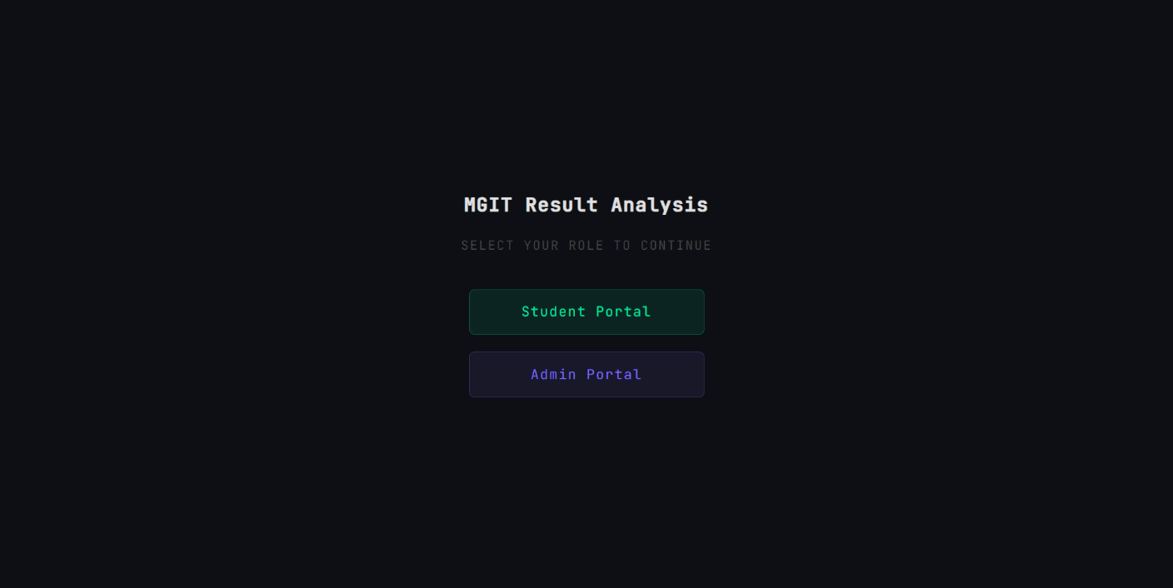Figure 6.1: Login Page — Role tab switcher with Student and Admin tabs, identifier and password fields

6.2 Student Dashboard Tab
The Dashboard tab shows the MGIT logo, the student's HT number, four summary stat cards (CGPA, latest SGPA, semesters completed, backlog count), a batch rank card showing the student's rank and percentile within their batch, and a summary table of the most recent semester's results. 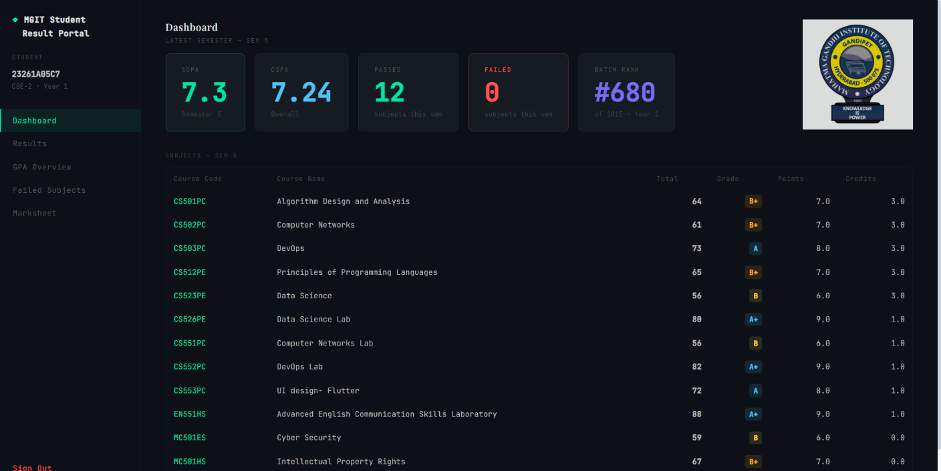Figure 6.2: Student Dashboard Tab — Stat cards, batch rank card, and latest semester results table

6.3 Student Results Tab
The Results tab displays all subject results grouped by semester. A text search box and semester filter allow targeted browsing. Failed subjects are marked with a red indicator. Each semester group header shows the corresponding SGPA.
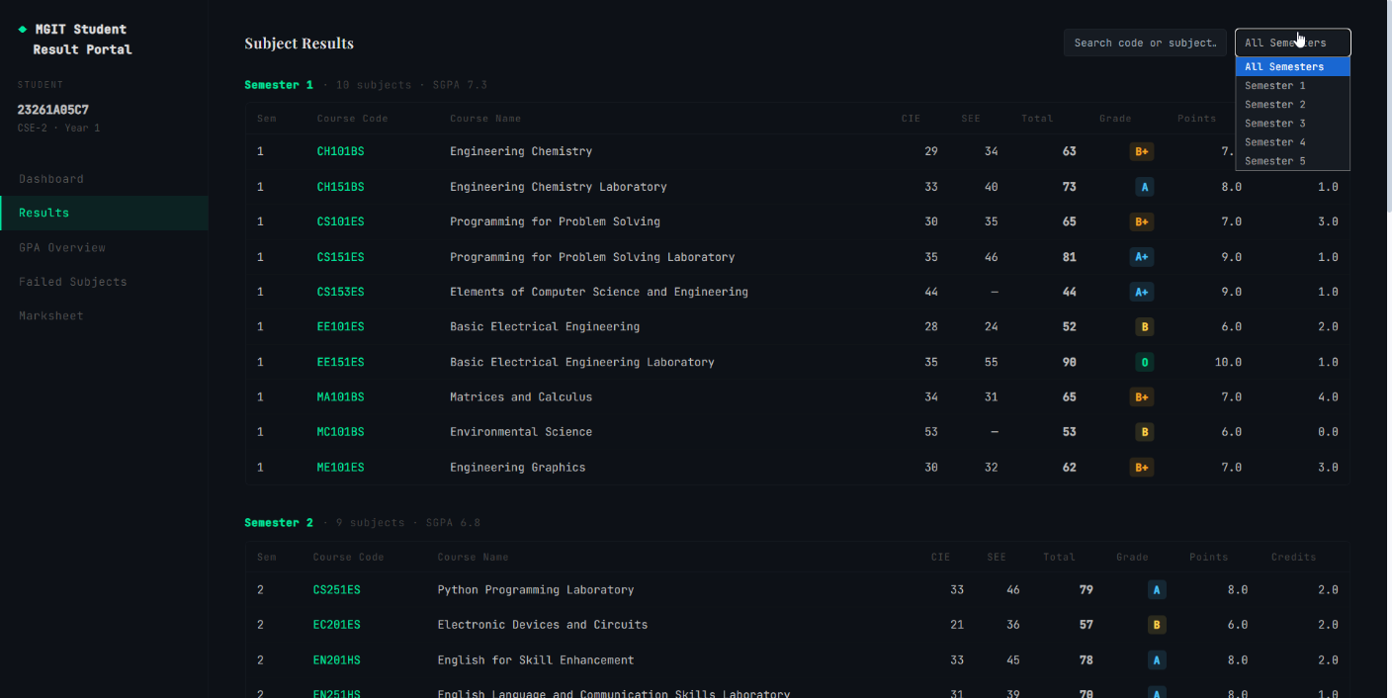Figure 6.3: Student Results Tab — Semester-grouped table with search filter and grade badges

6.4 Student GPA Overview Tab — Actual Trend
The GPA Overview tab shows a cumulative CGPA trend line and a semester-wise SGPA chart. Both are rendered as pure SVG. The actual SGPA values are plotted as a solid line with labelled 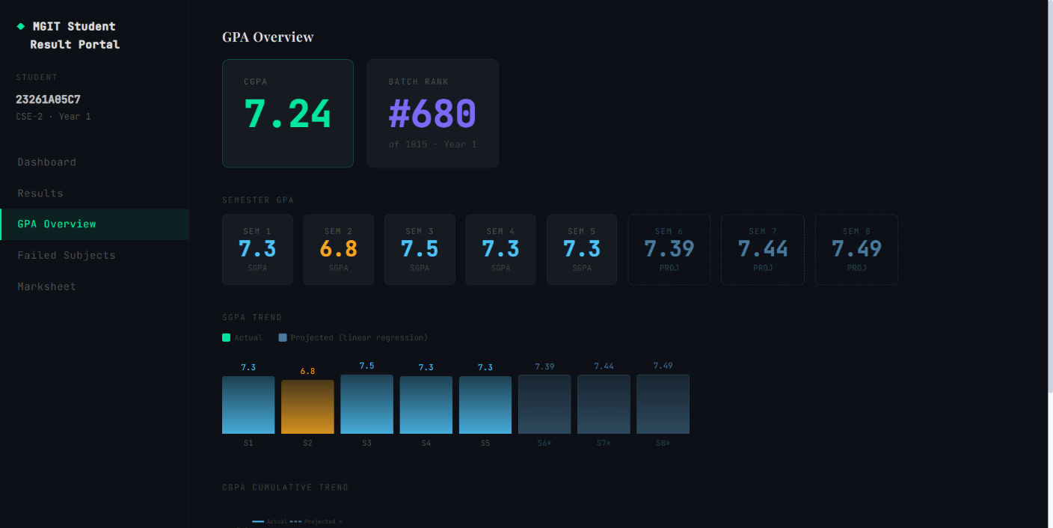
Figure 6.4: GPA Overview Tab — Cumulative CGPA trend and semester-wise SGPA chart (actual data)

6.5 Student GPA Overview Tab — Projection
For Year 3 and Year 4 students with sufficient historical data, the SGPA chart extends into future semesters using a linear regression projection. The projected portion is rendered as a dashed line in a distinct colour, clearly separating historical data from the statistical forecast. 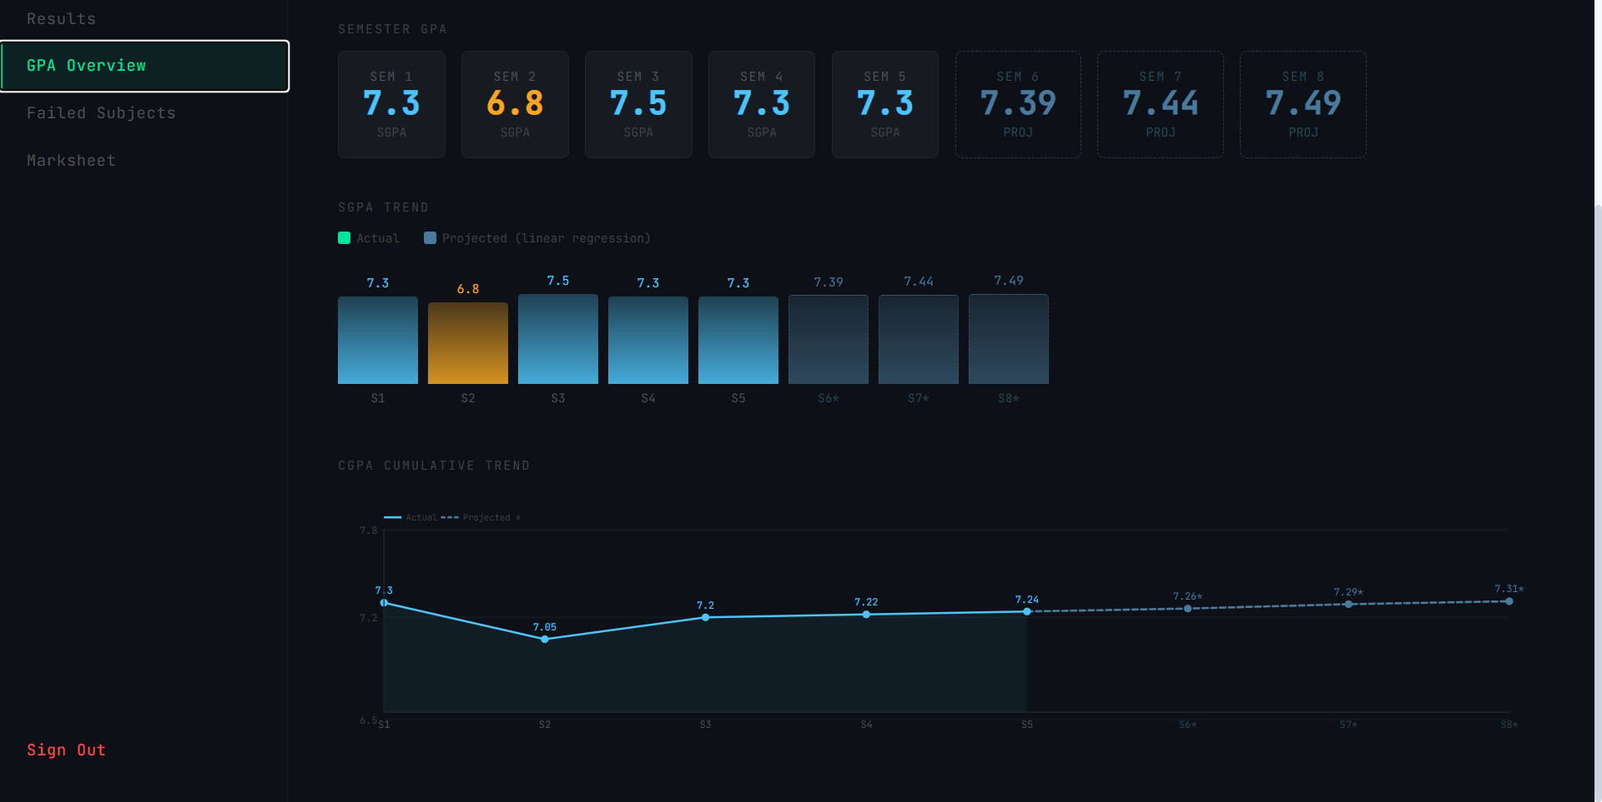Figure 6.5: GPA Overview Tab — Linear regression projection shown as dashed line beyond actual semesters

6.6 Student Failed Subjects Tab
The Failed Subjects tab lists all subjects in which the student has received an F grade. A semester filter narrows the view to a specific term. Each entry shows subject code, subject name, semester, marks obtained, and grade. 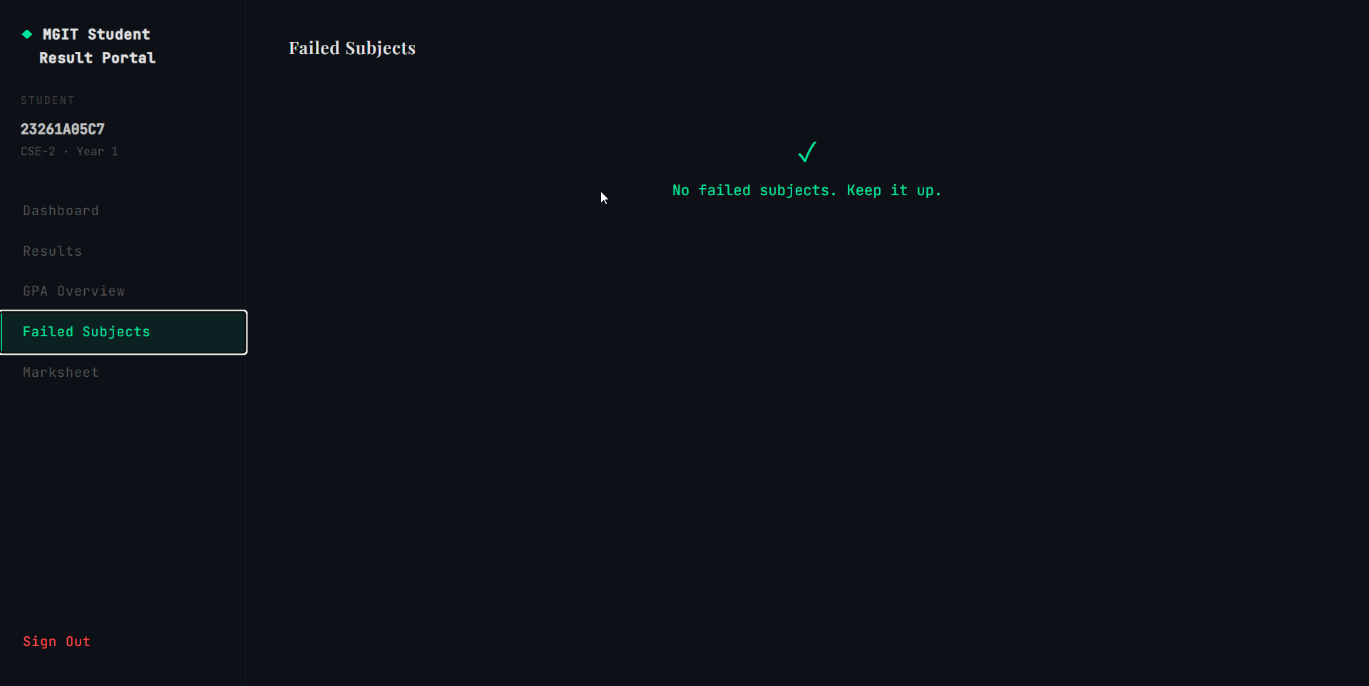Figure 6.6: Failed Subjects Tab — Backlog list with per-semester filter

6.7 Student Marksheet Tab and PDF Output
The Marksheet tab shows one download card per semester with the SGPA for that term. Clicking download generates a formatted A4 PDF using pdfkit. The PDF includes the college header, student details, a full subject table, an SGPA summary row, and a colour-coded pass/fail banner. 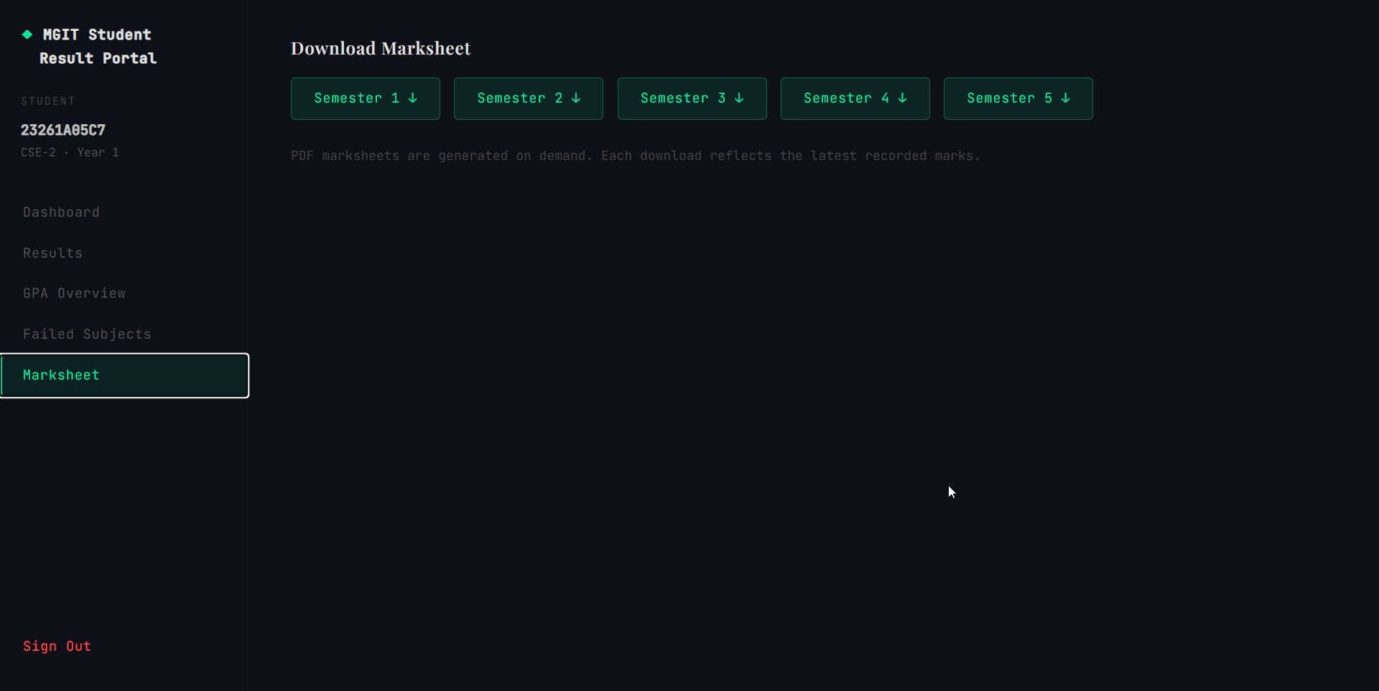Figure 6.7: Marksheet Tab — Per-semester download cards
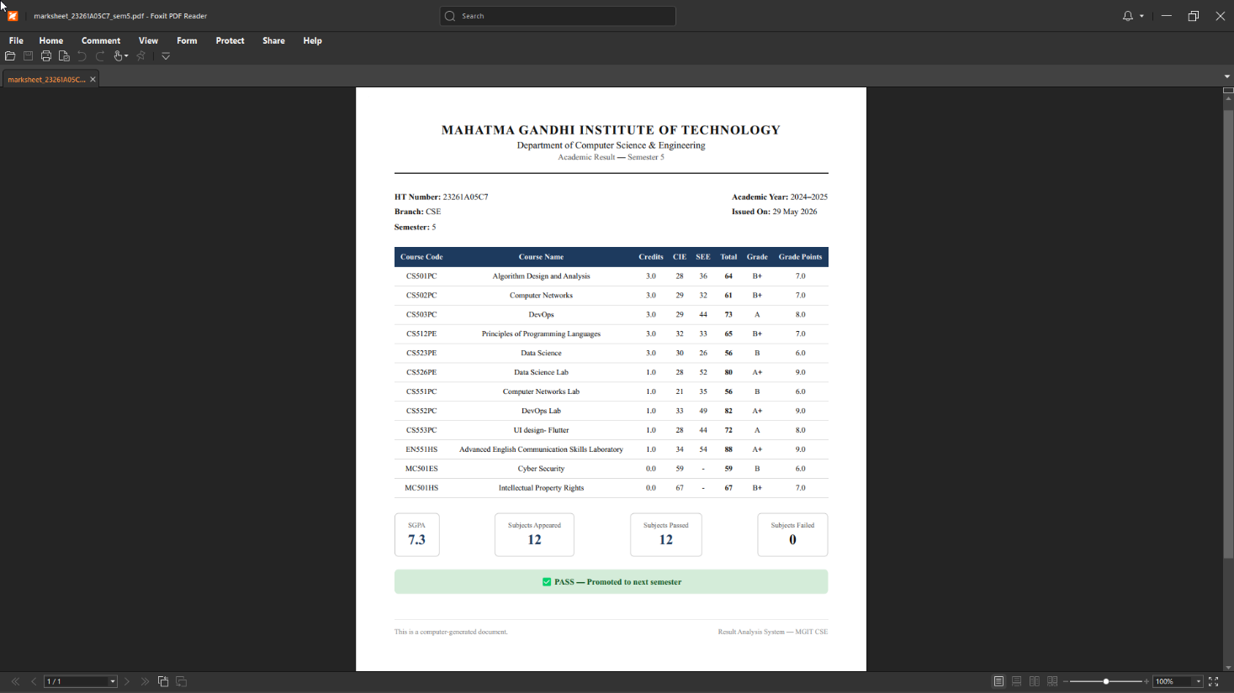
Figure 6.7.1: Generated PDF Marksheet — A4 layout with subject table, SGPA summary, and pass/fail banner

6.8 Admin Dashboard Overview
The Admin Dashboard tab shows four stat cards (total students, total results, total pass, total fail), a section breakdown table comparing CSE-1 through CSE-5, and a semester-wise performance table with average marks and pass percentages. 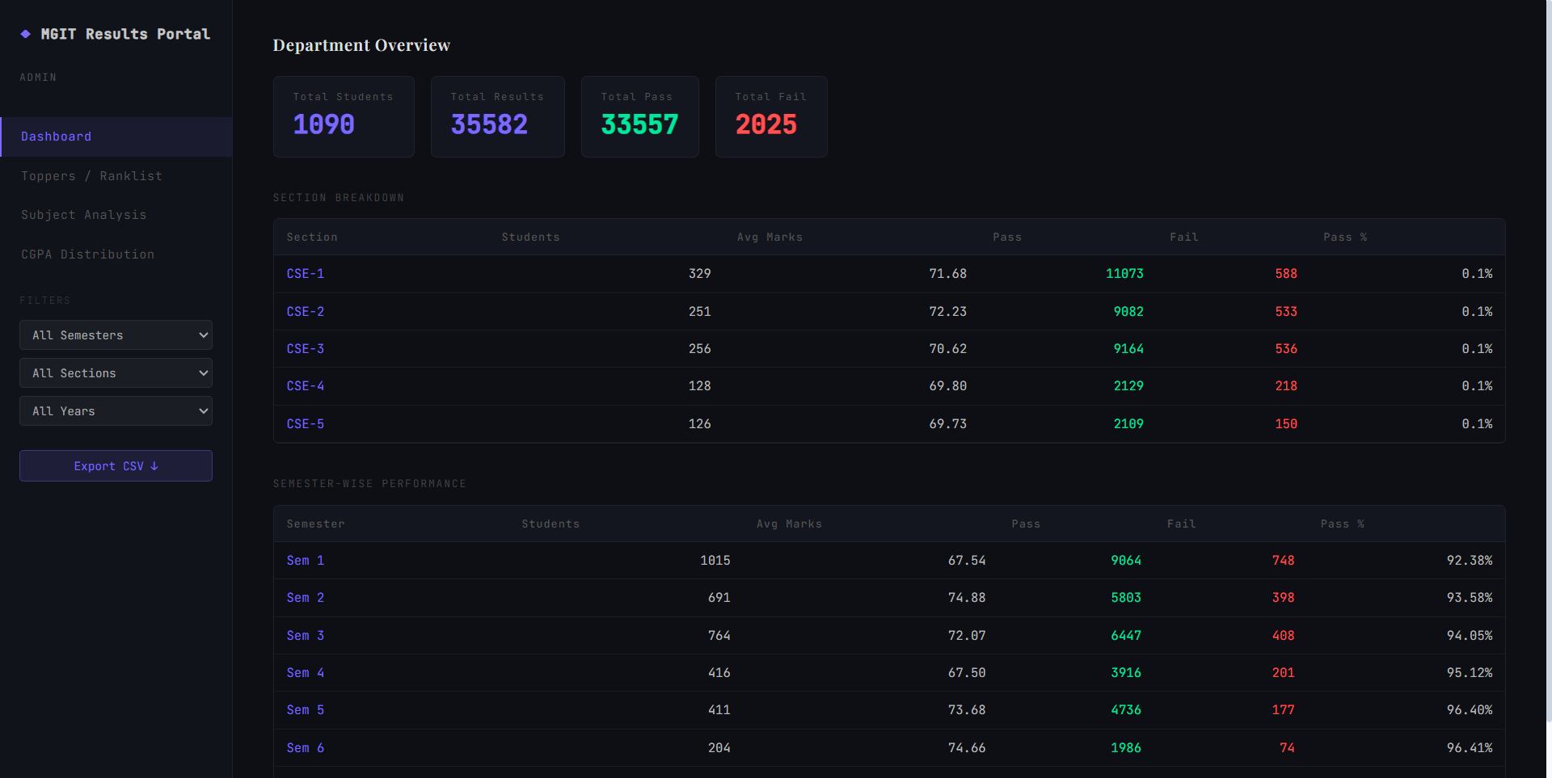
Figure 6.8: Admin Dashboard — Department stat cards, section breakdown, and semester performance table

6.9 Admin Toppers / Ranklist
The Toppers tab generates a ranked list by CGPA by default. Selecting a semester switches to SGPA-based ranking. Section and year filters allow cohort-specific drill-down. Tied GPA values receive the same rank number.
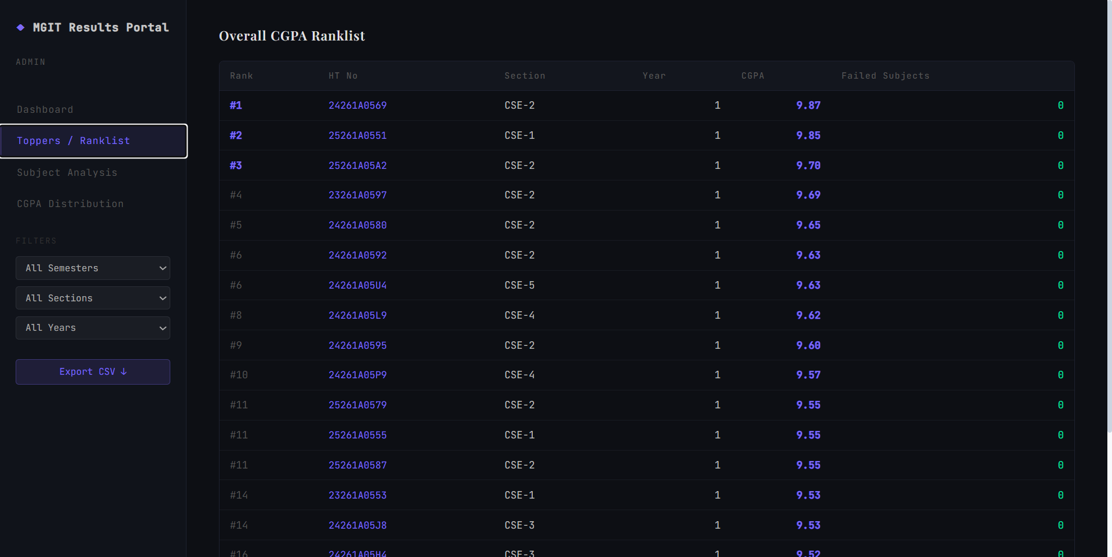Figure 6.9: Admin Toppers — CGPA-ranked student list with section, year, and semester filters

6.10 Admin Subject Analysis
The Subject Analysis tab shows a row per subject with average marks, highest and lowest scores, pass count, fail count, and pass percentage. A semester filter reduces the view to a specific term. 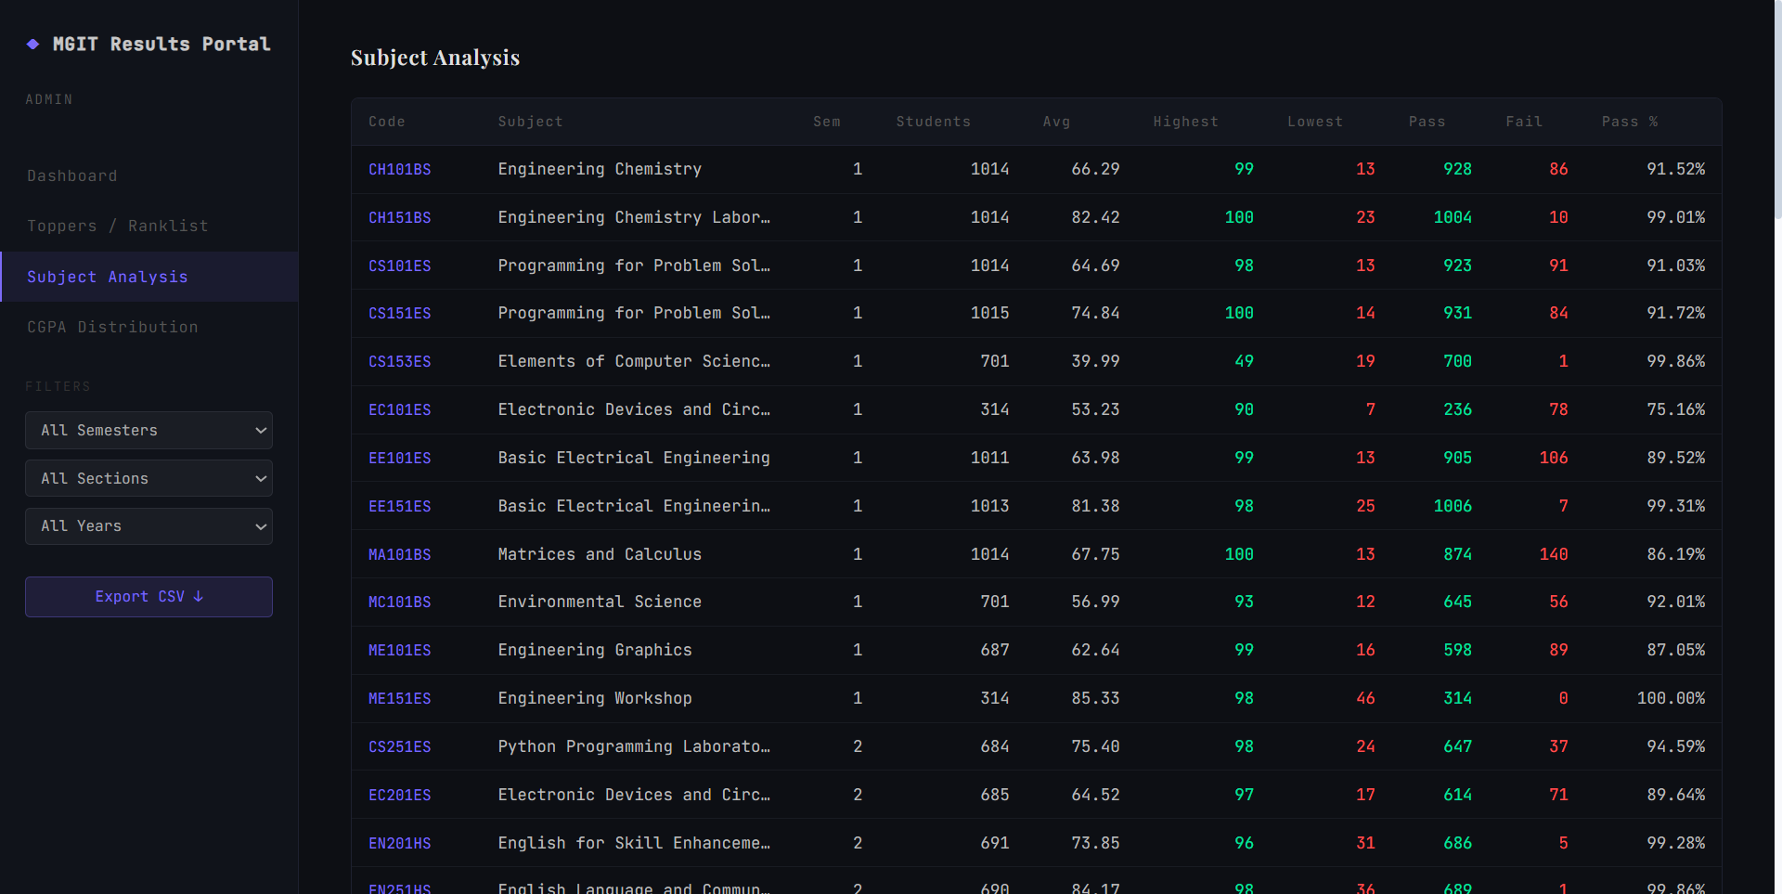Figure 6.10: Admin Subject Analysis — Per-subject statistics table with pass percentage

6.11 Admin CGPA Distribution
The CGPA Distribution tab displays a horizontal bar chart with 0.5-step CGPA buckets. Summary cards below aggregate students into four broad performance bands with percentage share of the total cohort.
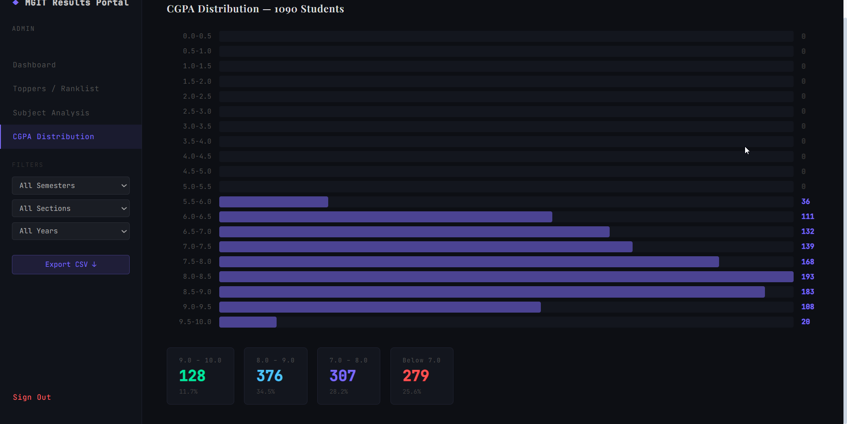 Figure 6.11: Admin CGPA Distribution — Histogram with 0.5-step buckets and summary band cards

7. ENHANCEMENTS

7.1 Student Name Integration
The current dataset contains no student names — students are identified solely by their hall ticket number. The database schema includes a name column in the students table that is currently unpopulated. Once the department provides a name mapping, the import script can be extended to populate this field and all student-facing screens can display a personalised greeting alongside the HT number.

7.2 Password Change Feature
Students currently use a default password that cannot be changed through the application. Adding a password change route and a form on the dashboard would allow students to set a personal password, improving both usability and security.

7.3 Projection Model Improvement
The current SGPA projection uses simple linear regression, which assumes a linear trend. A polynomial regression or weighted regression model (where more recent semesters carry greater weight) would produce more accurate projections for students whose performance has been non-linear. This would be a natural extension once more semester data is available.

7.4 Email Notifications
Automated email notifications could alert students when marks are updated by the admin or when a new semester's results are imported. This would eliminate the need for students to check the portal manually and would increase platform engagement.

7.5 Mobile Application
A React Native or Flutter mobile application would provide a more native experience for the student role. Push notifications for result updates and direct camera access for document scanning would become possible through a mobile client.

7.6 Attendance Integration
Integrating attendance data alongside result data would allow the admin dashboard to correlate attendance percentages with academic performance, providing richer insights into the factors that affect student outcomes across sections and subjects.

8. CONCLUSION
The Result Analysis System successfully demonstrates the practical application of Node.js, Express.js, MySQL, and React in building a production-grade, multi-role web application. Developed as a two-person team project, it is fully deployed and publicly accessible, making it a functional deliverable beyond a purely academic exercise.
The system manages result data for 1,090 students across 35,582 result entries, supports two distinct user roles with JWT-based role-specific access control, automates SGPA and CGPA calculation, implements a linear regression-based SGPA projection for advanced students, generates PDF marksheets, enables batch rank computation, and provides comprehensive department-wide analytics across sections and semesters.
The student dashboard's five-tab design — covering an overview with batch rank, a searchable results browser, a GPA overview with projection charts, a failed subjects tracker, and marksheet downloads — demonstrates how a complex feature set can be organised for clarity and usability. The linear regression projection in particular represents a meaningful application of statistical reasoning to a practical academic problem.
Key engineering concepts applied include RESTful API design, stateless JWT authentication, relational database schema design with foreign key constraints and unique indexes, bcrypt password security, middleware-based route protection, cloud deployment across multiple platforms, and collaborative Git-based development. The project encountered and resolved real-world challenges including MySQL strict mode compatibility, CORS configuration for cross-origin deployment, PDF generation library incompatibility with serverless hosting, and SPA routing on static CDN hosting.
The codebase is designed for extensibility. The modular route structure, shared utility functions, and clean separation between the frontend and backend make it straightforward to add the faculty role, additional analytics, or extended reporting without disrupting existing functionality.

