Result Analysis System

Node JS / React JS / Django (CS454PC)

Submitted
In partial fulfilment of the requirements for completion of
Bachelor of Technology
in
Computer Science and Engineering

By

Srinivas Konala
24261A05R0

And

Timothy Saxena
24261A05R4

Under the guidance of

Ms. Anitha Talari
Assistant Professor
Department of Computer Science and Engineering


Department of Computer Science and Engineering,
MAHATMA GANDHI INSTITUTE OF TECHNOLOGY(A)
GANDIPET, HYDERABAD-500 075, INDIA.
2025-2026
MAHATMA GANDHI INSTITUTE OF TECHNOLOGY(A)
(Affiliated to Jawaharlal Nehru Technological University Hyderabad)
Gandipet, Hyderabad-500 075, Telangana (India)


CERTIFICATE

This is to certify that the NODE JS/ REACT JS/ DJANGO (CS454PC) entitled Result Analysis System”, is being submitted by Mr. Srinivas Konala bearing Roll No: 24261A05R0 and Mr. Timothy Saxena bearing Roll No: 24261A05R4 in partial fulfillment for completion of Bachelor of Technology IV Semester in Computer Science and Engineering to Mahatma Gandhi Institute of Technology is a record of Bonafide work carried out by them under our guidance and supervision. The results embodied in this project have not been submitted to any other University or Institute for the award of any degree or diploma.

Project Guide Head of the Department
Ms. Anitha Talari Dr. C.R.K Reddy
Asst. Professor, Dept. of CSE Professor, Dept. of CSE

DECLARATION

This is to certify that the work reported in NODE JS/ REACT JS/ DJANGO (CS454PC) titled “Result Analysis System” is a record of work done by us in the Department of Computer Science and Engineering, Mahatma Gandhi Institute of Technology, Hyderabad. No part of the work is copied from books/journals/internet and wherever the portion is taken, the same has been duly referred to in the text. The report is based on the work done entirely by us and not copied from any other source.

SRINIVAS KONALA
(24261A05R0)

TIMOTHY SAXENA
(24261A05R4)

ACKNOWLEDGEMENT
The satisfaction that accompanies the successful completion of any task would be incomplete without the mention of people who made it possible because success is the abstract of hard work and perseverance, but steadfast of all is encouraging guidance. So, we acknowledge all those whose guidance and encouragement served as a beacon light and crowned my efforts with success.

We would like to express our sincere thanks to, Prof G. Chandra Mohan Reddy, Principal MGIT, for providing the working facilities in college.

We wish to express our sincere thanks and gratitude to Dr. C R K Reddy, Professor and HoD, Department of CSE, MGIT, for all the timely support and valuable suggestions during the period of project.

We are extremely thankful to Ms. Anitha Talari, Assistant Professor, Department of CSE, MGIT, NODE JS/ REACT JS/ DJANGO (CS454PC) faculty for her encouragement and support throughout the project.

We are also extremely thankful and indebted to our mentor, Dr. B. Madhava Rao, Assistant Professor, Department of CSE, MGIT for his constant guidance, encouragement, and moral support throughout the project.

Finally, we would also like to thank all the faculty and staff of the CSE Department who helped us directly or indirectly in completing this project.

SRINIVAS KONALA
(24261A05R0)

TIMOTHY SAXENA
(24261A05R4)

TABLE OF CONTENTS
CERTIFICATE 1
DECLARATION 2
ACKNOWLEDGEMENT 3
TABLE OF CONTENTS 4
LIST OF FIGURES 6
LIST OF TABLES 7
LIST OF ABBREVIATIONS 8
ABSTRACT 9

1. INTRODUCTION 10
1.1 Problem Definition 10
1.2 Existing Systems 11
1.3 Proposed System 11
1.4 Requirements Specification 12

2. LITERATURE SURVEY 13
2.1 Paper Summaries 13
2.2 Literature Survey Table 17

3. METHODOLOGY 19
3.1 Technologies Used 19
3.2 Development Process 20

4. DESIGN 22
4.1 System Architecture 22
4.2 Entity-Relationship and Database Schema 23
4.3 Activity Diagram 24
4.4 Modules 26
4.5 System Workflow 27

5. IMPLEMENTATION 28
5.1 Backend API 28
5.2 Gemini Integration 29
5.3 Database Operations 30
5.4 Frontend Implementation 31
5.5 Error Handling 31

6. TESTING AND RESULTS 32

7. CONCLUSION AND FUTURE SCOPE 38
7.1 Conclusion 38
7.2 Future Scope 38

BIBLIOGRAPHY 39
APPENDIX A 40
APPENDIX B 43
LIST OF FIGURES
FIGURE PAGE NO

Figure 4.1: System Architecture Diagram 22
Figure 4.2: Entity-Relationship Diagram 23
Figure 4.3: Activity Diagram 25
Figure 4.4: Module Interaction Diagram 26
Figure 4.5: System Workflow Sequence Diagram 27
Figure 6.1: Home screen showing the meal photograph upload interface 32
Figure 6.2: Analysis results screen showing nutritional breakdown 33
Figure 6.3: Meal quality score section of the results screen 34
Figure 6.4: Detailed feedback panel showing nutrient gaps 35
Figure 6.5: Activity equivalents panel showing calorie burn estimates 36
Figure 6.6: Daily dashboard displaying calorie progress & meals for the current day 37

LIST OF TABLES
TABLE PAGE NO

Table 2.1: Literature Survey Table 17
Table 4.1: Meals Table Schema 23

LIST OF ABBREVIATIONS
ABBREVIATION EXPANSION

AI : Artificial Intelligence
API : Application Programming Interface
ASGI : Asynchronous Server Gateway Interface
CNN : Convolutional Neural Network
CORS : Cross-Origin Resource Sharing
CRUD : Create, Read, Update, Delete
CSS : Cascading Style Sheets
DB : Database
ER : Entity Relationship
GPU : Graphics Processing Unit
HTML : Hypertext Markup Language
HTTP : Hypertext Transfer Protocol
HTTPS : Hypertext Transfer Protocol Secure
JS : JavaScript
JSON : JavaScript Object Notation
LLM : Large Language Model
MLLM : Multimodal Large Language Model
NLP : Natural Language Processing
ORM : Object Relational Mapper
RAG : Retrieval-Augmented Generation
REST : Representational State Transfer
SDK : Software Development Kit
SQL : Structured Query Language
SQLite : Self-Contained Lightweight SQL Database Engine
UI : User Interface
URL : Uniform Resource Locator

ABSTRACT

Keeping track of what we eat every day is something most people know they should do, but rarely manage to stick with. The main reason is that existing nutrition tracking apps require a lot of manual effort — searching for food items, estimating portions, and entering data by hand. Over time this becomes tedious and people stop using them. This project addresses that problem by building an AI-based system that makes meal logging as simple as taking a photograph.
The AI-Based Food Recognition and Nutrition Tracking System allows a user to photograph a meal and instantly receive a detailed nutritional analysis powered by Google Gemini 2.5 Flash, a multimodal large language model capable of understanding both images and text. The model identifies the dish, estimates its nutritional content — calories, protein, carbohydrates, fat, and dietary fibre — and also generates a meal quality score out of ten along with a short insight explaining why the meal scored the way it did. It additionally tells the user what nutrients the meal is lacking, what is present in excess, and gives practical improvement suggestions with physical activity equivalents for the calorie count.
A key feature of the system is its confirm-before-save design. The analysis is shown to the user first, and the meal is only saved to the database after the user explicitly confirms it. This avoids incorrect entries while still keeping the logging process fast. A daily dashboard then aggregates all saved meals and shows cumulative calorie and macronutrient intake for the day with a progress bar.
The system is built with a Python FastAPI backend, SQLite database, and a Vanilla HTML/CSS/JavaScript frontend with a dark-themed, mobile-first interface. It is deployed on Render and accessible through any modern web browser without requiring any app installation.

Keywords: Food Recognition, Nutrition Tracking, Multimodal Large Language Model, Google Gemini, Dietary Assessment, FastAPI, SQLite

1. INTRODUCTION
The AI-Based Food Recognition and Nutrition Tracking System is a full-stack web application designed to help individuals become more conscious of their daily nutritional intake with minimal effort. By leveraging Google Gemini 2.5 Flash, a state-of-the-art multimodal large language model, the system allows users to photograph their meals and receive an instant, detailed nutritional breakdown — all without manual food logging or database lookups.
The application follows a confirm-before-save workflow: the user uploads a meal photograph, the system analyses it using the Gemini API and returns a structured nutrition report, the user reviews the report, and only then confirms saving it to the personal meal log. A daily dashboard aggregates all saved meals and tracks cumulative calorie intake, macronutrient distribution, and meal quality trends over the course of the day.
The system is built with a Python FastAPI backend, an SQLite database for persistent meal storage, and a Vanilla HTML/CSS/JavaScript frontend with a dark-themed, mobile-first interface. The project is designed to be lightweight, deployable on free-tier hosting platforms such as Render, and accessible entirely through a web browser without the need for any native app installation.
1.1 PROBLEM DEFINITION
Despite widespread awareness of the importance of nutrition, most people find it difficult to track what they eat on a daily basis. Existing manual approaches — writing down meals, estimating portion sizes, or searching food databases — are time-consuming, error-prone, and frequently abandoned. Studies consistently show that people underestimate calorie consumption by significant margins when relying on memory or self-reporting.
The core problem is the friction between intent and action: people want to be aware of their nutrition, but the effort required to log food manually is too high for sustained daily use. There is a clear need for a system that reduces this friction dramatically — ideally to a single step — while still providing meaningful, actionable nutritional feedback.
Additionally, most users lack the nutritional literacy to judge whether a meal is well-balanced. Simply knowing the calorie count of a dish is insufficient; users need context — which nutrients are missing, what is present in excess, and how the meal compares to recommended daily values. The proposed system addresses all of these gaps.
1.2 EXISTING SYSTEMS
Several nutrition tracking applications currently exist in the market, each with notable strengths and limitations:
MyFitnessPal is the most widely used nutrition tracker, offering a large food database and barcode scanning. However, it relies entirely on manual search and entry, which is cumbersome for home-cooked or restaurant meals that are not in its database.
Cronometer provides granular micronutrient tracking and is popular among health enthusiasts. Like MyFitnessPal, it depends on manual entry and offers no visual recognition capability.
Lose It! includes a photo-logging feature, but the nutritional analysis is based on simple image classification matched against a predefined food database, rather than generative AI reasoning. It cannot handle complex mixed dishes or provide qualitative meal feedback.
Google Lens / Samsung Food can identify food items visually, but are not purpose-built nutrition trackers and do not provide a structured daily logging workflow or persistent meal history.
None of these systems combine AI-based photo analysis, qualitative meal feedback (quality score, improvement suggestions, nutrient gaps), and a clean daily dashboard in a single, open, lightweight application. This gap defines the opportunity for the proposed system.
1.3 PROPOSED SYSTEM
The AI-Based Food Recognition and Nutrition Tracking System proposes a streamlined, AI-first approach to meal logging that reduces the effort of food tracking to a single action: photographing a meal.
The proposed workflow is as follows: the user opens the web application and uploads or captures a photograph of their meal. The image is sent to the FastAPI backend, which forwards it to the Google Gemini 2.5 Flash model along with a structured prompt that instructs the model to identify the dish, estimate portion size, and return a complete nutritional breakdown. The response includes calorie count, macronutrients (protein, carbohydrates, fat, fibre), a meal quality score out of ten, a short qualitative insight, a list of what the meal lacks and what is in excess, improvement suggestions, and physical activity equivalents for the calorie count.
The user reviews this analysis on the results screen before deciding to save it. On confirmation, the meal data is stored in an SQLite database. The daily dashboard, accessible from the main screen, aggregates all saved meals for the current day and displays total calories consumed, a calorie progress bar relative to a daily target, and macronutrient summaries.
The system is intentionally simple in its architecture — no user authentication, no cloud database, no native app — making it easy to self-host and extend. Future enhancements include quantity adjustment to scale nutrition values, an Android interface using the device camera, and deployment as a public web service.
1.4 REQUIREMENTS SPECIFICATION
The following software and hardware requirements are necessary to develop, deploy, and run the AI-Based Food Recognition and Nutrition Tracking System.
Software Requirements
- Operating System: Windows 10 or later / Linux (Ubuntu 20.04+) / macOS 11+
- Programming Language: Python 3.10 or later
- Backend Framework: FastAPI (Python) with Uvicorn ASGI server
- Database: SQLite 3 (file-based, no separate server required)
- AI / LLM API: Google Gemini 2.5 Flash via the google-generativeai Python SDK
- Frontend: Vanilla HTML5, CSS3, JavaScript (ES6+) — no frontend framework
- Key Python Libraries: fastapi, uvicorn, google-generativeai, python-multipart, python-dotenv, Pillow
- Version Control: Git with GitHub (remote repository: timothy-saxena/food_logger)
- Deployment Platform: Render (free-tier web service)
- Environment Management: .env file for storing the Gemini API key securely

Hardware Requirements
- Processor: Intel Core i3 or equivalent (minimum); i5 or higher recommended
- Memory: 4 GB RAM minimum; 8 GB recommended
- Storage: 500 MB free disk space for application, dependencies, and SQLite database
2. LITERATURE SURVEY
2.1 PAPER SUMMARIES
The following section presents a survey of key research works related to the AI-Based Food Recognition and Nutrition Tracking System. The papers are arranged in reverse chronological order, from the most recent to the earliest, covering the evolution from traditional deep learning-based food recognition systems to modern multimodal large language model approaches.
1. “DietAI24: A Framework for Comprehensive Nutrition Estimation Using Multimodal Large Language Models" by Yan et al.
This study introduces DietAI24, a unified dietary assessment framework that combines multimodal large language models (MLLMs) with Retrieval-Augmented Generation (RAG) to ground visual food recognition in authoritative nutrition databases rather than relying on the model's internal parametric knowledge. The system identifies food items from photographs, estimates portion sizes, and computes values for 65 distinct nutrients. By anchoring LLM outputs to the USDA Food and Nutrient Database for Dietary Studies (FNDDS), DietAI24 substantially improves nutritional accuracy over conventional CNN-based approaches and prior MLLM baselines.

2. "Performance Evaluation of 3 Large Language Models for Nutritional Content Estimation from Food Images" by Svenningsen et al.
This paper presents a rigorous experimental evaluation of three leading multimodal LLMs — ChatGPT-4o, Claude 3.5 Sonnet, and Gemini 1.5 Pro — in estimating macronutrients and calorie content from 52 standardised food photographs, spanning individual components and complete meals across three portion sizes. All models received identical structured prompts requesting food identification, volume estimation relative to visible reference objects, and nutrient quantification. The study reports moderate-to-strong correlations between LLM estimates and ground truth values, suggesting these models are capable of relative dietary pattern tracking even when absolute accuracy requires calibration.

3. "FoodLMM: A Versatile Food Assistant using Large Multi-modal Model" by Yin et al.
FoodLMM is a purpose-built large multimodal model for the food domain that unifies food recognition, ingredient identification, recipe generation, nutrition estimation, food segmentation, and multi-round conversational interaction within a single architecture. The model introduces novel task-specific tokens and prediction heads, enabling it to output both natural language responses and structured nutritional data, and is trained in two stages: multi-task learning on public food benchmarks followed by fine-tuning on a curated food dialogue dataset constructed with GPT-4. FoodLMM demonstrates that specialising a general-purpose multimodal LLM for the food domain through targeted instruction tuning significantly improves performance over zero-shot baselines on nutrition estimation tasks.

4. "Large Scale Visual Food Recognition" by Min, Wang, Liu, Luo, Kang, Wei, Wei, and Jiang.
This paper introduces Food2K, the largest food recognition benchmark to date, comprising 2,000 food categories and over one million images, alongside a deep progressive region enhancement network that employs progressive local feature learning and region feature enhancement for fine-grained classification. The authors demonstrate that the scale and diversity of training data are the primary determinants of food recognition generalisation, and that attention-based region mining significantly improves performance on visually similar dish categories. The work also establishes evaluation protocols that have become standard references in the food vision community.

5. “Image-Based Food Classification and Volume Estimation for Dietary Assessment: A Review”" by Lo, Sun, Qiu, and Lo.

This comprehensive review published in IEEE Journal of Biomedical and Health Informatics surveys the landscape of computer vision methods for image-based dietary assessment, covering food recognition algorithms from traditional hand-crafted feature approaches to deep convolutional neural networks, and volume estimation techniques spanning stereo-based, model-based, depth-camera, and perspective transformation methods. The authors systematically evaluate these methods across popular food image datasets and highlight that while food classification accuracy has improved substantially with deep learning.

6. "DeepFood: Deep Learning-Based Food Image Recognition for Computer-Aided Dietary Assessment" by Liu, Cao, Luo, Chen, Vokkarane, and Ma.

DeepFood proposes a deep learning-based food recognition system aimed at improving the accuracy of computer-aided dietary assessment by analysing meal images captured by mobile devices. The system employs CNN architectures fine-tuned on food image datasets, achieving competitive top-1 accuracy on the UEC-256 and Food-101 benchmarks. The paper demonstrates that deep learning models substantially outperform traditional hand-crafted feature methods for food classification and frames food image analysis as a practical tool for combating obesity and diet-related chronic illness.
7. "Food Recognition Using Fusion of Classifiers Based on CNNs" by Aguilar, Bolanos, and Radeva.

This paper investigates the application of transfer learning with pre-trained CNN models for food image classification, demonstrating that fine-tuning deep networks pre-trained on large general-purpose image datasets (such as ImageNet) achieves significantly higher food recognition accuracy than training CNN models from scratch on food-specific data alone. The authors evaluate multiple CNN architectures and show that features learned from large-scale visual corpora transfer effectively to the food domain despite the domain shift. The work establishes transfer learning as the standard paradigm for food recognition tasks where labelled food image datasets are limited.

8. "Leveraging Context to Support Automated Food Recognition in Restaurants" by
Bettadapura, Thomaz, Parnami, Abowd, and Essa.

This paper proposes a context-aware food recognition system designed for restaurant settings, where knowledge of the restaurant and its menu is used as contextual prior information to constrain and improve image-based food classification. By incorporating metadata such as location and menu information alongside visual features, the system achieves higher recognition accuracy than image-only baselines, particularly for visually ambiguous dishes. The work demonstrates that contextual signals substantially complement appearance-based food recognition, especially in real-world deployment conditions.
9. "Food Image Recognition with Deep Convolutional Features" by Kawano and Yanai.
This paper reports one of the early demonstrations that deep convolutional neural network features, when combined with traditional hand-crafted features such as Fisher Vectors, Histogram of Oriented Gradients (HoG), and colour patches, significantly boost food recognition accuracy. Evaluated on the UEC-FOOD100 dataset, the proposed approach achieves 72.26% top-1 accuracy and 92.00% top-5 accuracy, substantially surpassing the previous best result of 59.6% on the same benchmark. The paper establishes the superiority of learned deep representations over engineered features for food classification.

10. "Measuring Calorie and Nutrition from Food Image" by Pouladzadeh, Shirmohammadi, and AlMaghrabi.
This paper demonstrates the feasibility of estimating calorie and nutritional content directly from food images using image analysis and machine learning techniques. The system segments food regions from images, estimates geometric volume using reference objects in the scene, and maps food categories to nutritional databases to compute calorie counts and macronutrient values. The work shows that automated image-based calorie measurement is achievable but is critically dependent on accurate portion size estimation, which in turn requires reference objects or depth information. The primary limitation identified is that estimation accuracy degrades significantly with varying camera angles and when reference objects are absent.

2.1 LITERATURE SURVEY TABLE
Table 2.1: Literature Survey Table
S. No | Author(s) | Title | Year | Merits | Demerits
1 | Yan et al. | DietAI24: A Framework for Comprehensive Nutrition Estimation Using Multimodal Large Language Models | 2025 | Combines MLLMs with RAG grounded in authoritative nutrition databases; estimates 65 nutrients from food photographs without model retraining. | Dependent on external database coverage; less effective for foods not present in the FNDDS database.
2 | Svenningsen et al. | Performance Evaluation of 3 Large Language Models for Nutritional Content Estimation from Food Images | 2024 | Directly compares GPT-4o, Claude, and Gemini on standardised food photographs; demonstrates moderate-to-strong correlation with ground truth for relative dietary tracking. | Absolute accuracy limited, especially for large portions; requires calibration for clinical use.
3 | Yin et al. | FoodLMM: A Versatile Food Assistant using Large Multi-modal Model | 2023 | Unifies food recognition, nutrition estimation, segmentation, and multi-round dialogue in one model; | Requires significant compute for training and inference; performance depends on quality of multi-task training data.
4 | Min et al. | Large Scale Visual Food Recognition | 2023 | Introduces Food2K with 2,000 categories and 1M+ images; progressive region enhancement network | Recognition limited to predefined categories;
5 | Lo et al. | Image-Based Food Classification and Volume Estimation for Dietary Assessment: A Review | 2020 | Comprehensive survey covering classification and volume estimation methods; | Review paper without novel methodology; findings may not reflect post-2020 advances including LLM-based approaches.
6 | Liu et al. | DeepFood: Deep Learning-Based Food Image Recognition for Computer-Aided Dietary Assessment | 2016 | Demonstrates CNN-based food recognition achieves high accuracy on standard benchmarks; | Provides only category-level output; does not estimate portion sizes or generate nutritional feedback.
7 | Aguilar et al. | Food Recognition Using Transfer Learning | 2017 | Shows transfer learning from large datasets substantially improves food classification accuracy; | Performance tied to visual similarity between training and test distributions;
8 | Bettadapura et al. | Leveraging Context to Support Automated Food Recognition in Restaurants | 2015 | Demonstrates that contextual metadata significantly improves food recognition accuracy. | Requires prior knowledge of location and menu;
9 | Kawano and Yanai | Food Image Recognition with Deep Convolutional Features | 2014 | Shows deep CNN features combined with hand-crafted features greatly outperform prior methods | Difficulty in recognising mixed or composite dishes;
10 | Pouladzadeh et al. | Measuring Calorie and Nutrition from Food Image | 2014 | Demonstrates feasibility of image-based calorie and nutrition estimation; | Accuracy highly dependent on image angle and presence of reference objects;
3. METHODOLOGY
This section describes the technologies selected for the development of the AI-Based Food Recognition and Nutrition Tracking System and the iterative process followed during its design and implementation.
3.1 TECHNOLOGIES USED
a) Python 3.10+
Python was chosen as the primary programming language due to its extensive ecosystem of libraries for web development, AI integration, image processing, and database management. Its readability and rapid development cycle make it well-suited for a solo project with a short development timeline.
b) FastAPI
FastAPI is a modern, high-performance Python web framework built on ASGI (Asynchronous Server Gateway Interface). It was selected for its automatic OpenAPI documentation, native support for asynchronous request handling, built-in data validation via Pydantic, and significantly faster request processing compared to traditional frameworks such as Flask or Django. FastAPI's decorator-based route definition closely mirrors the clean structure of the project's API endpoints.
c) SQLite
SQLite is a lightweight, serverless, file-based relational database that requires no separate installation or configuration. It was chosen for this project because the application is single-user, the data volume is small, and the goal was to keep the deployment footprint minimal. SQLite integrates directly with Python via the built-in sqlite3 module.
d) Google Gemini 2.5 Flash (Multimodal LLM)
Google Gemini 2.5 Flash is a multimodal large language model capable of processing both text and images in a single prompt. It serves as the analytical core of the system. A structured prompt instructs the model to identify the meal in the uploaded photograph, estimate quantities, and return a complete nutritional analysis in a predefined JSON-compatible format. Gemini 2.5 Flash was specifically chosen over other models for its speed, cost-effectiveness, and strong performance on food recognition tasks.
e) Vanilla HTML/CSS/JavaScript (ES6+)
The frontend is intentionally built without any JavaScript framework (React, Vue, etc.) to minimise bundle size, reduce complexity, and eliminate build tooling requirements. Vanilla JS with the Fetch API handles asynchronous communication with the FastAPI backend.
f) Google Generativeai Python SDK
The official google-generativeai SDK provides a clean Python interface for sending multimodal prompts to the Gemini API, handling authentication via API key, and parsing structured responses.
g) Render (Deployment)
Render is a cloud platform that supports free-tier deployment of Python web services. It was selected for its straightforward GitHub integration, automatic redeploy on push, and zero-cost hosting for low-traffic applications, making it appropriate for a project submission and demonstration context.
3.2 DEVELOPMENT PROCESS
The development of the system followed an iterative, feature-driven process divided into the following phases:
a) Requirement Analysis
The problem of high-friction nutrition tracking was identified and the core user workflow was defined: photograph a meal, receive instant AI analysis, review, confirm, and log. The decision to use a multimodal LLM instead of a traditional image classification + food database approach was made at this stage to enable richer, more contextual nutritional feedback.
b) Backend Development
The FastAPI backend was set up first, with two primary route modules: the analysis route (/api/analyze), which accepts an image upload and returns the Gemini-generated nutrition report, and the meals route (/api/meals/save and /api/meals), which handles saving confirmed meals to SQLite and retrieving the daily meal log. The database schema was designed and the SQLite connection layer was implemented.
c) Gemini Prompt Engineering
Significant effort was invested in crafting the prompt sent to Gemini 2.5 Flash. The prompt instructs the model to return structured data including dish name, calorie estimate, macronutrients, quality score, a one-line insight, lists of nutritional gaps and excesses, improvement suggestions, and activity equivalents.
d) Frontend Development
The frontend was developed as three interlinked HTML/CSS/JS modules: the upload interface (index.html, upload.js), the analysis results screen (results.js), and the daily dashboard (dashboard.js). The confirm-before-save flow was implemented by staging the Gemini analysis response in the browser before making a second API call to save the meal only on explicit user confirmation.
e) Integration and Testing
The frontend and backend were integrated and tested end-to-end with a variety of meal photographs, including single-item dishes, mixed plates, and restaurant meals. Edge cases such as unrecognisable images, network failures, and empty daily logs were handled with appropriate user feedback.
f) Version Control and Deployment
The project was version-controlled using Git with a remote repository hosted on GitHub (timothy-saxena/food_logger). A .gitignore file was configured to exclude the .env file containing the API key. The application is deployed on Render using the GitHub integration for continuous deployment.
4. DESIGN OF THE AI-BASED FOOD RECOGNITION AND NUTRITION TRACKING SYSTEM
The system is designed as a lightweight, modular web application following a clear client-server separation. The frontend handles all user interaction and display logic, while the backend manages AI integration, data persistence, and API routing.
4.1 SYSTEM ARCHITECTURE
The system architecture consists of three primary layers: the frontend client, the FastAPI backend server, and the external Gemini AI service, with SQLite serving as the local data store.
Key Components:
- Frontend Client: Vanilla HTML/CSS/JS served as static files. Communicates with the backend via the Fetch API (REST calls). Handles image capture/upload, displays analysis results, and renders the daily dashboard.
- FastAPI Backend: The central application server. Exposes REST API endpoints for meal analysis (/api/analyze) and meal management (/api/meals/save, /api/meals). Forwards images to the Gemini API and returns structured responses.
- Google Gemini 2.5 Flash: External multimodal AI service. Receives the meal image and structured prompt, performs food recognition and nutritional reasoning.
This is shown in the Figure 4.1 explaining how the system works and uses AI.
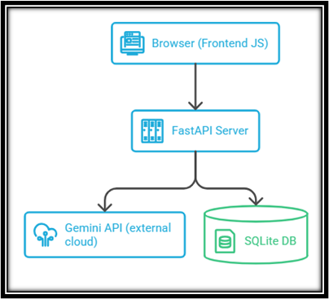
Figure 4.1: System Architecture Diagram of Food Recognition System
4.2 ENTITY-RELATIONSHIP AND DATABASE SCHEMA
The SQLite database contains a single primary table — meals — which stores all confirmed meal records.
The meals table has the following columns:
Table 4.1: Meals Table Schema
Column Name | Data Type | Description
id | INTEGER | Primary key, auto-incremented unique meal identifier
dish_name | TEXT | Name of the identified dish as returned by Gemini
calories | REAL | Estimated calorie count for the meal
protein | REAL | Protein content in grams
carbs | REAL | Carbohydrate content in grams
fat | REAL | Fat content in grams
fibre | REAL | Dietary fibre content in grams
quality_score | REAL | Meal quality score out of 10 as assessed by Gemini
insight | TEXT | One-line qualitative insight about the meal
logged_at | DATETIME | Timestamp of when the meal was saved (UTC)
The Entity-Relationship Diagram shown in Figure 4.2 represents the database structure. Since the application is designed as a single-user tool with one primary data entity, the schema consists of a single table — meals — with no relationships to other entities. Each record in the meals table is uniquely identified by an auto-incremented integer primary key (id).
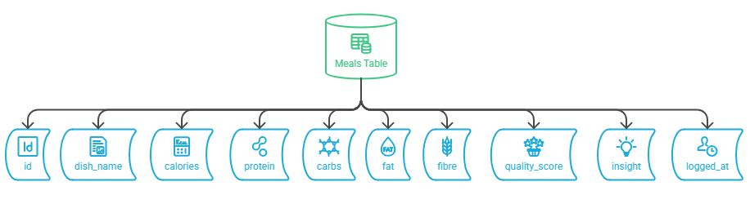
Figure 4.2: Entity-Relationship Diagram of the Meals Table.
4.3 ACTIVITY DIAGRAM
The Activity Diagram shown in Figure 4.3 illustrates the end-to-end flow of the meal logging process, from image upload through AI analysis to database storage.
The key steps in the activity flow are:
- User opens the web application and selects a meal photograph from the device.
- The frontend sends the image to the /api/analyze endpoint via a multipart POST request.
- The backend encodes the image and forwards it to the Gemini 2.5 Flash API along with the structured nutrition prompt.
- Gemini processes the image and returns a structured JSON response containing the nutritional analysis.
- The backend parses the response and returns it to the frontend.
- The frontend displays the full analysis on the results screen (dish name, calories, macros, quality score, insights, suggestions).
- The user reviews the analysis and chooses to either confirm and save or discard the meal.
- On confirmation, the frontend sends a POST request to /api/meals/save with the meal data.
- The backend inserts the meal record into the SQLite database.
- The user is redirected to the daily dashboard, which retrieves and displays all saved meals for the day.

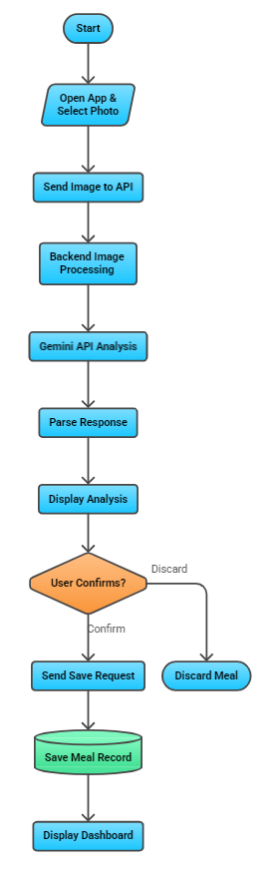
Figure 4.3: Activity Diagram of Food Tracking system.
4.4 MODULES
The system is organised into four functional modules, each corresponding to a distinct area of responsibility within the application as illustrated in Figure 4.4.
a) Image Upload Module
Handles the user-facing meal photograph input. Provides a file picker and drag-and-drop interface on the frontend. On submission, the image is sent as a multipart/form-data payload to the backend analysis endpoint.
b) AI Analysis Module
The core intelligence of the system. The FastAPI /api/analyze route receives the uploaded image, encodes it in base64, and constructs a multimodal prompt for the Gemini 2.5 Flash API. The prompt requests a structured nutritional breakdown.
c) Meal Storage Module
Manages persistent storage of confirmed meals. The /api/meals/save endpoint receives the validated meal data from the frontend and writes it to the SQLite meals table. The /api/meals endpoint retrieves all meals logged on the current date, supporting the daily dashboard view.
d) Daily Dashboard Module
Aggregates and displays the user's meal log for the current day. The frontend queries /api/meals on load, receives the list of today's saved meals, and computes totals for calories, protein, carbohydrates, fat, and fibre.
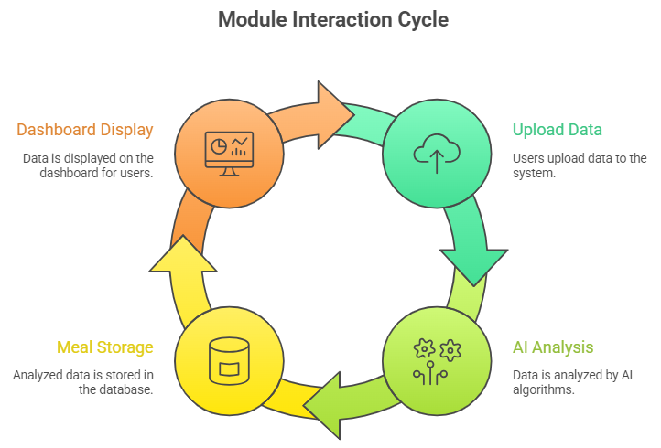
Figure 4.4: Module Interaction Diagram of the Food Tracking System.
4.5 SYSTEM WORKFLOW
The following sequence describes a complete user session with the system, as illustrated in Figure 4.5.
Step 1 — Image Capture: The user navigates to the application home page and either uploads an image from the file system or captures a photograph using the device camera (on mobile).
Step 2 — Analysis Request: The frontend sends the image to the FastAPI /api/analyze endpoint. A loading indicator is displayed while the Gemini API processes the request.
Step 3 — Results Display: The analysis results screen presents the identified dish name, estimated calories, macronutrient breakdown, meal quality score.
Step 4 — User Confirmation: The user reviews the analysis and decides whether to log the meal. Two action buttons are presented: 'Save Meal' and 'Discard'. If discarded, the user returns to the home screen with no data written.
Step 5 — Meal Saved: On confirmation, the meal data is posted to /api/meals/save and stored in SQLite. A success notification is shown.
Step 6 — Dashboard View: The user navigates to the daily dashboard to view cumulative nutrition data for the day, including total calories consumed.
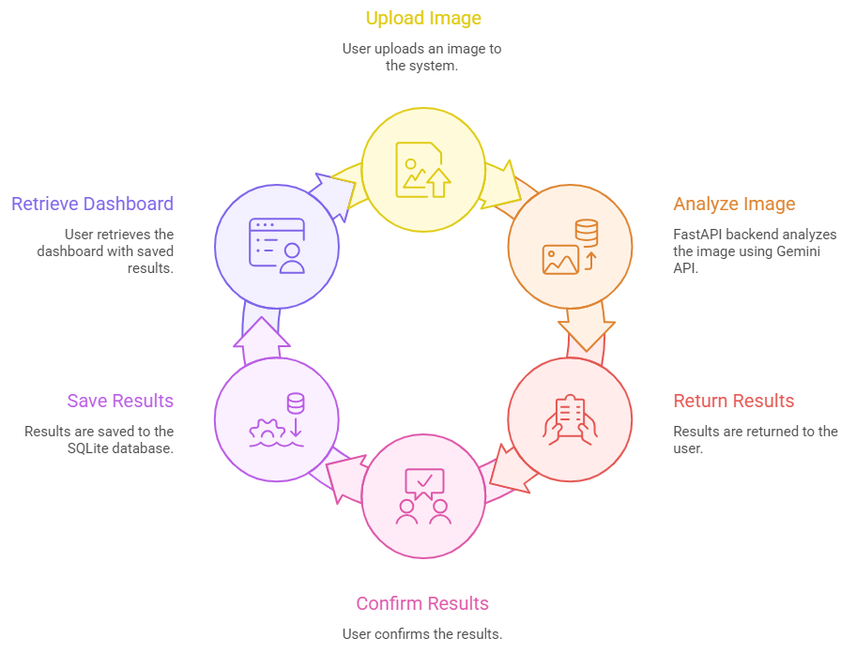
Figure 4.5: System Workflow Sequence Diagram of the Food Tracking System.
5. IMPLEMENTATION
The AI-Based Food Recognition and Nutrition Tracking System is implemented as a full-stack web application with a clear separation between the FastAPI backend and the Vanilla JavaScript frontend. The backend handles all AI interaction and data persistence, while the frontend is responsible for user interaction, display logic, and state management between analysis and confirmation. \
5.1 BACKEND API
The FastAPI backend is structured into two route modules housed in the backend/routes/ directory. The application entry point (backend/main.py) initialises the FastAPI application instance, configures CORS to allow the frontend origin, mounts the route modules, and creates the SQLite database table on startup if it does not already exist.
The /api/analyze endpoint accepts a multipart POST request containing a meal photograph. The uploaded image is read into memory as bytes, encoded in base64, and forwarded to the Gemini 2.5 Flash API via the google-generativeai SDK along with a structured prompt. The endpoint is stateless
The /api/meals/save endpoint accepts a POST request containing the confirmed meal data (dish name, calories, macronutrients, quality score, insight, and timestamp) and inserts a new record into the SQLite meals table.

# backend/main.py (excerpt)
from fastapi import FastAPI
from fastapi.middleware.cors import CORSMiddleware
from routes.analyze import router as analyze_router
from routes.meals import router as meals_router
from db.database import create_table

app = FastAPI()
app.add_middleware(CORSMiddleware, allow_origins=['*'],
allow_methods=['*'], allow_headers=['*'])
app.include_router(analyze_router, prefix='/api')
app.include_router(meals_router, prefix='/api')

5.2 GEMINI INTEGRATION
The core intelligence of the system resides in the Gemini integration implemented in backend/routes/analyze.py. When the /api/analyze endpoint receives an uploaded image, the image bytes are base64-encoded and passed to the Gemini 2.5 Flash model as an inline image part alongside a structured text prompt.
The prompt is the most critical engineering component of the system. It instructs Gemini to identify the dish, estimate portion size, and return a structured JSON object containing: dish_name, calories, protein, carbs, fat, fibre, quality_score (out of 10), insight (one sentence), what_meal_lacks (list), what_is_in_excess (list), improvement_suggestions (list), and activity_equivalents (list). The prompt explicitly specifies that the response must be valid JSON with no surrounding text or markdown formatting, which ensures reliable parsing on the backend.

# backend/routes/analyze.py (excerpt)
import google.generativeai as genai
import base64, json

genai.configure(api_key=os.getenv('GEMINI_API_KEY'))
model = genai.GenerativeModel('gemini-2.5-flash')

PROMPT = '''Analyze this meal image and return ONLY a JSON object with:
dish_name, calories, protein, carbs, fat, fibre, quality_score (0-10),
insight (one sentence), what_meal_lacks, what_is_in_excess,
improvement_suggestions, activity_equivalents.
Return raw JSON only, no markdown.'''

async def analyze_meal(file: UploadFile = File(...)):
img_bytes = await file.read()
img_b64 = base64.b64encode(img_bytes).decode()
response = model.generate_content([
{'mime_type': file.content_type, 'data': img_b64}, PROMPT
])
return json.loads(response.text)

5.3 DATABASE OPERATIONS
The database layer is implemented in backend/db/database.py using Python's built-in sqlite3 module. No third-party ORM is used, keeping the dependency footprint minimal. The module exposes three functions: create_table(), which runs the CREATE TABLE IF NOT EXISTS statement on startup; save_meal(), which executes a parameterised INSERT statement to store a confirmed meal record; and get_meals_today(), which queries all meal records where the logged_at timestamp falls within the current calendar day.

# backend/db/database.py (excerpt)
import sqlite3, datetime

DB = 'meals.db'

def create_table():
con = sqlite3.connect(DB)
con.execute('''CREATE TABLE IF NOT EXISTS meals (
id INTEGER PRIMARY KEY AUTOINCREMENT,
dish_name TEXT, calories REAL, protein REAL,
carbs REAL, fat REAL, fibre REAL,
quality_score REAL, insight TEXT,
logged_at DATETIME)''')
con.commit(); con.close()

def save_meal(data: dict):
con = sqlite3.connect(DB)
con.execute('''INSERT INTO meals
(dish_name,calories,protein,carbs,fat,fibre,quality_score,insight,logged_at)
VALUES (?,?,?,?,?,?,?,?,?)''',
(data['dish_name'], data['calories'], data['protein'],
data['carbs'], data['fat'], data['fibre'],
data['quality_score'], data['insight'],
datetime.datetime.utcnow()))
con.commit(); con.close()

5.4 FRONTEND IMPLEMENTATION
The frontend is implemented as three interconnected JavaScript modules served as static files alongside a single index.html..
frontend/js/upload.js handles the meal photograph upload workflow. It listens for the form submission event, creates a FormData object containing the selected image file, and sends a POST request to /api/analyze. While awaiting the response, a loading spinner is displayed. On success, the parsed analysis JSON is stored in sessionStorage and the browser navigates to the results view.
frontend/js/results.js retrieves the staged analysis from sessionStorage and renders the full nutritional breakdown — dish name, calorie count, macronutrient bars, quality score badge, insight text, nutrient gap and excess lists, improvement suggestions, and activity equivalents. Two action buttons are rendered:

// frontend/js/upload.js (excerpt)
document.getElementById('upload-form')
.addEventListener('submit', async (e) => {
e.preventDefault();
const formData = new FormData();
formData.append('file', fileInput.files[0]);
showSpinner();
const res = await fetch('/api/analyze', {
method: 'POST', body: formData });
const data = await res.json();
sessionStorage.setItem('analysis', JSON.stringify(data));
window.location.href = 'results.html';
});

5.5 ERROR HANDLING
Error handling is implemented at both the backend and frontend layers. On the backend, the /api/analyze endpoint wraps the Gemini API call in a try-except block. If the model returns a response that cannot be parsed as valid JSON — which can occur when the uploaded image does not contain recognisable food — the endpoint returns a structured error response with HTTP status 422 and an appropriate message.
6. TESTING AND RESULTS
The system was tested end-to-end using a variety of meal photographs spanning single-item dishes, mixed plates, home-cooked meals, and restaurant food. Testing covered the complete user workflow: image upload, Gemini analysis, results review, meal confirmation, and dashboard aggregation. The following figures illustrate the key screens of the application.
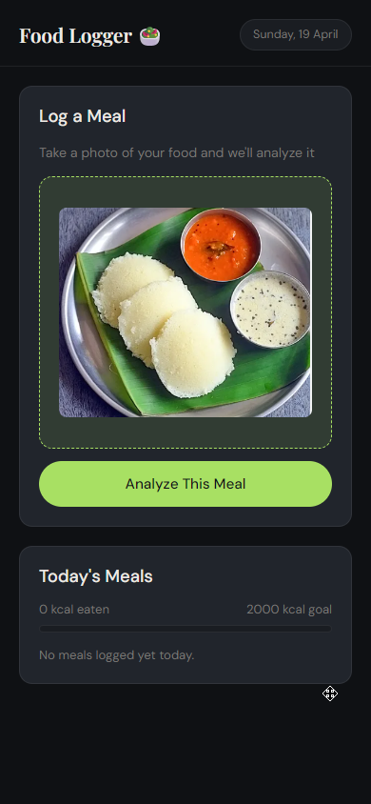
Figure 6.1: Home screen showing the meal photograph upload interface.
As shown in Figure 6.1, the home screen presents a clean, dark-themed upload interface. The user selects or captures a meal photograph using the file picker, which supports JPEG, PNG, and WEBP formats. A loading indicator is displayed while the Gemini API processes the image.
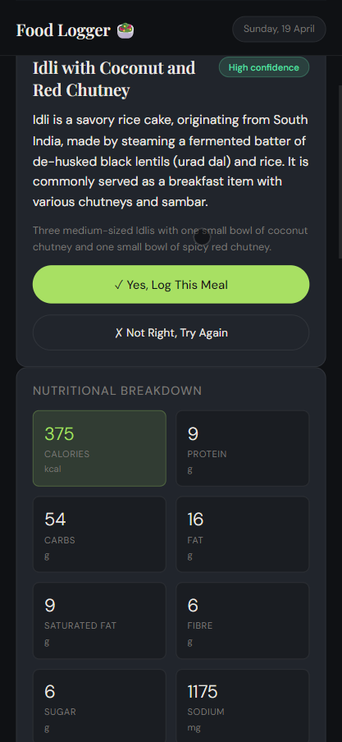
Figure 6.2: Analysis results screen showing nutritional breakdown.
Figure 6.2 shows the analysis results screen returned by the Gemini 2.5 Flash model. The screen displays the identified dish name, estimated calorie count, and a macronutrient breakdown covering protein, carbohydrates, fat, and fibre.
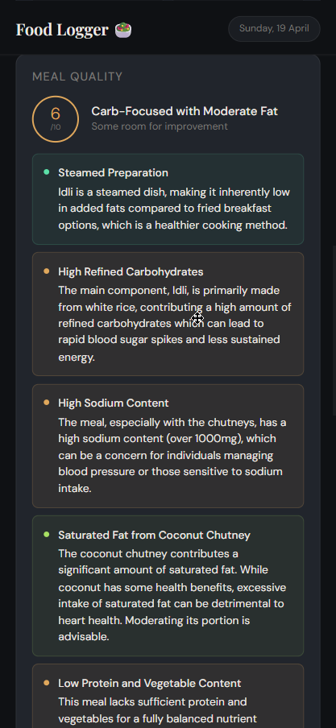
Figure 6.3: Meal quality score section of the results screen.
Figure 6.3 shows the meal quality score section of the results screen. The system assigns the analysed meal a score out of ten based on its overall nutritional composition. A short one-line insight is displayed below the score, giving the user a quick understanding of why the meal received that rating.
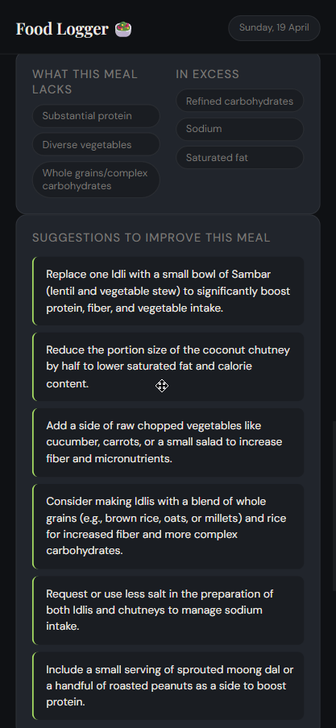
Figure 6.4: Detailed feedback panel showing nutrient gaps, excesses, and improvement suggestions.
As shown in Figure 6.4, the results screen presents a detailed breakdown of what the meal is lacking nutritionally, what is present in excess, and a set of practical improvement suggestions tailored to the specific dish. This qualitative feedback is generated by Gemini and is intended to help the user make better dietary choices at the next meal.
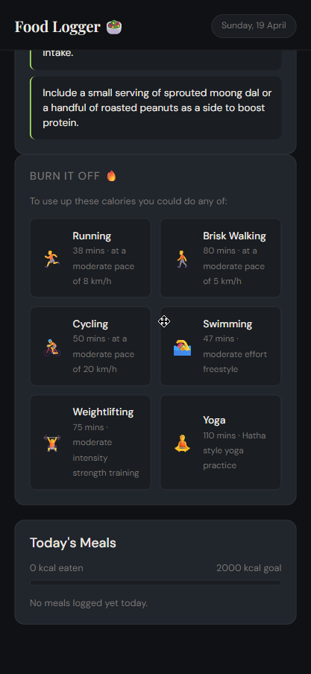
Figure 6.5: Activity equivalents panel showing calorie burn estimates.
Figure 6.5 shows the activity equivalents panel, which translates the calorie count of the analysed meal into relatable physical activities — for example, how many minutes of walking, cycling, or swimming would be needed to burn the equivalent calories.
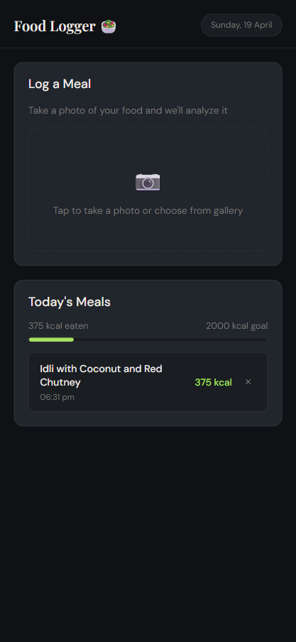
Figure 6.6: Daily dashboard displaying calorie progress and all saved meals for the current day.
Figure 6.6 shows the daily dashboard, which aggregates all meals saved during the current day. The dashboard displays total calories consumed relative to a 2000 kcal daily target via a colour-coded progress bar.
7. CONCLUSION AND FUTURE SCOPE
7.1 CONCLUSION
The AI-Based Food Recognition and Nutrition Tracking System successfully demonstrates a practical, low-friction approach to automated dietary awareness using a multimodal large language model. By reducing the act of meal logging to a single step — photographing a meal — and leveraging Google Gemini 2.5 Flash to generate a comprehensive nutritional analysis, the system eliminates the manual effort that causes most users to abandon traditional nutrition trackers.
The system was built with deliberate architectural simplicity: a Python FastAPI backend, a SQLite database, and a Vanilla JavaScript frontend, with no user authentication layer or cloud database dependency. This lightweight design makes the application easy to deploy on free-tier hosting platforms and straightforward to extend. The project demonstrates that a solo developer can build a functional, AI-powered health tool using modern LLM APIs without requiring specialised machine learning expertise or large training datasets, and confirms the viability of multimodal LLMs as the analysis backbone for food-based dietary assessment applications.
7.2 FUTURE SCOPE
The following enhancements are identified as directions for future development:
- Android Application: A native or cross-platform mobile app (using Flutter or React Native) would allow direct camera capture without browser limitations, improving the mobile experience significantly.
- Quantity Adjustment: A UI control to adjust the estimated portion size (e.g., 0.5x or 2x) that proportionally scales all nutritional values, addressing the known limitation of single-image portion estimation.
- User Authentication: Adding a lightweight authentication layer (JWT-based) would enable multi-user support and personalised meal history across devices.
- Streak and Goal Tracking: Daily and weekly nutrition goal setting with streak tracking would improve long-term user engagement and motivate consistent logging behaviour.

BIBLIOGRAPHY
[1] Yan, J., Ganapathy, A., Nieves, J., et al., "DietAI24: A Framework for Comprehensive Nutrition Estimation Using Multimodal Large Language Models," Communications Medicine, Nature Publishing Group, 2025. https://doi.org/10.1038/s43856-025-01159-0
[2] Svenningsen, H., et al., "Performance Evaluation of 3 Large Language Models for Nutritional Content Estimation from Food Images," PMC / JMIR, 2024. https://pmc.ncbi.nlm.nih.gov/articles/PMC12513282/
[3] Yin, L., et al., "FoodLMM: A Versatile Food Assistant using Large Multi-modal Model," arXiv preprint arXiv:2312.14991, 2023. https://arxiv.org/abs/2312.14991
[4] Min, W., Wang, Z., Liu, Y., Luo, M., Kang, L., Wei, X., Wei, X., and Jiang, S., "Large Scale Visual Food Recognition, 2023. https://doi.org/10.1109/TPAMI.2023.3237871
[5] Lo, F. P. W., Sun, Y., Qiu, J., and Lo, B., "Image-Based Food Classification and Volume Estimation for Dietary Assessment: A Review," IEEE Journal of Biomedical and Health Informatics, vol. 24, no. 7, pp. 1926-1939, 2020. https://doi.org/10.1109/JBHI.2020.2987943
[6] Liu, C., Cao, Y., Luo, Y., Chen, "DeepFood: Deep Learning-Based Food Image Recognition for Computer-Aided Dietary Assessment," in Lecture Notes in Computer Science, vol. 9677, Springer, Cham, 2016, pp. 37-48. https://doi.org/10.1007/978-3-319-39601-9_4
[7] Aguilar, E., Bolanos, M., and Radeva, P., "Food Recognition Using Fusion of Classifiers Based on CNNs," in Image Analysis and Processing - ICIAP 2017, Lecture Notes in Computer Science, vol. 10485, pp. 177-187. https://doi.org/10.1007/978-3-319-68548-9_17
[8] Bettadapura, V., Thomaz, E., Parnami, A., Abowd," in Proceedings of the IEEE Winter Conference on Applications of Computer Vision (WACV), 2015, pp. 580-587. https://doi.org/10.1109/WACV.2015.82
[9] Kawano, Y. and Yanai, K., "Food Image Recognition with Deep Convolutional Features," in Proceedings of the 2014 ACM International Joint Conference on Pervasive and Ubiquitous Computing: ACM, 2014, pp. 589-593. https://doi.org/10.1145/2638728.2641339
[10] Pouladzadeh, P., Shirmohammadi "Measuring Calorie and Nutrition from Food Image," in Proceedings of the IEEE International Conference on Multimedia and Expo Workshops (ICMEW), 2014, pp. 1-6. https://doi.org/10.1109/ICMEW.2014.6890711
APPENDIX A
1. FastAPI Application Entry Point (backend/main.py)

from fastapi import FastAPI
from fastapi.middleware.cors import CORSMiddleware
from fastapi.staticfiles import StaticFiles
from routes.analyze import router as analyze_router
from routes.meals import router as meals_router
from db.database import create_table

app = FastAPI(title='MealScan API')
app.add_middleware(
CORSMiddleware,
allow_origins=['*'], allow_methods=['*'], allow_headers=['*']
)
app.include_router(analyze_router, prefix='/api')
app.include_router(meals_router, prefix='/api')
app.mount('/', StaticFiles(directory='../frontend', html=True))

@app.on_event('startup')
def startup_event(): create_table()

2. Gemini Analysis Route (backend/routes/analyze.py)

import os, base64, json
import google.generativeai as genai
from fastapi import APIRouter, File, UploadFile, HTTPException

router = APIRouter()
genai.configure(api_key=os.getenv('GEMINI_API_KEY'))
model = genai.GenerativeModel('gemini-2.5-flash')

PROMPT = '''You are a nutrition expert. Analyze this meal image.
Return ONLY a valid JSON object (no markdown) with keys:
dish_name, calories, protein, carbs, fat, fibre,
quality_score (0-10), insight (one sentence),
what_meal_lacks (list), what_is_in_excess (list),
improvement_suggestions (list), activity_equivalents (list).'''

@router.post('/analyze')
async def analyze_meal(file: UploadFile = File(...)):
img_bytes = await file.read()
img_b64 = base64.b64encode(img_bytes).decode('utf-8')
try:
response = model.generate_content([
{'mime_type': file.content_type, 'data': img_b64},
PROMPT
])
return json.loads(response.text)
except Exception as e:
raise HTTPException(status_code=422,
detail=f'Analysis failed: {str(e)}')

3. Database Layer (backend/db/database.py)

import sqlite3, datetime

DB_PATH = 'meals.db'

def create_table():
with sqlite3.connect(DB_PATH) as con:
con.execute('''CREATE TABLE IF NOT EXISTS meals (
id INTEGER PRIMARY KEY AUTOINCREMENT,
dish_name TEXT, calories REAL,
protein REAL, carbs REAL,
fat REAL, fibre REAL,
quality_score REAL, insight TEXT,
logged_at DATETIME)''')

def save_meal(data: dict):
with sqlite3.connect(DB_PATH) as con:
con.execute(
'INSERT INTO meals VALUES (NULL,?,?,?,?,?,?,?,?,?)',
(data['dish_name'], data['calories'], data['protein'],
data['carbs'], data['fat'], data['fibre'],
data['quality_score'], data['insight'],
datetime.datetime.utcnow())
)

def get_meals_today():
today = datetime.date.today().isoformat()
with sqlite3.connect(DB_PATH) as con:
con.row_factory = sqlite3.Row
rows = con.execute(
'SELECT * FROM meals WHERE DATE(logged_at)=?', (today,)
).fetchall()
return [dict(r) for r in rows]

4. Frontend Fetch Call — Save Meal (frontend/js/results.js excerpt)

async function saveMeal(analysisData) {
try {
const res = await fetch('/api/meals/save', {
method: 'POST',
headers: { 'Content-Type': 'application/json' },
body: JSON.stringify(analysisData)
});
if (!res.ok) throw new Error('Save failed');
sessionStorage.removeItem('analysis');
window.location.href = 'dashboard.html';
} catch (err) {
showToast('Could not save meal. Please try again.');
}
}

APPENDIX B
User Manual

This manual describes how to set up and run the AI-Based Food Recognition and Nutrition Tracking System on a local machine. The application is also accessible as a live web service at: https://meal-scan-zqwd.onrender.com

Prerequisites
- Python 3.10 or later
- Git (https://git-scm.com/)
- A Google Gemini API key (obtainable free at https://aistudio.google.com/)
- A modern web browser (Chrome, Firefox, Edge, or Safari)

Installation and Setup
Step 1 — Clone the repository:
git clone https://github.com/timothy-saxena/food_logger.git
cd food_logger

Step 2 — Create and activate a virtual environment:
python -m venv venv
# Windows:
venv\Scripts\activate
# macOS / Linux:
source venv/bin/activate

Step 3 — Install dependencies:
cd backend
pip install -r requirements.txt

Step 4 — Configure the environment file:
Create a file named .env inside the backend/ directory with the following content:
GEMINI_API_KEY=your_gemini_api_key_here

Running the Application
Step 5 — Start the FastAPI server:
# From inside the backend/ directory:
uvicorn main:app --reload --port 8000

Step 6 — Open the application:
Navigate to http://localhost:8000 in your web browser. The frontend is served directly by FastAPI as static files.

Using the Application
- On the home screen, click 'Choose File' and select a meal photograph from your device.
- Click 'Analyse Meal'. A loading indicator will appear while Gemini processes the image.
- Review the nutritional analysis on the results screen — dish name, calories, macronutrients, quality score, insights, and suggestions.
- Click 'Save Meal' to log the meal to the database, or 'Discard' to return to the home screen without saving.
- Click 'Dashboard' in the navigation bar to view your daily meal log and cumulative nutrition totals.
- To delete a logged meal, click the delete icon on the meal card and confirm the prompt.

Note: The application requires an active internet connection to reach the Gemini API for meal analysis. The dashboard and delete functions work with local data stored in meals.db and do not require internet access after meals are saved.

