Let’s go, Timothy ⚡ — Paging is actually much easier than it looks, once you “see” it clearly.

🧠 PART 1 — What is Paging (INTUITION FIRST)

📦 Real-life Analogy

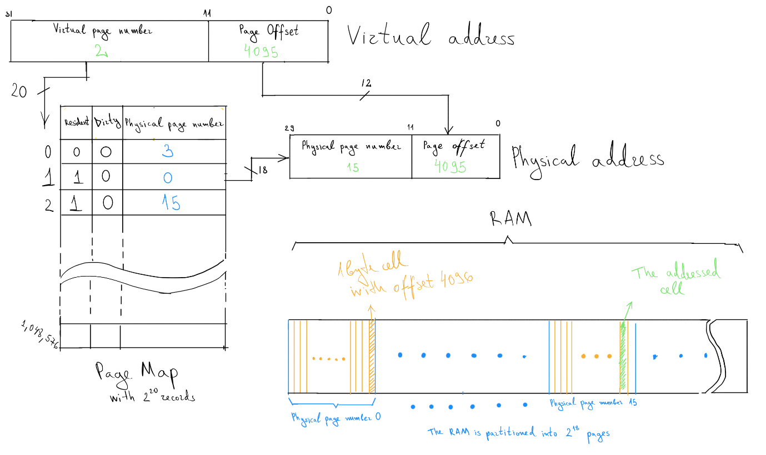
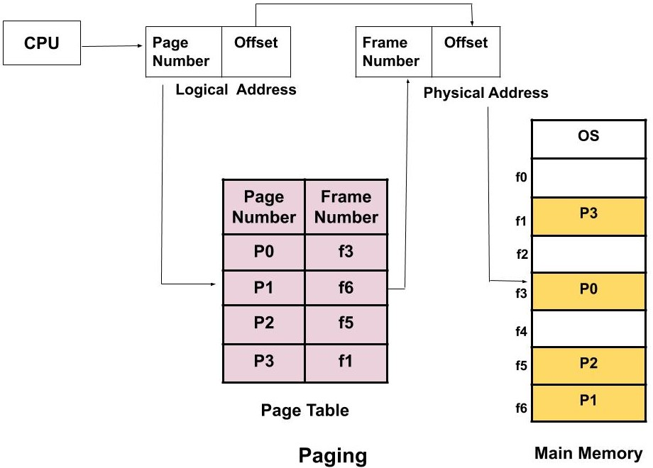
Think of:
- 📘 Logical memory → a book (pages: 0,1,2,…)
- 🧠 Physical memory (RAM) → random shelves (frames)
👉 Pages are stored in any free frame (not contiguous)

💡 Key Idea
Logical Address =
(page number, offset)
Physical Address =
(frame number, offset)
👉 Mapping is done using Page Table

🔍 PART 2 — Your Code (Quick Understanding)
From your file

Core Logic:
page[pno] → gives frame number
👉 So:
Physical Address = frame number + offset

✅ PART 3 — What Your Code Does Right
✔ Takes:
- number of pages
- page size
- page table input
✔ Checks:
if(page[pno] == -1)
👉 page not in memory → page fault concept
✔ Converts:
logical → physical address

❌ PART 4 — Problems in Your Code
Let’s sharpen it 🔍

❌ 1. No bounds checking (VERY IMPORTANT)
scanf("%d%d",&pno,&off);
👉 What if:
- pno >= n ❌ (invalid page)
- off >= page size ❌ (invalid offset)

❌ 2. Wrong return value
return 1;
👉 Should be:
return 0;

❌ 3. Physical address calculation is incomplete conceptually
You printed:
frame, offset
👉 But actual physical address is:
(frame * page_size) + offset

❌ 4. No explanation of page fault (missed learning)

✅ PART 5 — IMPROVED CLEAN VERSION
#include <stdio.h>
#define MAX 50

int main() {
int page[MAX], n, f, ps;
int pno, off, choice = 0;

printf("Enter number of pages: ");
scanf("%d", &n);

printf("Enter page size: ");
scanf("%d", &ps);

printf("Enter number of frames: ");
scanf("%d", &f);

// Initialize page table
for (int i = 0; i < n; i++)
page[i] = -1;

printf("\nEnter page table (frame number for each page):\n");
for (int i = 0; i < n; i++) {
printf("Page %d: ", i);
scanf("%d", &page[i]);
}

do {
printf("\nEnter logical address (page number and offset): ");
scanf("%d%d", &pno, &off);

// Validation
if (pno < 0 || pno >= n) {
printf("Invalid page number!\n");
continue;
}

if (off < 0 || off >= ps) {
printf("Invalid offset!\n");
continue;
}

if (page[pno] == -1) {
printf("Page Fault! Page not in memory.\n");
} else {
int frame = page[pno];
int physical_address = frame * ps + off;

printf("Frame number: %d\n", frame);
printf("Physical Address: %d\n", physical_address);
}

printf("Continue? (1/0): ");
scanf("%d", &choice);

} while (choice == 1);

return 0;
}

🔄 PART 6 — DRY RUN (SUPER IMPORTANT)
Given:
Page size = 10
Page table:
Page 0 → Frame 5
Page 1 → -1
Page 2 → Frame 3

Input:
Logical address: (2, 5)

Step-by-step:
- Page = 2
- Offset = 5
- page[2] = 3 → frame found
👉 Physical address:
= (3 * 10) + 5
= 35

⚡ PART 7 — KEY CONCEPTS YOU MUST REMEMBER

✅ 1. Paging removes external fragmentation
(no need for contiguous memory)

✅ 2. Page Table is mandatory

✅ 3. Page Fault
👉 When page not in memory → -1

✅ 4. Address Translation Formula
This is VERY IMPORTANT for exams:
Physical Address = (Frame Number × Page Size) + Offset

🧠 PART 8 — INTUITION LOCK-IN
👉 Why do we keep offset SAME?
Because:
Offset represents position INSIDE the page → same in frame

🎯 Quick Check (Answer mentally)

Q1:
👉 Why can't offset exceed page size?

Q2:
👉 Why do we multiply frame number with page size?

🚀 Next Step
Now last one remains:
👉 Segmentation (VERY IMPORTANT difference from paging)
This one is often asked:
“Difference between Paging and Segmentation”

Say:
👉 “Segmentation”
and we’ll finish strong 🔥

