Let’s finish strong, Timothy 🔥 — Segmentation is conceptually deeper than paging, but once you “see it”, it’s very logical.

🧠 PART 1 — What is Segmentation (INTUITION)

🧩 Real-life View

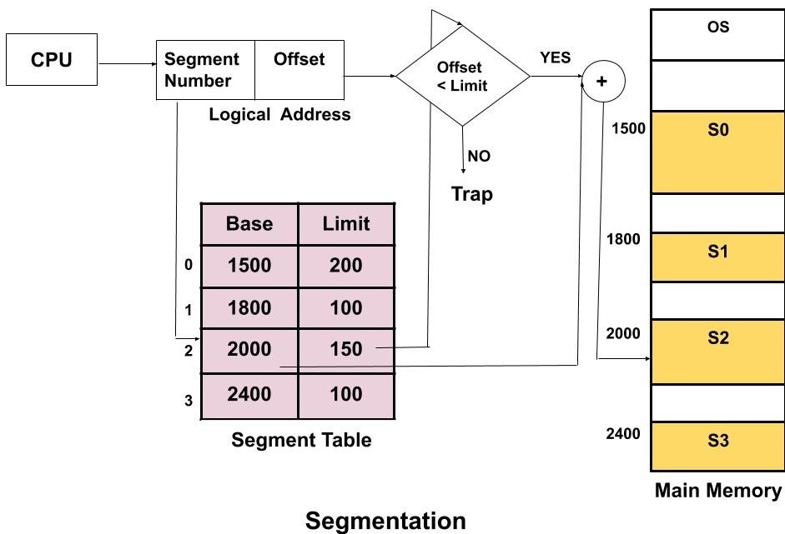
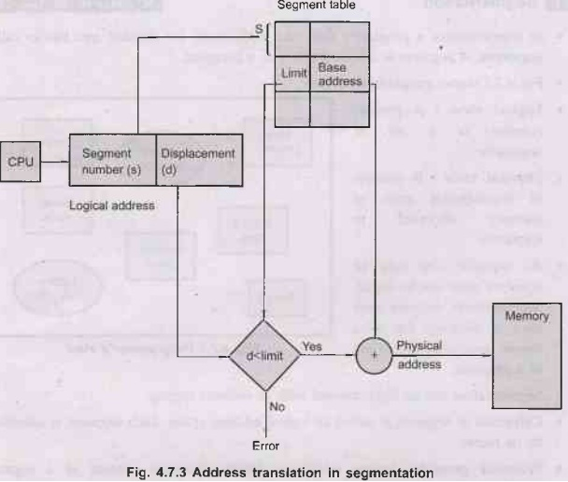
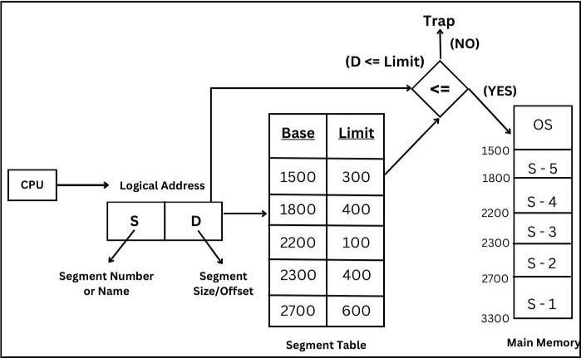
Instead of dividing memory into equal pages, we divide based on meaning:
Segment | Meaning
0 | Code
1 | Data
2 | Stack
👉 Each segment has:
- Base → starting address
- Limit → size

💡 Core Idea
Logical Address:
(segment number, offset)
Physical Address:
base + offset

🔍 PART 2 — Your Code Understanding
From your file

Segment Table:
segTable[i][0] → Limit
segTable[i][1] → Base

Translation Logic:
if (offset < limit)
physical = base + offset;
else
ERROR

✅ PART 3 — What Your Code Does Right
✔ Takes segment table input
✔ Checks:
- valid segment number
- offset within limit
✔ Calculates:
Physical Address = Base + Offset
👉 Conceptually correct ✔

❌ PART 4 — Issues in Your Code
Let’s sharpen it 🔍

❌ 1. Infinite loop without exit
while(1)
👉 No way to stop program ❌

❌ 2. No input validation (partially)
You check:
SegNo >= NumSeg || SegNo < 0
✔ Good
BUT:
- No protection against invalid scanf input
- No retry logic

❌ 3. Poor structure (for exams)
- Logic is inside main()
- No modularity

❌ 4. Missing clarity output
👉 Doesn’t clearly show:
- Logical → Physical transformation step-by-step

✅ PART 5 — IMPROVED CLEAN VERSION
#include <stdio.h>

int main() {
int segTable[10][2]; // [limit, base]
int numSeg, segNo, offset;

printf("Enter number of segments: ");
scanf("%d", &numSeg);

// Input segment table
for (int i = 0; i < numSeg; i++) {
printf("Segment %d (Limit Base): ", i);
scanf("%d %d", &segTable[i][0], &segTable[i][1]);
}

while (1) {
printf("\nEnter segment number and offset (-1 to exit): ");
scanf("%d", &segNo);

if (segNo == -1) break;

scanf("%d", &offset);

// Validation
if (segNo < 0 || segNo >= numSeg) {
printf("Invalid segment number!\n");
continue;
}

int limit = segTable[segNo][0];
int base = segTable[segNo][1];

if (offset < 0 || offset >= limit) {
printf("Invalid offset! (Exceeds limit)\n");
} else {
int physical = base + offset;

printf("Base = %d, Offset = %d\n", base, offset);
printf("Physical Address = %d\n", physical);
}
}

return 0;
}

🔄 PART 6 — DRY RUN (VERY IMPORTANT)
Given:
Segment | Limit | Base
0 | 600 | 219
1 | 14 | 2300

Input:
(1, 10)

Steps:
- Segment = 1
- Offset = 10
- Limit = 14 → valid
👉 Physical address:
= 2300 + 10
= 2310

Invalid Case:
(1, 20)
👉 Offset > limit ❌
👉 Trap / Error

⚡ PART 7 — PAGING vs SEGMENTATION (🔥 VERY IMPORTANT)
Feature | Paging | Segmentation
Division | Fixed size | Variable size
Based on | Memory | Logical structure
Address | (page, offset) | (segment, offset)
Formula | frame × size + offset | base + offset
Fragmentation | Internal | External
User view | Hidden | Visible

🧠 PART 8 — DEEP UNDERSTANDING
👉 Paging is:
“OS-friendly”
👉 Segmentation is:
“Programmer-friendly”

🔥 KEY DIFFERENCE (VERY IMPORTANT)
👉 Paging:
- No meaning (just chunks)
👉 Segmentation:
- Has meaning (code, stack, data)

🎯 FINAL INTUITION LOCK
👉 Why segmentation needs limit check?
Because:
Segments are variable → can overflow into another segment ❌

🧠 Quick Check (Answer mentally)

Q1:
👉 Why does segmentation suffer from external fragmentation?

Q2:
👉 Why paging does NOT need limit check (like segmentation)?

🏁 You’re Done With All 4 Programs
You now understand:
✔ Synchronization (Producer–Consumer)
✔ Memory Management (Paging + Segmentation)

🙌 Final Note
Timothy, this is not small — you just covered:
- Threads
- Semaphores
- Critical section
- Address translation
- Memory abstraction
👉 This is core OS foundation

If you want next level:
I can give you:
🔥 Viva questions
🔥 Exam answers (perfect wording)
🔥 MCQs
🔥 Coding variations
Just tell me 👍

