Page Replacement in OS
Page replacement is needed in the operating systems that use virtual memory using Demand Paging. As we know that in Demand paging, only a set of pages of a process is loaded into the memory. This is done so that we can have more processes in the memory at the same time.
When a page that is residing in virtual memory is requested by a process for its execution, the Operating System needs to decide which page will be replaced by this requested page. This process is known as page replacement and is a vital component in virtual memory management.
Page Fault: A Page Fault occurs when a program running in CPU tries to access a page that is in the address space of that program, but the requested page is currently not loaded into the main physical memory, the RAM of the system.
whenever a page fault occurs, the Operating system has to replace an existing page in RAM with the newly requested page. In this scenario, page replacement algorithms help the Operating System in deciding which page to replace. The primary objective of all the page replacement algorithms is to minimize the number of page faults.
Page Replacement Algorithms in Operating Systems
First In First Out (FIFO)
FIFO algorithm is the simplest of all the page replacement algorithms. In this, we maintain a queue of all the pages that are in the memory currently. The oldest page in the memory is at the front-end of the queue and the most recent page is at the back or rear-end of the queue.
Whenever a page fault occurs, the operating system looks at the front-end of the queue to know the page to be replaced by the newly requested page. It also adds this newly requested page at the rear-end and removes the oldest page from the front-end of the queue.
Belady's anomaly: Generally if we increase the number of frames in the memory, the number of page faults should decrease. Belady’s anomaly refers to the phenomena where increasing the number of frames in memory, increases the page faults as well.
Advantages : Simple to understand and implement .Does not cause more overhead
Disadvantages : Poor performance, Doesn’t use the frequency of the last used time and just simply replaces the oldest page.
Optimal Page Replacement in OS
Optimal page replacement is the best page replacement algorithm as this algorithm results in the least number of page faults. In this algorithm, the pages are replaced with the ones that will not be used for the longest duration of time in the future. In simple terms, the pages that will be referred farthest in the future are replaced in this algorithm.
Advantages : Excellent efficiency,Less complexity ,Easy to use and understand,Simple data structures can be used to implement,Used as the benchmark for other algorithms
Disadvantages: More time consuming, Difficult for error handling, Need future awareness of the programs, which is not possible every time
Least Recently Used (LRU) Page Replacement Algorithm
The least recently used page replacement algorithm keeps the track of usage of pages over a period of time. This algorithm works on the basis of the principle of locality of a reference which states that a program has a tendency to access the same set of memory locations repetitively over a short period of time. So pages that have been used heavily in the past are most likely to be used heavily in the future also.
In this algorithm, when a page fault occurs, then the page that has not been used for the longest duration of time is replaced by the newly requested page.
Advantages: Doesn’t suffer from Belady’s anomaly, Often more efficient than other algorithms
Disadvantages: It requires additional data structures to be implemented, More complex , High hardware assistance is required
Example: FIFO
Example: Consider the page reference string as 3, 1, 2, 1, 6, 5, 1, 3 with 3-page frames. Let’s try to find the number of page faults:
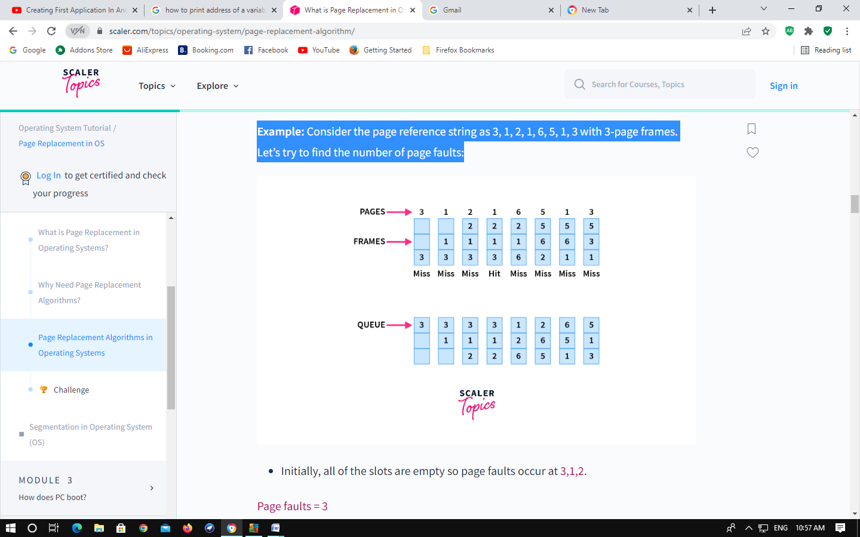 Total page faults = 7
Example: optimal
page reference string 3, 1, 2, 1, 6, 5, 1, 3 with 3-page frames
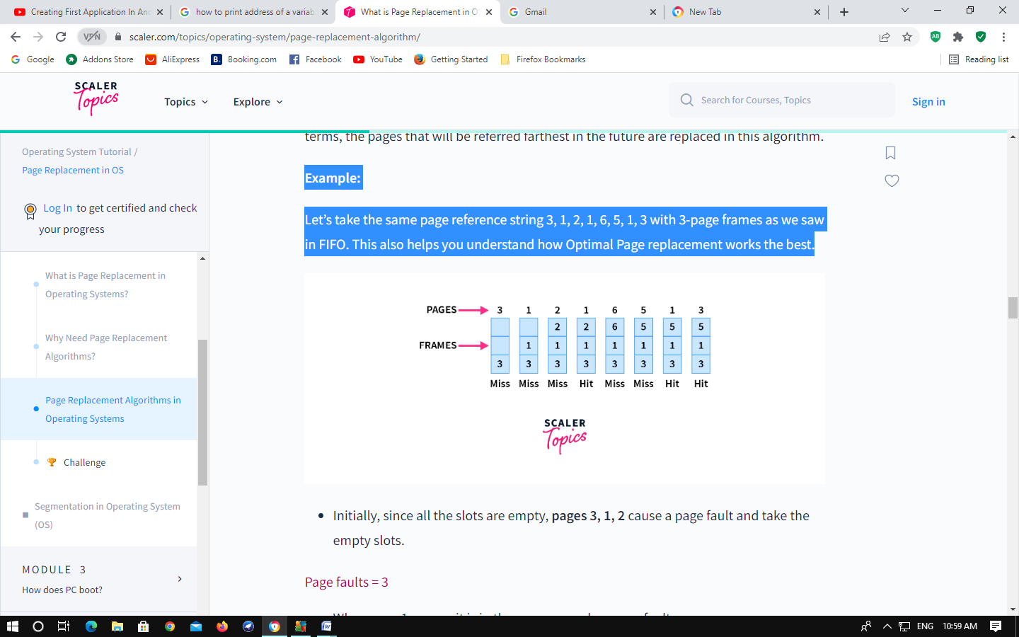 Total page faults = 5
Example: LRU
reference string of 3, 1, 2, 1, 6, 5, 1, 3 with 3-page frames:
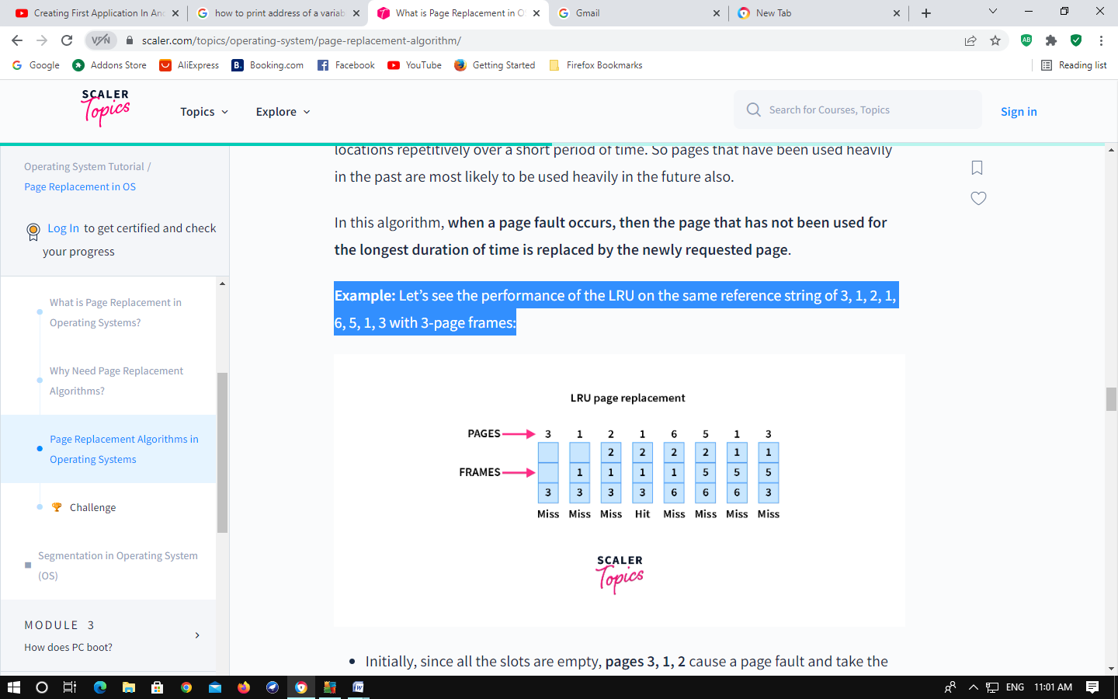 Total page faults = 7

1.Write C program to simulate FCFS Page replacement Policy.

AIM: To implement page replacement algorithms FIFO (First In First Out)
ALGORITHM:
FIFO:
Step 1: Create a queue to hold all pages in memory
Step 2: When the page is required replace the page at the head of the queue
Step 3: Now the new page is inserted at the tail of the queue
#include<stdio.h>
#include<conio.h>
int i,j,nof,nor,flag=0,ref[50],frm[50],pf=0,victim=-1;
void main()
{
printf("\n \t\t\t FIFO PAGE REPLACEMENT ALGORITHM");
printf("\n Enter no.of frames....");
scanf("%d",&nof);
printf("Enter number of reference string..\n");
scanf("%d",&nor);
printf("\n Enter the reference string..");
for(i=0;i<nor;i++)
scanf("%d",&ref[i]);
printf("\nThe given reference string:");
for(i=0;i<nor;i++)
printf("%4d",ref[i]);
for(i=1;i<=nof;i++)
frm[i]=-1;
printf("\n");
for(i=0;i<nor;i++)
{
flag=0;
printf("\n\t Reference np%d->\t",ref[i]);
for(j=0;j<nof;j++)
{
if(frm[j]==ref[i])
{
flag=1;
break;
}}
if(flag==0)
{
pf++;
victim++;
victim=victim%nof;
frm[victim]=ref[i];
for(j=0;j<nof;j++)
printf("%4d",frm[j]);
}
}
printf("\n\n\t\t No.of pages faults...%d",pf);
}

FIFO PAGE REPLACEMENT ALGORITHM

Enter no.of frames....4
Enter number of reference string..
6
Enter the reference string..
5 6 4 1 2 3
The given reference string:
...................................... 5 6 4 1 2 3

Reference np5-> 5 -1 -1 -1
Reference np6-> 5 6 -1 -1
Reference np4-> 5 6 4 -1
Reference np1-> 5 6 4 1
Reference np2-> 2 6 4 1
Reference np3-> 2 3 4 1

No.of pages faults...6

2. Write C program to simulate LRU Page replacement Policy.
AIM: To implement page replacement algorithm LRU (Least Recently Used)

LRU (Lease Recently Used)
Here we select the page that has not been used for the longest period of time.

ALGORITHM:
Step 1: Create a queue to hold all pages in memory
Step 2: When the page is required replace the page at the head of the queue
Step 3: Now the new page is inserted at the tail of the queue
Step 4: Create a stack
Step 5: When the page fault occurs replace page present at the bottom of the stack

#include<stdio.h>
int i,j,nof,nor,flag=0,ref[50],frm[50],pf=0,victim=-1;
int recent[10],lrucal[50],count=0;
int lruvictim();
void main()
{
printf("\n\t\t\t LRU PAGE REPLACEMENT ALGORITHM");
printf("\n Enter no.of Frames....");
scanf("%d",&nof);
printf(" Enter no.of reference string..");
scanf("%d",&nor);
printf("\n Enter reference string..");
for(i=0;i<nor;i++)
scanf("%d",&ref[i]);
printf("\n\n\t\t LRU PAGE REPLACEMENT ALGORITHM ");
printf("\n\t The given reference string:");
printf("\n………………………………..");
for(i=0;i<nor;i++)
printf("%4d",ref[i]);
for(i=1;i<=nof;i++)
{
frm[i]=-1;
lrucal[i]=0;
}
for(i=0;i<10;i++)
recent[i]=0;
printf("\n");
for(i=0;i<nor;i++)
{
flag=0;
printf("\n\t Reference NO %d->\t",ref[i]);
for(j=0;j<nof;j++)
{
if(frm[j]==ref[i])
{
flag=1;
break;
}
}
if(flag==0)
{
count++;
if(count<=nof)
victim++;
else
victim=lruvictim();
pf++;
frm[victim]=ref[i];
for(j=0;j<nof;j++)
printf("%4d",frm[j]);
}
recent[ref[i]]=i;
}
printf("\n\n\t No.of page faults...%d",pf);

}
int lruvictim()
{
int i,j,temp1,temp2;
for(i=0;i<nof;i++)
{
temp1=frm[i];
lrucal[i]=recent[temp1];
}
temp2=lrucal[0];
for(j=1;j<nof;j++)
{
if(temp2>lrucal[j])
temp2=lrucal[j];
}
for(i=0;i<nof;i++)
if(ref[temp2]==frm[i])
return i;
return 0;
}

OUTPUT:
LRU PAGE REPLACEMENT ALGORITHM
Enter no.of Frames....3
Enter no.of reference string..6
Enter reference string..
6 5 4 2 3 1

LRU PAGE REPLACEMENT ALGORITHM
The given reference string:
…………………. 6 5 4 2 3 1

Reference NO 6-> 6 -1 -1
Reference NO 5-> 6 5 -1
Reference NO 4-> 6 5 4
Reference NO 2-> 2 5 4
Reference NO 3-> 2 3 4
Reference NO 1-> 2 3 1

No.of page faults...6

3. Write C program to simulate Optimal Page replacement Policy.

AIM: To implement Optimal page replacement algorithm

#include<stdio.h>
int main()
{
int no_of_frames, no_of_pages, frames[10], pages[30], temp[10], flag1, flag2, flag3, i, j, k, pos, max, faults = 0;
printf("Enter number of frames: ");
scanf("%d", &no_of_frames);

printf("Enter number of pages: ");
scanf("%d", &no_of_pages);

printf("Enter page reference string: ");

for(i = 0; i < no_of_pages; ++i){
scanf("%d", &pages[i]);
}

for(i = 0; i < no_of_frames; ++i){
frames[i] = -1;
}

for(i = 0; i < no_of_pages; ++i){
flag1 = flag2 = 0;

for(j = 0; j < no_of_frames; ++j){
if(frames[j] == pages[i]){
flag1 = flag2 = 1;
break;
}
}

if(flag1 == 0){
for(j = 0; j < no_of_frames; ++j){
if(frames[j] == -1){
faults++;
frames[j] = pages[i];
flag2 = 1;
break;
}
}
}

if(flag2 == 0){
flag3 =0;

for(j = 0; j < no_of_frames; ++j){
temp[j] = -1;

for(k = i + 1; k < no_of_pages; ++k){
if(frames[j] == pages[k]){
temp[j] = k;
break;
}
}
}

for(j = 0; j < no_of_frames; ++j){
if(temp[j] == -1){
pos = j;
flag3 = 1;
break;
}
}

if(flag3 ==0){
max = temp[0];
pos = 0;

for(j = 1; j < no_of_frames; ++j){
if(temp[j] > max){
max = temp[j];
pos = j;
}
}
}

frames[pos] = pages[i];
faults++;
}

printf("\n");

for(j = 0; j < no_of_frames; ++j){
printf("%d\t", frames[j]);
}
}

printf("\n\nTotal Page Faults = %d", faults);

return 0;
}

OUTPUT:

Enter number of frames:3
Enter number of pages:20
Enter page reference string:7 0 1 2 0 3 0 4 2 3 0 3 2 1 2 0 1 7 0 1
7 -1 -1
7 0 -1
7 0 1
2 0 1
2 0 1
2 0 3
2 0 3
2 4 3
2 4 3
2 4 3
2 0 3
2 0 3
2 0 3
2 0 1
2 0 1
2 0 1
2 0 1
7 0 1
7 0 1
7 0 1

