This is headerPanel. It has been added to the NORTH region of the frame. It uses a flowLayout and contains a JLabel which has both text and an image.

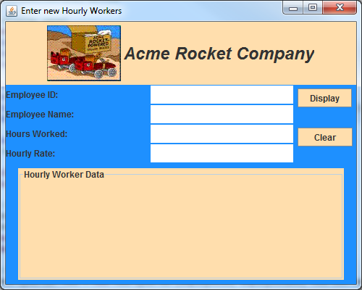

This is buttonPanel. It has been added to the EAST region of the frame. It uses a 2X1 gridLayout and contains two JPanels. Each of the JPanels contains a single JButton. I chose this approach so that the JButtons would not be resized to fit the cells in the grid.

This is displayPanel. It has been added to the SOUTH region of the frame. It uses a flowLayout and contains a JTextArea.

This is entryPanel. It has been added to the CENTER region of the frame. It uses a 3X2 gridLayout and contains three JLabels and three JTextFields.