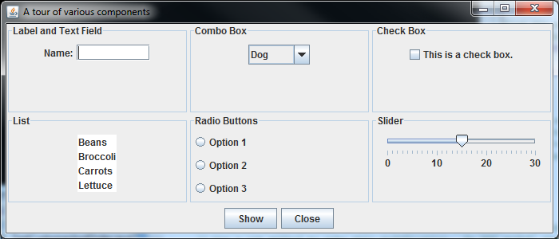

This is buttonPanel. It is created by calling the buildButtonPanel() method and it has been added to the SOUTH region of the frame. It has a FlowLayout and contains 2 JButtons.

This is panel5. It is created in the buildBigPanel() method and it has been added to one of the cells in the grid. panel5 uses a 3 X 1 GridLayout and contains 3 JRadioButtons. I used a GridLayout for this panel so that the three radio buttons would stay in a vertical column. The other 5 small panels all use a FlowLayout because they only have one or two components.

This is bigPanel. It is created by calling the buildBigPanel() method and it has been added to the CENTER region of the frame. It has a 2 by 3 GridLayout and contains 6 smaller panels. Each of the smaller panels contains one or more GUI components.