Instructions of QR code
Access Device
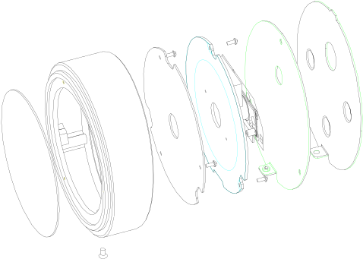

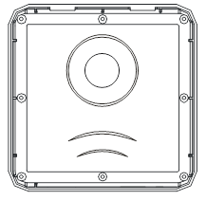

Use environment
notice
- The installation wall shall have a certain thickness and can bear at least 3 times the weight of QR code access device
- 86 cassette shall be installed first, and then installed hanging wallboard
- If it is a wooden wall, it can be installed directly with self tapping screws。

Installation precautions

- Before installation, confirm that the power system of the device is turned off during installation。
- unused of all wiring terminals，Please do not expose the wire，It may cause short circuit damage to the line。
- The power supply is far away from the device. It is strictly prohibited to use network cable and other special wires to replace the power wires。When selecting the power wires, the voltage attenuation caused by excessive transmission shall be considered.
- When wiring the qr code access device, main board and scanner are burned out due to abnormal wiring, resulting in the failure of normal use of the device, which is not within the scope of warranty
。
- It is installed on the outside of the door, generally on the side where the door is opened, and the installation height from the ground is 1.4 ~1.5m, which is more suitable。

Product structure,specification and function

（1）Technical parameter

Memoery | 85000 people, 100000 events
Speed | Qrcode <0.5s , card<0.1s
Communication mode | TCP / IP, scalable WiFi / 4G / Lora A
Offline running | Support
Input / output port | 2 relay outputs, Wiegand output, exit button input, door magnetic input and alarm input
Safety protection | Input overcurrent protection  Instantaneous overvoltage protection
Power supply | Voltage 9-28VDC,Current<1A
Product size | Diameter 110 mm, thickness 25-34.62 mm
Weight | 400g
Work environment | Hmidity 5%~95% ，  Temperature -20℃~60℃

（2）Appearance
Model 1
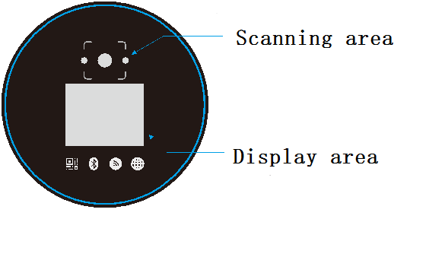
Model 2
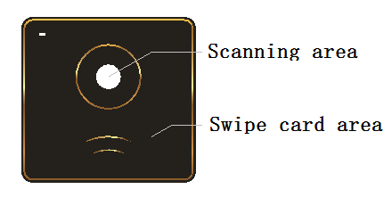

- Scanning area Scan the QR code here to open
- Swipe card area Swipe card here to open。
- Display area Display qrcode or other information

（3）QR code device structure unit (mm)
Model 1
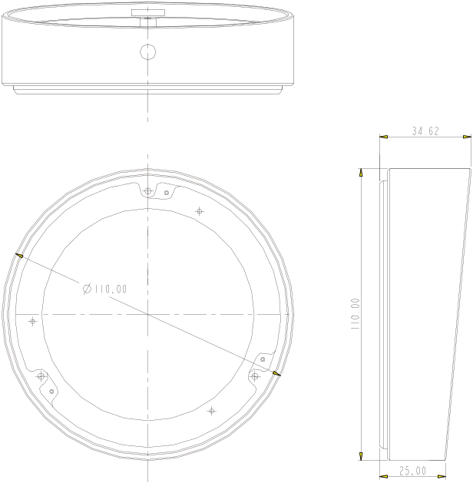

Model 2
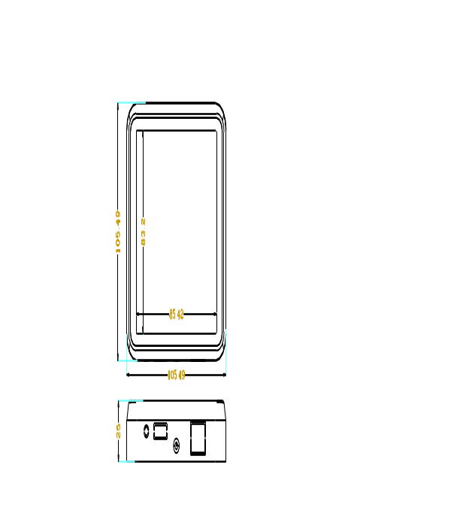

（4）Hanging wallboard structure
unit (mm)
Model 1
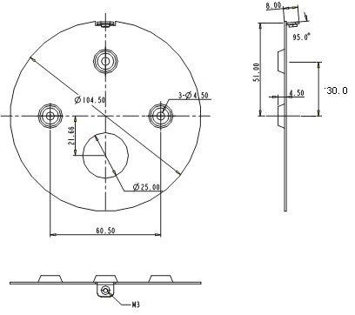

Model 2
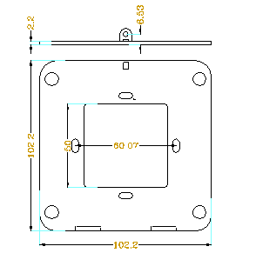

（5）Terminal block identification

标识 | 7P说明 |  | 标识 | 6P说明
WGD1 | 韦根D1输出 （棕） |  | 2NC | 常闭端扩展 （棕）
WGD0 | 韦根D0输出 （黄） |  | 2NO | 常开端扩展 （黄）
IN1 | 自定义输入 （蓝） |  | 2C | 公共端扩展 （蓝）
SEN | 门磁输入 （白） |  | 1NC | 控锁常闭端 （白）
BTN | 出门按钮输入（绿） |  | 1NO | 控锁常开端 （绿）
12V | 电源输入 （红） |  | 1C | 控锁公共端 （红）
GND | 电源地 （黑）

Symbol | 7P Specify | Symbol | 6P Specify
WGD1 | Wiegand_D0 Brown | 2NC | Relay2_Close Brown
WGD0 | Wiegand_D0 Yellow | 2NO | Relay2_Open Yellow
IN1 | User_Input Blue | 2C | Relay2_COM Blue
SEN | DoorContact White | 1NC | Relay1_Close white
BTN | Exit_Button Green | 1NO | Relay1_Open Green
12V | 12VDC_Power Red | 1C | Relay1_COM Red
GND | Power_Gnd Black

（6）Wiring diagram

