Instructions of
QR code Access Device

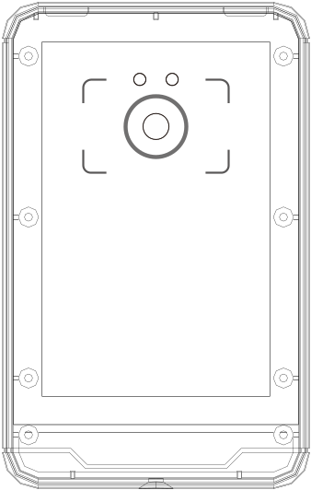

Use environment
notice
- The installation wall shall have a certain thickness and can bear at least 3 times the weight of QR code access device
- 86 cassette shall be installed first, and then installed hanging wallboard
- If it is a wooden wall, it can be installed directly with self tapping screws。

Installation precautions

- Before installation, confirm that the power system of the device is turned off during installation。
- unused of all wiring terminals，Please do not expose the wire，It may cause short circuit damage to the line。
- The power supply is far away from the device. It is strictly prohibited to use network cable and other special wires to replace the power wires。When selecting the power wires, the voltage attenuation caused by excessive transmission shall be considered.
- When wiring the qr code access device, main board and scanner are burned out due to abnormal wiring, resulting in the failure of normal use of the device, which is not within the scope of warranty
。
- It is installed on the outside of the door, generally on the side where the door is opened, and the installation height from the ground is 1.4 -1.5m, which is more suitable。

Product structure,specification and function

（1）Technical parameter

Memoery | 85000 people, 100000 events
Speed | Qrcode <0.5s , card<0.1s
Communication mode | TCP / IP, scalable WiFi / 4G / Lora
Offline running | Support
Input / output port | 1 relay outputs, exit button input, door magnetic input or alarm input
Safety protection | Input overcurrent protection  Instantaneous overvoltage protection
Power supply | Voltage 9-28VDC,Current<1A
Product size | 120mmx76mmx21 mm(H*W*D)
Weight | 300g
Work environment | Hmidity 5%~95% ，  Temperature -20℃~60℃

（2）Appearance
Model 1:
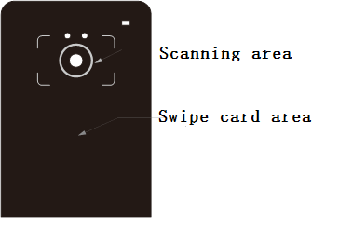
Model 2:
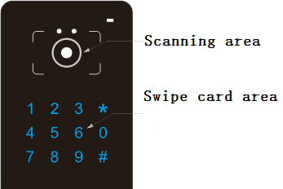

Model 3:
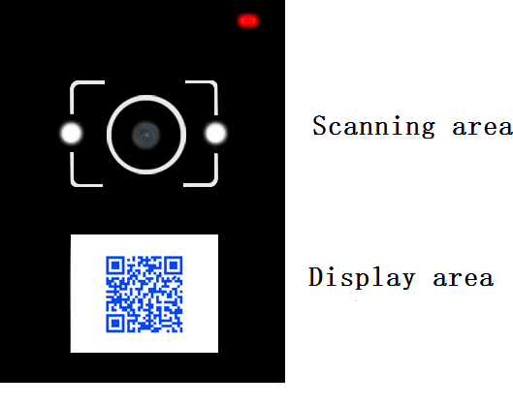
notice
Describe Specify
——————————————————————————————————
- Scanning area Scan the QR code here to open
- Swipe card area Swipe card here to open。
- Display area Display qrcode or other information

（3）QR code device structure
unit (mm)
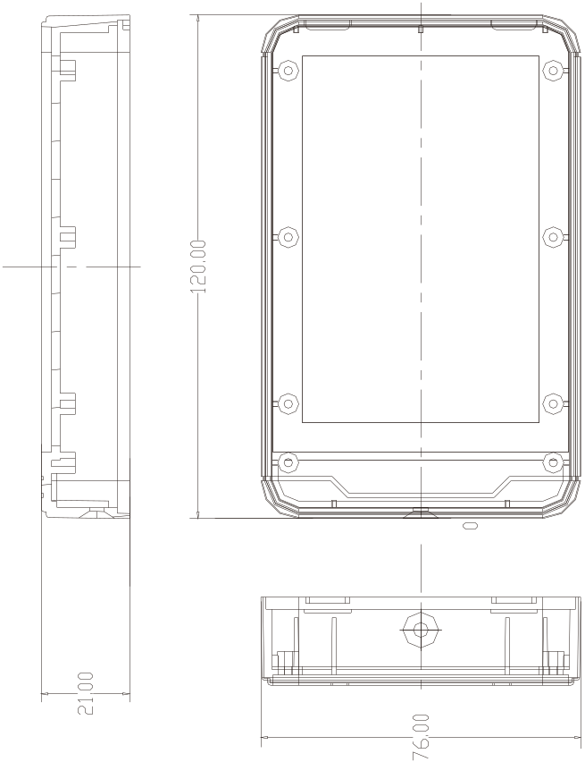
（4）Hanging wallboard structure
unit (mm)
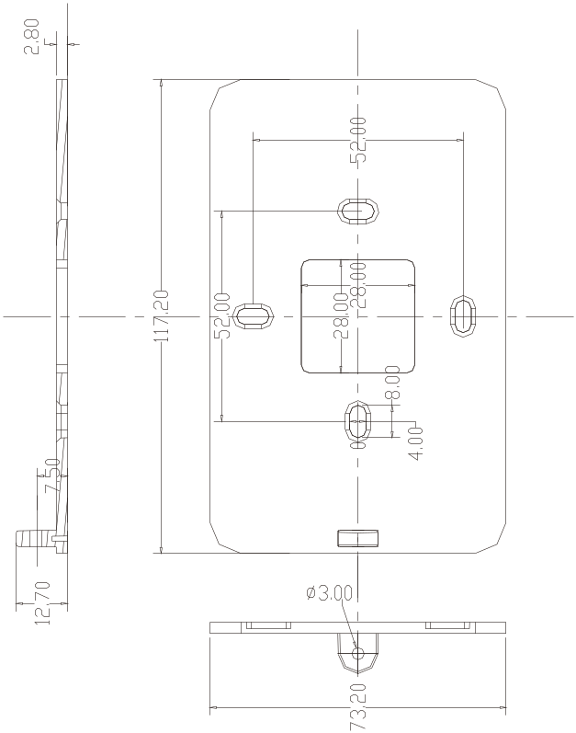
（5）Terminal block identification

标识 | 颜色 | 说明
COM | 棕 | 继电器公共端
NO | 黄 | 继电器常开端
NC | 蓝 | 继电器常闭端
SEN | 白 | 门磁输入
BTN | 绿 | 出门按钮输入
12V | 红 | 电源12V
GND | 黑 | 电源地

Symbol | WiresColor | 6P Specify
COM | Brown | Relay_COM
NO | Yellow | Relay_Open
NC | Blue | Relay_Close
SEN | White | DoorContact Input
BTN | Green | Exit_Button Input
12V | Red | 12VDC_Power
GND | Black | Power_GND

（6）Wiring diagram
