D365 F&O MCP X++ Server

1. Solution Context
The D365 F&O MCP Server is a Model Context Protocol (MCP) server that turns a private Dynamics 365 Finance & Operations codebase into grounded AI context. It pre-indexes the entire D365FO installation (580,000+ symbols across standard, ISV, and custom models) and exposes them as 26 specialised MCP tools to AI clients.
Reference architecture: docs/ARCHITECTURE.md
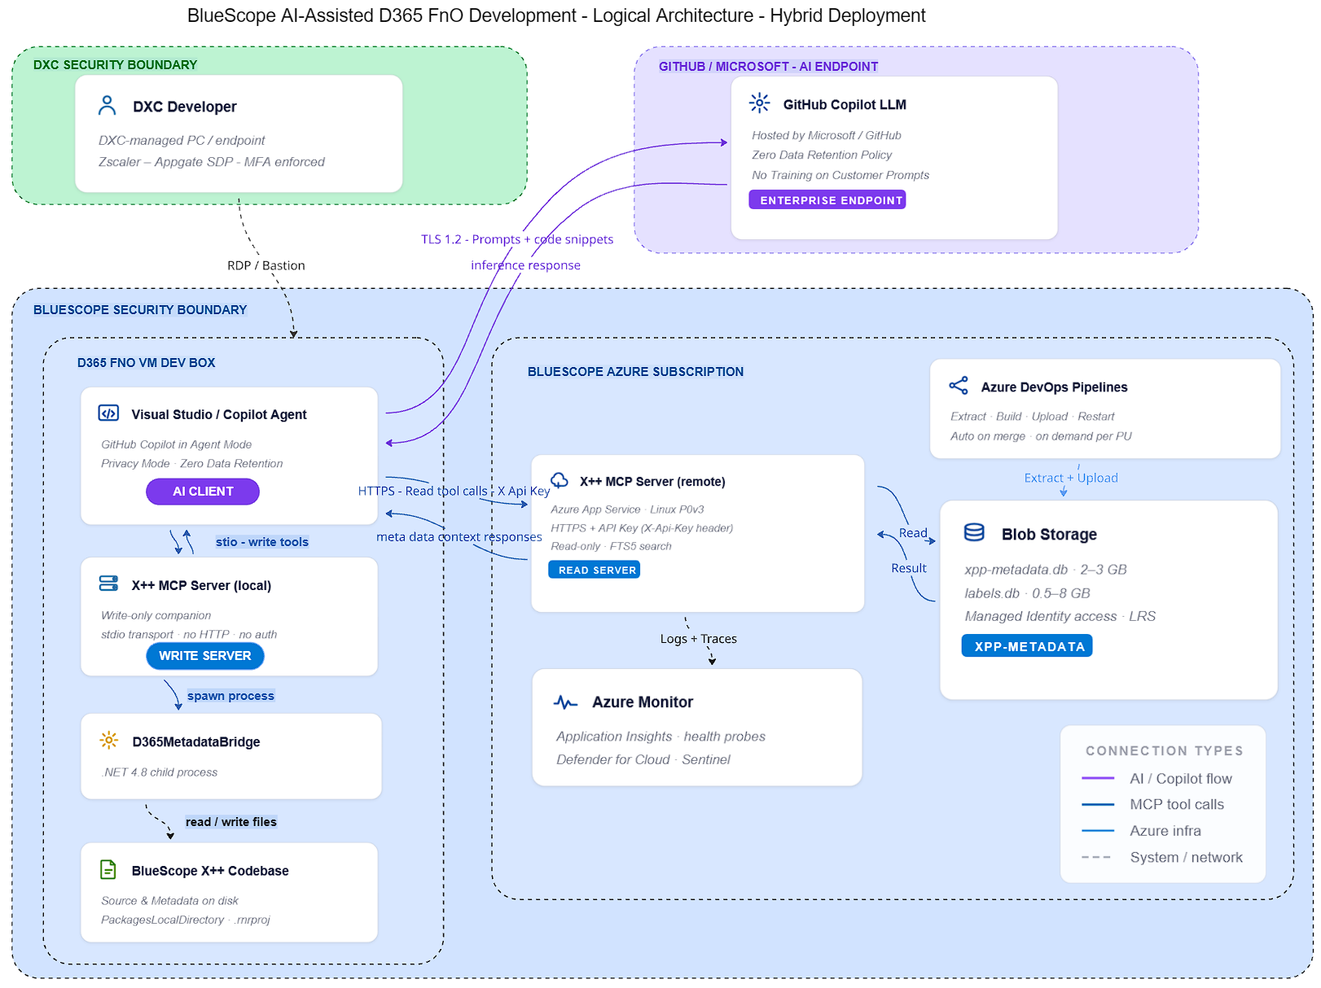

GitHub Copilot.
BlueScope will need to provide a Microsoft GitHub Copilot subscription.

MCP++ Server
The MCP++ Server is split into 2 separate components when installed in “Hybrid Mode” (this proposal).
Once the components are installed this distinction is abstracted away from the end user and all interactions with the MCP X++ Server are controlled by the CoPilot Agent.

- Local component. This is installed on the D365 FnO DevBox VM.
  - Is used by the Agent to inspect live metadata, create and modify AOT XML files via the C# IMetadataProvider bridge, i.e. Write operations.
  - Local tool calls, resource reads, and prompt requests are done over stdio, the standard MCP transport for locally-registered servers.
- Remote component. This is installed in BlueScope Azure as an App Service.
  - Is used by the Agent to call the MCP server's knowledge and grounding tools, i.e. Read operations.
  - Remote tool calls, resource reads, and prompt requests are forwarded as an HTTP POST, with an X-Api-Key header for authentication.

2. Simplified Request and Response Flow for AI Operations

2a. Request Flow
Internal / External | Request Local | Request Remote | Detail
Developer VM (Internal) | 1.Developer |  | Natural language prompt entered in GitHub Copilot
Developer VM (Internal) | 2.AI Client |  | LLM resolves intent, selects tool(s).  (Hosted by Microsoft)
Developer VM (Internal)  Azure(Internal) | 3.MCP X++ Server Local | 3.MCP X++ Server Azure (Read only) | Transport: stdio (local) / Express HTTP (Azure).  Tool selection determines Local or Remote call
Developer VM (Internal)  Azure(Internal) | 4.Data Sources  C# Metadata Bridge | 4.Data Sources  SQLite db | 1. C# Bridge IMetadataProvider, DYNAMICSXREFDB  2. SQLite xpp-metadata.db  3. SQLite xpp-metadata-labels.db
Developer VM (Internal) | 5.D365FO Metadata Files |  | AOT objects in PackagesLocalDirectory

2b. Response Flow
Internal / External | Response Local | Response Remote | Detail
Developer VM (Internal) | 5. D365FO Metadata Files return result |  | Symbol metadata / written object Files
Developer VM (Internal)  Azure(Internal) | 4. Data Sources  C# Metadata Bridge | 4. Data Sources  SQLite | Structured JSON payload
Developer VM (Internal)  Azure(Internal) | 3. MCP Server | 3.MCP Server remote | Structured JSON-RPC response with data
Developer VM (Internal) | 2. AI Client |  | LLM interprets tool result composes final answer  (Hosted by Microsoft)
Developer VM (Internal) | 1. Developer |  | Receives compilable X++

3. Security Controls for the MCP Server
Component | Capability | Category | Note / Implementation
MCP Server Local / Remote | Identity & Access Management | Authentication | Local. LCS VM access credentials. RDP / Bastion  Remote. API Key
 |  | Secure Authorization | LCS VM access credentials. RDP / Bastion  Remote. API Key
 | Network Security | Network flow control | MCP traffic to BlueScope Azure tenant only
 | Application Security | Supply chain risk and Governance | Code is open source
 |  | Input validation and  Sanitize context | MCP has no access to BlueScope material other than X++ code and the Developer intent.
 |  | Secrets Management | No Application Secrets used. Azure DevOps variable groups use secret variables for pipeline credentials.
 |  | Security hardening at Host | When using the Hybrid model the Azure App service is deployed as a Linux environment
 | Data Security | Detect and Protect Sensitive Data | MCP Server access to X++ Metadata only. No access to Business data.
 | Monitoring and Logging |  | When using the Hybrid model, Azure Application insights can be configured for the Azure App service
 | Monitoring and threat intelligence

