EV vs ICE Efficiency — Figures Only (Compact)

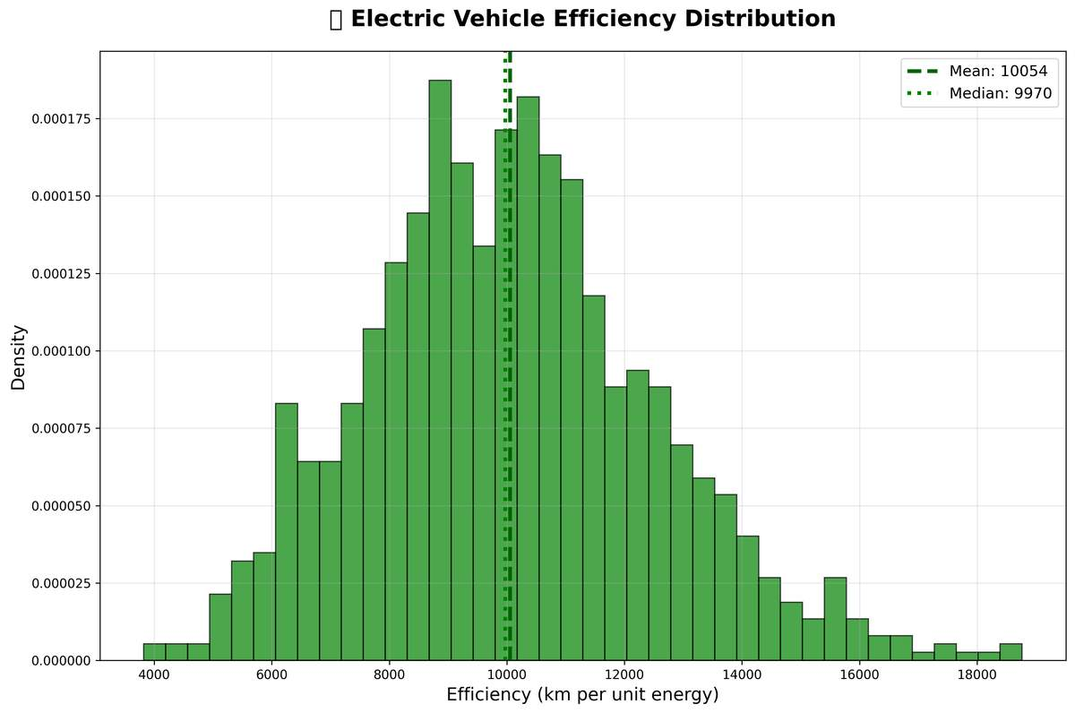

EV efficiency distribution (km per energy unit).

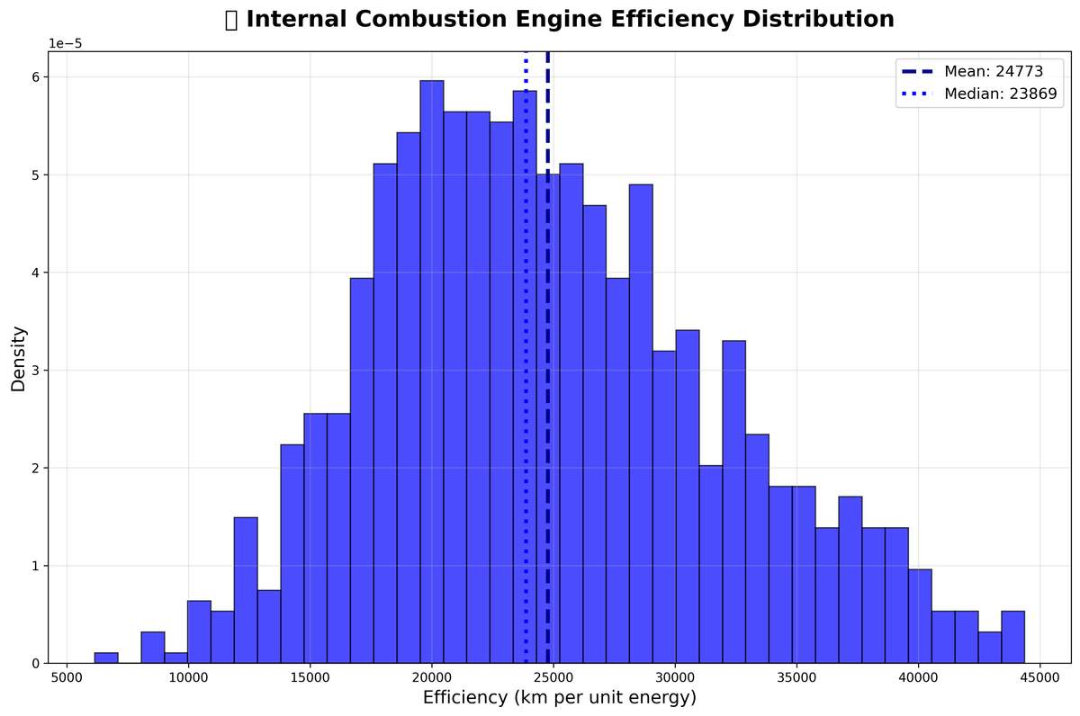

ICE efficiency distribution (km per energy unit).

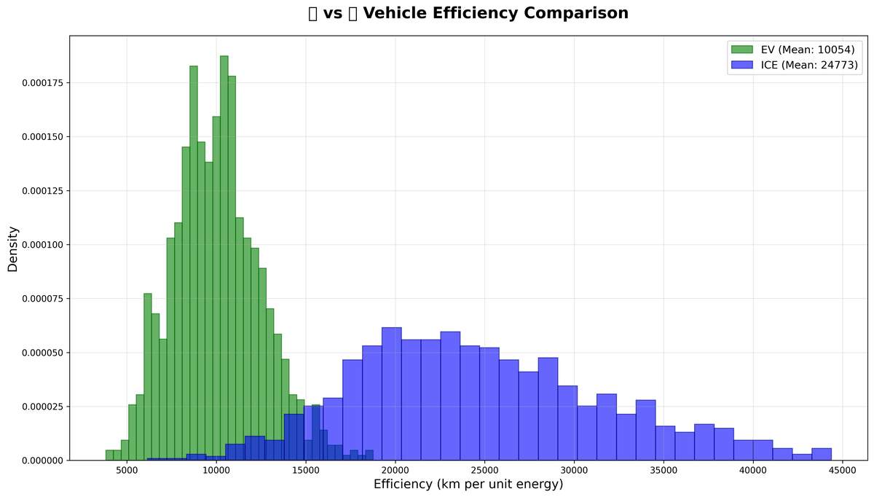

EV vs ICE efficiency comparison.

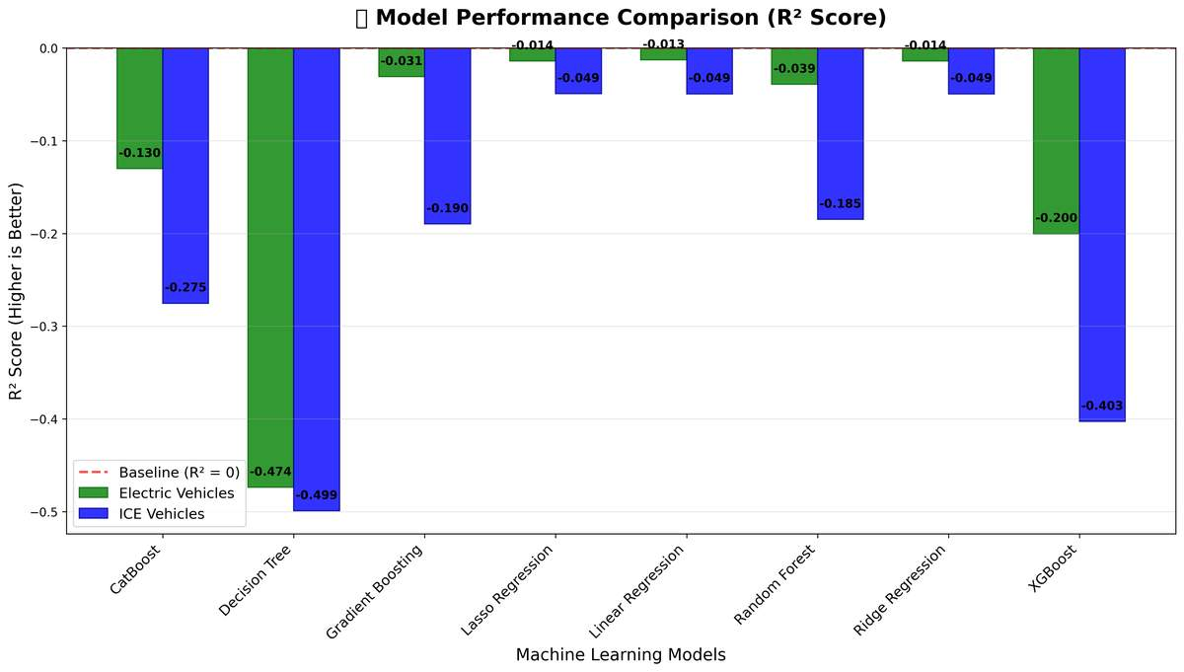

Cross-validated R² comparison across models.

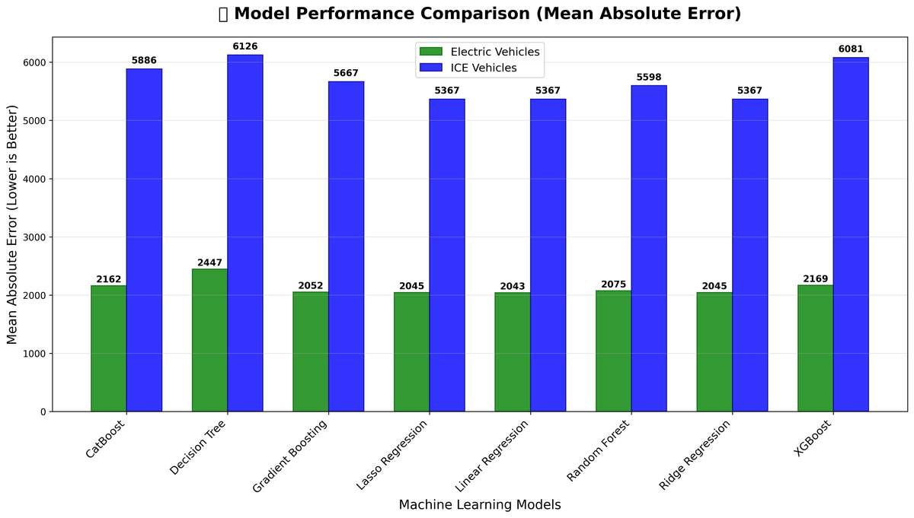

Cross-validated MAE comparison across models.

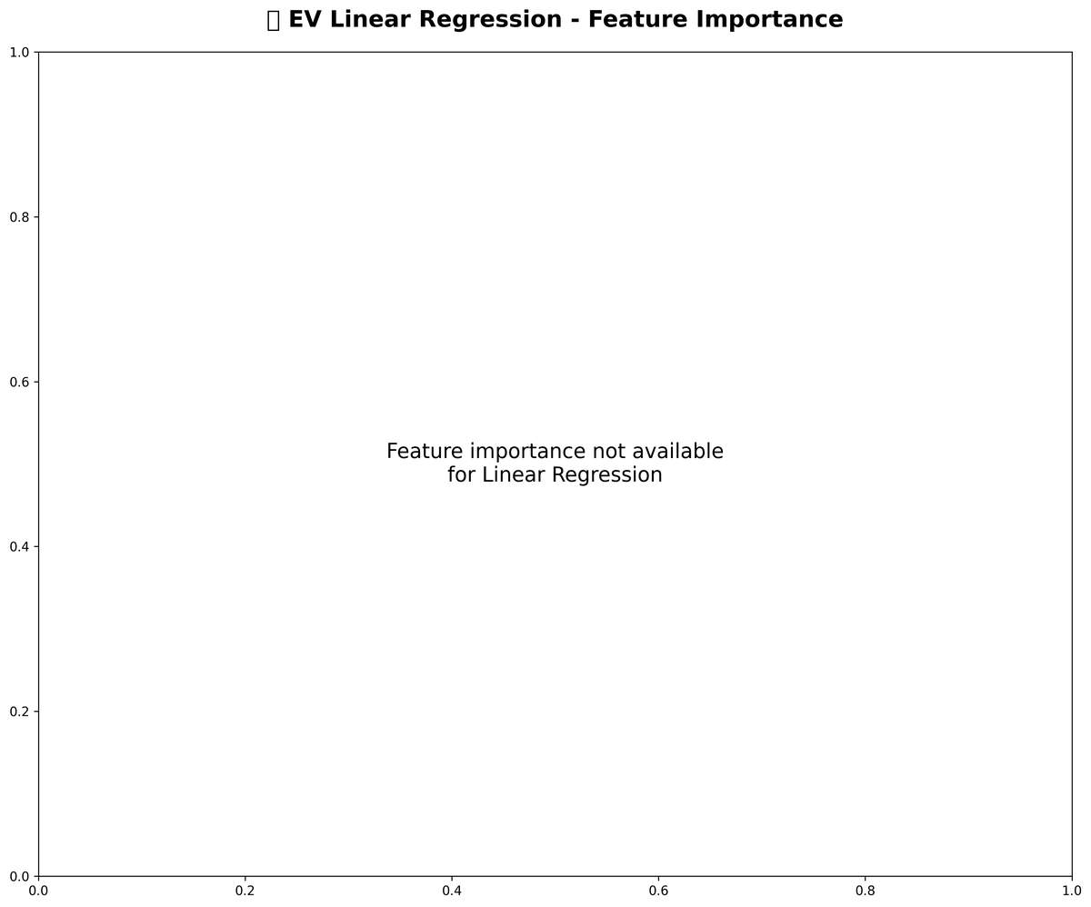

EV model feature importance (tree-based).

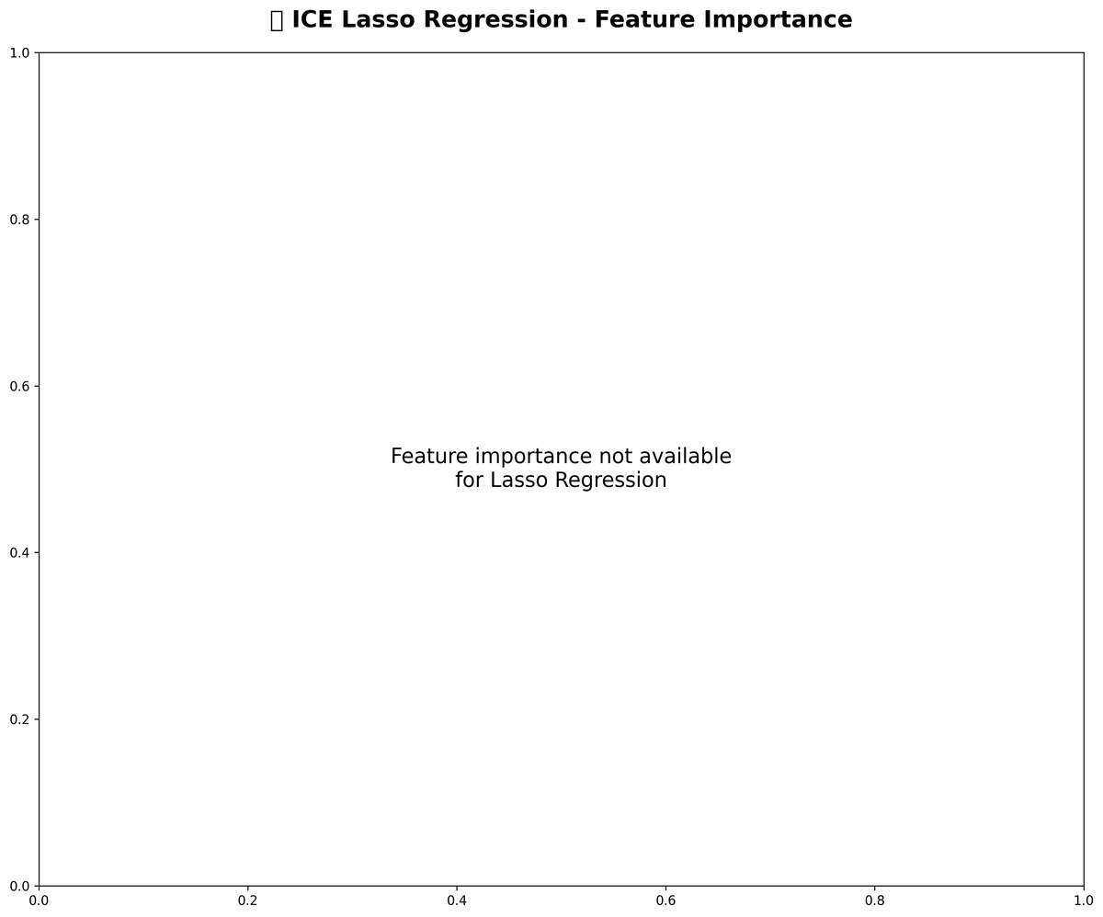

ICE model feature importance (tree-based).

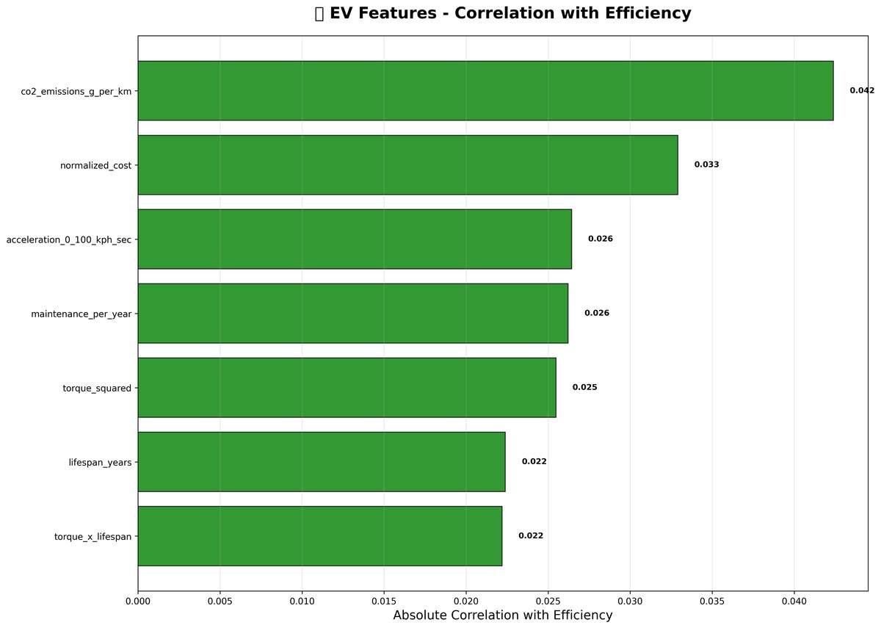

EV correlation analysis.

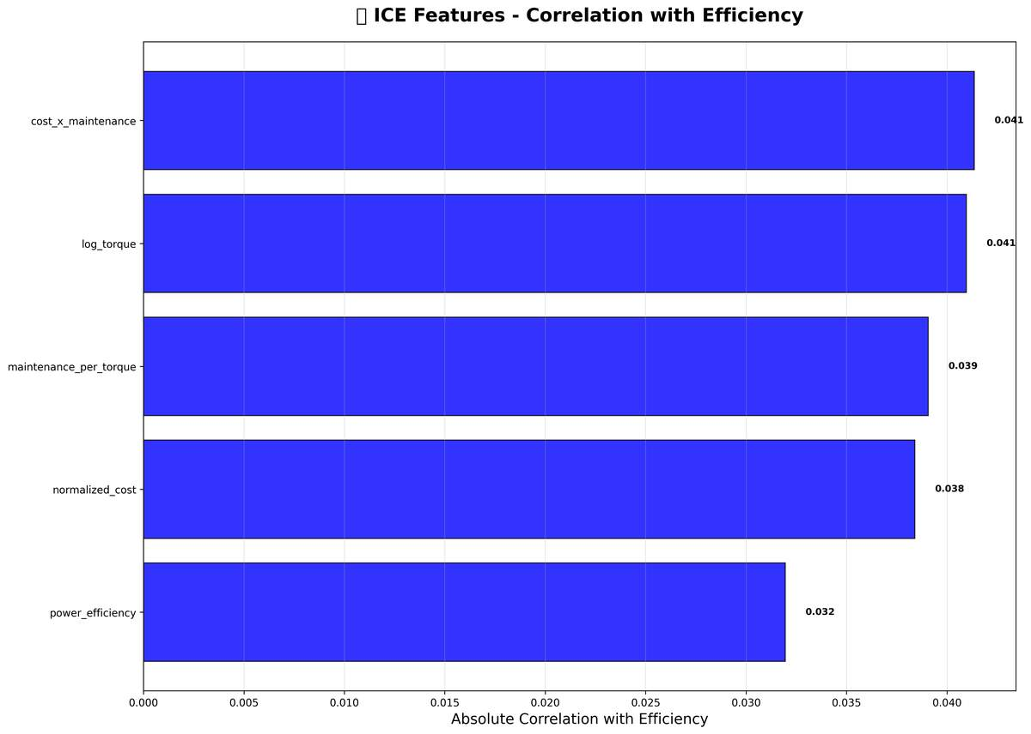

ICE correlation analysis.

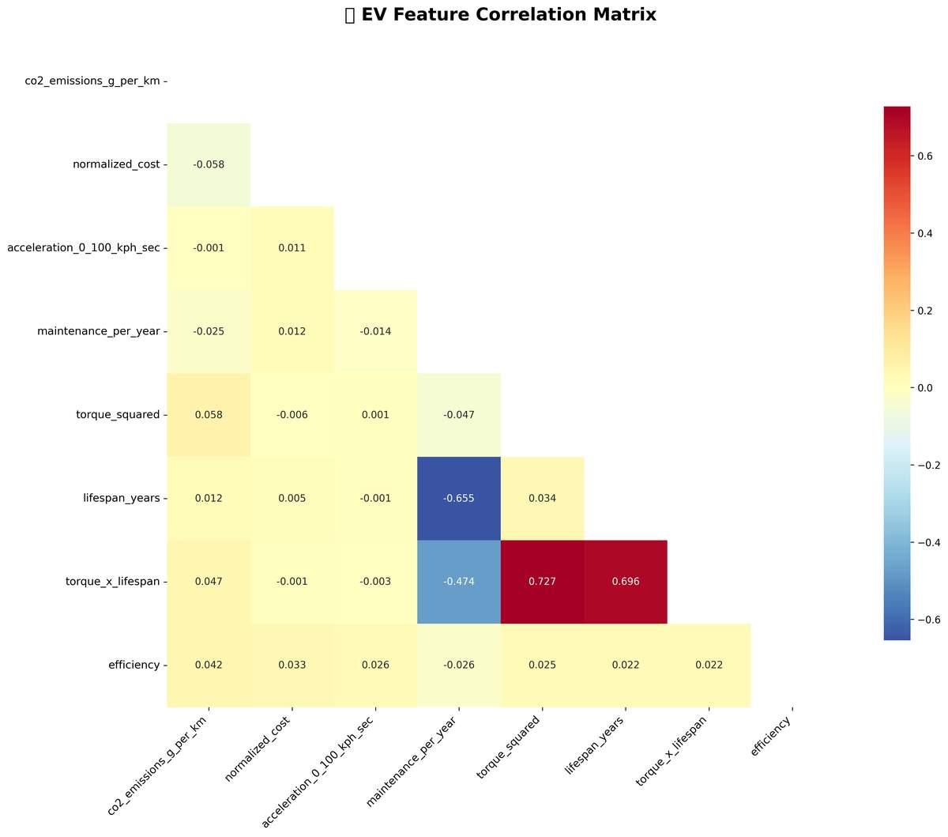

EV correlation heatmap.

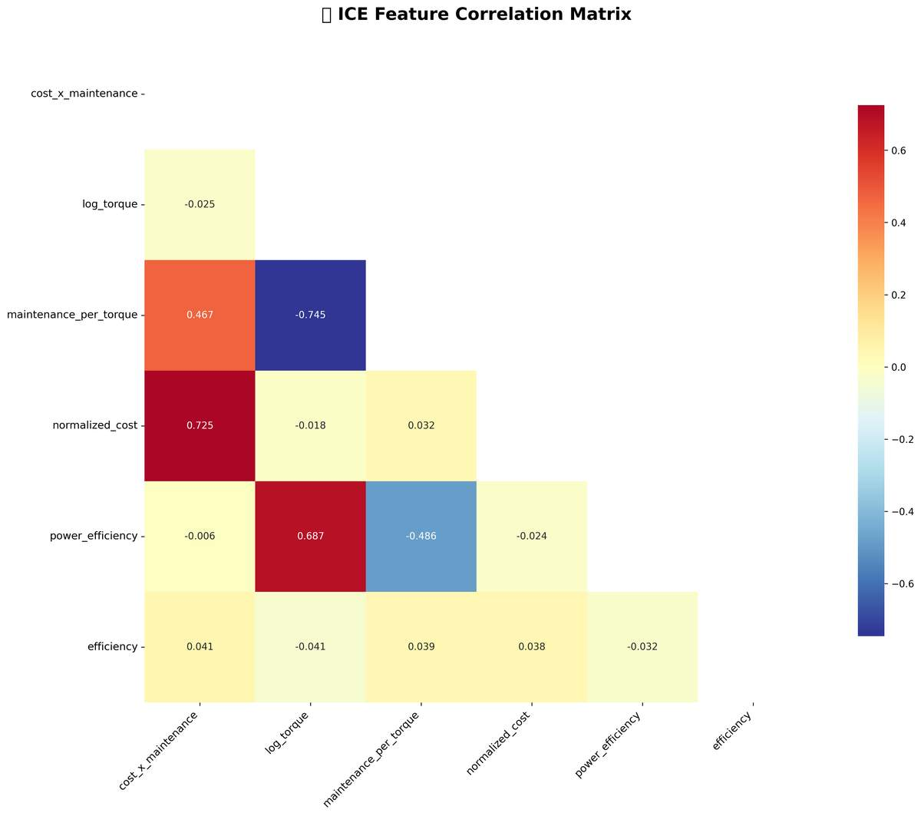

ICE correlation heatmap.

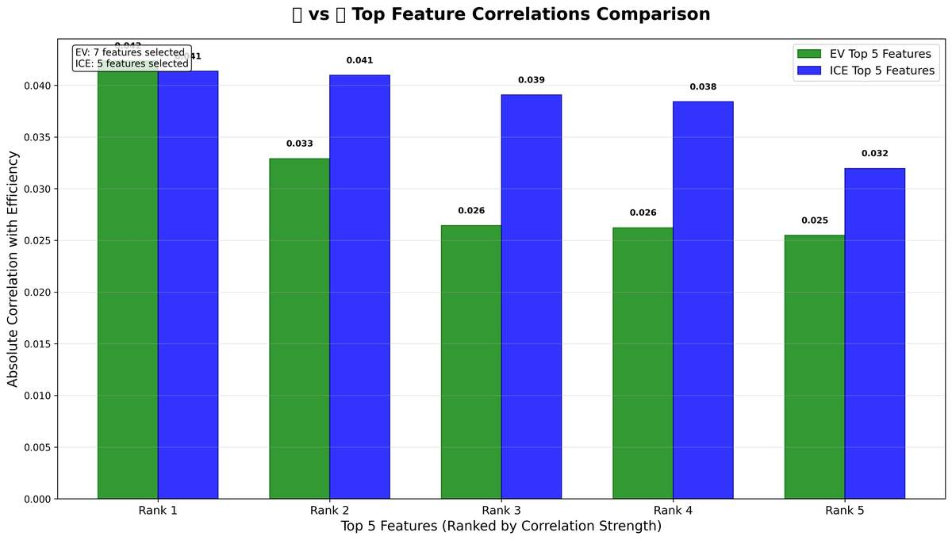

Cross-group correlation comparison.

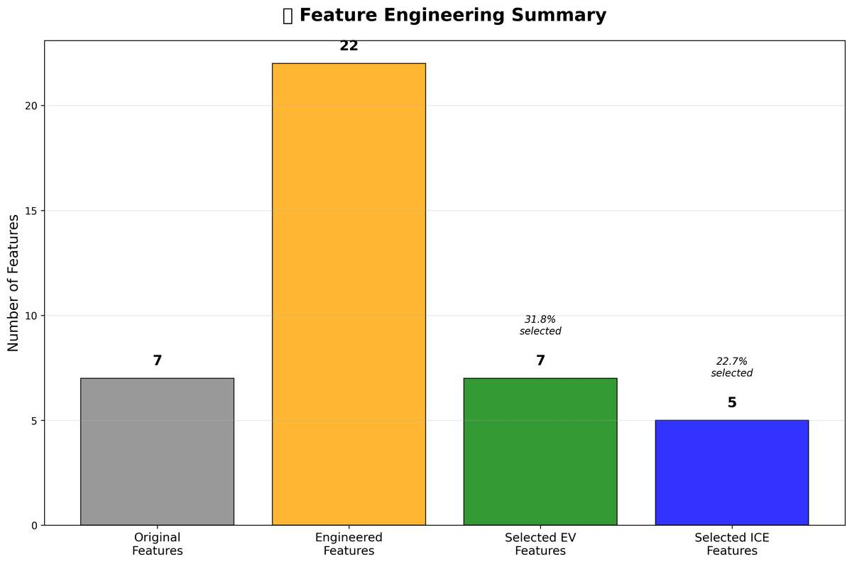

Summary of feature engineering steps and gains.

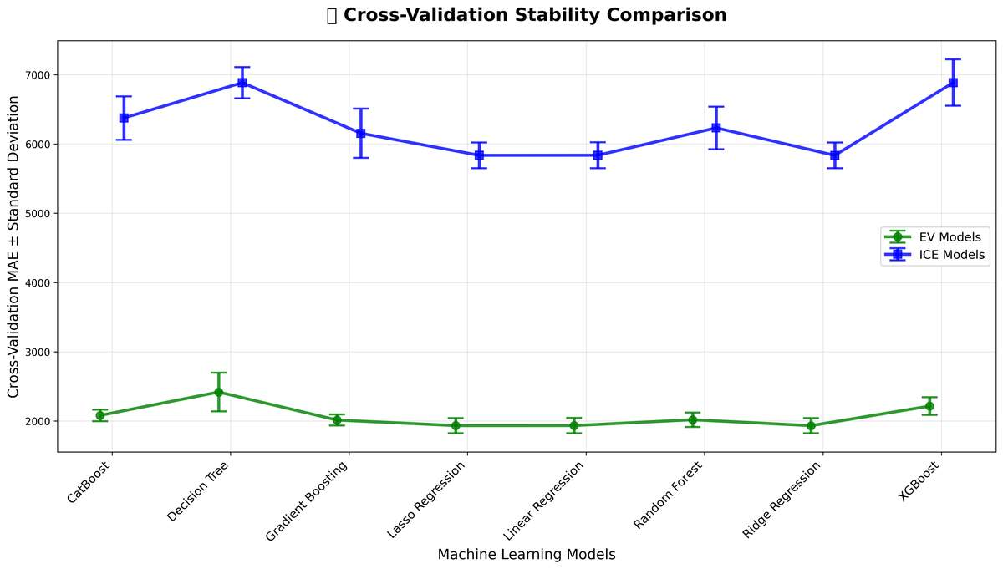

Cross-validation stability comparison (variance reduction).

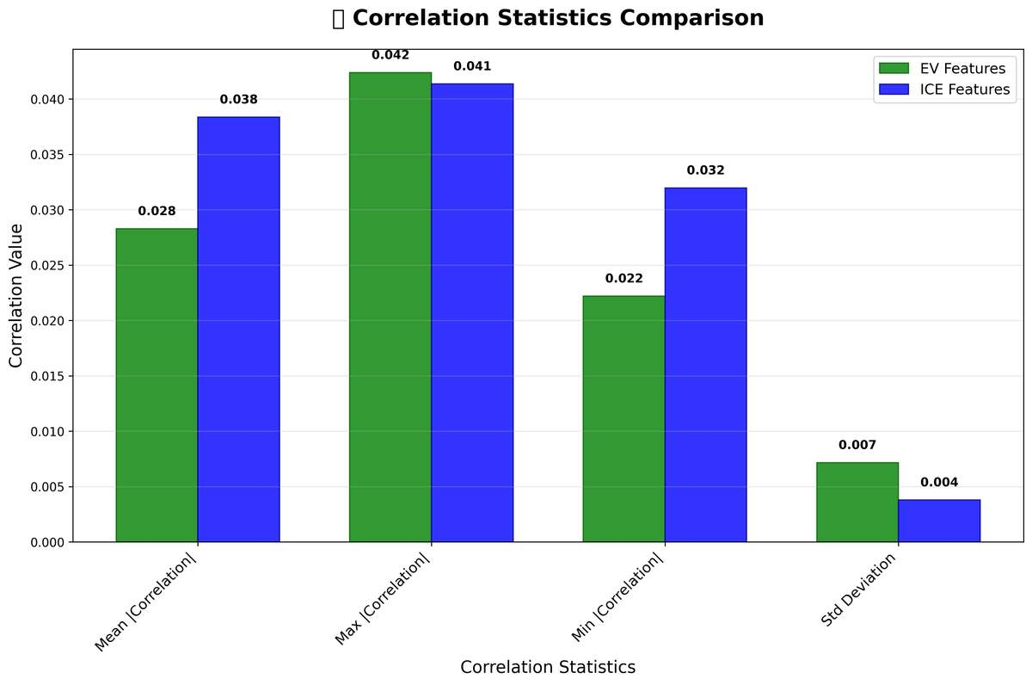

Correlation statistics overview.

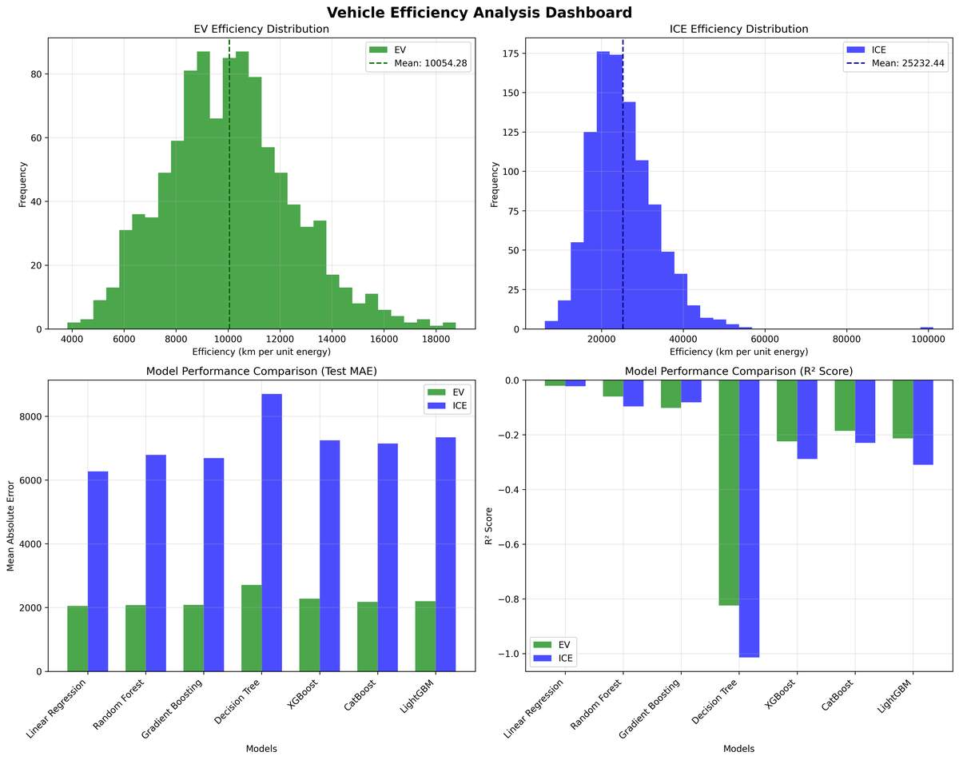

Efficiency Analysis Dashboard

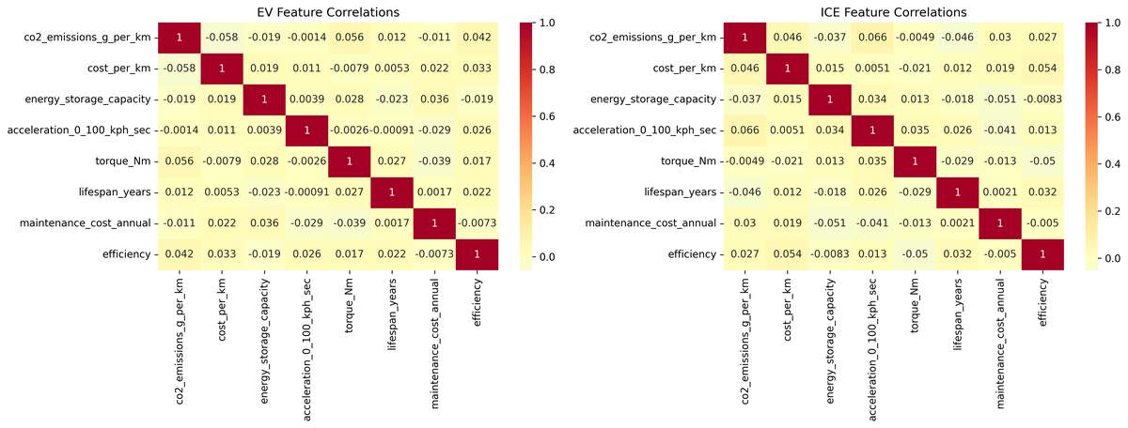

Feature Correlations